**DARAJANI SECONDARY SCHOOL,**

**P.O. BOX 20-90129, NGWATA.**

**MID_TERM 2, 2015_ EXAMINATION**

**FORM 3**

**CHEMISTRY PAPER 2**

**233/2**

**TIME: 2HRS**

**NAME………………………………...……………ADM. NO……………….. CLASS:…………….**

1. The following are observations made from two solid substances x and y.

|  |  |  |  |
| --- | --- | --- | --- |
| Solid | Electrical conductivity in solid state | Solubility in water | Boiling point |
| X | Poor | Insoluble | Sublimes |
| Y | poor | soluble | high |

1. State the most likely type of bonding in

(i)Solid x ……………………………………………………. (1 mark)

(ii) Solid y……………………………………………………. (1 mark)

1. When air is bubbled through pure water (PH=7) the PH drops to 6.0. Explain. (2 marks)

……………………………………………………………………………………………………..

……………………………………………………………………………………………………………………………………………………………………………………………………………..

3. The set-up below shows laboratory preparation of hydrogen gas, use it to answer the questions that follow.

dilute

sulphuric

acid

Zinc granules Conc. H2SO4

* + 1. Identify two mistakes in the set-up (2 marks)

………………………………………………………………………………………………………………………………………………………………………………………………………………………………………………………………………………………………………………………………………………

b)Why is dilute nitric acid not used in preparation of hydrogen gas. (1 mark)

………………………………………………………………………………………………………………………………………………………………………………………………………………………………

4. The diagram below represents an incomplete paper chromatogram of pure dyes x, y, z and

mixture w.

w x y z

Mixture w contains dyes y and z only. Complete the chromatogram to show how mixture w separates

(2 marks)

5. 22.2cm3 of sodium hydroxide solution containing 4.0g per litre sodium hydroxide were required for complete neutralisation of 0.1g of a dibasic acid. Calculate the relative formula mass of the dibasic acid. (Na = 23, O=16, H=1) (3 marks)

……………………………………………………………………………………………………………………………………………………………………………………………………………………………………………………………………………………………………………………………………………………………………………………………………………………………………………………………………………………………………………………………………………………………………………..

6.Determine the relative atomic mass of element K whose isotopic mixture occur in the proportions;

 (3mks)

7. Using dots (•) and crosses (x) to represent electrons .Show the bonding in compounds formed when the following elements react, 

a) Sodium and Chlorine (2mk)

8. (a) Amorphous carbon is the impure form of Carbon . Name two examples of this form of Carbon (2mk)

**……………………………………………………………………………………………………**

**……………………………………………………………………………………………………**

(b) State two uses of Amorphous carbon (2mks)

**………………………………………………………………………………………………….**

**……………………………………………………………………..........................................**

9 (a) State Graham’s Laws of diffusion (1mk)

**……………………………………………………………………………………………….......**

**……………………………………………………………………………………………………**

1. )A certain volume of gas A diffuses through a porous plug in 41 seconds and the same volume of air diffuses through the plug in 155 seconds. Calculate the density of gas A. (Density of air is 1.0g/cm3) (2mk)

10.Excess Iron fillings were allowed to rust in 1dm3 of moist air and the volume of the remaining air measured each day.

|  |  |  |  |  |  |  |  |  |  |  |
| --- | --- | --- | --- | --- | --- | --- | --- | --- | --- | --- |
| Day |  |  |  |  |  |  |  |  |  |  |
| Volume of Air (cm3) |  |  |  |  |  |  |  |  |  |  |

1. Why did the volume of the air remain constant from day six (1mk)

**………………………………………………………………………………………………………………………………………………………………………………………….**

1. Determine the % volume of oxygen in air (2mk)

1. write the chemical formula of rust (1mk)

11.Describe how you would prepare a sample of Lead (II) chloride using the following reagents, Dilute Nitric (v) acid; dilute Hydrochloric acid and Lead (II) carbonate. (2mks)

**…………………………………………………………………………………………………**

**…………………………………………………………………………………………………..**

**…………………………………………………………………………………………………..**

**…………………………………………………………………………………………………..**

12.Given that element G has an electronic arrangement of 2.8.18.7 and element H has an atomic number 17.

To which period of the periodic table does element G belong? Explain (1mk)

**……………………………………………………………………………………………………………………………………………………………………………………………….**

b) How would the reaction of Sodium metal with G compare to its reaction

with H ? Explain (2mks)

13. The diagram below shows apparatus arrangement during combustion of Ethane gas.

Excess gas P

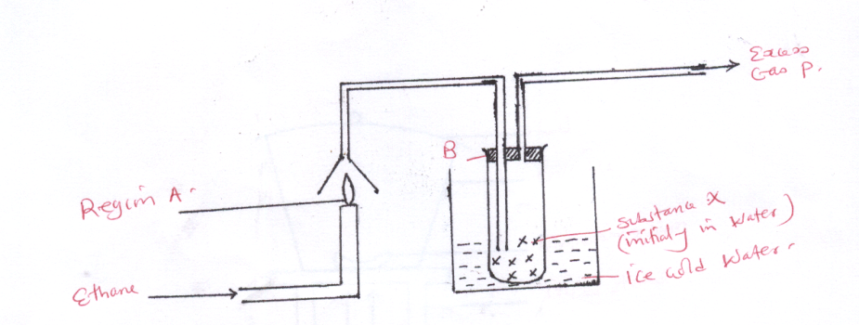

B

Substance X(initially in water)

Ice cold water

Region A

Ethane

Write down the equation for the reaction occurring at region A . (1mk)

* + 1. What is expected to be the PH of substance X. (1mk)

**………………………………………………………………………………………………. ……………………………………………………………………………………………….**

Identify excess gas P (1mk)

14. Explain why when one is stung by a bee application of a little solution of sodium

hydrogen carbonate helps to relieve the pain. ( 3 marks )

___________________________________________________________________________

___________________________________________________________________________

___________________________________________________________________________

____________________________________________________________________________

___________________________________________________________________________

15.The following table gives information about elements that belong to a group in the periodic table.

|  |  |  |  |  |
| --- | --- | --- | --- | --- |
| Element | B | C | D | E |
| Atomic radii (nm) | 0.152 | 0.186 | 0.231 | 0.244 |

Give reasons why both atomic and ionic radii increase down the group. (3mks)

…..……………………………………………………………………………………….

……………………………………………………………………………………………...

……………………………………………………………………………………………..

……………………………………………………………………………………………...

……………………………………………………………………………………………...

16.Both graphite and lead (II) bromide can conduct electricity. Explain how each of the substances conducts electricity.

Graphite (1mk)

…………………………………………………………………………………………………………………………………………………………………………………………………..

Lead(II)bromide (1mk)

……………………………………………………………………………………………………………………………………………………………………………………………………

17.The diagram below represents the results obtained when paper chromatography was used to identify the two substances present in a mixture M Study it to answer the questions that follow.

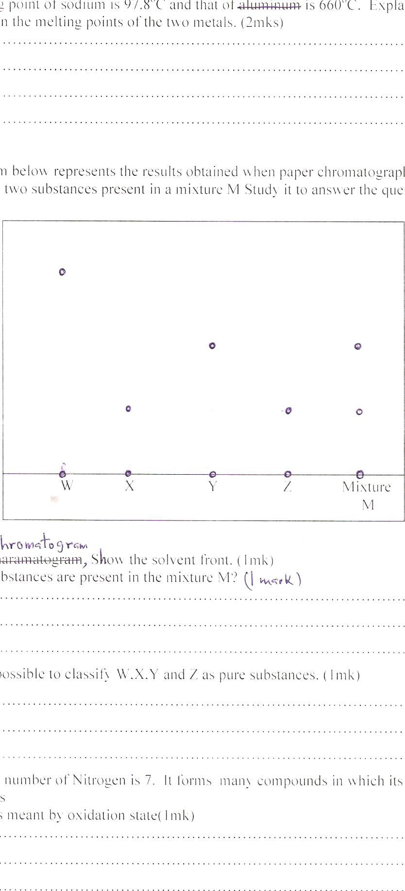

1. On the chromatogram, show the solvent front. (1mk)
2. Which substances are present in the mixture M?(1mk)

……………………………………………………………………………………………………………………………………………………………………………………………………………………………………………………………………………………………..

© Why is it possible to classify W,X,Y and Z as pure substances. (1mk)

………………………………………………………………………………………….........

…………………………………………………………………………………………………

…………………………………………………………………………………………….

18.The melting point of sodium is 97.8oC and that of aluminium is 660oC. Explain the difference in the melting points of the two metals. (2mks)

…………………………………………………………………………………………………………………………………………………………………………………………………………………………………………………………………………………………………………………………………………………………………………………………………………

19. The diagram below shows a set up which was used by a student to investigate the effect of electricity on molten Lead(II)iodide.

a)On the diagram, label the anode and cathode(1mk)

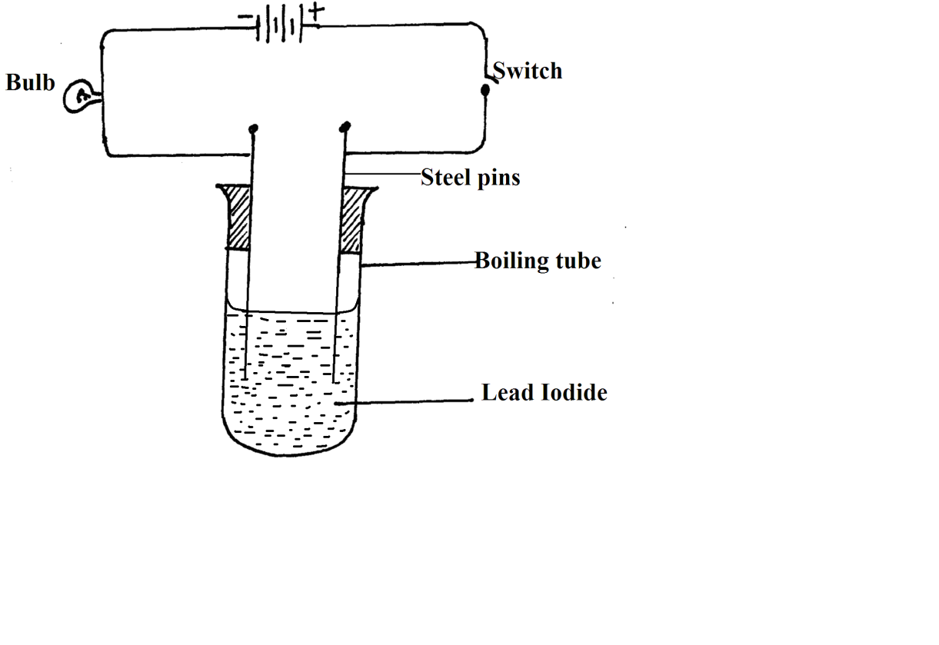

(b) What observations would be made on the lead iodide during the electrolysis. Explain (2mks)

……………………………………………………………………………………………………………………………………………………………………………………………………………….

……………………………………………………………………………………………………….

(b) Why was it important to carry out the experiment in a fume chamber? (1mk)

……………………………………………………………………………………………………………………………………………………………………………………………………………….

20. In an experiment to investigate the effect of burning hydrogen gas, a student set up the apparatus as shown below:

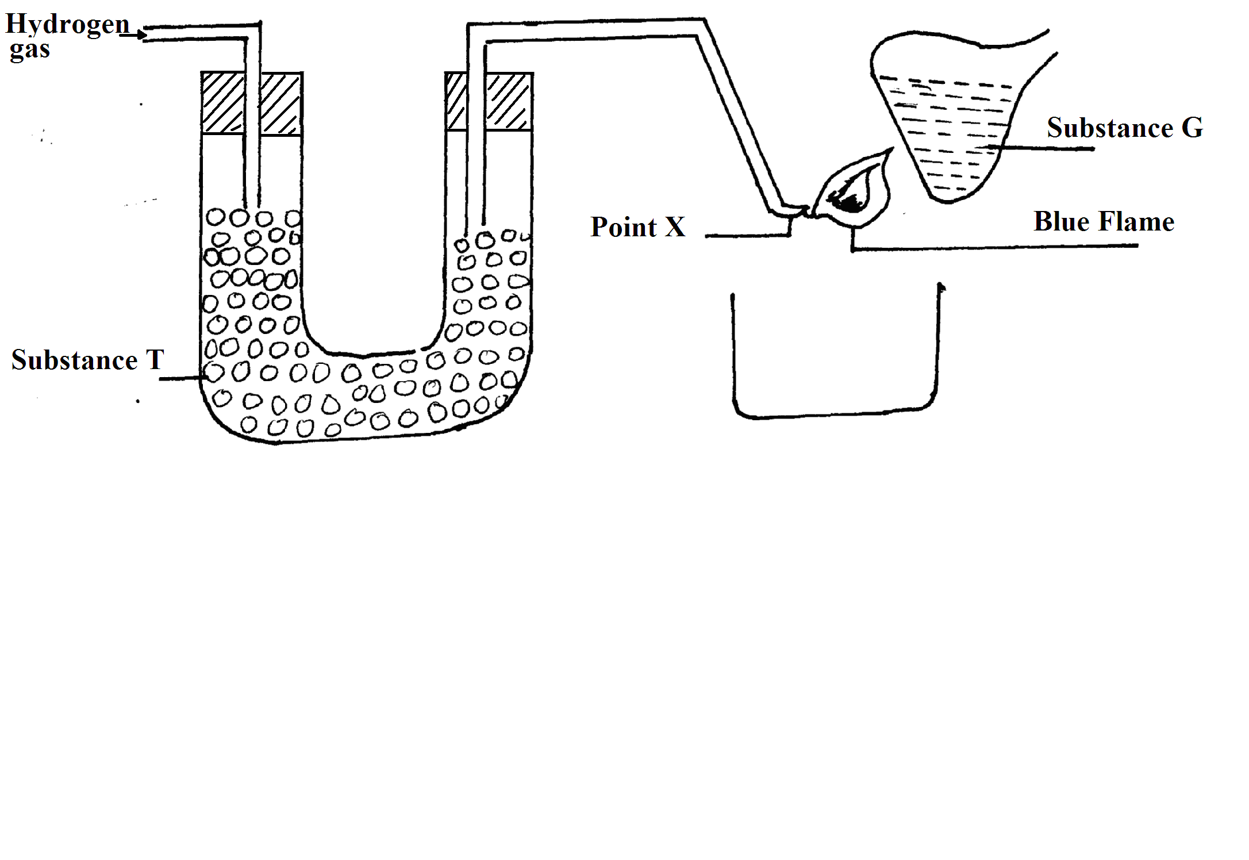

(a) Identify:

(i) Substance T……………………………………………………. ( 1 mk)

(ii) Substance G…………………………………………………… ( 1 mk)

(b) Write the equation for the reaction of point X (1mk)

……………………………………………………………………………………………

21. The structure of water molecule can be represented as shown below.

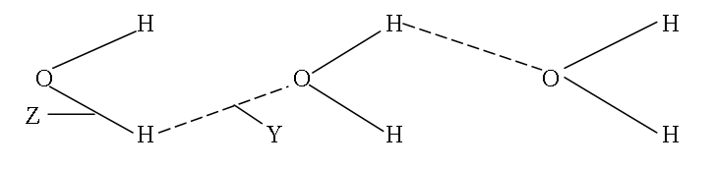

(a) Name the type of bond represented by letters Y and Z. (2mks)

Y…………………………………………………………………..

z……………………………………………………………………

(b) Relative molecular mass of methane and water are almost similar. However, the boiling point of water is 1000C while methane is -1610C. explain (2mks)

……………………………………………………………………………………………………………………………………………………………………………………………………………….

……………………………………………………………………………………………………………………………………………………………………………………………………………….

22. Briefly explain how you would obtain pure sample of lead (II) chloride from a mixture of lead (II) chloride and silver chloride. (2mks)

**……………………………………………………………………………………………………….……………………………………………………………………………………………………….**

**……………………………………………………………………………………………………….……………………………………………………………………………………………………….**

**……………………………………………………………………………………………………….…………………………………………………………………………………................................**

23. Name the process which takes place when:

(a) Solid carbon (IV) oxide changes directly into gas. (1mk)

**……………………………………………………………………………………………………**

24.The diagram below shows a Bunsen burner when in use

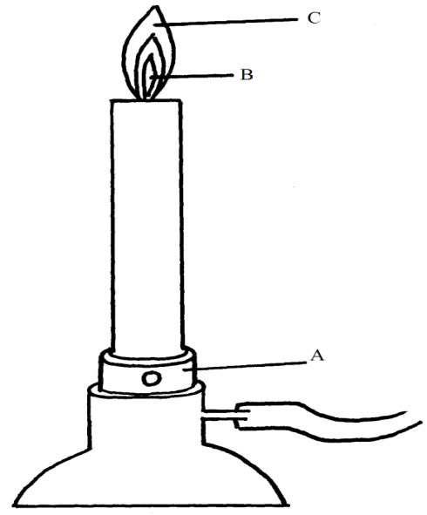

(a) Name the regions labelled B and C. (2mks)

B……………………………………………………………………………………………

C…………………………………………………………………………………………….

(b) What is the function of the part labelled A? (1mk)

**……………………………………………………………………………………………………….……………………………………………………………………………………………………….**

25. The graph below shows the changes which take place when a solid is heated.

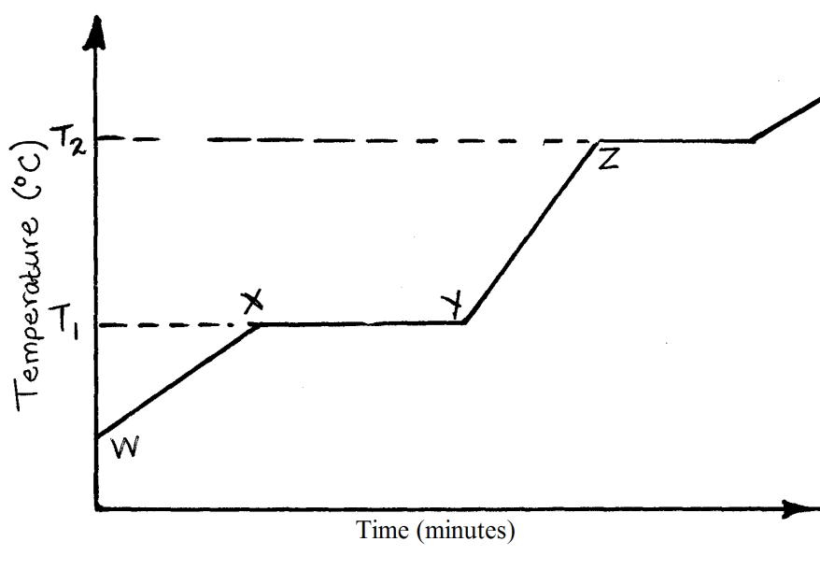

(a) What happens to the molecules between W and X? (1mk)

**……………………………………………………………………………………………………….……………………………………………………………………………………………………….**

(b) Explain why the temperature does not rise between X and Y. (1mk)

**……………………………………………………………………………………………………….……………………………………………………………………………………………………….**

(c) Is the substance represented pure or impure? Give a reason. (1mk)

**……………………………………………………………………………………………………….**

**……………………………………………………………………………………………………….……………………………………………………………………………………………………….**

26. i) Name the piece of apparatus shown below (1mk)

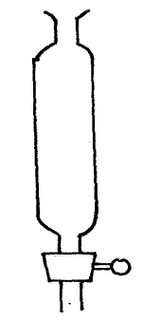

ii) What is the use of the apparatus (1mk)

……………………………………………………………………………………………………….

27. Propane and Chlorine react as shown



a) Name the type of reaction that takes place (I mk)

…………………………………………………………………………………………………

b) State the condition under which the reaction takes place. (1 mk)

………………………………………………………………………………..…………………………………………………………………………………………………………………………………………………..............

28. The figure below shows a paper that was placed horizontally across the middle of a non-luminous flame and quickly withdrawn.

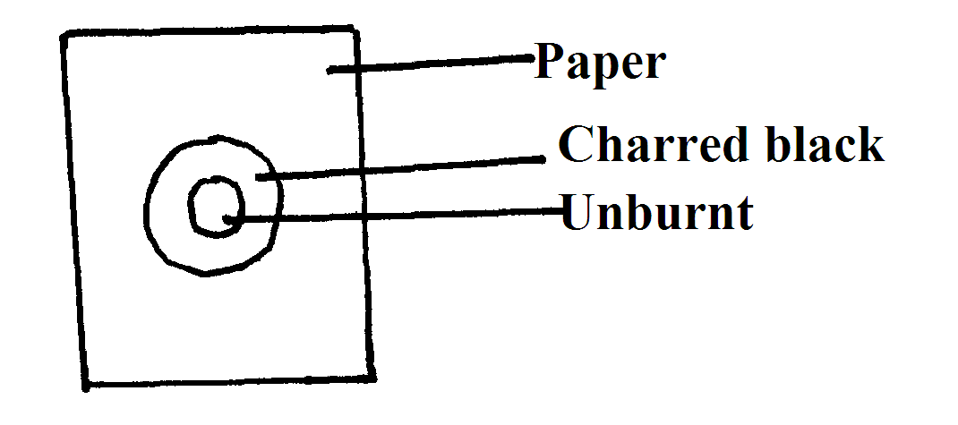

(a) Explain the observations. (1mk)

……………………………………………………………………………………………………………………………………………………………………………………………………………….

(b) Why is luminous flame not used for heating in the laboratory? (1mk)

……………………………………………………………………………………………………………………………………………………………………………………………………………….

29. Give the systematic names of the following compounds.

(a)  (1mk)

……………

b)Draw and name two isomers of pentane(2mks)