GATITU MIXED SECONDARY SCHOOL
FORM 3 CHEMISTRY
MID-TERM EXAM

1. Hydrogen gas is one of the lightest gas known but has not lived to its expectation to be used in observation balloons. Explain (2mks)
…………………………………………………………………………………………………..………
……………………………………………………………………………………………………....….
2. Using dots (•) and crosses(x), show bonding in magnesium chloride. (2mks)

- Below is a table of 1st ionization energies for elements A, B, C, and D which are metals.

Elements | A | B | C | D
Ionization energies Kjmol⁻¹ | 494 | 418 | 519 | 376

a) What is meant by 1st ionization energy? (1mk)
………………………………………………………………………………………………………….
…………………………………………………………………………………………………………
…………………………………………………………………………………………………..………
b) With an explanation, arrange the elements in order of increasing relativities. (2mks)
…………………………………………………………………………………………………..………
……………………………………………………………………………………………………....….
4. The catalytic oxidation of ammonia gas is done as per the set up below.
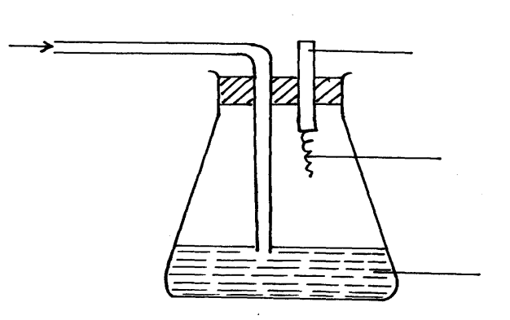
Oxygen
gas
Glass rod

Platinum wire

Concentrated
Ammonia solution

a) Name the catalyst used in the above reaction. (1mk)
…………………………………………………………………………………………………..………
b) After sometime, brown fumes are formed in the flask. Explain briefly how this observation
occurs. (1mk)
………………………………………………………………………………………………………..
………………………………………………………………………………………………………….
…………………………………………………………………………………………………..………
c) Why does the metal catalyst stay red hot for some time? (1mk)
…………………………………………………………………………………………………………….
…………………………………………………………………………………………………..………
5. Using a suitable equation explain why it is not advisable to use hard water in hot water systems. (3mks)
…………………………………………………………………………………………………..………
……………………………………………………………………………………………………....….
6. (i) Carbon(IV) oxide is one of the main contributor to global warming.
Name two other gases. (2mks)
…………………………………………………………………………………………………..………
……………………………………………………………………………………………………....….
(ii) What is cloud seeding? (1mk)
…………………………………………………………………………………………………………
…………………………………………………………………………………………………..………
7. Classify the following processes as either chemical or physical.
Process Type of change
a) Heating of copper(II) suplphate crystals | (1mk)
b) Obtaining Kerosene from crude oil | (1mk)
c) Souring of milk | (1mk)
8. (a) State Gay-Lussac’s law (1mk)
………………………………………………………………………………………………………………………………………………………………………………………………………………………………….
…………………………………………………………………………………………………..………
(b) Under certain conditions, methane reacts with steam to form carbon (II) oxide and hydrogen only.
Calculate the total volume of the gas that can be formed when 100cm³ of steam reacts completely with methane. (2mks)

9. The diagram below represents set-up that can be used to prepare and collect oxygen gas
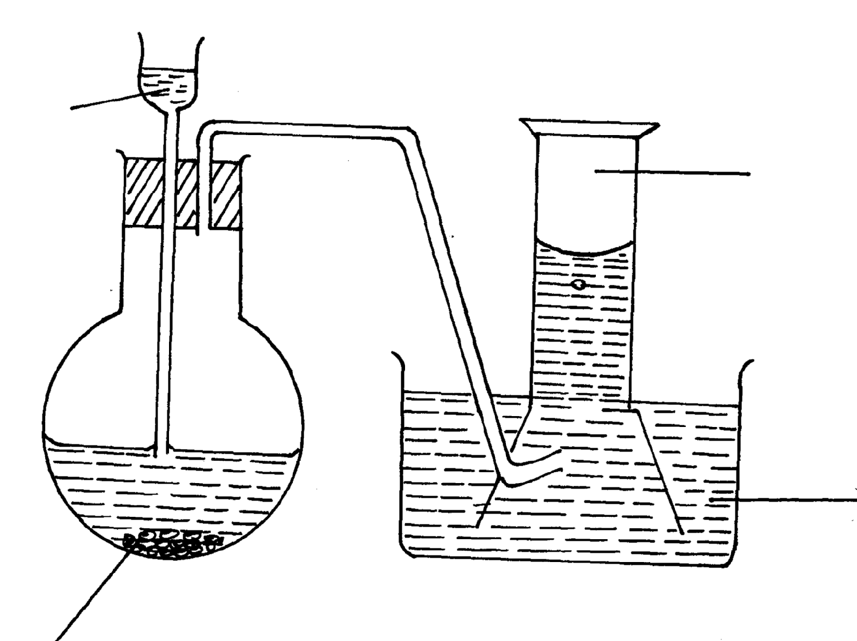
Solids P
Water
Oxygen gas
Water

- Name solid P (1mk)…………………………………………………………………………………………………..……
b) What property of oxygen makes it possible for its collection as indicated by the diagram. (1mk)
…………………………………………………………………………………………………..………
- Explain why it is important not to collect any gas for the first few seconds of the experiment. (1mk)

10. 36cm³ of a solution of potassium hydroxide requires 25cm³ of 0.5M sulphuric acid to neutralize it. Calculate the concentration of alkali in g/dm³ (3mks)

11. The following table gives the melting points of oxides of elements in period 3. Study it and answer the
questions that follow:-

Formula of oxide | Na₂O | MgO | Al₂O₃ | SiO₂ | P₄O₁₀ | SO₃
Melting point (ºC) | 1190 | 3080 | 2050 | 1730 | 560 | -73

(i) Explain the difference in melting points of MgO and P₄O₁₀ (2mks)
…………………………………………………………………………………………………..………
……………………………………………………………………………………………………....….
(ii) Name the compound in the above table that will dissolve both in dilute hydrochloride acid and
dilute sodium hydroxide. (1mk)
…………………………………………………………………………………………………..………

12. Describe how you would prepare crystals of sodium nitrate starting with 200cm³ of 2M sodium hydroxide. (3mks)
…………………………………………………………………………………………………..………
……………………………………………………………………………………………………....….
……………………………………………………………………………………………………....…
13. The diagram below shows an iron bar, which supports a bridge. The iron bar is connected to a
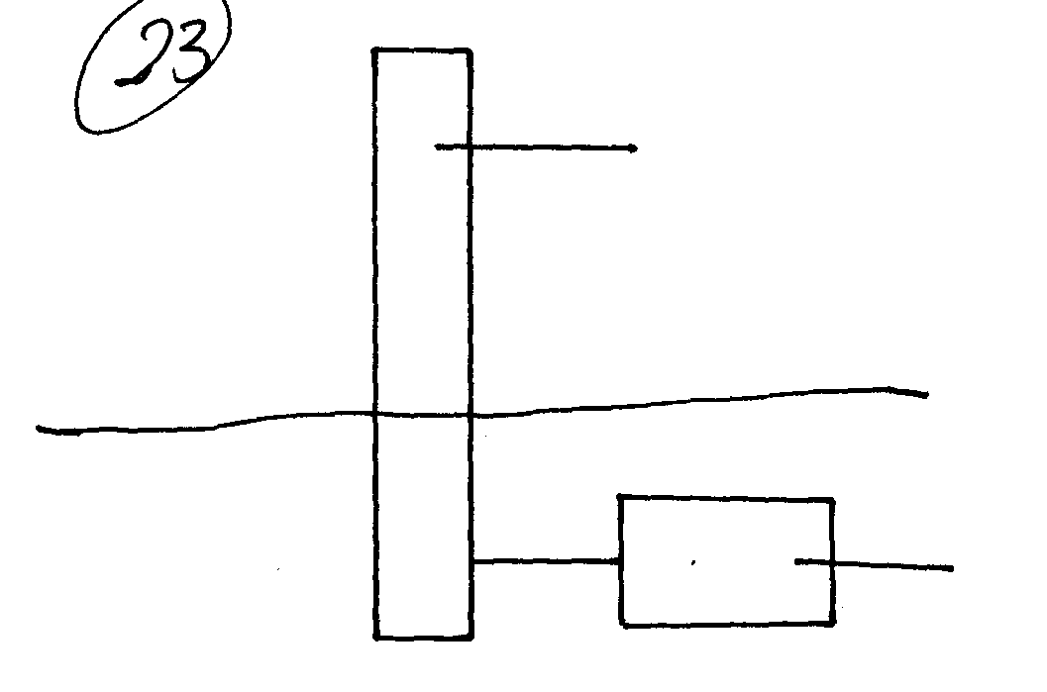 piece of magnesium metal.
Magnesium metal
Iron bar
Soil

Explain why it is necessary to connect the piece of magnesium metal to the Iron bar. (2mks)
……………………………………………………………………………………………………....….
……………………………………………………………………………………………………....….
14. Study the set-up below and answer the questions that follow
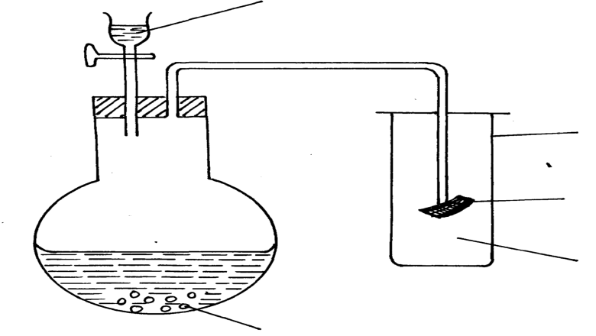
Dilute hydrochloric acid

A gas jar

Red litmus paper

Sodium sulphite
Gas x

a) Identify gas X (1mk)
……………………………………………………………………………………………………....….
b) Write an equation for the reaction that produces gas x. (1mk)

c) What is the effect of the gas x above on the red-litums paper (1mk)
……………………………………………………………………………………………………....….

15. Study the scheme below and use it to answer the questions that follow.
Salt solution
P
White precipitate
Colourless gas which is acidic
BaCl₂ (_{aq)}
HCl_{(aq)}

Write down the formulae of two possible anions present in salt solution P. (2mks)

16 The diagram below shows a Bunsen burner when in use
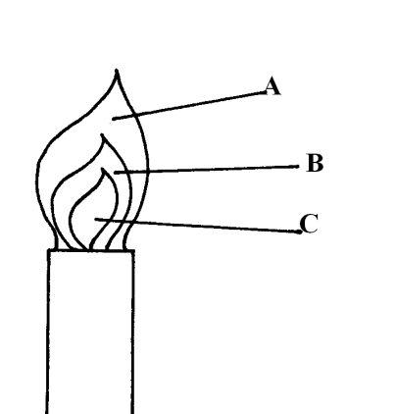

Which of the labeled parts is used for heating? Give a reason (2mks)
……………………………………………………………………………………………………....….
……………………………………………………………………………………………………....….

1. It is highly flammable / it burns or explodes in air.
2. Correct charge√ correct electronic structure √
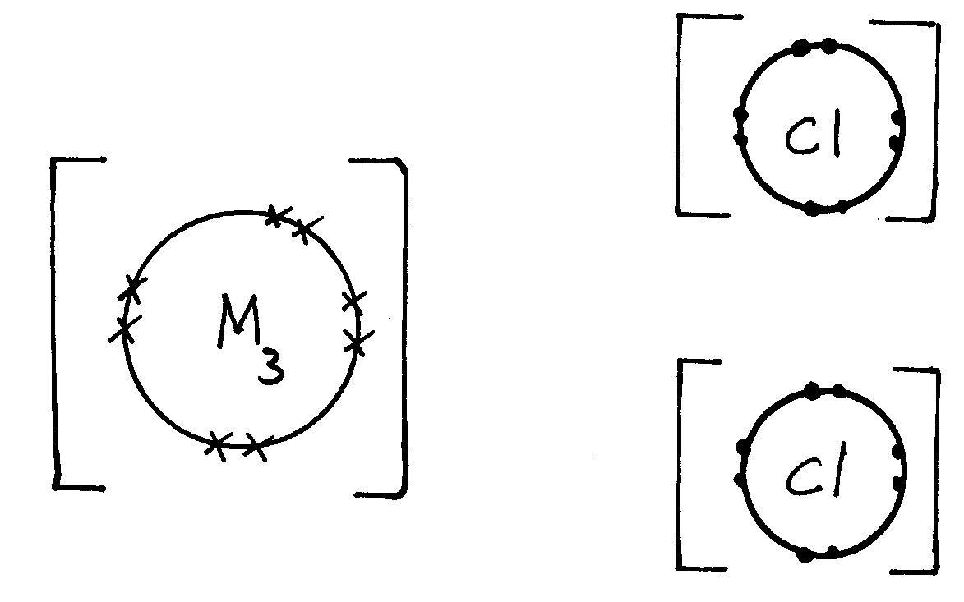
-
Correct charge √
Correct electronic structure √
2+
-

3. (a) This is the energy required to remove the 1st outermost electron from an atom in gaseous state to form an ion √ 1
(b) C A B D √ 1
Increasing reactivity
Higher ionization energy implies high nuclear charge which hinders removal of electron.

4. (a) Pt or copper
(b) No formed is oxidized by O₂ to NO₂ which is brown
(c) The reaction is exothermic

5. Ca(HCO₃)_{2 (aq)} CaCO_{3(s)} + CO_{2(g)} + H₂O_{(l)}
Mg(HCO₃)_{2(aq)} MgCO_{3(s)} + CO_{2(g)} + H₂O_{(l)}
When water containing these salts are boiled, they decompose into carbonate, carbon (IV) oxide and water. These carbonates precipitate out and form scales.

6. (i) N₂O, ozone – methane
water vapour
(ii) Spraying of CO₂ into the sky using jets so that cloud may form and rain may fall.

7. (a) physical (b) Physical (c) Chemical

8. (a) When gases react together, the volumes of the gases which react and those of the products; if gases, bear a simple whole number ratio to one another, all volumes being measured at the same temperature and pressure.

(b) CH_{4(g)} + H₂O_{(g)} CO_{(g)} + 3H_{2(g)}
1vol. 1vol. 1vol. 3vol
1cm³ of H₂O react to produce 1cm³ CO_{(g)} and 3cm³ H_{2(g)}
100cm³ of steam react to produce 100cm³ CO_{(g)} and 300cm³ H_{2(g)}
Total volume of the gases formed = 100 + 300 = 400cm³

9. (a) Solid P – Sodium Peroxide, reject formula
(b) Slightly soluble in water
(c) To ensure that the air that occupied the apparatus initially is expelled.

10. 2KOH_{(aq)} + H₂SO_{4(aq)} → K₂SO_{4(aq)} + 2H₂O_{(l)}
36cm³ 0.5M 25cm³
Moles of H₂SO₄ = 0.5 x 25 = 0.0125moles
1000
Moles of KOH = 2 x 0.0125 = 0.025
Molarity of KOH = 0.025 x 1000 = 0.6944
36
≈ 0.7
Concentration in g/dm³ = 38.9g

11. (i) MgO has giant ionic structure with ionic bonds.
P₄O₁₀ has molecular structure with weak intermolecular forces
(ii) Aluminium oxide

12. (a) Drying agent H₂SO₄ in a wash bottle// anhydrous CaCl₂ in U-tube
Collection by downward delivery.
(b) NaCl_{(s)} + H₂SO_{4(l)} → NaHSO_{4(s)} + HCl_{(g)}
Balanced √1mk with state symbols
No state symbols award ½mk

13. Magnesium is above iron in the activity series. It supplies electrons to the iron bar hence prevent
it from rusting.

14. (a) Sulphur (IV) oxide / SO_{2(g)}
(b) Na₂SO_{3(s)} + 2HCl_{(aq)} 2NaCl_{(aq)} + SO_{2(g)} + H₂O_{(l)}
(c) It bleaches the litmus paper/ it decolourises
SO₂ in water form H₂SO₃ which ionizes to give SO₃²⁻ ions.
H₂SO_{3(aq)} 2H⁺_{(aq)} + SO₃²⁻_{(aq)}
SO₃²⁻ pick [O]from litmus paper to form SO₄²⁻ _{(aq)}

Or -121.8KJmol⁻¹
15. SO₃²⁻ and CO₃²⁻
Reject SO₄²⁻ it does not react with dil. HCl acid

16. A – hottest

