COUNTY MULTILATERAL
END OF TERM II EXAM
JULY / AUGUST 2015

CHEMISTRY
FORM 3
QUESTION PAPER
TIME : 2/12 HOURS.

1. Why are most laboratory apparatus made of glass. (2mks)

2.(a) State Gay Lussacs law of combining volume of gases. (1 mk)

b) A mixture of 100cm² of oxygen were exploded with 100cm^{s} of carbon (II) oxide. Which gas was in excess and by how much? (3 mks)

3. The set up below was used to study effect of current on substances. Study it and answer questions that follow.
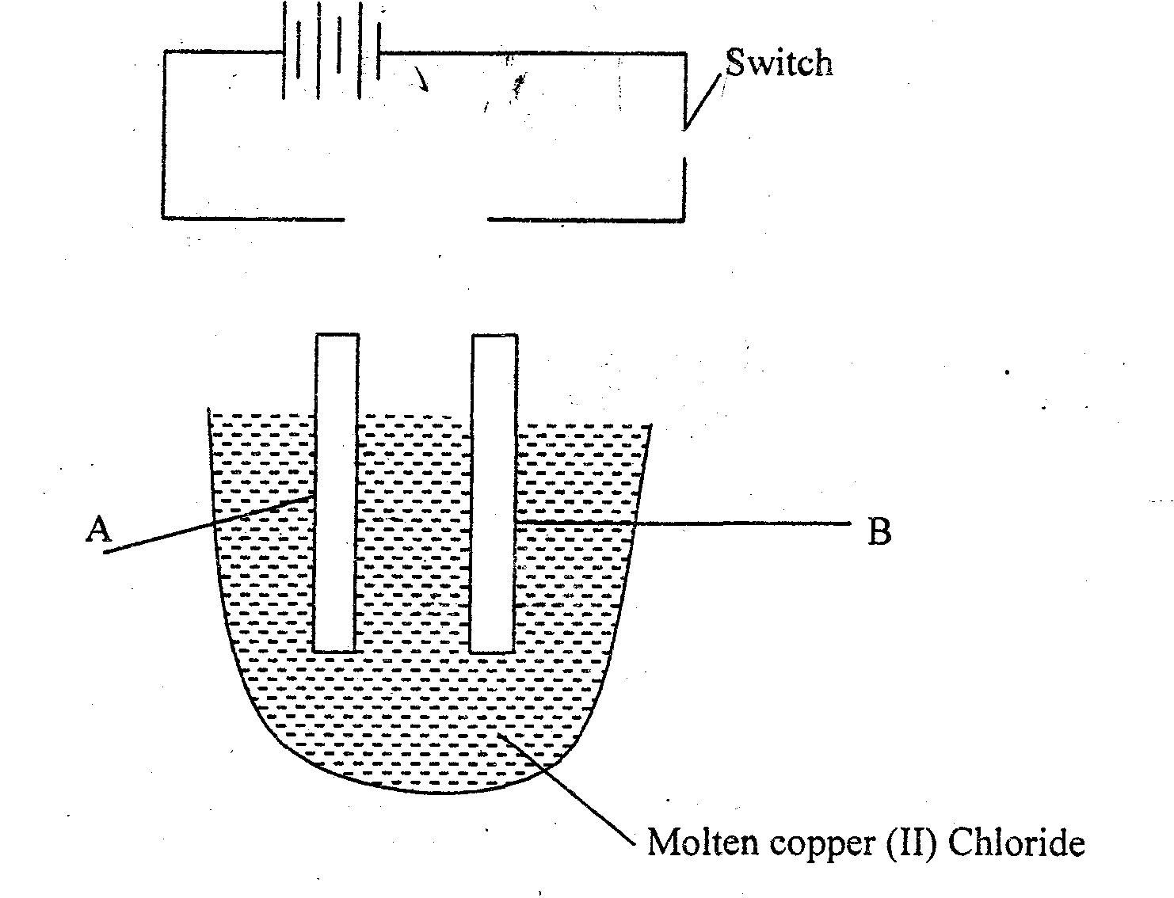
(i) Identify the anode and the cathode. (1 mk)

(ii) State and explain the observations made. (2mks)

4(a) State the boyle’s law. (1 mk)

b) A fixed mass of a gas has a volume of 250cm³ at 27⁰C and 750mm Hg pressure. Calculate the gas volume that the gas would occupy at 41⁰C and 750mm Hg pressure. (2 mks)

5. Study the chromatogram below and answer the questions that follow. (4 mks)
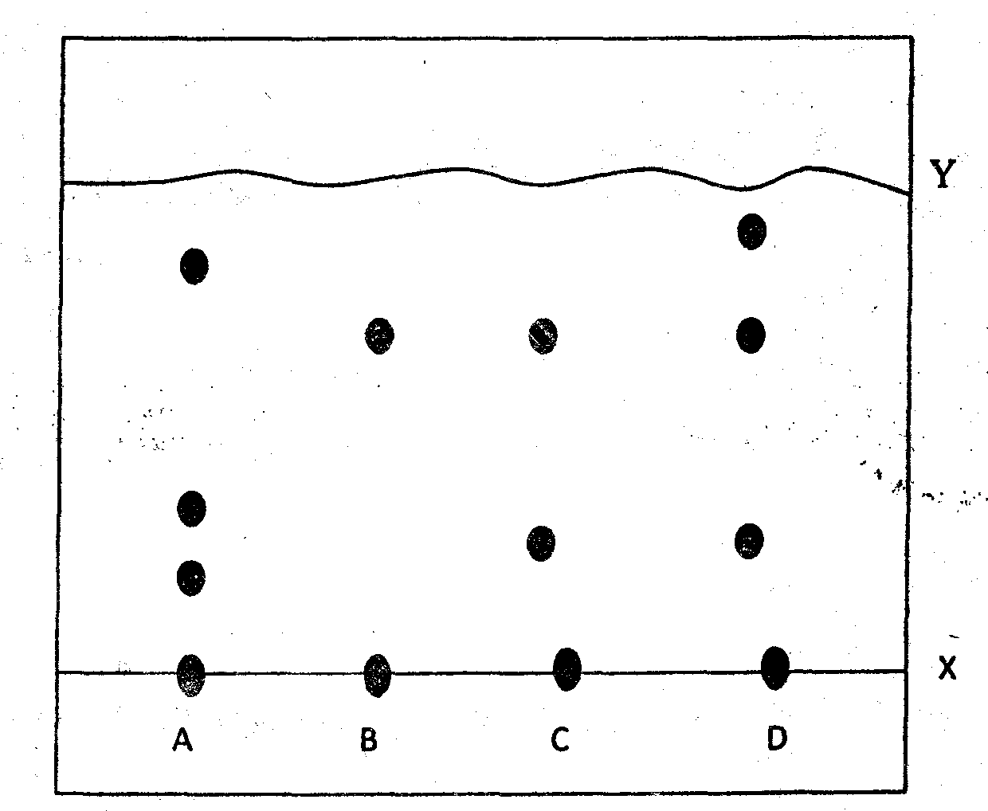
(a) Name line X and Y. (1 mk)
X

Y

(b) Which is a pure substance (green dye) (1 mk)

c) Which other substance contain green dye. (1 mk)

d) State one application chromatography. ( 1mk)

6(a) A certain solution K was analyzed using various reagents. The table below shows test results and observations made.
 | Test | Observation
1 | Addition of few drops of lead (II) Nitrate | White ppt formed
II | Addition of few drops of Barium chloride | White ppt formed
III | Addition of few drop of hydrochloric acid | Effervescence occurs
IV | Addition of acidified potassium chromate (VI) | Change from orange to green

(i) Name the anion present in solution K. (1 mk)

(ii) Write an ionic equation for the reaction in Test II. ( 1mk)

(iii) Solid Aluminum hydroxide can be obtained by reaching excess ammonia with aluminum chloride solution. Explain why excess sodium hydroxide may not be used (1 mk)

7. A piece of phosphorus was burnt in air. The product obtained was shaken with a small amount of hot water.
a) Write an equation of reaction of burning phosphorus. (1 mk)

b) The solution obtained in the above reaction was found to have a PH of 2. Give a reason for this observation. (2mks)

8. A form one student set up the following apparatus to investigate the percentage of oxygen in air.
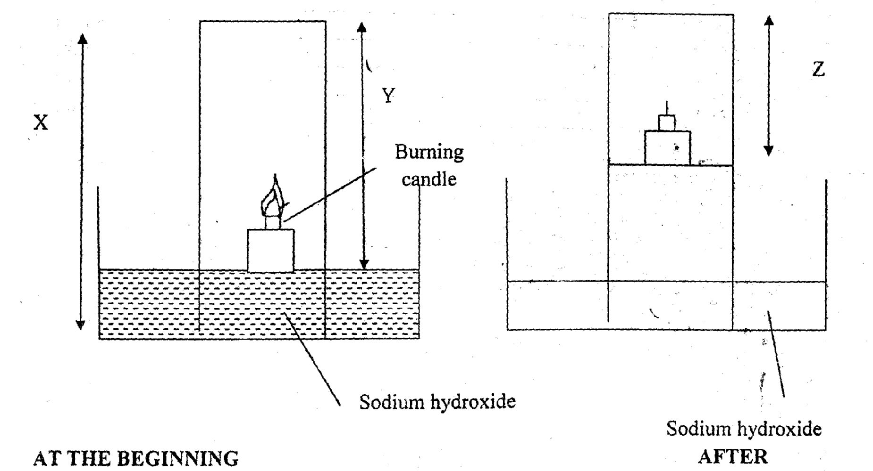
(a) Write an expression to show how percentage of air used can be calculated. ( 1mk)

b) Why was sodium hydroxide used instead of water. ( 1mk)

c) Instead of candle wax, list any other substance that can be used to give same results. (1 mk)

9. Study the flow chart below and answer the questions that follow.
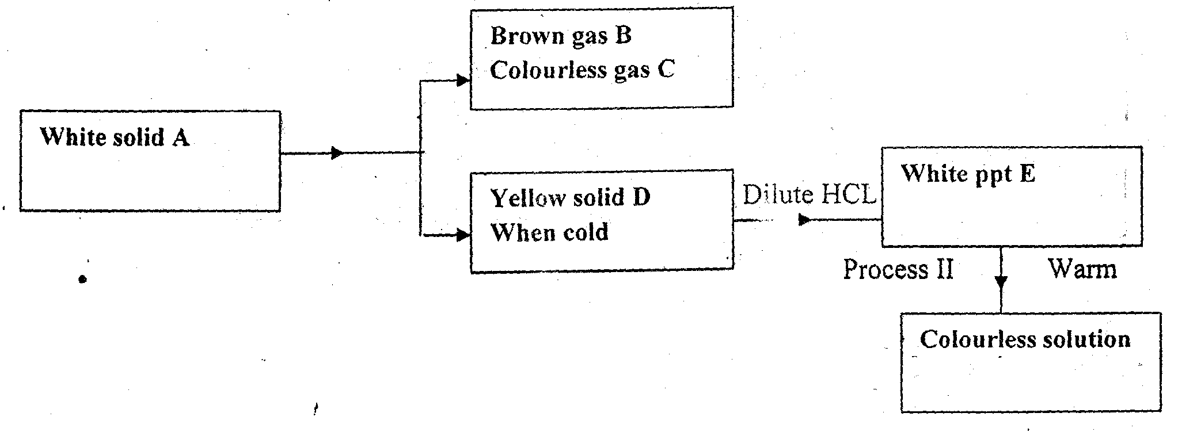

Identify
A______________________(½ mk)
B______________________(½ mk)
C______________________(½ mk)
D______________________ (½ mk)

(ii) Name process I (½ mk)

(iii) Write equation for formation of B, C and D. (1 mk)

(iv) Describe the test of colourless gas C. (1 mk)

v) What does process II indicate about solubility of E. (1mk)

10. Study the s et up below and answer the question that follow;
- What observation is made in the tube? ( 1mk)

- Indicate with a cross (x) on the diagram the likely position nof observation made in (i) above. ( 1mk)

- If hydrogen chloride gas moved a distance of 17cm. how long did Ammonia diffuse. (3mks)

11. The flow chart below shows the industrial preparation of ammonia and the process used in manufacture of some ammonium compound. Study it and answer questions that follow:
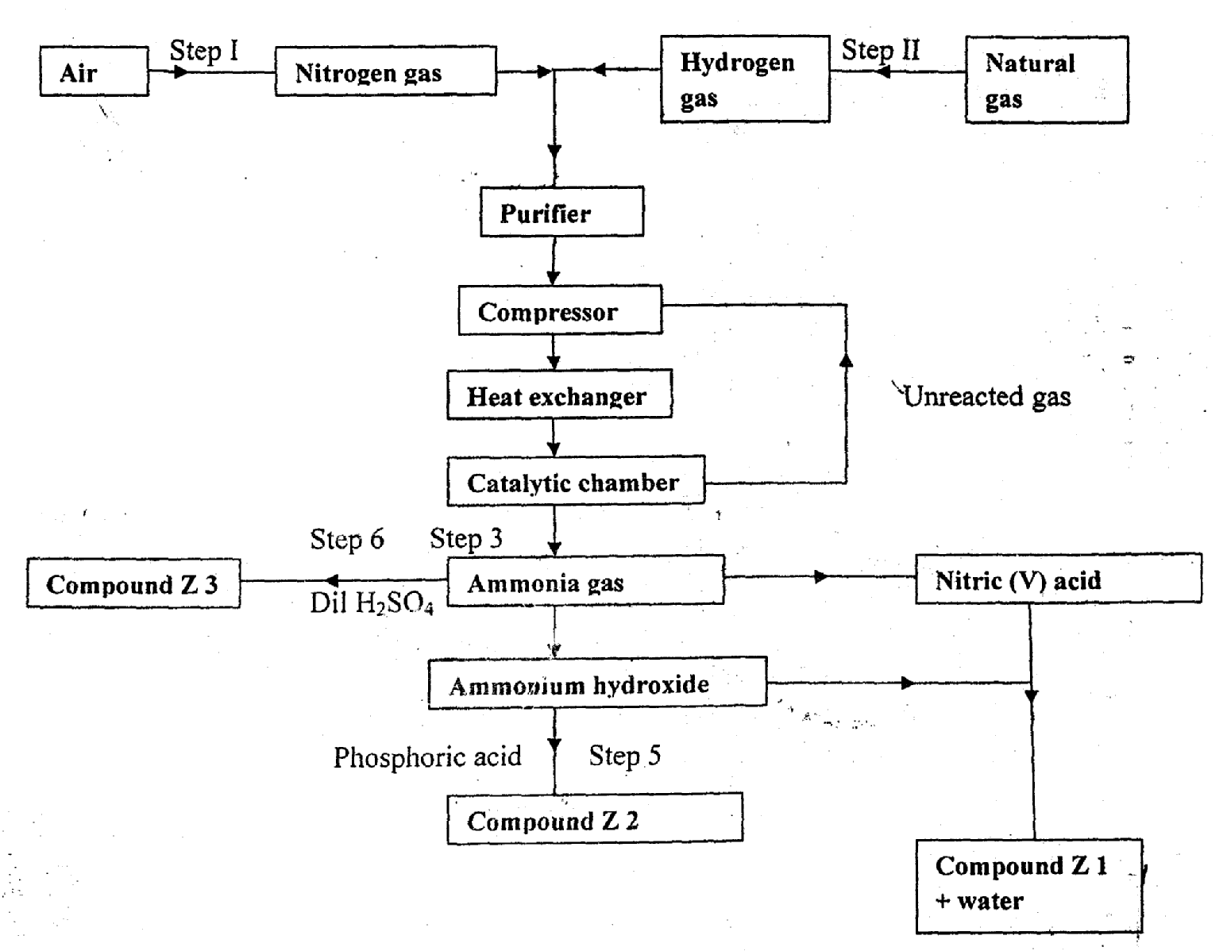
a) Give the name of the: (1 mk)
- Process step 1 (1 mk)

- Reaction taking place in step 5 ( 1mk)

b) State one other source of hydrogen other than natural gas. ( 1mk)

c) Explain why it is necessary to compress hydrogen and nitrogen in these process.
( 1mk)

d) Write an equation of reaction taking place in step 6. ( 1mk)

e) Name the catalyst and reagent used in step 3. (2 mks)

f) Name compounds ZI. ( 2mks)

g) Give one commercial use of Z2 and Z3.

12.(a) (i) What are hydrocarbons? ( 1mk)

(ii) Name two categories of hydrocarbons. ( 1mk)

(iii) Give two sources of hydrocarbons. ( 1mk)

b) Study the scheme below and answer questions that follow;
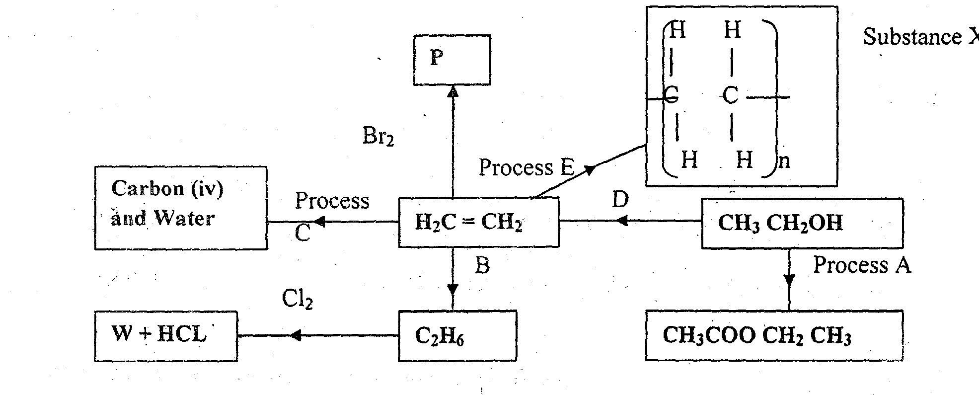
i) Give the name and structure of P. (2 mks)

ii) Name process C and write equation of reaction for the process. ( 2mks)

(iii) State the conditions and reagent for process D. ( 2mks)

(iv) Name process B and state industrial application of the process. ( 2mks)

v) The product of process E have serious impact on our environment. State the concern and give a remedy. (2 mks)
13. The table below show stages involved in large scale manufacture of compound Z. study the diagram and answer question that follow;
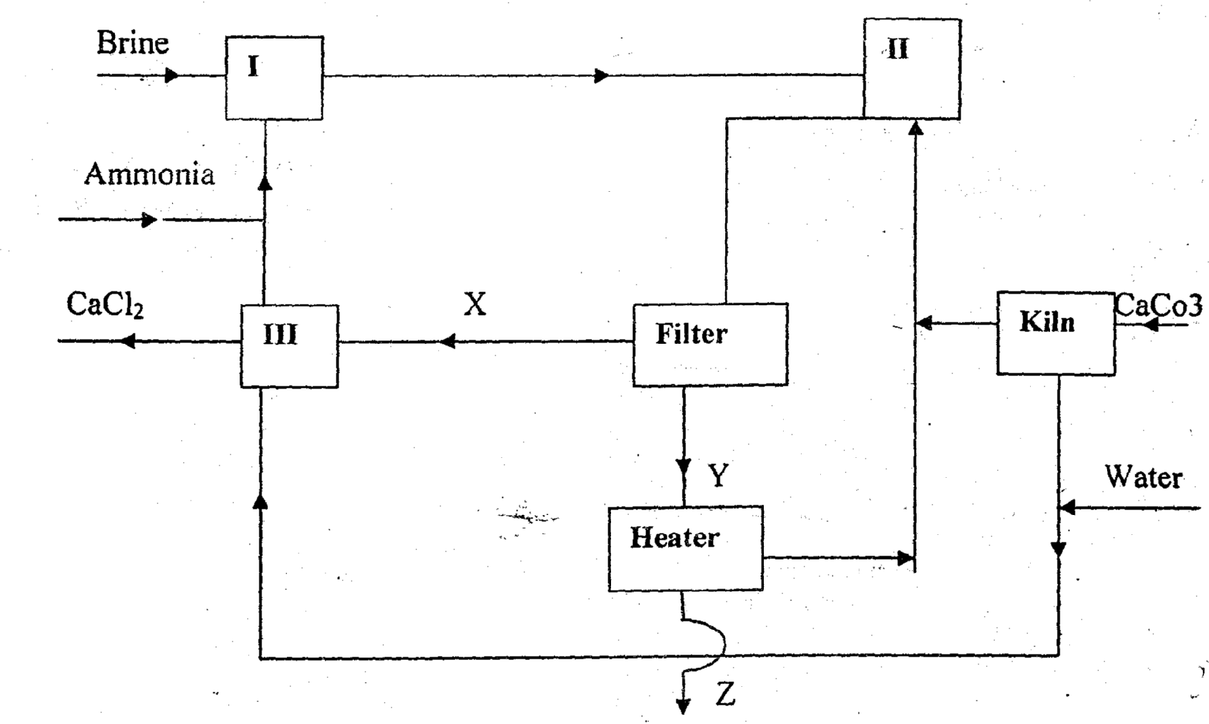

(a) Name the above process and identify compound Z. ( 2mks)

b) Name two starting raw materials. (2mks)
c) Name substance X and Y. (2 mks)
X
Y
d) Give equation of the reaction which occur in chambers.
(i) Chamber II (1 mk)

ii) Chamber II (1 mk)

e) State two commercial uses of substance Y. ( 2mks)

f) Which material is regarded as waste? (1 mk)

g) The process is economically viable and environmentally friendly. Explain. (2mks)

14. On complete combustion of a hydrocarbon 3.52g of carbon (IV) oxide and 1.44g of water were formed. Determine the molecular formula of the hydrocarbon given that its R.M.M is 56. (C=12, H=1). (4 mks)

15. The equation below represents reaction of calcium carbonate and dilute hydrochloric acid.
i) Balance the equation and state observation made. (1 mk)

ii) 2.0g of CaCO₃ were used. What volume of Carbon (IV) oxide were given at s.t.p. (C=12, H=1, O=16)m.g.v = 24dm³) (2mks)

- What mass of carbon (iv) oxide was given out. (1mk)

16. Study the information in the table below and answer the questions that follow. The letters do not represent the actual symbols of the element.

Element | Atomic number | Boiling point ⁰C | Formula of oxide
A | 11 | 890
B | 12 | 1110
C | 13 | 2470
D | 15 | 280
E | 17 | -34.7
F | 20 | 1140

a) Complete the table by writing the formula of the oxides. ( 3mks)

b) Select the most reactive element whose ionic radius is larger than its atomic radius. ( 1mk)

c)(i) Write the electron arrangement of element A. ( 1mk)

ii) State and explain observations made when A is put in water in a trough. (2 mks)

iii) Metals can be used to prepare hydrogen gas by reacting them with an acid. Explain why metal A should not be reacted with an acid. ( 1mk)

d) Which of the above elements is likely to be;
i) A non-metal (1 mk)

ii) A conductor (1 mk)

e) To which group and period does element D belong?
Group ______________________( 1 mk)
Period_______________________(1 mk)
f) The chloride of element C is acidic in nature. Explain. (2mks)

g) Write an equation for the reaction between E and water. ( 1mk)

h) Select elements that belong to the same group. ( 1mk)

(i) When a piece of burning element B is lowered in a gas jar of carbon (IV) oxide, it continues to burn forming a white solid and black specks. ( ½ mk)

- Write the formula of the white solid. ( ½ mk)

- Name the black specks. ( ½ mk)

- Write a chemical equation for the reaction taking place. (1 mk)

