NAME…………………………………ADM NO…………DATE…………………
KISIRIRI SECONDARY SCHOOL
P.O. BOX 93-20500 TEL 0721-451-691
END OF 2ND TERM EXAMINATIONS
FORM THREE
CHEMISTRY PAPER TWO
TWO HOURS
1. The grid below represents part of the periodic table. Study it and answer the questions that follow.
The letters do not represent the actual symbols of the elements.
A |  |  |  |  |  |  |  | K
B | D |  |  |  | G |  | I
 |  |  | F |  | H |  |  | L
C | E |  |  |  |  |  | J

(a) (i) Which letter represents an element that is least reactive. (1 mk)
……………………………………………………………………………………………………….
(ii) Why are elements D and E referred to as alkali earth metals. (1 mk)
……………………………………………………………………………………………………….
……………………………………………………………………………………………………….
(b) How does the atomic radius of F and H compare? (2mks)
……………………………………………………………………………………………………….
……………………………………………………………………………………………………….
(c) Select two letters representing a pair of elements that would react most explosively.
(2mks)
(d) Write an equation showing how D forms its ions. (1 mk)

(e) Write the formulae of
(i) Bromide of D (1mk)
(ii) Sulphate of C (1 mk)
(f) What type of bonding exists between
(i) E and I (1mk)
(ii) G and J (1 mk)

(g) Explain why the melting point of J is higher than that of I. (2 mk)
2. Study the flow chart below and answer the questions that follow.

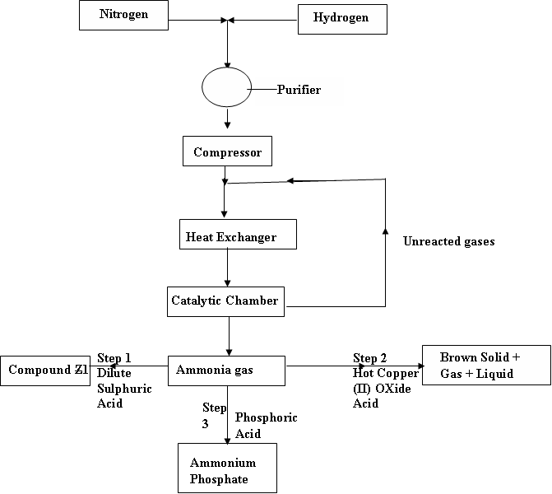
a) i) Give one source of nitrogen gas (1mk)

ii) Give the name of compound Z (1mk)

iii) Write an equation for the formation of the brown solid. (1mk)

iv) write the equation for the conversion taking place in the catalytic chamber (1mk)

b) Why is it necessary to compress nitrogen and hydrogen in this process? (1mk)

c) The catalyst used in this process is finely divided iron impregnated with aluminium oxide what is the function of aluminium oxide? (1mk)

d) i) if 10000 litres of 2.0 moles per litre of phosphoric acid were completely neutralized by
ammonia gas to make ammonium phosphate, how many kg of the fertilizer were made? (N=14,
H=1, O=16, P=31) (3mks)

ii ) with reasons, identify a better nitrogenous fertilizer between ammonium phosphate and
ammonium nitrate (2mks)

3. (a) Give the names of the following compounds.
(i) CH₃CH₂CH₂ (1 mk)

(ii) CH(Br)₂CH₂Cl (1 mk)

(b) Study the information in the table below and answer the questions that follow.
No. of carbon atoms per molecule | Relative molecular mass of hydrogen
2 | 28
3 | 42
4 | 56

(i) Write the general formula of the hydrocarbons in the table. (1 mk)

(ii) Predict the relative molecular mass of the hydrocarbon with 5 carbon atoms. (l mk)

(iii) Determine the molecular formula of the hydrocarbon in (ii) and draw its
structuralformula. (2 mks)

(c) Study the scheme given below and answer questions that follow.
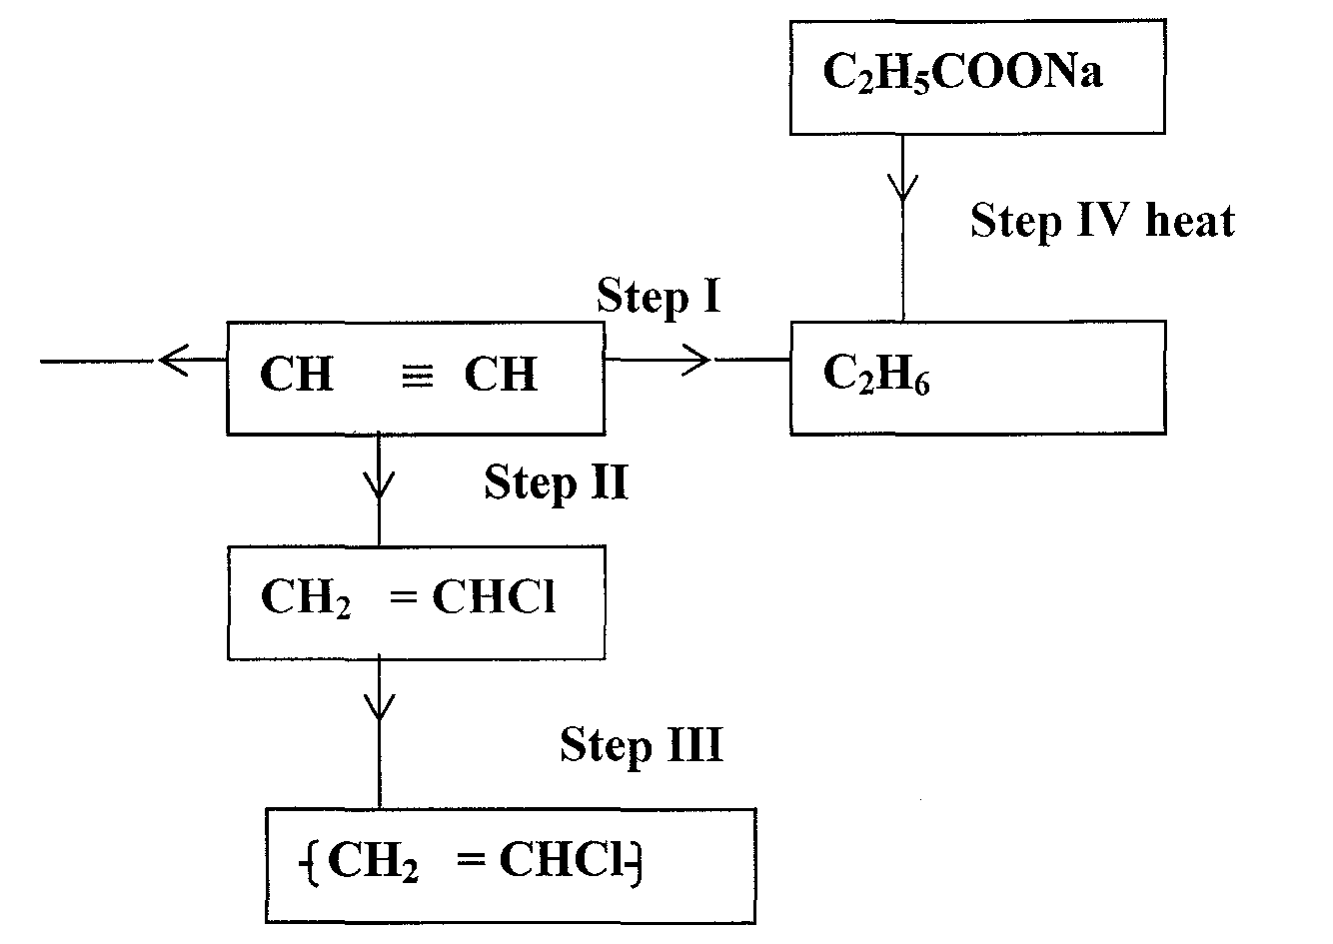
(i) Name the reagent used in
Step I (l mk)

Step II (1 mk)

Step III (1 mk)

ii) Write an equation for complete combustion of CH ≡ CH (1 mk)

(iii) Explain one disadvantage of the continued use of items in step III. (1 mk)
……………………………………………………………………………………………………….
……………………………………………………………………………………………………….
4. (a) The diagram below represents a set-up that was used to obtain dry nitrogen from air. Study it and answer the questions that follow.
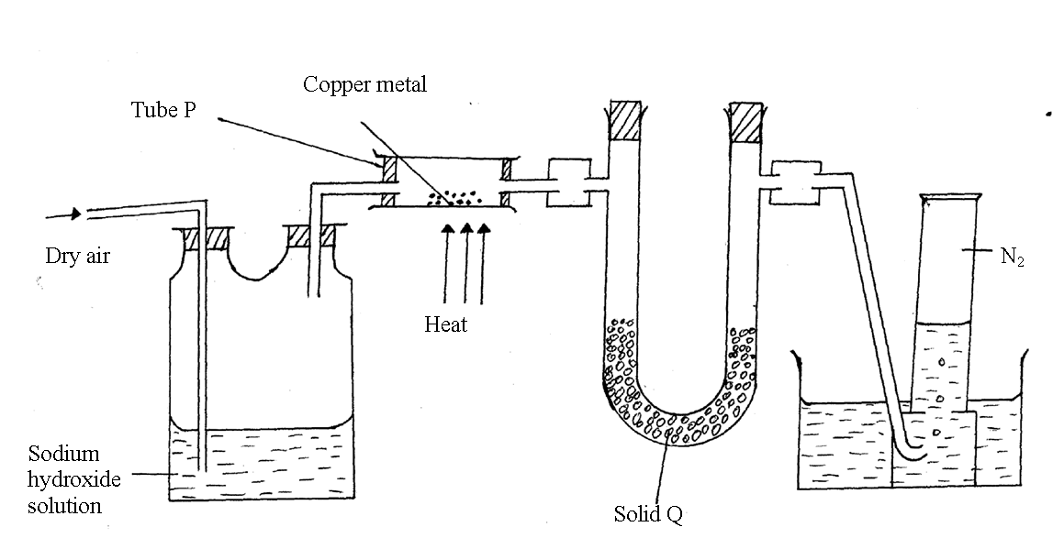
- Name solid Q (1mk)
………………………………………………………………………………………………………
- What is the purpose of NaOH_{(aq)} ? (1mk)
………………………………………………………………………………………………………
- Write an equation for the reaction which took place in tube P (1mk)

- Give the name of one impurity in the nitrogen gas obtained. (1mk)
………………………………………………………………………………………………………
- Why is liquid nitrogen used for storage of semen for artificial insemination.(1mk)
……………………………………………………………
(b) The set –up below was used to prepare nitric acid.
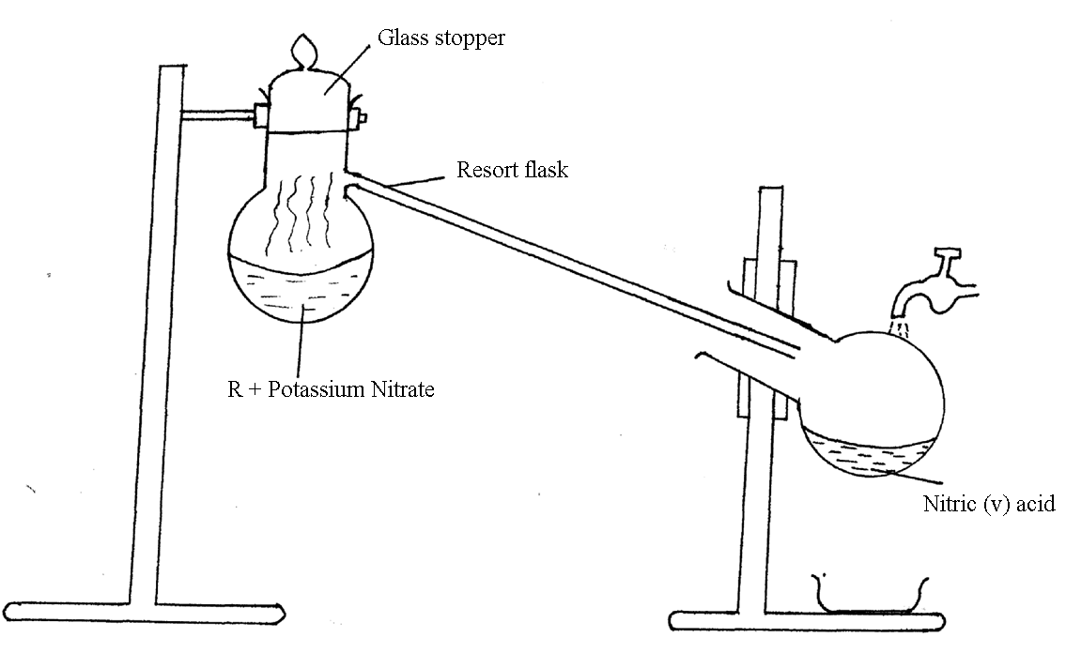
- Give the name of R (1mk)
………………………………………………………………………………………………………
- Write an equation for the reaction which took place in the retort flask (1mk)

- Explain the following
(a) Nitric acid is not stored in clear / transparent glass. (2mks)
………………………………………………………………………………………………………………………………………………………………………………………………………………
(b) The reaction between copper metal with 50% nitric acid (one volume of
acid added to an equal volume of water) in an open test tube, brown fumes are not observed. (2mks)
………………………………………………………………………………………………………….

5. During a practical lesson, solution Xwas prepared by dissolving Yg of a mixture of sodium carbonate and sodium hydrogen carbonate in enough distilled water and made up to 1000cm3 of solution. 25cm3 of solution X was titrated with 0.1M HCl, first using screened methyl orange followed by phenolphthalein as indicators.
(i) Using screened methyl orange indicator, the solution required 45.0cm3 of the acid for the colour to change from yellow to red as show below:

Na₂CO_{3(aq)} +HCl_{(aq}) NaHCO_{3(aq)} +NaCl_{(aq)}

(ii) Using phenolphthalein as indicators, the solution required 25.0cm3 of the acid for the color to change from pink to colorless as shown below:

NaHCO_{3(aq)} + HCl_{(aq)} NaCl_{(aq)} +H₂O_{(l)} + CO_{2(g)}

a) Calculate the number of moles of sodium carbonate in the mixture. (2mks)

b) Determine the mass of sodium carbonate in the 1000cm3 solution of X (3mks)

c) Calculate the number of moles of sodium hydrogen carbonate in the mixture. (3mks)

d) Determine the mass of sodium hydrogen carbonate in the 1000cm3 solution of X (3mks)

e) Determine the mass of Y in grams (1mk)

f) Determine the molarity of sodium hydrogen carbonate in solution X (3mks)

6. a) (i)a part diamond and graphite, name any other allotropy of carbon.(1mk)

(ii) state any three differences between diamond and graphite (3mks)

DIAMOND | GRAPHITE

b) write a balanced chemical equation to show how calcium hydrogen carbonate solution is decomposed by heat. (2mks)

c) (i) draw a well labeled diagram to show how carbon (II) oxide can be prepared and collected using carbon (IV) oxide and charcoal (4mks)

(ii) State one use of carbon (II) oxide. (1mk)

d) (i) state any two substances that are recycled in the solvey process. (2mks)

(ii) Name any two raw materials in the above process. (2mks)

(iii) Write a balanced chemical equation to explain how sodium carbonate is formed from sodium hydrogen carbonate in the solvey process. (1mk)

(iv) Give one use of sodium carbonate. (1mk)

