NAME…………………………………ADM NO…………DATE…………………
KISIRIRI SECONDARY SCHOOL
P.O. BOX 93-20500 TEL 0721-451-691
END OF 2ND TERM EXAMINATIONS
FORM THREE
CHEMISTRY PAPER ONE
TWO HOURS
1. The relative atomic mass of element R is 10.28. it has two isotopes and . Calculate the relative percentage of each isotope. (3 marks)

2. Work out the number of sulphate ions in 50 cm³ of 1.0M aluminium sulphate(Avogadro’s constant=6.0x10²³) (3 marks)

3. a) Give the names of the following compounds
i) CH₃CCCH₂CH₃ (1 mark)
……………………………………………………………………………………………………
ii) CH₃CH(Br)C(CH₃)₂CH₃ (1 mark)

……………………………………………………………………………………
- Butane and bromine react as shown below:
CH₃CH₂CH₂CH₃+ Br₂ CH₃CH₂CH₂CH₂Br+ HBr
i) Name the type of reaction taking place in the equation above (1 mark)
………………………………………………………………………………
ii) State the condition under which the above reaction takes place. (1 mark)
………………………………………………………………………………………………………………
ii) Name the compounds formed……………………………………………………… (2mk)

4. A mixture of carbon(iv) oxide and carbon (ii) oxide are passed through potassium hydroxide as shown in the following setup
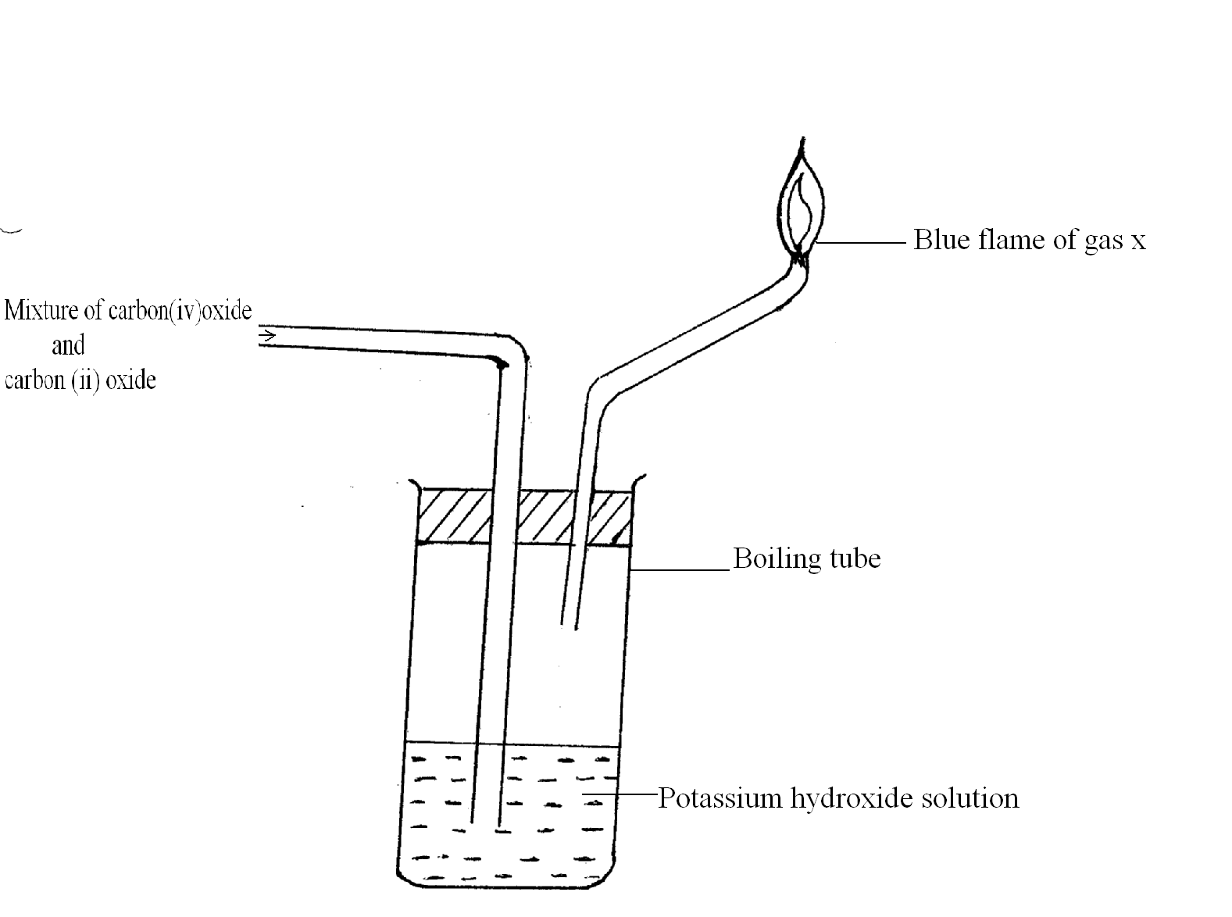

a) Name gas X (1 mark)
………………………………………………………………………………………………………
b) Write the equation of the reaction that takes place in the boiling tube in the first 30 seconds. (2 mark)
………………………………………………………………………………………………………………………………………………………………………………………………………………
c) Explain why calcium hydroxide is used to confirm the presence of carbon (iv) oxide and not sodium hydroxide. (2 mark)
………………………………………………………………………………………………………………………………………………………………………………………………………………
………………………………………………………………………………………………………
5. 2 grams of sodium hydroxide is added to 30 cm³ of 1M sulphuric(vi) acid. What volume of 0.1M potassium hydroxide solution will be needed to neutralize the excess acid.(Na=23,O=16,H=1)
(3 marks)

6. The set-up below shows the catalytic oxidation of ammonia in the laboratory
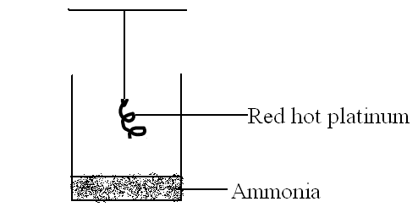
a) State and explain the observation made. (3 marks)
………………………………………………………………………………………………………………………………………………………………………………………………………………
………………………………………………………………………………………………………
b) Write a chemical equation for the first reaction taking place in the beaker.(1 mark)
………………………………………………………………………………………………………………
7. An element has an atomic radius of 0.136mm and an ionic radius of 0.065mm. Is this element a metal or non-metal? Give a reason. (3 marks)
……………………………………………………………………………………………………………………………………………………………………………………………………………………………………………………………………………………………………
8 A bicycle was found to hold a maximum volume of 990 cm³ at s.t.p. On one hot sunny day the temperature was 30⁰C and pressure 800mm/Hg. The rider inflated the tire. Explain what happened. (Show your calculations)(Standard temperature and pressure=0⁰C and 760mm/Hg respectively) (3 marks)
………………………………………………………………………………………………………………………………………………………………………………………………………………………………………………………………………………………………………………………………………………………………………………………………………………………………………………………………………………………………………………………………………………………………………………………………………………………………………………
9. In term of structure and bonding, explain why the melting point of silicon (iv) oxide is much higher than that of sulphur(iv) oxide (3 marks)
………………………………………………………………………………………………………………………………………………………………………………………………………………………………………………………………………………………………………………………
10 A compound Q with a molecular mass of 28 contains 85.7% carbon and 14.3% hydrogen. (C=12;H=1)
a) Determine the molecular formula of Q. (3 marks)
b) Write the structural formula of Q. (1 mark)

11. Study the reaction below:
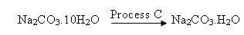
A B
a) Give the IUPAC name for compound A. (1 mark)
………………………………………………………………………………………
b) Give the name for process C. (1 mark)
……………………………………………………………………………………
c) Write an equation to show when compound B is heated in a boiling tube. (1 mark)
………………………………………………………………………………………………………
12. A wooden splint was slipped through a region of a particular flame in the laboratory and was burnt as shown in the diagram below.
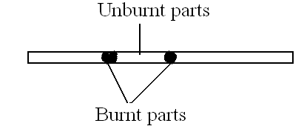
a) Name the type of flame the splint was slipped through. (1 mark)
……………………………………………………………………………………………
b) Explain why the splint was burnt the way it is shown in the diagram. (2 mark)
………………………………………………………………………………………………………
………………………………………………………………………………………………………
13. Given lead(ii)oxide, nitric(v) acid, sodium carbonate solid and water. Explain briefly how you
Can prepare lead(ii) carbonate. (3 marks)
………………………………………………………………………………………………………
………………………………………………………………………………………………………
………………………………………………………………………………………………………
………………………………………………………………………………………………………
…………………………………………………………………
14. The diagram below represents a set-up for the laboratory preparation of oxygen gas.
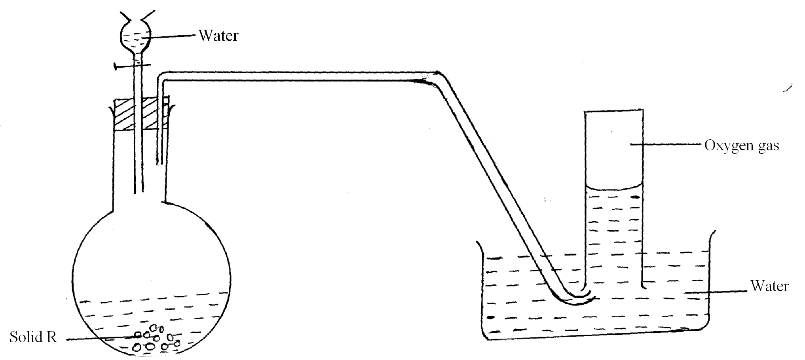
a) Name solid R (1 mark)
………………………………………………………………………………………………………
b) Write a chemical equation for the reaction in the flask. (1 mark)
……………………………………………………………………………………
c) State one commercial use of oxygen gas. (1 mark)
…………………………………………………………………………………………
15. The 1st 2nd and 3rd ionization energies in KJ/Mol of element G and R are given below.
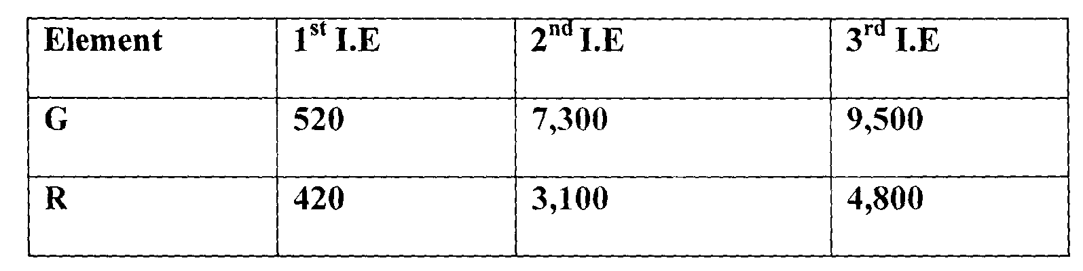

(i) Define the term 1st ionization energy. (2mk)
………………………………………………………………………………………………………………
………………………………………………………………………………………………………………
(ii) Apart from the decrease in energy levels, explain the big difference between the 1st and 2nd ionization energies. (1 mk)
………………………………………………………………………………………………………………
………………………………………………………………………………………………………………
(iii) Calculate the amount of energy for the process. (1mk)
R(g) R(g) +3e

16. (a) The diagram below represents an incomplete set-up of apparatus that can be used to
Prepare dry carbon (iv) oxide gas. Complete the diagram and answer the questions that
follow. (2mks)
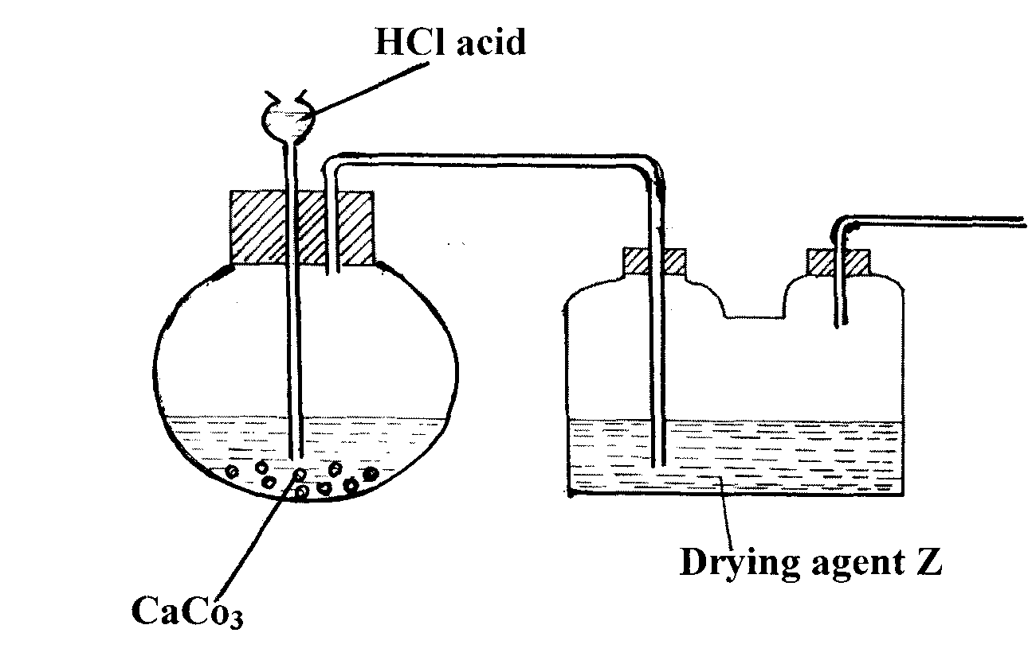
(i) Write an equation for the reaction that takes place. (lmk)

(ii) Name liquid Z. (1mk)
………………………………………………………………………………………………………………
(b) State two advantages of using ‘dry ice’ over ordinary ice as a refrigerant. (2mks)
………………………………………………………………………………………………………………
………………………………………………………………………………………………………………
17. In an experiment, ammonium chloride was heated in a test-tube. A moist red litmus paper placed at the mouth of the test-tube first changed blue then red.
Explain these observations. (2mks)
………………………………………………………………………………………………………………
……………………………………………………………………………………………
18. An element X has two naturally occurring isotopes X and Y. If its relative atomic mass is 21.8, calculate the percentage abundance of the more stable isotope. (2mks)

19. Study the diagram below and answer the questions that follow.
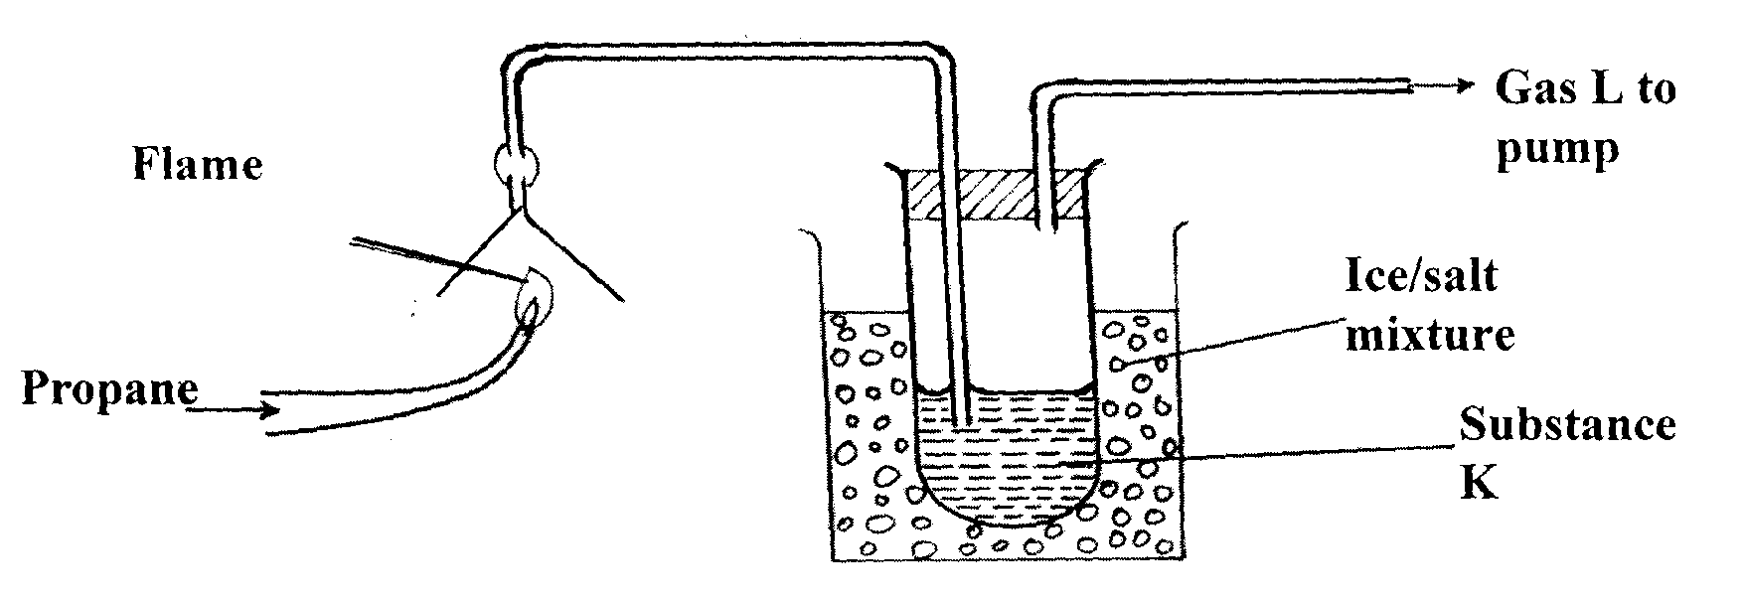
(i) Write the equation for the combustion of propane. (1mk)

(ii) The PH of substance K was found to be less than 7. Explain this observation. (2mk)
………………………………………………………………………………………………………………
………………………………………………………………………………………………………………
20. The set-up below was used to collect gas F, provided by the reaction between water and calcium metal.
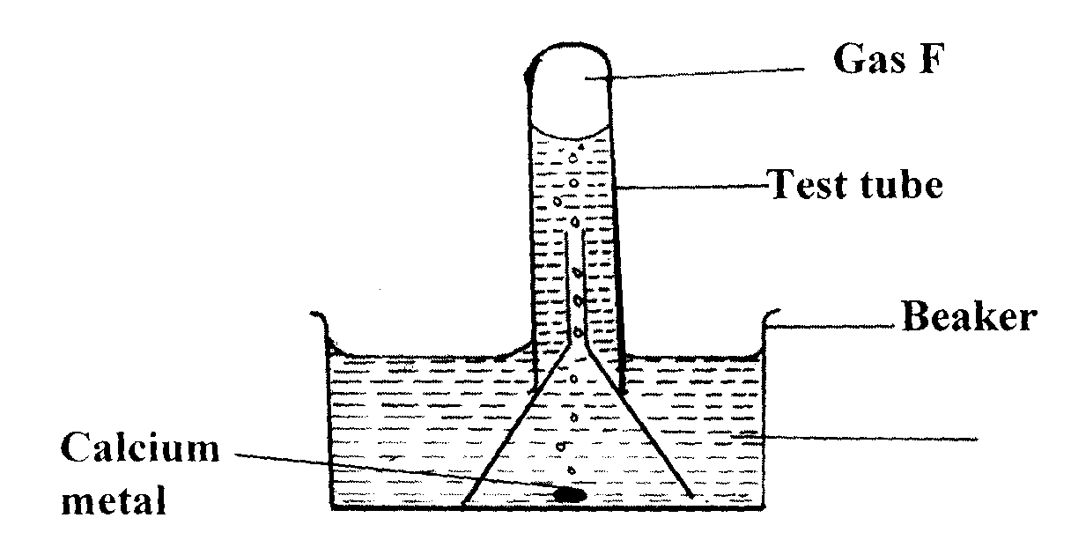
(a) Name gas F. (1mk)
………………………………………………………………………………………………………………
(b) At the end of the experiment the solution was found to be a weak base. Explain why the solution is a weak base. (2mks)
………………………………………………………………………………………………………………
………………………………………………………………………………………………………………

(c) Give one laboratory use of the solution formed in the beaker. (1mk)
……………………………………………………………………………………………
21. In terms of structure and bonding, explain why graphite is used as a lubricant. (3mks)

22. A hydrocarbon Q was found to decolourise potassium manganete (VII) solution. When two moles of Q are burnt completely, six moles of carbon (IV) oxide and six moles of water were formed.
a) Write the structural formula of Q (2mk)

b) Name the homologous series to which Q belongs. (1mk)

c) Name one industrial source of Q (1mk)

23. Name the three oxides of nitrogen

