GATITU MIXED SECONDARY SCHOOL.
ARISE & SHINE
FORM 3 CHEMISTRY-MIDTERM EXAMS-TERM 3 2014
NAME…………………………………………………………………………………………………………..ADM.NO…………………………………………

1.A fixed mass of a gas has a volume of 250cm³ at a temperature of 27⁰C and 750mm Hg pressure. Calculate the volume the gas would occupy at 42⁰C (2mks)

2.a) Using dots(.) and crosses (x) to represent electrons draw diagram to represent the
bonding in:
(i) NH3 (ii) NH₄⁺ (1mk)

b) State why an ammonia molecule (NH₃) can combine with H+ to form NH4⁺ (Atomic numbers: N=5 and H=1)

(1mk)

3.The reaction of propane with chlorine gas gave a compound of formula C3H7Cl.
a) What condition is necessary for the above reaction to take place? (1mk)

b) Draw two structural formulae of the compound C3H7Cl (2mks)

4. On strong heating, sodium nitrate oxygen gas. In the spaces provided below, draw a labeled diagram of a set-up that could be used for heating sodium nitrate and collecting the oxygen gas liberated. (3mks)

5. a)What is meant by isomerism? (1mark)

(b)Draw and name two isomers of butane. (2 marks)

6.60cm3 of oxygen gas diffused through a porous partition in 50 seconds. How long would it take 60cm3 of sulphur (IV) oxide gas to diffuse through the same partition under the same conditions? (S= 32.0, 0 = 16.0) (3marks)

7.(a) The diagram below represents a set up that was used to obtain dry nitrogen from air.
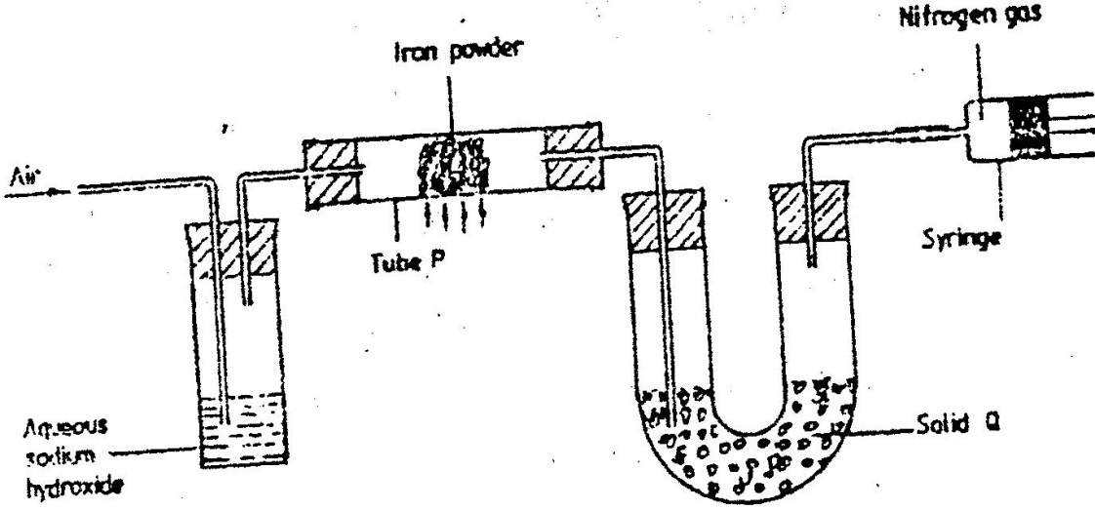
Study it and answer the questions that follow

  - Name solid Q(1mk)

  - What is the purpose of sodium hydroxide?(1mk)

  - Write an equation for the reaction which took place in tube P(2mk)

  - Give a reason why liquid nitrogen is used for storage of semen for artificial insemination(1mk)

(v) Give the name of one impurity present in the nitrogen gas obtained(1mk)

- The set up below was used to prepare nitric acid
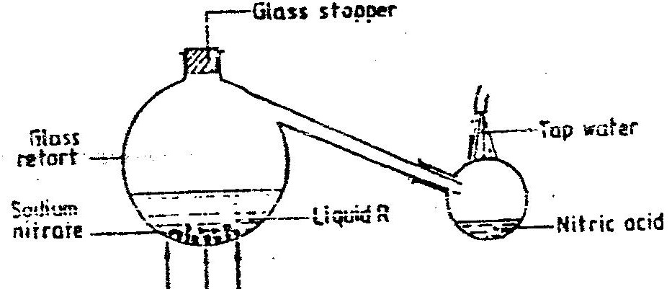

      - Give the name of liquid R(1mk)
\

      - Write an equation for the reaction which took place in the glass retort(2mks)

      - Explain the following(2mks)
I. Nitric acid is stored in dark bottles

II. The reaction between copper metal with 50% nitric acid (one volume of acid
added to an equal volume of water) in an open test tube gives brown fumes.

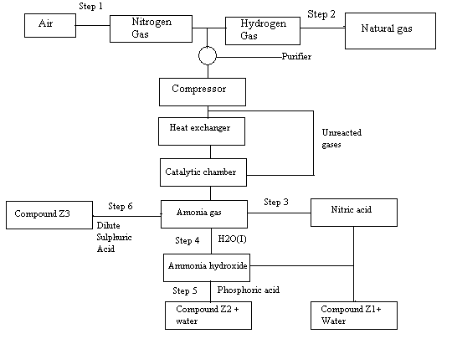
8. The flow chart below shows the industrial preparation of ammonia and the process used in the manufacture of some ammonium compounds. Study and answer the questions that follow

  - Give the name of the(2mks)
  - Process in step 1

  - Reaction that takes place in step 5

  - State one other source of hydrogen gas apart from natural gas(1mk)

  - Explain why it necessary to compress nitrogen and hydrogen in this process91mk)

  - Write an equation for the reaction which takes place in step 6(2mks)

  - Name the catalyst and the reagents used in step 3(2mks)
Catalyst
Reagent
  - Name compound Z1(1mk)

  - Give one commercial use of compound Z2(1mk)

9.a) Fraction distillation of liquid air usually produces nitrogen andoxygen as the major products.

i)Name one substance that is used to remove carbon dioxide from the air
before it is changed into liquid.(1mk)

ii) Describe how nitrogen gas is obtained from the liquid air.(4mks)
(Boiling points nitrogen = - 196oC, oxygen = -183oC
b) Study the flow chart below and answer the questions that follow.
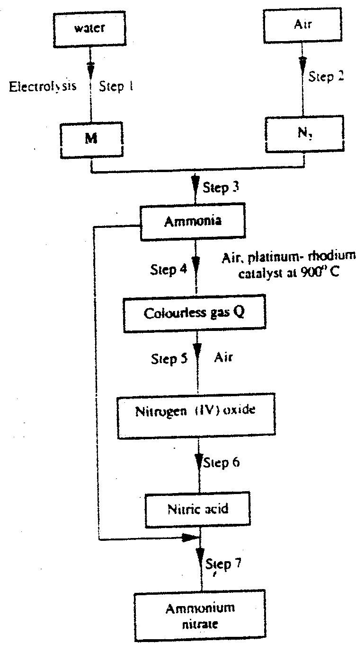

i)Name element M.(8mks)
ii)Why is it necessary to use excess air in step 4?
iii)Identify gas Q.
iv)Write an equation for the reaction in step 7
v)Give one use of ammonia nitrate.
c) State and explain the observations that would be made if a sampler of
sulphur is heated with concentrated nitric acid

10.. (a)Name one raw material which sodium hydroxide is manufactured ( 1 mk)
(b)Sodium hydroxide pellets were accidentally mixed with sodium chloride 17.6 g of the mixture were dissolved in water to make one litre of solution. 100 cm³ of the mixture were dissolved in water to make one litre solution. 100cm³ of the solution was neutralized by 40cm³ of 0.M sulphuric acid
(i)Write an equation for the reaction that took place
(ii)Calculate the:
(i) Number of moles of the substance that reacted with sulphuric acid ( 2mks)

(ii) Number of moles of the substances that would react with sulphuric acid in the one litre of solution ( 1mk)

(iii) Mass of the unreacted substances in one litre of solution ( 2 mks)
(H = 1,0 ; Na = 23.0 ; Cl= 35.5 ; 0= 16.0)

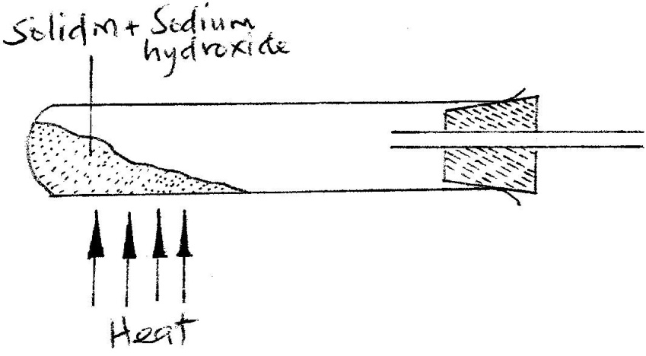
(c) The diagram below shows an incomplete set-up used to prepare and collect ammonia gas

(i) Name solid M ( 1 mk)

(ii) Complete the diagram to show how a dry sample of ammonia gas can be collected
( 3 mks)

(d) In an experiment, excess ammonia gas passed over heated copper (II) oxide on a combustion tube.
(i) State the observation that was made in the combustion tube at the end of the experiment ( 1 mk)

(ii) What property of ammonia is shown in the above reaction (1 mk)

(iii) Name one use of ammonia (1 mk)

14.(a) Study the flow chart below and answer the questions that follow.
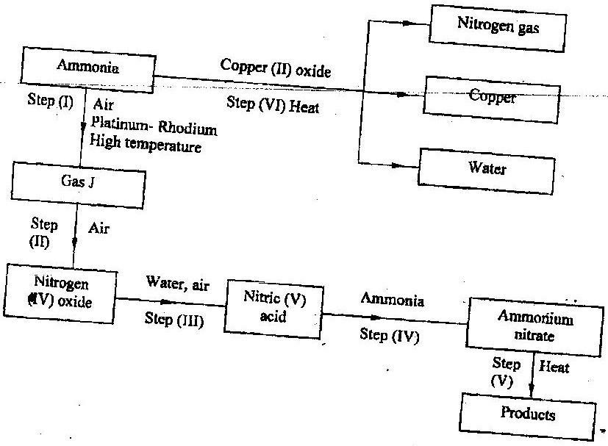

(i) Identify gas J. (1 mk)

(ii)Using oxidation numbers show that ammonia is the reducing agent in step (VI) (2mks)

(iii)Write the equation for the reaction that occurs in step (V). (1mk)

(iv)Give one use of ammonium nitrate. (1mk)

c)The table below shows the observations made when aqueous ammonia was added to cations of elements F₂F and G until in excess.

Cation of | Addition of a few drops of  Aqueous ammonia. | Addition of excess aqueous ammonia.
E | White precipitate | Insoluble
F | No precipitate | No precipitate
G | White precipitate | Dissolves

(i)Select the cation that is likely to be Zn²⁺ (1mk)

(ii)Given that the formula of the cation of element E is E ²⁺, write the ionic equation for the reaction between E²⁺ _{(aq)} and aqueous ammonia. (1mk)



