## PERFECT STEPS PUBLISHERS

END TERM EXAMS 2015

**0721 745374/ 0721 707626 NAIROBI**

CHEMISTRY

FORM 2

**1.** Study the diagram below then use it to answer the questions that follow.

  a) Draw the wooden splint at the end of the experiment. If it was slipped then removed. (1mark)

............................................................................................................................................................

b) Explain the appearance of the wooden splint in (a) above. (2marks)

............................................................................................................................................................

............................................................................................................................................................

2. Use the diagram below to answer the questions that follow.



 a) Why is sodium hydroxide solution preferred to water in the above set-up? (1mark)

............................................................................................................................................................

b)What modification should be made to the above set-up if percentage of oxygen used in air should be determined (1mark)

............................................................................................................................................................

c) Name the main component of air not used in the above set-up. (1mark)

............................................................................................................................................................

3. A piece of chromatography paper was spotted with coloured inks obtained from pens labelled 1 to 6. The diagram below shows the spots after the chromatogram was developed.



 a) Which two pens contained the same pigment? (1mark)

............................................................................................................................................................

b) Which pens contained only one pigment? (1mark)

............................................................................................................................................................

c) According to the chromatogram, which pigments are present in the ink of pen number 6. (1mark)

............................................................................................................................................................

.....................................................................................................................................................

.

3. Magnesium reacts as shown below.

 a) Identify gas X. (1mark)

............................................................................................................................................................

b) Between wet sand and magnesium ribbon, which one should be heated first? Explain. (2marks)

............................................................................................................................................................

............................................................................................................................................................

4. Rusting is a destructive process in which iron is converted to hydrated iron (III) oxide.

a) State

i) Two conditions necessary for rusting to occur. (2marks)

............................................................................................................................................................

............................................................................................................................................................

ii) Two methods used to protect iron from rusting other than galvanizing. (1mark)

............................................................................................................................................................

............................................................................................................................................................

b) Explain why it is not advisable to wash vehicles using sea water. (2marks)

............................................................................................................................................................

............................................................................................................................................................

c) Explain why galvanized iron objects are better protected even when scratched. (1mark)

............................................................................................................................................................

............................................................................................................................................................

d) The set-up below was used to prepare oxygen gas.

i) Complete the diagram to show how a sample of the gas can be collected. (2marks)



ii) Write an equation for the reaction producing oxygen gas. (1mark)

............................................................................................................................................................

............................................................................................................................................................

5. a)Name two commonly abused drugs in Kenya. (1mark)

............................................................................................................................................................

............................................................................................................................................................

b)Differentiate between prescription drugs and over the counter drugs. (2marks)

............................................................................................................................................................

............................................................................................................................................................

............................................................................................................................................................

6. starting with sodium metal, describe how a sample of crystals of sodium hydrogen carbonate may be prepared. (3marks)

............................................................................................................................................................

............................................................................................................................................................

............................................................................................................................................................

............................................................................................................................................................

**7.** Study the diagram below and answer the questions that follow. The diagram shows the method used to separate component of mixture P.

**a)** Name X ......................................................................................................................... (1mark) (1 mark)

**b)** What is the name given to the method used in separation of mixture P ? (1mark)

............................................................................................................................................................

**c)** What would happen if the inlet and outlet of water were interchanged ? (1mark)

............................................................................................................................................................

............................................................................................................................................................

**d)** Which physical property is used to separate mixture P ? (1mark)

............................................................................................................................................................

**8.** The diagram below is a section of a model of the structure of element T.



**a)** State the type of bonding that exist in T. (1 mark)

**b)** In which group of the periodic table does element T belong? Give a reason. (2marks)

............................................................................................................................................................

............................................................................................................................................................

**9.** The set up below was used to prepare hydrogen gas.



**a)** Complete the diagram to show how a dry sample of hydrogen gas can be collected. (2marks)

**b)** Write an equation which takes place when hydrogen gas burns in air. (1mark)

............................................................................................................................................................

............................................................................................................................................................

10.The simplified flow chart below shows some of the steps in the manufacture of sodium carbonate by the Solvay process.



**a)** Identify substance L. (1mark)

............................................................................................................................................................

**b)** Name the process taking place in step II (1mark)

............................................................................................................................................................

**c)** Write an equation for the reaction which takes place in step III. (1mark)

............................................................................................................................................................

.........................................................................................................................................................

11. Below are PH values of some solutions.

|  |  |  |  |  |
| --- | --- | --- | --- | --- |
| Solution | Z | Y | X | W |
| PH | 6.5 | 13.5 | 2.2 | 7.2 |

**i)** Which solution is likely to be

I. acidic rain ................................................................................................................ (1mark)

II. Potassium hydroxide ............................................................................................... (1mark)

**ii)** A basic substance V reacted with both solutions Y and X. What is the nature of V. (1mark)

............................................................................................................................................................

............................................................................................................................................................

**iii)** Identify two substances that show these characteristics in question (ii) above. (1mark)

............................................................................................................................................................

............................................................................................................................................................

12. Metal S removes oxygen combined with P. Q reacts with an oxide of R and not with an oxide of P. P reacts with cold water but Q does not.

**a)** Which is the most reactive metal? (1mark)

............................................................................................................................................................

**b)** Which is the least reactive metal? (1mark)

............................................................................................................................................................

**c)** Arrange the metals in order of reactivity starting with most reactive to the least reactive. (1mark)

............................................................................................................................................................

............................................................................................................................................................

13. The electronic structures for elements represented by letters A, B, C and D are

A - 2.8.6 B - 2.8.2 C - 2.8.1 D - 2.8.8

**a)** Select the element which forms:

i) A double charged cation (1mark)

............................................................................................................................................................

ii) A soluble carbonate (1mark)

**b)** Which element has the shortest atomic radius? (1mark)

............................................................................................................................................................

14. a)The diagram below shows a set up used to het hydrated copper (II) sulphate crystals.



State the colour change that occurred in the copper (II) sulphate crystals when heated. (1mark)

............................................................................................................................................................

Identify liquid P (1mark)

.........................................................................................................................................................

iii. Describe the chemical test that could be used to confirm liquid P. (2marks)

............................................................................................................................................................

............................................................................................................................................................

............................................................................................................................................................

15. The grid below shows part of the periodic table. Study it and answer the questions that follow.



 a)Give the name of the elements represented by the shaded region. (1mark)

............................................................................................................................................................

b)Identify an element which form ion with +2 charge. (1mark)

............................................................................................................................................................

c)Which non-metal is most reactive? (1mark)

............................................................................................................................................................

d)Element V is in the second period and group V of the periodic table. Place it on the above grid of the periodic table. (1mark)

............................................................................................................................................................

e) State and explain how the atomic radius of U and J compare. (2marks)

............................................................................................................................................................

............................................................................................................................................................

............................................................................................................................................................

f)Write a chemical equation for the reaction between the oxide of A and water. (1mark)

............................................................................................................................................................

............................................................................................................................................................

g)Explain how the electrical conductivity of A and Y compare. (2marks)

............................................................................................................................................................

............................................................................................................................................................

............................................................................................................................................................

16. a) Study the set-up below and answer the question that follows.



State and explain the observation that would be made at the cathode and anode when the circuit is completed. (3marks)

i)Anode

............................................................................................................................................................

............................................................................................................................................................

ii)Cathode

............................................................................................................................................................

............................................................................................................................................................

17. Graphite is one of the allotropes of carbon.

a) Name the other allotrope (1mark)

............................................................................................................................................................

b) Explain why graphite is used in the making of pencil leads. (1mark)

............................................................................................................................................................

............................................................................................................................................................

18. State two reasons why most of the laboratory apparatus are transparent. (2marks)

............................................................................................................................................................

............................................................................................................................................................

............................................................................................................................................................

19.State and explain the change in mass when the following are heated in air.

i. Copper metal (2marks)

............................................................................................................................................................

............................................................................................................................................................

1. Copper (II) carbonate (2marks)

............................................................................................................................................................

............................................................................................................................................................20. The graph below shows the changes which take place when a solid is heated.

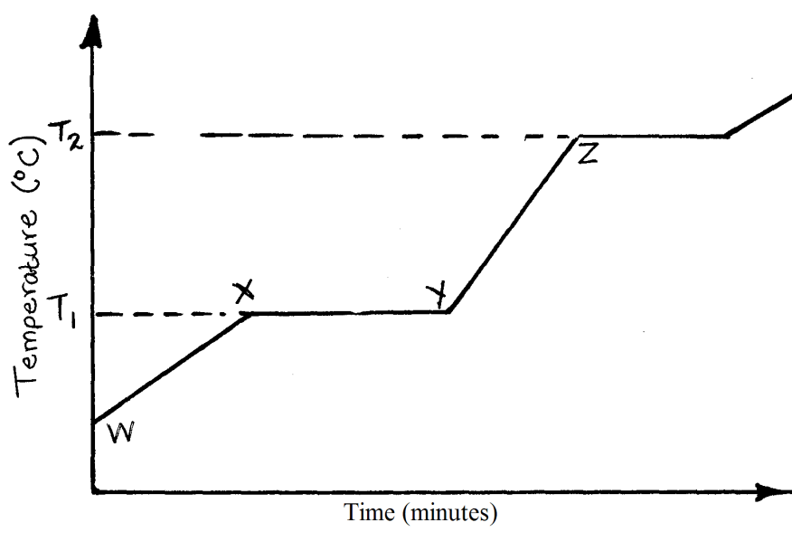

1. What happens to the molecules between W and X? (1mark)

……………………………………………………………………………………………………….……………………

1. What is the significance of temperatures T1 and T2? (1mark)

……………………………………………………………………………………………………….………..…………………………………………………………………………………………….

1. Explain why the temperature does not rise between X and Y. (1mark)

……………………………………………………………………………………………………….……………………………………………………………………………………………………...

1. Is the substance represented pure or impure? Give a reason. (1mark)

……………………………………………………………………………………………………….…………………………..………………………………………………………………………….

21. Starting with lead oxide, nitric acid, sodium sulphate, water and all necessary apparatus, describe how you would prepare a dry sample of lead (II) sulphate. (3marks)

............................................................................................................................................................

............................................................................................................................................................

............................................................................................................................................................

............................................................................................................................................................

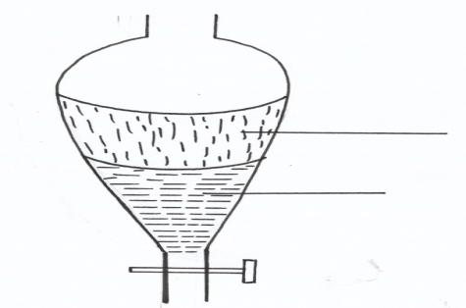22. A mixture of hexane and water was shaken and left to separate out as shown in the diagram below:-

**A**

**B**

(i) Identify liquids A and B (2marks)

**A**………………………………………………………………………………………………….…

**B**…………………………………………………………………………………………………….

(ii) Apart from density, state **one** other property that makes it possible to separate them using the

set-up above? (1mark)

............................................................................................................................................................

............................................................................................................................................................

23. a) The set-up below is used to investigate the properties of hydrogen.

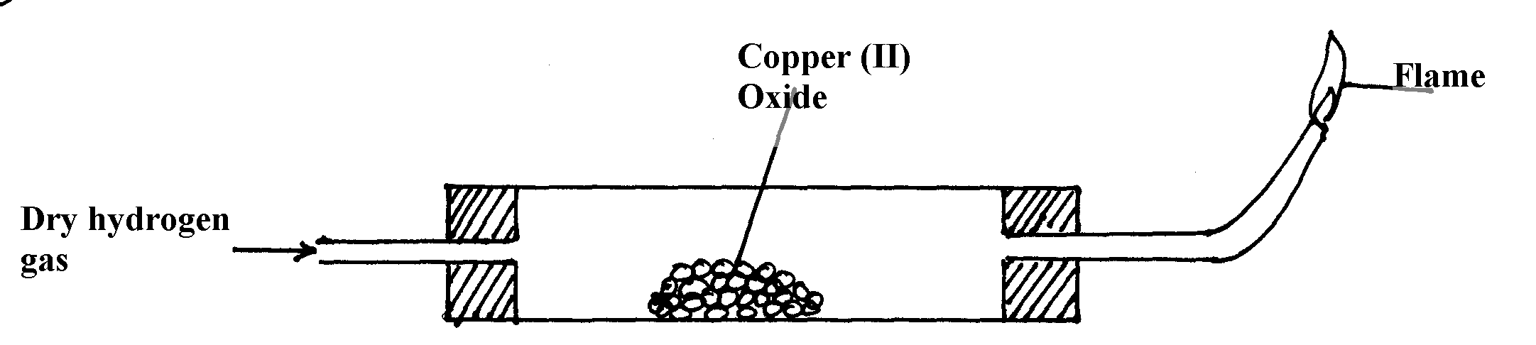

1. On the diagram, indicate what should be done for the reaction to occur (1mark)
2. Hydrogen gas is allowed to pass through the tube for some time before it is lit. Explain (1mark)

............................................................................................................................................................

............................................................................................................................................................

Write an equation for the reaction that occurs in the combustion tube (1mark)

............................................................................................................................................................

............................................................................................................................................................

.......................................................................................................................................................

When the reaction is complete, hydrogen gas is passed through the apparatus until the cool down. Explain (1mark)

............................................................................................................................................................

............................................................................................................................................................

What property of hydrogen is being investigated? (1mark)

............................................................................................................................................................

............................................................................................................................................................

PRINTED AND COMPILED BY

PERFECT STEPS PUBLISHERS

0721 745374/ 0721 707626 NAIROBI