FORM2 CHEMISTRY 2015
233/1/2
1. The electron arrangement of ions Q²⁻ and R³⁺ are as 2, 8, 8, and 2,8respectively.
(a) Write the electron arrangement of the elements Q and R (2marks)
Q……………………………………………………………………………………………….

R……………………………………………………………………………………………….
(b) Write the formula of the compound that would be formed between Q and R (1mark)
……………………………………………………………………………………………………………..…………………………………………………………………………………………………….
2. Explain why a high temperature is required for Nitrogen to react with oxygen (1mark)
…………………………………………………………………………………………………………………………………………………………………………………………………………………..
3. Give one advantage and one disadvantage of using petrol containing tetraethyl lead in motor vehicles (2marks)
Advantage………………………………………………………………………………………………..

Disadvantage…………………………………………………………………………………………………

4. The products of a burning candle were passed through a tube containing calcium oxide as shown in the diagram below.

Funnel
Candle
Calcium Oxide
Gases to suction pump
Tube R
Tube P

- Write two chemical equations for the reactions that took place in tube P. (2marks)
………………………………………………………………………………………………………………………………………………………………………………………………………………………………………………………………………………………………………………………………..
- Name two gases that came out through tube R. (1mark)
…………………………………………………………………………………………………………………………………………………………………………………………………………………….
5. Study the diagram below and use it to answer the questions that follow.
Carbon (IV) Oxide
+
Carbon (II) Oxide
Conc.
Sodium Hydroxide
Gas P

- Name two reagents that are reacted to produce both Carbon (IV) Oxide and Carbon (II) Oxide. (1mark)
………………………………………………………………………………………………………………………………………………………………………………………………………………………………………………………………………………………………………………………………..
- Write the equation for the reactions that took place in the wash bottle. (1mark)
…………………………………………………………………………………………………………………………………………………………………………………………………………………..
- Give a reason why Carbon (II) Oxide is not easily detected. (1mark)
……………………………………………………………………………………………………………………………………………………………………………………………………………………
6. The table below gives some properties of three elements X,Y and Z.
ELEMENT | Atomic No. | Meeting point(⁰C) | Boiling Point (⁰C)
X | 53 | 114 | 184
Y | 35 | -7 | 58.8
Z | 17 | -101 | -34.7
- Which element is in liquid form at room temperature? Give reason. (1mark)
……………………………………………………………………………………………………………………………………………………………………………………………………………………
- Explain why the boiling point of element X is higher than that of element Z. (2marks)
…………………………………………………………………………………………………………………………………………………………………………………………………………………………………………………………………………………………………………………………………………………………………………………………………………………………………………..
7. The diagram below is a set up for the laboratory preparation of dry oxygen gas.
Sodium peroxide
Liquid X
Liquid Y

- Name:
I. Liquid Y (^{1/}₂ Mark)
………………………………………………………………………………………………………….
II. Liquid X (^{1/}₂ Mark)
……………………………………………………………………………………………………………
(b) Write an equation for the reaction that took place in the flask. (1mark)
…………………………………………………………………………………………………………………………………………………………………………………………………………………….
(c) Complete the diagram to show how dry oxygen can be collected. (1mark)
8. (a) Describe how you would prepare crystals of sodium nitrate starting with 200cm³ of 2M sodium hydroxide (2marks)
………………………………………………………………………………………………………………………………………………………………………………………………………………………………………………………………………………………………………………………………
(b) Write an equation for the reaction that takes place when a solid sample of sodium nitrate is heated. (1mark)
……………………………………………………………………………………………………………..………………………………………………………………………………………………………
9. Magnesium reacts with both concentrated and dilute acid. Write the equations for the two reactions. (2marks)
……………………………………………………………………………………………………………………………………………………………………………………………………………………………………………………………………………………………………………………………….

10. The graph below shows how the PH value of soil in a farm changed over a period of time.
PH
2
4
6
A
B
C
D
E
Time

- Describe how the PH of the soil can be determined. (2marks)
………………………………………………………………………………………………………………………………………………………………………………………………………………………………………………………………………………………………………………………………………………………………………………………………………………………………………..
- State one factor that may have been responsible for the change in the soil PH in the time interval AB. (1mark)
……………………………………………………………………………………………………………………………………………………………………………………………………………………
11. A student put calcium carbonate and calcium hydrogen carbonate in separate test tubes and performed
the tests as shown in the table below. Complete the table by giving the expected observations.
Salt | Adding water | Heating
Calcium Carbonate
Calcium hydrogen carbonate
(2marks)
12. A mixture contains Iron (III) Chloride, calcium chloride and iron filings. Describe how one can separate and recover the substances in the mixture. (3marks)
……………………………………………………………………………………………………………..…………………………………………………………………………………………………………………………………………………………………………………………………………………………………………………………………………………………………………………………....

13.Below is a set-up of apparatus used to prepare hydrogen gas in the laboratory. Study it and answer the questions that follow.
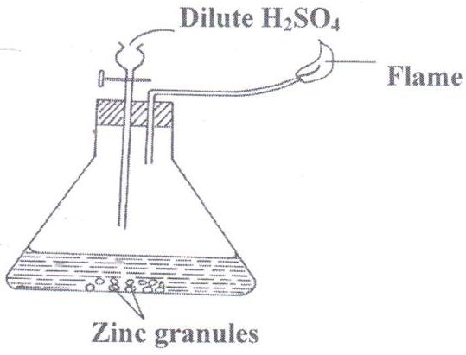
- Write a chemical equation for the two reactions taking place in he above set-up. (2marks)
………………………………………………………………………………………………………………………………………………………………………………………………………………………………………………………………………………………………………………………………
- State the chemical test for hydrogen gas. (1mark)
……………………………………………………………………………………………………………………………………………………………………………………………………………………..
14. State three reasons why air is considered to be a mixture but not a compound. (3marks)
…………………………………………………………………………………………………………………………………………………………………………………………………………………………………………………………………………………………………………………………………………………………………………………………………………………………………………………………….
15An experiment was set up using chlorine water as shown below.
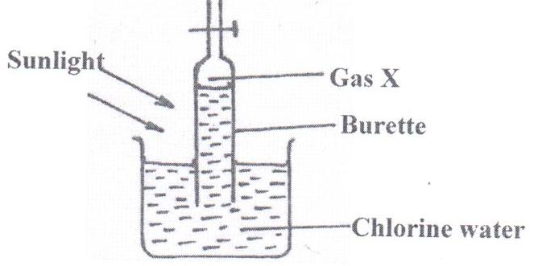

- Identify gas X. (1mark)
……………………………………………………………………………………………………..
- Write an equation for the production of gas X. (2marks)
………………………………………………………………………………………………………………………………………………………………………………………………………………………………………………………………………………………………………………………………
16. The table below shows the pH values of some solutions.
Solution | J | K | L | M | N
pH | 6 | 13 | 2 | 10 | 7

  - Which solution is likely to be:
- Potassium hydroxide (1mark)
..........................................................................................................................................
(ii) Lemon juice (1mark)
…………………………………………………………………………………………………
  - Explain why a solution of hydrogen chloride gas in methyl benzene was identified as N.(1mark)

……………………………………………………………………………………………………………………………………………………………………………………………………………………
17. Using dots (•) and crosses (x) to represent electrons, show bonding in the compound formed when the following elements reacts. (N = 14, H = 1).
Nitrogen and Hydrogen. (1mark)
………………………………………………………………………………………………………………………………………………………………………………………………………………………………………………………………………………………………………………………………………………………………………………………………………………………………………………………………………………………………………………………………………………………………………………………………………………………………………………………………
18. Some salts may be classified as double salts or basic salts. Trona with the formula Na₂CO₃.NaHCO₃ is an example of a double salt. An example of a basic salt is basic magnesium carbonate with formula MgCO₃.Mg (OH)₂.
  - What is meant by a double salt? (1mark)
…………………………………………………………………………………………………………………………………………………………………………………………………………………..
  - Write equations of reactions that occur when dilute hydrochloric acid is reacted with: (2marks)
  - Trona……………………………………………………………………………………………………………………………………………………………………………………………………………………………………………………………………………………………………………………..
  - Basic magnesium carbonate
………………………………………………………………………………………………………………………………………………………………………………………………………………………………………………………………………………………………………………………………..

19During Olympics, urine sample of five short distance runners were taken and tested for the presence of two illegal steroids by paper chromatography. Methanol was used as the solvent. A chromatogram from the test appeared as shown below. Study the chromatogram and answer the questions that follow.

KEY
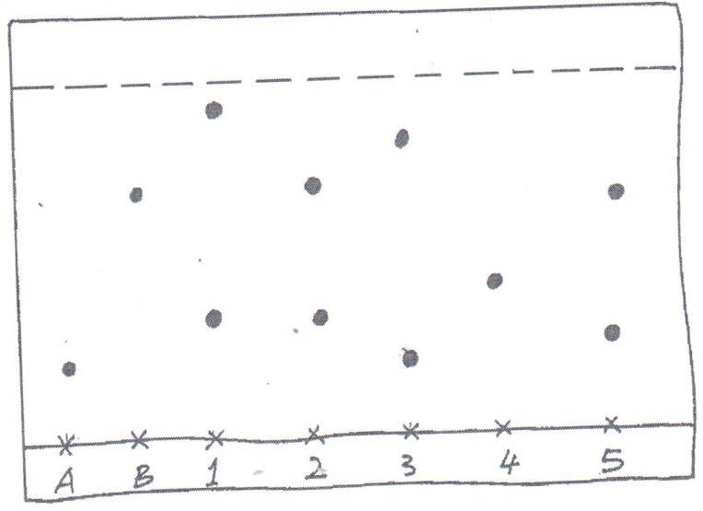
SPOT A – STEROID A
SPOT B – STEROID B
SPOT 1 – ATHLETE 1
SPOT 2 – ATHLETE 2
SPOT 3 – ATHLETE 3
SPOT 4 – ATHLETE 4

x x x x x x x
A B 1 2 3 4 5

  - Which of the two steroids is most likely to be more soluble in methanol? Give a reason.(1mark)
……………………………………………………………………………………………………………………………………………………………………………………………………………………...
  - Identify the athletes that tested positive for the illegal steroids. (2marks)
……………………………………………………………………………………………………………………………………………………………………………………………………………………
20.The 1st, 2nd and 3rd ionization energies in KJ/Mol of elements G and R are given below.
Element | 1st I.E | 2nd I.E | 3rd I.E
G | 520 | 7,300 | 9,500
R | 420 | 3,100 | 4,800
- Define the term 1st ionization energy. (1mark)

………………………………………………………………………………………………………………………………………………………………………………………………………………………………………………………………………………………………………………………………

- Apart from the decrease in energy levels, explain the big difference between the 1st and 2nd ionization energies. (1mark)

………………………………………………………………………………………………………………………………………………………………………………………………………………………………………………………………………………………………………………………………..
- Calculate the amount of energy for the process: (1mark)
R_{(g)} R³⁺_{(g)} + 3e⁻

…………………………………………………………………………………………………………………………………………………………………………………………………………………...
21.A. In an experiment to determine the percentage of oxygen in air, the apparatus below were set up. Study the set up and the information provided to answer the questions that follow.

Copper turnings

Heat

Water
I
K
Flask H (500cm³)
J
100

200

300

400

500

A 500cm³ measuring cylinder K was filled with water and assembled for gas collection. Copper turnings were heated red hot and water was slowly passed into 500cm³ flask H until it reached the 500cm³ mark. A colorless gas was collected in K.
(i) What was the purpose of passing water into flask H? (1 mark)

……………………………………………………………………………………………………….

(ii) What observations were made in the tube I? (1 mark)

…………………………………………………………………………………………………………………………………………………………………………………………………………................
(iii) Name one of the gases that is likely to be found in J. (1 mark)

……………………………………………………………………………………………………..
(iv)What was the volume of the gas collected in the measuring cylinder at the end of the experiment? (1 mark)
…………………………………………………………………………………………………......
- Calculate the percentage of oxygen in air using the above results. (2 marks)
………………………………………………………………………………………………………………………………………………………………………………………………………………………………
B. Study the diagram below and answer the questions that follow.

Colourless liquid Y
Copper (II) oxide

Ice cold water

Heat

(a) Give one observation made in the combustion tube after some time. (1 mark )
…………………………………………………………………………………………………………………………………………………………………………………………………………………….
(b) Write an equation for the formation of the colorless liquid Y. (1 mark)
……………………………………………………………………………………………………………………………………………………………………………………………………………………
(c)What was the aim of the above experiment as demonstrated in the combustion tube? Explain. (2 marks)
……………………………………………………………………………………………………………………………………………………………………………………………………………………
22. Use the information below to answer the questions that follow. The letters are not the actual symbols of the elements.
Element | Atomic No. | M.P⁰C | B.P⁰C | Ionic radius (nm)
P | 11 | 98 | 890 | 0.095
Q | 12 | 650 | 1110 | 0.065
R | 13 | 660 | 2470 | 0.050
S | 14 | 1410 | 2360 | 0.041
T | 15 | 44.2 & 590 | 280 | 0.034
U | 16 | 113 & 119 | 445 | 0.184
V | 17 | -101 | -35 | 0.181
W | 18 | -189 | -186 | -
(a) (i) Write the electronic configuration of the atoms represented by letters T and W. (1 mark) T…………………………………….W……………………………..
(ii) State the nature of the oxides of the elements represented by Q and U. (2 marks)

……………………………………………………………………………………………………………..………………………………………………………………………………………………………
(b) Why does the elements represented by the letters T and U have two values of melting points. (1 mark)
…………………………………………………………………………………………………………………………………………………………………………………………………………………….
(c) Explain the following observations in terms of structure and bonding.
(i) There is an increase in boiling point from P to R. (2 marks)
……………………………………………………………………………………………………………………………………………………………………………………………………………………
(ii) Element S has a high boiling point. (2 marks)
……………………………………………………………………………………………………………………………………………………………………………………………………………………
(iii) There is a decrease in boiling points from U to W. (2 marks)
…………………………………………………………………………………………………………………………………………………………………………………………………………………..
(d) (i) Compare the atomic radius of U and V. (1 mark)
……………………………………………………………………………………………………………………………………………………………………………………………………………………
(ii) Why is there no ionic radius for W reported in the table? (1 mark)
……………………………………………………………………………………………………………..……………………………………………………………………………………………………..
23. The table below gives some elements in the periodic table. Use it to answer the questions that follow. The letters do not represent the actual symbols of the elements.
Element | A | B | C | D | E
Atomic number | 12 | 13 | 14 | 15 | 16
Which of the above letters represent?
- A metallic element which forms ions with the smallest ionic radius? Explain (1 mark)
……………………………………………………………………………………………………………………………………………………………………………………………………………………
- A non metallic element with the largest atomic size? Explain. ( 1 mark)
…………………………………………………………………………………………………………………………………………………………………………………………………………………….
24. The diagram below shows a burning jiko. Study it and answer the questions that follow.
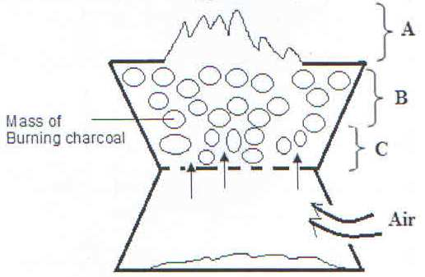

- Write the equation for the reaction taking place in region A. (1 Mark)
……………………………………………………………………………………………………………………………………………………………………………………………………………………...
- Name the gas produced at region B. (1 Mark)
…………………………………………………………………………………………………………………………………………………………………………………………………………………….
- State two uses of the gas named in (b) above. (2Marks)
…………………………………………………………………………………………………………………………………………………………………………………………………………………………………………………………………………………………………………………………………………………………………………………………………………………………………………

THIS IS THE LAST PRINTED PAGE.

