GATITU MIXED SECONDARY SCHOOL
THIRD TERM 2015
FORM 2 CHEMISTRY ENDTERM EXAM

- The grid below represents part of the periodic table. Study it and answer the questions that follow: - The letters given do not represent the actual symbols of the elements.
 |  |  |  |  |  |  | A
 | B |  |  | C |  | D |  | E
F | G
 |  |  |  |  |  |  |  | H
- Select the element that can form an ion with a change of-2. Explain your answer. (2mks)

- What type of structure would the oxide of C have? Explain your answer.(2mks)

- How does reaction of H compare with that of E? (2mks)

iv)
Explain how you would expect the following to compare and why?
a) Atomic radii of “F” and “G” (4mks)

b) The pH values of aqueous solution of oxides of B and D. (2mks)

v) The table below shows some physical properties of some substances. Use the information in the table to answer the questions that follow:-
 |  |  |  | Electrical conductivity
Substances | Melting | Boiling point ⁰C | Solid | Liquid
U | 1083 | 2595 | Good | Good
V | 801 | 1413 | Poor | Good
W | 5.5 | 80.1 | Poor | Poor
X | -114.8 | -84.9 | Poor | Poor
Y | 3550 | 4827 | Poor | Poor
i) Which substance is likely to be? Give a reason for each.
(I) A metal (2mks)

(II) Liquid at room temperature (2mks)

ii) Which substance is likely to have the following structures? Give a reason for each.
(I) Simple molecular (2mks)

(II) Giant atomic (2mks)

- Give two properties of carbon (IV) oxide which make it suitable for use in extinguishers.(2mks)

3. Give a reason why calcium hydroxide solution is used to detect the presence of Carbon (IV) oxide gas while sodium hydroxide sodium is NOT (1mk)

4. A sample of air contaminated with carbon (II) oxide and sulphur (IV) oxide was passed through the apparatus shown below.
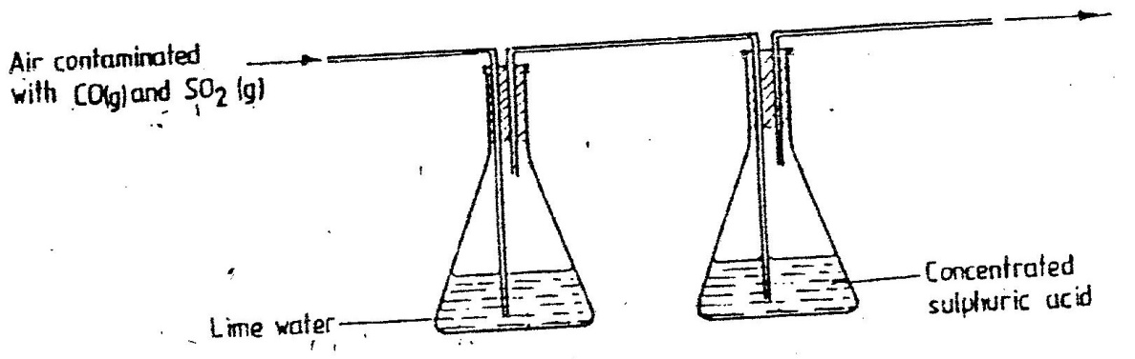

Which contaminant was removed by passing the contaminated air through the apparatus? Explain (2mks)

5. When extinguishing a fire caused by burning kerosene, carbon (IV) oxide is used in preference to water. Explain (2mks)

6. When dilute nitric acid was added to a sample of solid “C” a colourless gas that formed a white precipitate with lime water was produced. When another sample of solid “C” was heated strongly in a test tube, there were no observations changes. Write the formula of the ions in solid “C” (2mks)

7. Identify the particles that facilitate electric conductivity of the following substances (3mks)
i.sodium metal

ii.sodium chloride solution

iii. Molten lead ii bromide

8. When extinguishing fire caused by burning petrol, carbon iv oxide is used in preference of water. Explain (2mks)

9. The students set up the experiment below to collect gas v.the wet sand and
Was heated before heating zinc powder

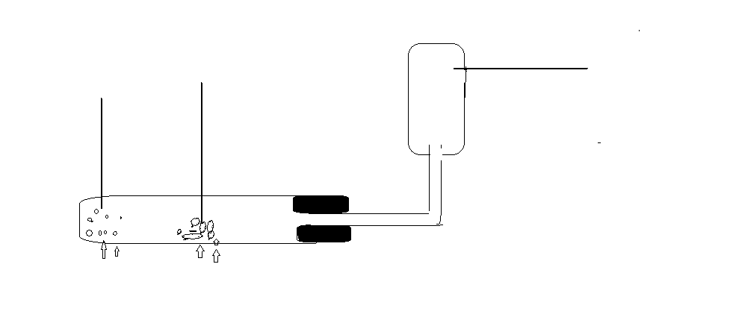

- Why was it necessary to heat wet sand before heating zinc powder (2mks)

- What would happen if zinc powder was heated before heating sand (2mks)

- During the experiment the delivery tube is removed before heating stops…explain (2mks)

- Identify another substance that can be used in place of wet sand (1mk)

- When copper metal was used in place of zinc, there was no gas produced. Explain (2mks)

- Identify another metal that can give the same result as copper metal (1mk)

10. What is meant by the following terms (3mks?)
i. Mass number

ii. Deliquescence

- Atomic radius

11. The set up below was used during electrolysis of molten lead ii bromide
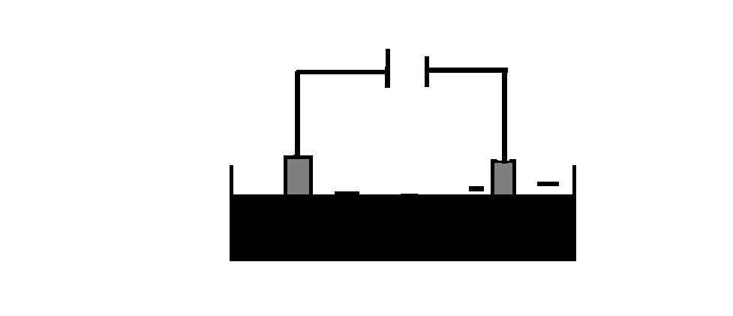

- on the diagram label the anode and the cathode (2mks)

ii) State the observation made at the cathode during electrolysis (2mks)

- Write half ionic equation for the reaction taking place at the cathode and anode (4mks)

- Identify another compound which can be used in place of lead ii bromide (1mk)

12. Explain the following observations

- When lead ii carbonate reacts with dilute hydrochloric acid, very little carbon iv gas is produced (2mks)

- When hydrogen chloride gas is dissolved in water the solution formed turns blue litmus paper red, but there is no effect on blue litmus paper when the gas is dissolved in carbon tetra oxide (ccl4).explain (2mks)

13.
- Name two allotropes of carbon (2mks)

- Under which circumstances will graphite be used as lubricant instead of grease. explain 2mks

- Explain why sugar and candle wax do not conduct electricity in molten and ionic state 2mks

- Amorphous form of carbon does not conduct electricity. Explain 2mks

- Identify two examples of amorphous form of carbon. 2mks

Marking scheme (40mks)
1. i) “A” It is in group (VI) and gaining two electrons .
ii) Giant ionic structure: C₂O₃ is an ionic compound. This is a very strong force of attraction (electrostatic force) between the ions.
iii) “E” is more reactive than H. “E” has a small atomic radii and gains electrons very easily compared to H.
iv) (I) B _{(s)} + Cl_{2 (g)} → BCl_{2(s)}
v) “G” has a small atomic radius compared to F. G has many protons and hence attracts electrons very easily to its nuleus.
b) i) The oxide of B is alkaline in mature with a PH greater than (8.0).
B is a metal and forms basic oxide. D is a non metal and forms acidic oxide with a PH less than 5.0
ii) i) I U
II W
ii) I X
II Y
2. - Dense than air
- Does not burn
- Put off burning flame
3. Ca(OH)₂ produces CaCO₃ which is insoluble . NaOH forms Na₂Co₃ which is soluble.
4. SO_{2;} It is an acidic gas and react with Ca (OH)₂ which is basic.
5. Kerosene is less dense and float spreading the fire. CO₂ is more dense and covers the fire preventing oxygen reaching the fire.
6. K⁺/ Na⁺ and CO₃⁻²
7. i) C_{(s)} + O_{2(s)} CO_{2(g)}
ii) CO_{2(g)} + C_{(s)} 2CO_{(s)}
8. a) PBO_{(s)} + CO_{(s)} Pb_{(s) +} CO₂(g)
b) Colour of PbO change from yellow when cold, brown when hot, Finally grey.
c) Hydrogen gas
9. a) ammonia gas
b) Filtration/precipitation/crystallization
c) 2NaHCO_{3(s)} Na₂CO_{3(s)} + CO_{2 (g)} + H₂O _{(l)}

