GATITU MIXED SECONDARY SCHOOL
END OF TERM ONE EXAM CAT 1
CHEMISTRY
FORM IV 2015
INSTRUCTIONS:
Answer all questions in the space provided.
Remember to write your registration number.
- (a) Differentiate between lattice and hydration energy. (2 marks)
………………………………………………………………………………………………………………………………………………………………………………………………………………………………………………………………………………………………………………………………………………………………………………………………………………………………
(b) Use the information below to answer the questions that follow:- (3 marks)
Ca_{(s)} + ½ O_{2(g)} CaO_{(s)} ΔH =-635KJ/mol
C_{(s)} + O_{2(g)} CO_{2(g)} ΔH= -394KJ/mol
Ca_{(s)} + C_{(s)} + ³/₂O_{2(g)} CaCO₃ ΔH = -1207KJ/mol
Calculate the enthalpy change for the reaction:
Ca_{(s)} + CO_{2(g)} CaCO_{3(s)}
………………………………………………………………………………………………………………………………………………………………………………………………………………………………………………………………………………………………………………………………………………………………………………………………………………………………………………………………………………………………………………………………………………………………………………………………………………………………………………………………………………………………………………………………………………………………………………………………………………………………………………………………………………………………………………………………………………………………………
- 0.92g of ethanol was found to burn in excess air producing a temperature rise of 32.5⁰C in 200cm³ of water. (C=12.0 H=1.0 O=16.0) (Density of water 1g/cm³, Specific heat capacity of water 4.2kj kg⁻¹k⁻¹)
a) Write the equation for combustion of ethanol. (1 mark)
………………………………………………………………………………………………………………………………………………………………………………………………………………………………………………………………………………………………………………………………………………
b) Determine the molar heat of combustion of ethanol. (3 marks)
………………………………………………………………………………………………………………………………………………………………………………………………………………………………………………………………………………………………………………………………………………………………………………………………………………………………………………………………………………………………………………………………………………………………………………
- The diagram below shows energy levels for the reaction
½ H_{2(g)} + ½ F_{2(g)} HF_{(g)}

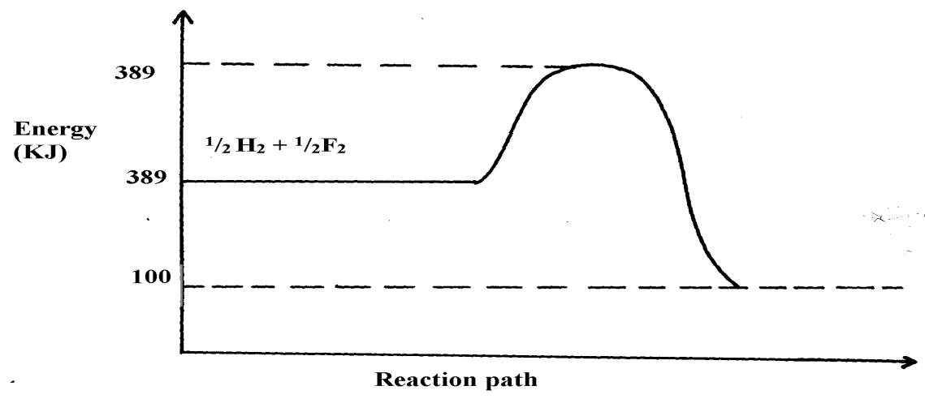

(a) Work out the activation energy for the reaction (2 marks)
……………………………………………………………………………………………………………………………………………………………………………………………………………………………………………………………………………………………………………………………………………
(b) Calculate the heat of formation of HF (2 marks)
………………………………………………………………………………………………………………………………………………………………………………………………………………………………………………………………………………………………………………………………………………
(c) Is the reaction endothermic or exothermic? (1 mark)
……………………………………………………………………………………………………………..

- Study the standard electrode potentials for the elements given below and answer the questions that follow. The letters do not represent the actual symbols of the elements
E^{θ}
Q + 2e⁻ 2Q- _{(aq)} +2.87
_{2(g)}
R_{2(g}) + 2e⁻ 2R-(aq) +1.36
S²⁺ _{(aq)} + 2e⁻ S (s) + 1.23
2T⁺_{(aq)} + 2e⁻ T₂(g) 0.00
U²⁺_{(aq)} + 2e⁻ U(s) -0.13
V²⁺_{(aq)} + 2e⁻ V(s) -0.76
- Define the following; (2 marks)
- Reduction
............................................................................................................................................................................................................................................................................................................
- Oxidation
...........................................................................................................................................................................................................................................................................................................
- What is the E^{θ} value of the weakest reducing agent? (1 mark)
……………………………………………………………………………………………………………………………………………………………………………………………………………
- Which element is likely to be hydrogen? Give a reason for your answer (2 marks)
……………………………………………………………………………………………………………………………………………………………………………………………………………...
- Draw a labeled diagram for the cell that would be obtained when the half cell of elements S and V are combined. (2 marks)
………………………………………………………………………………………………………………………………………………………………………………………………………………………………………………………………………………………………………………………………………………………………………………………………………………………………………………………………………………………………………………………………………………………………………………………………………………………………………………………………………………………………………………………………………………………………………………………………………………………………………………………………
- Calculate the e.m.f of the electrochemical cell in a (iii) above (2 marks)
……………………………………………………………………………………………………………………………………………………………………………………………………………………………………………………………………………………………………………………………………………………………………………………………………………………………..

- When magnesium reacts with hydrochloric acid, a salt is formed and hydrogen gas.
- Define an acid. (2 marks)
………………………………………………………………………………………………………………………………………………………………………………………………………………………………………………………………………………………………………
- Write the chemical formulae of the salt formed. (1/2 mark)
………………………………………………………………………………………………………………………………………………………………………………………………………………………………………………………………………………………………………
- The compound was dissolved in water to form an aqueous solution. The solution was then electrolyzed using graphite electrodes containing planitised platinum. Write the half equation that occurred at the;
- Anode (2 marks)
……………………………………………………………………………………………………………………………………………………………………………………………………
- Cathode
……………………………………………………………………………………………………………………………………………………………………………………
- State one observation made at the cathode. (1/2 mark)
……………………………………………………………………………………………………………………………………………………………………………………………………………………………………………………………………………………………………………………………………………………………………………………………………………………………….
- Name three amphoteric oxides (1⅟2 marks)
………………………………………………………………………………………………………………………………………………………………………………………………………………………………………………………………………………………………………
- What is a strong acid? (1/2 mark)
……………………………………………………………………………………………………………………………………………………………………………………………………………………………………………………………………………………

