GATITU MIXED SECONDARY SCHOOL
FORM 4 CHEMISTRY AUGUST HOME ASSIGNMENT
INSTRUCTIONS: All questions and answers should be written at the back of the exercise book. (No question should be left unanswered)
- (a) Study the scheme given and answer the questions that follow
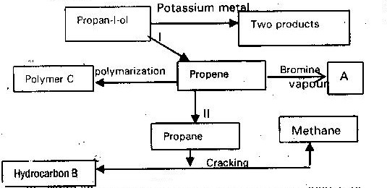

  - Write an equation for the reaction between propan-1-ol and potassium metal 1mk)
  - Name process I and II ( 2 mks)
  - Identify the products “A” and “B” ( 2 mks)
  - Name ONE catalyst used in process II (1 mk)
  - Draw the structural formula of the repeating unit in the polymer “C”
(b) State two uses industrial uses of methane (2 mks)
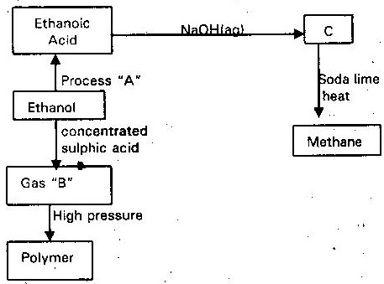
The flow chart below shows a series of reaction starting with ethanol. Study it and answer the questions that follow.

(i) Name
I Process “A”
II Substance “B” and C
(ii) Write the equation for the combustion of ethanol. ( 1 mk)
(iii) Explain why it is necessary to sue high pressure to change gas “B” into polymer
(iv) State one use of methane ( 1 mk
What name is given to a compound that contain carbon hydrogen only
Hexane is a compound that contain carbon and hydrogen only
(i) What method is used to obtain hexane from crude oil?
(ii) State one use of hexane ( 1 mks)
(c) Study the flow chart below and answer the questions that follows:

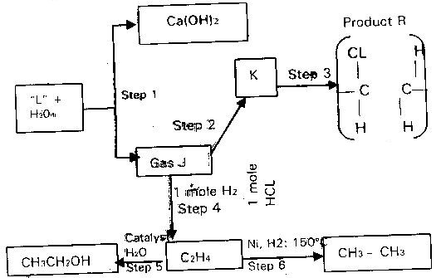

(i) Identify reagent L ( 1 mk)
(ii) Name the catalyst used in step 5 ( 5 mks)
(iii) Draw the structural formula of “J” ( 1 mk)
(iv) What name is given to the process that takes place in step 5
(v) State I. One use of product “R”
II. A commercial application of the process which take place in step 6
(d) (i) Write the equation for the reaction between aqueous sodium hydroxide and aqueous ethanoic acid (ii) Explain why the reaction between 1g sodium carbonate and 2 m hydrochloric acid is faster than the reaction between 1 g of sodium carbonate and 2 Methanoic acid (2mks)
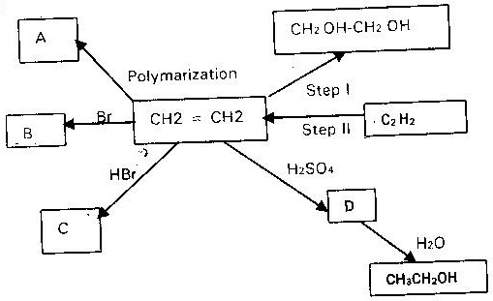
- Below is a scheme of some reaction of ethyne

(i) State the condition and reagents required to effect steps I and II (2mks)
(ii) Give the formula of products A, B, C and D (4mk
Study the crude oil fractionating column in the diagram and answer the questions that follows
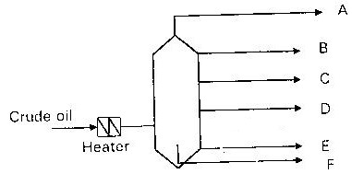

(a) How would you except the temperature to vary from A to E (2mks)
(b) For each fraction below state at which position it will be collected compound with(5mks)
- C₁₅- C₂₅ atoms
- C₄- C₁₂ atoms
- C₂₀ – upwards
- C₉- C₁₆
- C₁ – C₄
- A,B,C are three homologous series of organic compounds
Series | General formula
A | C_{n}H_{2n}-2
B | C_{n}H_{2n}
C | C_{n}H_{2n} + 2
(i) What is the name given to series C ( 1 mk)
(ii) Write down the name and structural formula of the second member of series “B”
(iii) Write down an equation and name the products of reaction between HBr with second member of series “B” ( 2 mks)

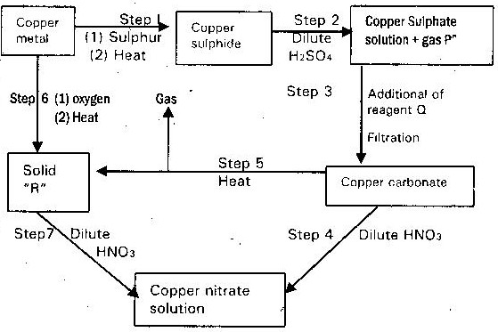
(b) The flow chart below shows a sequence of reaction starting with copper. Study it and answer the questions that follows

(i) Identify gas “p” and reagent Q and “R” (2 mks)
(ii) Write an equation for the reaction that place in step 5 (1 mk)
(iii) State the observation made in steps 4 and 7 (1 mk)
(c) Bronze is an alloy of copper and another metal
(i) Name the other metal (1 mk)
(ii) Give one use of bronze (1 mk)
The diagram below illustrates how sulphur is extracted by frasch process
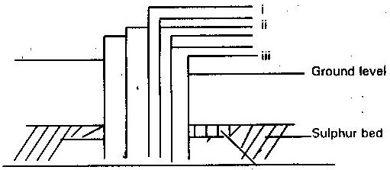

(a) Label the pipe through which superheated water is pumped in ( 1 mk)
(b) The equation below shows the oxidation of sulphur (IV) oxide to sulphur (VI) oxide in the contact process
2SO₂ (g) + O₂ (g) →2 SO₃(g) ∆H = - 196KJ
(i) Name the catalyst used in this process ( 1 mk)
(ii) State and explain the effect on the yield of sulphur (VI) oxide when
I. The temperature is increased ( 2 mks)
II. The amount of oxygen is increased ( 2 mks)
(iii) Describe how sulphur (VI) oxide is converted to sulphuric acid in the contact process
(c) Ammonium sulphate is a fertilizer produced by passing ammonia gas into concentrated sulphuric acid
(i) Write the equation for the reaction ( 1 mk)
(ii) Calculate the mass in kg of sulphuric acid required to produce 25kg of fertilizer (S= 32.0) (0= 16.0) (N = 14.0) (H. 1.0) (3 mks)
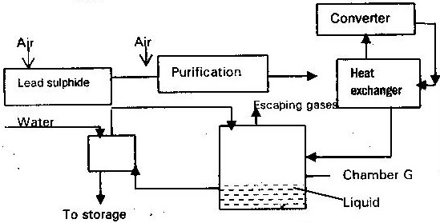
(a) The diagram below shows some processes that takes place during the industrial manufacture of sulphuric acid.

(i) Write the equation for the reaction in which sulphur (IV) Oxide is produced
(ii) Why is it necessary to keep the gas pure and dry? ( 1 mk)
(iii) Describe the process that takes place in chamber G ( 1 mk)
(iv) Name the gases that escape into the environment ( 1 mk)
(v) State and explain the harmful effect on the environment of one of the gases
(vi) Give one reason why it is necessary to use 2- 3 atmospheric pressures and not more
Below is a flow chart showing some of the major steps involved in the manufacture of sulphuric (VI) acid by contact process
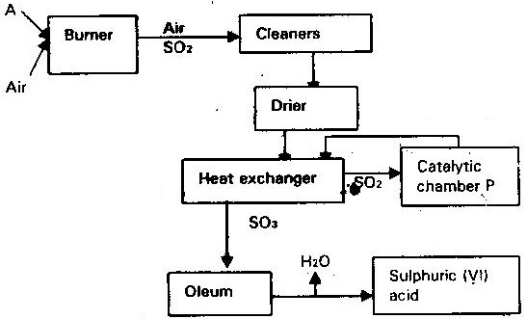

The set up below shows preparation of sulphur (VI) oxide study it and answer the questions that follows.
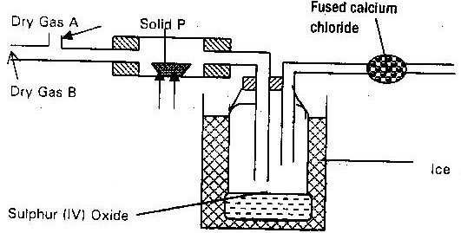

(b) Write an equation for the reaction taking place in the combustion tube. ( 1 mk)
- When sulphur (IV) oxide is passed into aqueous solution of chlorine the greenish yellow colour of chlorine disappears. Write equation for the reaction taking place
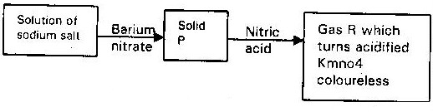
Study the flow chart below and answer the question that follows

(a) Name solid P ( 1 mk)
(b) Give the formula of sodium salt ( 1 mk)
(c) Name gas R ( 1 mk)
(d) Write an equation for the reaction between Nitric acid and solid “P”
4. Sulphur is one of the elements that exhibits allotropy
(i) What is allotropy ( 1 mk)
(ii) Give another element other than sulphur that shows allotropy ( 1 mk)
(iii) Name two allotropes of sulphur ( 2 mks)
(iv) State two major uses of sulphur ( 2 mks)
- 9.0g of zinc sulphide reacted with 100cm³ of 0.2m sulphuric acid. Determine the reagent that was in excess. (Zn = 65, S= 32) ( 2 mks)
- The diagram below shows the set up used in an experiment to prepare chlorine gas and react it with aluminium foil. Study it and answer the questions that follow
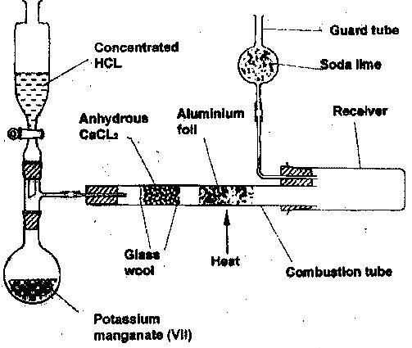

(a) In the experiment, concentrated hydrochloric acid and potassium manganate (VII) were used to prepare chlorine gas. State two precautions that should be taken in carrying out this experiment. ( 2 mks)
(b) Write the formula of another compound that could be used instead of potassium manganate (VII) ( 1 mk)
(c) Explain why is necessary to allow the acid to drip slowly onto potassium manganate (VII) before the aluminium foil is heated. (2 mks)
(d) State the property of the product formed in the combustion tube that makes it possible for it to be collected in the receiver. ( 1 mk)
(e) When 1.08g of aluminium foil were heated in a stream of chlorine gas, the mass of the product formed was 3.47g. Calculate the:
(i) Maximum mass of the product formed if chlorine was in excess
(AL = 27; Cl = 35.5) ( 3 mks)
(ii) Percentage yield of the product formed ( 1 mk)
(f) Phosphorous trichloride is a liquid at room temperature what modification should be made to the set up if it is to be used to prepare phosphorous trichloride ( 1 mk)
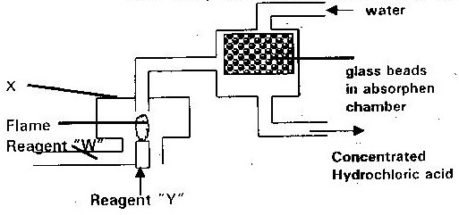
- The diagram below represents the industrial manufacturer of hydrochloric acid. Study it and answer the questions that follow.

(a) Name the reagents “W” and “Y” ( 1 mk)
(b) Explain the role of the glass beads in the absorption chamber ( 1 mk)
(c) Write an equation for the reaction in chamber “X” ( 1 mk)
(d) Explain why hydrochloric acid formed appears yellow in colour ( 1 mk)
- The diagram below shows preparation of hydrochloric acid

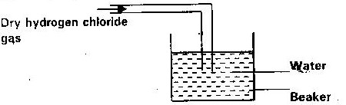

(i) State one mistake in the diagram
(ii) Hydrogen chloride does not have any effect on litmus paper unlike hydrochloric acid. Explain
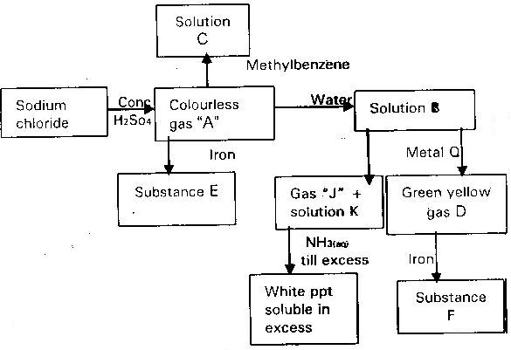
The flowchart below summarizes the results of series of chemical reactions; study it and answer the questions that flows

4.The extraction of aluminium from its ore takes place in two stages, purification stage and electrolysis stage. Below shows the set up for the electrolysis stage
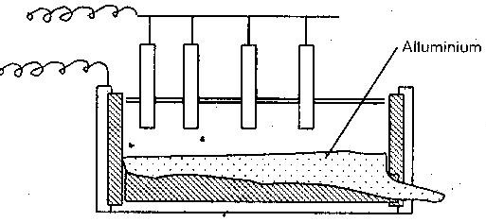

(a) (i) Name the ore from which aluminum is extracted (1 mk)
(ii) Name one impurity which is removed at the purification stage
(b) (i) Label on the diagram each of the following
I. Anode
II. Cathode
III. Region containing electrolyte
(ii) The melting point of aluminium oxide is 20540C, but the electrolysis is carried out at between 800 C and 9000C
I. Why is not carried out at 20500C (2mks)
II. What is done to lower the temperature (1 mk)
(iii) The aluminium which is produced is tapped off as a liquid. What does this suggest about its melting point?
(c) A typical electrolysis cell uses a current of 40,000 amperes. Calculate the mass (in kg) of aluminium produced in one hour (Al = 27) Faraday = 96,500 coulombs (3mks)
- Use the standard electrode potential for A, B, C, D and F given below to answer the questions that follows. The letters do not represent the actual symbols of the elements
E^{Q} volts
A (aq) ²⁺ + 2e → A(s) - 2.90V
B (aq) ²⁺ 2e →B(s) - 2.38V
C (aq) ⁺ + e→ ½ C₂ - 0.00V
D (aq) ⁺² + 2e → D(s) + 0.34V
½ Fe₂ + e → F (aq) + 2.87V
(i) Which element is likely to be hydrogen? Give a reason for your answer
(ii) What is E^{Q} value for the strongest reducing agent? (1 mk)
(iii) In the space provide, draw a labeled diagram of the electrochemical cell that would be obtained when a half cells of element “B” and “D are combined
(iv) Calculate the EQ value of the electrochemical cell constructed in (iii) above
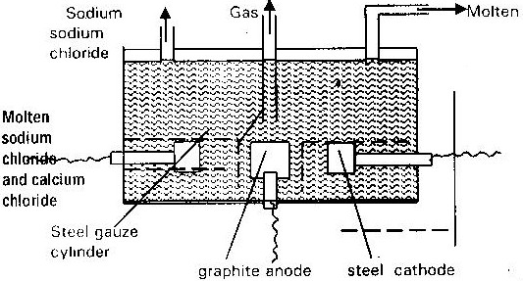
The diagram below shows the extraction of sodium metal using the down cell. Study it and answer the questions that follows

- Explain why in this process the sodium chloride is mixed with calcium chloride
(ii) Why is the anode made of graphite and not steel? ( 1 mk)
(iii) State two properties of sodium metal that make it possible for it to be collected as shown in the diagram
(iv) What is the function of steel gauze cylinder? ( 1 mk
(v) Write ionic equation for the reactions which take place at
I. Cathode ( 1 mk)
II. Anode ( 1 mk)
(vi) Give one industrial use of sodium metal ( 1 mk)
- The set up below was used during the electrolysis of aqueous magnesium sulphate using inert electrodes

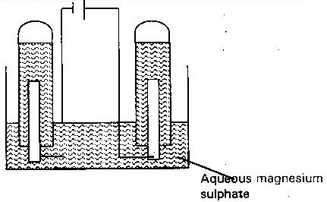

(i) Name a suitable pair of electrodes for this experiment (1 mk)
(ii) Identify the anions and cations present in the solution (2mks)
(iii) On the diagram label the cathode (1 mk)
(iv) Write ionic equation for the reaction that took place at the
I: Anode (1 mk)
II. Cathode (1 mk
- (a) The diagram below represents a mercury cathode cell that can be used in the industrial manufacture of sodium hydroxide. Study it and answer the question that follows

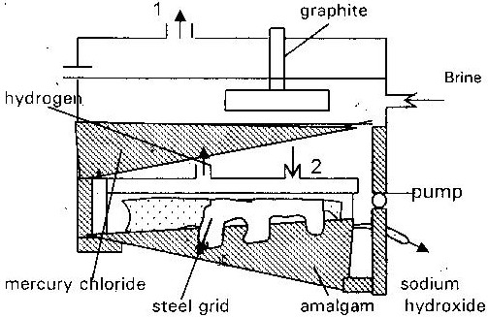

i. Name the
I: Raw material introduced at “2” (2mks)
II. Another substance, that can be used in the call instead of graphite ii. Identify the by products that come out at I
iii. Give
1. One use of sodium hydroxide (1 mk)
2. Two reasons why mercury recycled (1 mk)
(b) A current of 1000 amperes was passed through the cell for five (5) hours
i. Write equation for
I. The reaction that occurred at the mercury cathode (1 mk)
II. The reaction in which sodium hydroxide was produced (1 mk)

ii. Calculate the mass of sodium hydroxide that was produced (Na= 23) (O = 16) (H=1.0) Faraday = 96500 coulombs (4mks)
- (a) Study the standard electrode potentials for the half cells given below and answer the questions that follows. The letters do not represent the actual symbols of the elements
E volts
N⁺_{(av)} + e⁻ → N -2.92
J⁺_{(av)} + e → J +0.52
K⁺(aq) + e → ½ Kg 0.00
½ G(g) + e → G⁻(ag) +1.36
M²⁺ (g) + 2 e →m(g) -0.44
i. Identify the strongest oxidizing agent: Give a reason for your answer
ii. Which two half cells would produce the highest potential differences when combined? (1 mk)
iii. Explain whether the reaction represents below can take place (2mks)
2M⁻ + N → 2N + M²⁺
(aq) (s) (s) (aq)
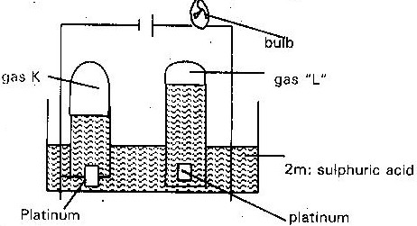
(b) 100 cm³ of 2m sulphuric acid was electrolyzed using the set up represented by the diagram below

i. Write an equation for the reaction that produce gas “L” ( 1 mk)
ii. Describe how gas “k” can be identified ( 1 mk)
iii. Explain the differences in
(a) The volume of gases produced at the electrodes
(b) Brightness of the bulb if 100 cm³ of 2m ethanoic acid was used in place of sulphic acid
The table below gives the standard electrode potentials for the metals represented by letters D, E, F & G. study it and answer the questions that follows
Metals | Standard electrical potential (volts)
D | -0.13
E | + 0.85
F | + 0. 34
G | - 0. 76

(a) Which metal can be displaced from a solution of its salt by all the other metals in the table? Give a reason
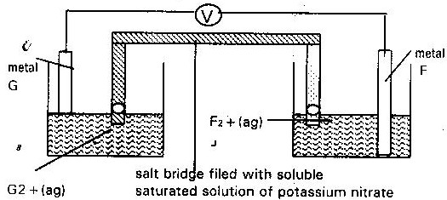
(b) Metal “F” and “G” was connected to form a cell as shown in the diagram

i. Write the equation for the reactions that occur at the electrode F and G
ii. On the diagram indicate with an arrow the direction in which electrons would flow
iii. What is the function of the salt bridge? (1 mk)
(c) An electric current was passed though concentrated solution of copper (ii) chloride as shown in the diagram below.

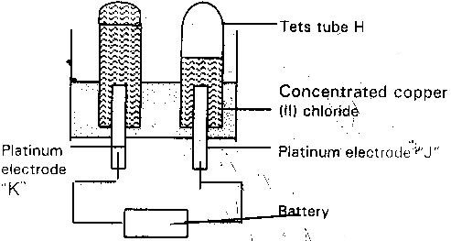

i. Explain the observation that would be made on the electrolyte as the experiment progress (2mks)
ii. After sometime test tube “H” was found to contain a mixture of two gases. Explain this observation( 3m
iii. Which of the electrodes is the anode? Explain (2mks)
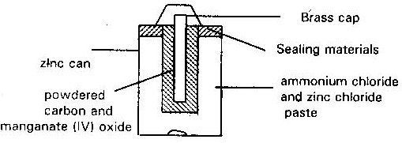
- The diagram below is a cross- section of a dry cell. Study it and answer the questions that follows

(i) On the diagram, show with a (+ve) sign the +ve (positive terminal) (1
(ii) Write the equation for the reaction in which electrons are produced (1
(iii) The zinc can is line with ammonium chloride and zinc chloride paste. What would happen if the mixture was to become dry? Give a reason
(iv) Give one advantage and one disadvantage of dry cell ( 2 mks)
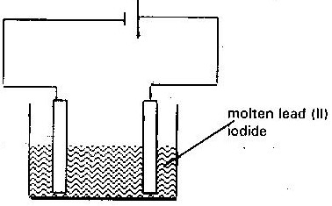
(b) The setup up below was used to electrolyze molten lead (ii) Iodide

i. State the observation that was made at the anode during the electrolysis. Give a reason for your answer.
ii. A current of 0.5A was passed for two hours. Calculate the mass of load that was deposited (Pb= 207) (1 faraday = 96500c) (3mk
- (a) Brine usually contains soluble calcium and magnesium salts. Explain how sodium carbonate is used to purify brine (2mks)
22. Below is a scheme of some reactions of ethanol. Study it and answer the questions that follow
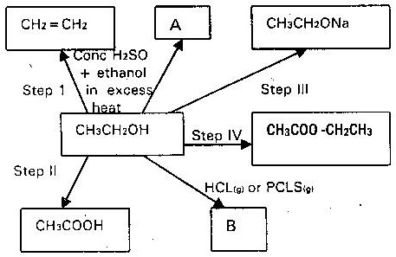

- State the conditions and the reagents required in steps I, II, III and IV
- (ii) Name the major products “A” and “B” (2mks)(e) (i) Draw the monomer of the polymer below (1 mk)
CH₃
|
― CH₂ ― C ― = CH ― CH― _{n}

(ii) Name the monomer (1mk).
- When magnesium metal is burnt in air it reacts with both oxygen and Nitrogen gas giving a white ash like substance. Write two equations for the two reactions that takes place.
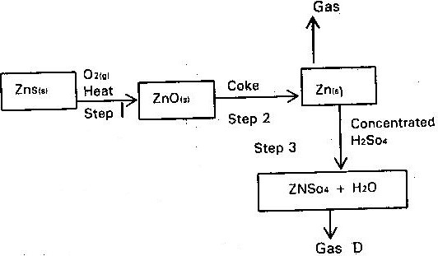
4 .Study the flow chart below and answer the question that follows

(a) State the conditions necessary for the reaction in step 2 to occur ( 1 mk)
(b) Name
(i) Gas P ( 1 mk)
(ii) One use of Zinc ( 1 mk)
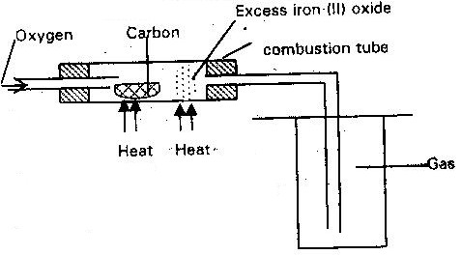
The set up below was used to obtain a sample of iron

Write two equations for the reactions which occur in the combustion tube
( 2 mks)
6. Dry carbon (II) oxide gas react with heated lead (II) oxide as shown in the equation below
(a) Name the process undergone by the lead (II) Oxide ( 2 mks)
(b) Give a reason for your answer (a) above
(c) Name another gas that can be used to perform the same function as carbon gas in the above reaction ( 1 mk)
7. In the industrial extraction of lead metal, the ore is first roasted in a furnace. The solid mixture obtained is then fed into another furnace together with coke limestone and scrape iron. State the functions of each of the following in this process.
(a) Coke ( 1 mk)
(b) Scrape iron ( 1 mk)
(c) Limestone ( 1 mk)
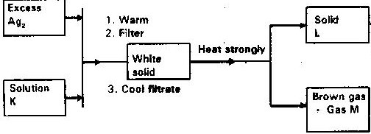
8. Study the flowchart and answer the questions that follow

Identify
(a) Solution K
(b) Solid
(c) Gas M
9. The flow chart below shows steps used in the extraction of zinc form one of its
Ores.
Zinc carbonate ore
Powdered zinc carbonate ore
Concentrated zinc carbonate ore
Zinc metal
Zinc oxide
Crushing
Step 1
Step 2
Step 3
Heat
Gas
Coke
Step 4

(a) Name the process that is used in step 2 to concentrate the ore. ( 1 mk)
(b) Write an equation for the reaction which takes place in step 3 ( 1 mk)
(c) Name one use of zinc other than galvanizing
10. During the extraction of aluminium from its ores; the ore is first purified to obtain alumina. The flow chart below shows the stages in the extraction of aluminium from alumina.
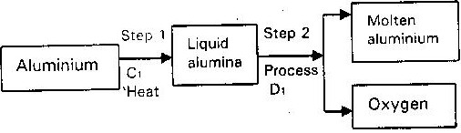

(a) Name
(i) Substance C₁ ( 1 mk)
(ii) Process D₁ ( 1 mk)
(b) Give two reasons why aluminium is used extensively in making of cooking pans
11. The flow chart below outlines some of the process involved in extraction of copper from pyrites. Study it and answer the questions that follows
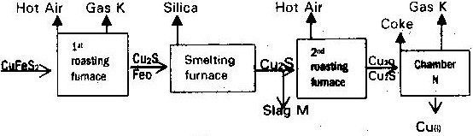

(a)(i) Name gas “k”
(ii) Write an equation for the reaction that take place in the 1st roasting furnace
(iii) Write the formula of the cations present in the slag “M”
(iv) Identify gas “P”
(v) What name is given to the reaction that take place in chamber N. Give a reason for your answer?
(b) The copper obtained “M” is not pure. Draw a labeled diagram to show the set up you would use to refine the copper by electrolysis. (2mks)
(c) Given that the mass of copper obtained from the above extraction was 210 kg. Determine percentage purity of the ore (Copper pyrite) if 810 kg of it was fed to the 1st roasting furnace(4mks)(Cu= 63.5) (Fe = 56) (S= 32)
(d) Give two effects that this process could have on the environment (2mks)
12. The flow chart below illustrates the industrial extraction of lead metal. Study it and answer the questions that follows
(a) (i) Name the ore that is commonly – used in this process ( 1 mk)
(ii) Explain what take place in the roasting furnace ( 1 mk)
(iii) Identify gas “p” ( 1 mk)
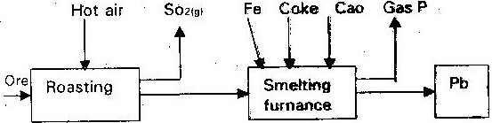

(iv) Write the equation for the main reaction that takes place in the smelting furnace
(v) Give two environmental hazards likely to be associated with extraction of lead
(vi) What is the purpose of adding iron in the smelting furnace? (1 mk)
(b) Explain why hard water flowing in lead pipes may be safer for drinking them soft water flowing in the same pipes (3mks)
(c) State one use of lead other than making lead pipes (1 mk)
13. The raw material for extraction of aluminum is bauxite.
(a) Name the method that is used to extract aluminium from bauxite (1 mk)
(b) Write the chemical formula for the major components of bauxite (1 mk)
(c) (i) Name the major impurities sin bauxite (3mks)
(ii) Explain how the impurities in bauxite are removed (3mks)
(d) Crayolite is used in the extraction of aluminium from bauxite. State its function
(e) Describe how carbon (IV) oxide is formed during the extraction of aluminium
(f) Aluminum is a reactive metal yet utensils made from aluminium do not corrode easily. Explain this observation
14. The extraction of iron from its ore takes place in the blast furnace. Below is a simplified diagram of a blast furnace. Study it and answer the questions that follow.
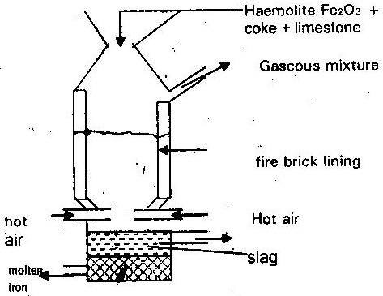

(a) (i) One of the substances in the slag (1 mk)
(ii) Another iron ore material used in the blast furnace (1 mk)
(One gas which is recycled) (1 mk)
(b) Describe the process which leads to the formation of iron in the blast furnace
(c) State the purpose of limestone in the blast furnace (1 mk)
(d) Give a reason why the melting point of iron obtained from the blast furnace is 1200⁰ while that of pure iron is 1535⁰C (1 mk)
(e) State two uses of steel

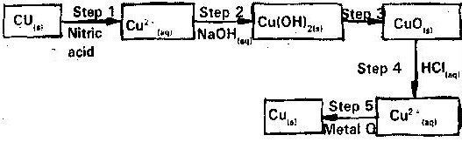
15. The flow chart below shows a sequence of chemical reactions starting with copper. Study it and answer the questions that follow

(a) In step 1, excess 3M nitric acid was added to 0.5 of copper powder
(i) State two observations which were made when the reaction was in
Progress (2mks)
(ii) Explain why dilute hydrochloric acid cannot be used in step 1 (1 mk)
(iii) I. Write the equation for the reaction that took place in step 1 (1mk)
II. Calculate the volume of 3M nitric acid that was needed to react completely with 0.5g of copper powder (Cu= 63.5) (3mks)
(b) Give names if the type of reactions that took place in steps 4 and 5
(c) Apart from the good conductivity of electricity, state two other properties that make it possible for copper to be extensively used in the electrical industr
16. Study the flow chart below and answer the questions that follow

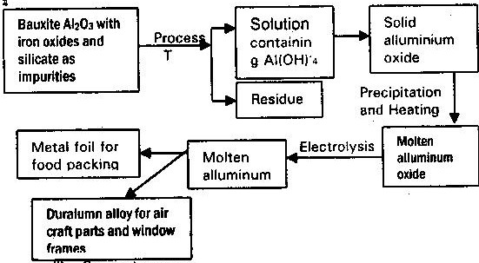

(i) Suggest a purpose for the industry process represented by the flow chart
(ii) Explain how process T is carried out (2mks)
(iii) Explain why it is necessary to heat aluminum oxide before electrolysis is carried out
(iv) Suggest a reason to why carbon is not used for reduction of aluminium Oxide(1 mk)
(v) What properties of aluminum and the alloy make them suitable for use indicated?
17. The flow chart illustrates the extraction of zinc and preparation of Zinc (II) sulphate crystals. Study it and answer the questions that follow

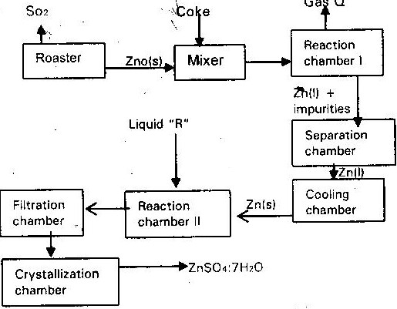

(a)(i) Name
I. Gas Q (1 mk)
II. Liquid R (1 mk)
(ii) Write an equation for the reaction that takes place in
    - Chamber I (1 mk)
    - The Roster (1 mk)
    - Chamber II (1 mk)
(iii) Given that the zinc sulphide ore contain 45% of Zinc sulphate by mass calculate
I. The mass in grains of Zinc sulphide that would be obtained from 250 kg of the ore (1 mk)
II. The volume of sulphur (IV) oxide (So₂) that would be obtained from the mass of zinc (1 mk)
III. Sulphide obtained in 1 above at room temperature and pressure (Zn = 65.4) (S = 32.0) molar gas volume = 24 dm³
(b) In such an experiment sulphur (IV) Oxide may keep escaping to the atmosphere. Explain how this could affect the environment. (2mks)
(c) Suggest one other man manufacturing plant that could be set up near Zinc extraction plant. Give a reason for your answer
(i) Give the chemical name of the substance formed when iron rust
(ii) Why does aluminium items does not corrode as quickly as iron
(iii) Explain why galvanized iron is resistant to corrosion even when the protective layer of zinc is broken (2mks)
Elements | Oxides | Sulphides
Copper | CUO, CU₂O | CuS, Cu2S
Hydrogen | H₂O | H₂S
20. Study the table below of oxides and sulphides formed by different elements and answer the questions that follow. With reference to the periodic table, what is the relationship between oxygen and sulphur

21. Two metals “A” and “B” have close packed and body centered cubic respectively. Which metal has the highest melting point ( 1 mk)
22. Aluminium metal is a good conductor and is used for over head cables. State any two other properties that make aluminium suitable for this use.
23. The table below shows the properties of substances K, L, M and N

Substance | Reaction with oxygen | Melting point | Conductivity
 |  |  | Solid | Molten
K | Unreactive | High | Good | Good
L | Reactive | Low | Poor | Poor
M | Unreactive | High | Good | Good
N | Unreactive | Low | Good | Good

Select the substance which is likely to be
(a) Copper metal (1 mk)
(b) Magnesium chloride
24. (a) An ore is suspected to containing mainly iron. Describe a method that can
be used to confirm the presence of iron in the ore (4mks)
(b) Excess Carbon (II) oxide was passed over a heated sample of an oxide of iron as shown in the diagram below. Study the diagram and the data below it to answer the question that follows
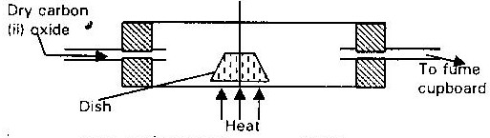

Mass of empty dish 10.98g
Mass of empty dish + oxide of iron 13.30g
Mass of empty dish + residue 12.66g
- Determine the formula of the oxide of iron. Relative mass of oxide of iron is 232, Fe= 56, O = 16
(ii) Write equation for the reaction which took place in the dish (1 mk)
(c) Corrosion is a destructive process in which iron is converted into hydrated (III) Oxide. State
(i) Two conditions necessary for rusting to occur (1 mk)
(ii) One method used to protect iron from rusting (1 mk)
(d) Explain why it is not advisable to wash vehicles using sea water (2mks)
25. Lithium metal react with water less vigorously than sodium metal explain (1 mk)

