GATITU MIXED SECONDARY SCHOOL
CHEMISTRY F4
OPENER EXAM (Radioactivity)
TERM II 2015
INSTRUCTIONS
Answer all questions.

1. Complete the following equation by determining the values of U and V. (2 mks)
u

v
234

90
0

-1
Th Pa + e

U……… V……………..

2. (a) Distinguish between nuclear fusion and fission (2 mks)

(b) Compete the nuclear equation below:- (1 mk)
230 230
90 91 +

3. Uranium -238 disintegrates by emitting an alpha particle to form substance Y.
Nuclide Y emits a beta particle to form substance Z. Write down nuclear equations to show how
substance Y and Z are formed (U=Atomic No. 92) (2 mks)

4. (a) What is a nuclide? (1 mk)

(b) The graph below shows the radioactive decay of a certain nuclide. Determine the
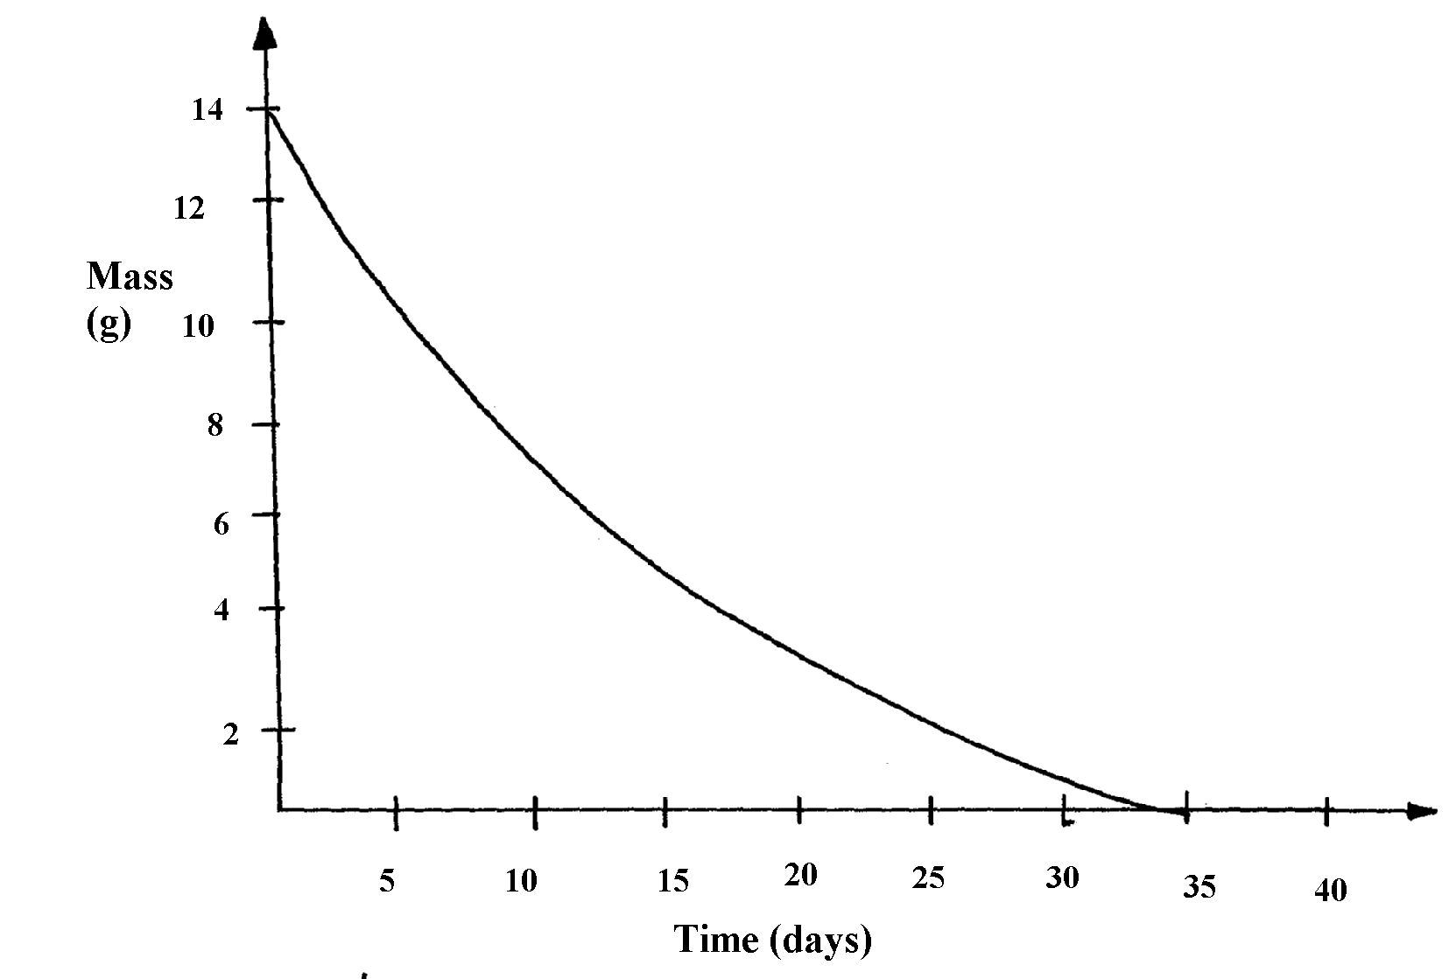
half-life of the nuclide (2 mks)

5. (a) State one way in which nuclear reactions differ from ordinary chemical reactions (1 mk)

(b) The following is a part of Uranium decay series
238
U
92
234
Th
90
234
Pa
91
Z
X
A
Step I
Step II
Step III

(i) Which particles are emitted in step I and II (1 mk)

(ii) If a beta particle is emitted in step III, find Z and A (1 mk)

(iii) If the activity of Thorium -234 is reduced to 25% in 48hours, find its half life (2 mk)

7. Some two elements are represented as:
16 27
and
8 13

(a) How many protons does X have? (1 mk)

(b) How many neutrons does Y have? (1 mk)

8. Y grams of a radioactive isotope take 120days to decay to 3.5grams. The half-life period
of the isotope is 20days
(a) Find the initial mass of the isotope (2 mks)

(b) Give one application of radioactivity in medicine (1 mk)

