Name…………………………………………………………Index No………………………… Class……………Signature……………………………Date………………………………………
CHEMISTRY
233/2
THEORY
2Hours

TOP EVALUATION TEST-2016
JULY/AUGUST 2016
FORM 4

INSTRUCTIONS TO STUDENTS:
- Write your name and index number in the spaces provided above.
- Sign and write the date of examination in the spaces provided.
- Answer all the questions in the spaces provided.
- All working must be clearly shown where necessary.
- Mathematical tables and electronic calculators may be used.

For Examiner’s Use Only:
Question | Maximum score | Candidate’s score
1 | 13
2 | 13
3 | 10
4 | 19
5 | 11
6 | 14
Total | 80

This paper consists of 11 printed pages. Students should check to ascertain that all pages are printed as indicated and that no questions are missing.

1.a) The grid below represents part of the periodic table. Study it and answer the questions that follow. The letters do not represent the actual symbols of the elements.

C |  |  |  | F | G |  | I
 |  |  |  |  |  | H |  | K
D | E
 |  |  |  |  |  |  | J
i) Identify the most reactive non-metal. Explain. (2 marks)
............................................................................................................................................................................................................................................................................................................................................
ii) What is the name given to the family of elements of which I and J belong? (1 mark)
.......................................................................................................................................................................
iii) Using dots (•) and crosses (×) to represent electrons, show bonding in the compound formed between C and H. (2 marks)

iv) How does the atomic radius of F compare with that of I ? Explain. (2 marks)
.............................................................................................................................................................................................................................................................................................................................................................................................................................................................................................................................
b) Study the table below and answer the questions that follow.

Substance | M | N | O | P | Q | R
M.P. °C | 801 | 1356 | -101 | 26 | -39 | 113
B.P °C | 1410 | 2850 | -36 | 154 | 457 | 445
Electrical conductivity in solid state | Poor | Poor | Poor | Poor | Good | Poor
Electrical conductivity in molten state | Good | Poor | Poor | Poor | Good | Poor

i) Explain why substance M is a good conductor in molten state and not in solid state. (2 marks)
.............................................................................................................................................................................................................................................................................................................................................
ii) What is the most likely structure of substance N? Explain. (2 marks)
................................................................................................................................................................................................................................................................................................................................................................................................................................................................................................................
iii) Identify, with reasons, a substance that exists as a liquid at room temperature. (2 marks)
………………………………………………………………………………………………………………………………………………………………………………………………………………………………………………………………………………………………………………………………………………

- The diagram below shows the apparatus for the preparation of gas A and investigate on its properties . Study it and answer the questions that follow.

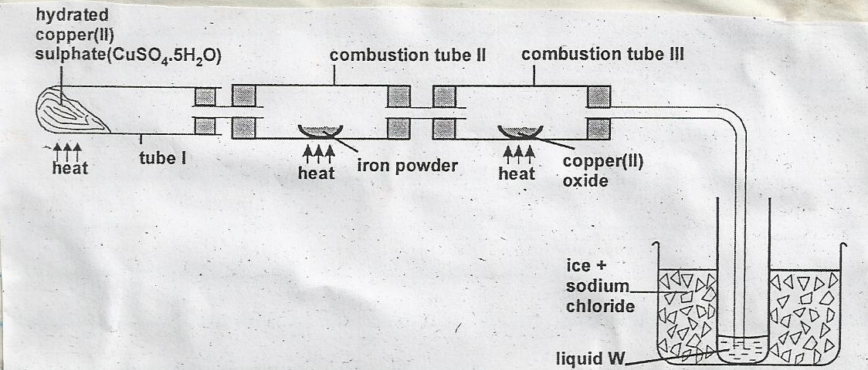

  - (i) Name gas A. …………………….……………… (1 mark)

(ii)Suggest the property of gas A under investigation. (1 mark)
................................................................................................................................................................................................................................................................................................
(iii) Write chemical equations for the reactions in the;

Boiling tube I (1 mark)

Combustion tube II (1 mark)

  - (i) State and explain the observation made in

Tube I. (2 marks)
…………………………………………………………………………………………………………………………………………………………………………………………………………….……………….

Combustion tube II (2 marks)
..................................................................................................................................................
..................................................................................................................................................

  - i) What is the use of hydrated copper (II) sulphate in the experiment. (1 mark)
.................................................................................................................................................
..................................................................................................................................................

(ii) Name one other substance that comes out of tube III. (1 mark)
................................................................................................................................................................................................................................................................................................
(iii) Name liquid W. (1 mark)
................................................................................................................................................................................................................................................................................................

(iv) What is the role of sodium chloride in the ice (freezing mixture) (1 mark)
................................................................................................................................................................................................................................................................................................

(v) Explain why hydrogen gas has been replaced by helium in filling of aeroplane tyres.
(1 mark)
................................................................................................................................................................................................................................................................................................

- Form 4 students of Mundika High school carried out an experiment to determine the molar heat of combustion of ethanol (C₂H₅OH). A small spirit lamp containing ethanol was weighed and then lit. The heat produced by the combustion of the ethanol was used to heat 200cm³ of water. The spirit lamp was weighted again at the end of the experiment. The following results were obtained.
Initial mass of spirit lamp = 85.3g
Final mass of spirit lamp = 84.8g
Initial temperature of water = 23.6°C
Final temperature of water = 35.6°C
a) Calculate
i) The mass of ethanol that burned (1 mark)

ii) The rise in the temperature of water. (1 mark)

iii) The heat gained by the water in kilojoules. (2 marks)

iv) Molar enthalpy of combustion of ethanol. (2 marks)
Density of water = 1.0gcm⁻³; specific heat capacity of water is 4.2kJ⁻¹ kg¹)

b) The actual enthalpy of combustion of ethanol is 1371kJmol⁻¹. Give one source of error that makes the experiment value to differ from the actual value. 1 mark)
.............................................................................................................................................................................................................................................................................................................................................
c) i) Write a balanced thermo chemical equation to show the combustion of ethanol. (1 mark)

ii) Sketch an energy-level diagram for the combustion of ethanol. (2 marks)

4. (I)An electric current was passed through concentrated solution of Copper (II) Chloride using inert pair of electrodes.
- Name a suitable pair of electrodes for this experiment. (1 Mark)
…………………………………………………………………………………………………………..
- Identify cations present in the solution. (1 Mark)
……………………………………………………………………………………………………….
- Which ions are preferentially discharged at the anode (1 Mark)
……………………………………………………………………………………………………..
- Write an ionic equation for the reaction that takes place at the cathode. (1 Mark)

- Explain the observation that would be made on the electrolyte as the experiment progresses.
(2 Marks)
………………………………………………………………………………………………………………………………………………………………………………………………………………………………………………………………………………………………………………………………
(II) Use the standard electrode potentials for elements V, W, X, Y and Z given below to answer the questions that follow.
Eθ Volts
W²⁺ _{(aq)} + 2e W_{(s)} -2.87
Z²⁺_{(aq)} + 2e⁻ Z_{(s)} -2.37
V⁺_{(aq)} + e⁻ ½ V_{2(g)} 0.00
X²⁺_{(aq)} + 2e⁻ X_{(s)} +0.34
½ Y₍₂₎ + e⁻ Y⁻_{(aq)} +1.99

- Identify the strongest reducing agent. (1 Mark)
…………………………………………………………………………………………………….
- Which element is likely to be hydrogen? Give a reason for your answer. (1 Mark)
……………………………………………………………………………………………………………………………………………………………………………………………………………………
- Which elements would form a couple with the highest E.M.F. Calculate the E.M.F
(2 Marks)

- Write the cell notation for the electrochemical cell formed by the cells in (c) above (1 Mark)

(III) The diagram shows an electric current being produced by a galvanic cell. Use it to answer questions that follow.
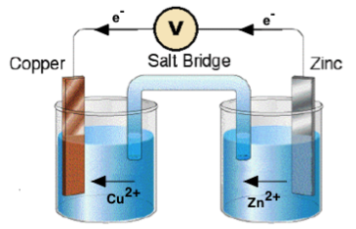
- State the observations made at the zinc electrode. (1 mark)
………………………………………………………………………………………………………………………………………………………………………………………………………………………………………..
- State the role played by the salt bridge in the set up. (1 mark)
…………………………………………………………………………………………………………………………………………………………………………………………………………………………………………
- In the electrolysis of copper sulphate solution using carbon electrodes 254g of copper was deposited on the negative electrode? Atomic masses: Cu = 63.5, O = 16.
- Write the ionic equation for the electrolysis. (1 mark)

- Determine the moles of copper deposited on the negative electrode. (2 marks)

- Find the moles of oxygen formed at the positive electrode. (1 mark)

- Find the mass and volume of oxygen deposited. (2 marks)

5. Study the reaction scheme below and answer the questions that follow.
Sulphur (IV) oxide
Hydrogen peroxide
Oxygen
Sodium peroxide
Sodium
Solution V
Substance U
Step 1
Step 2
Step 3
Step 5
+ Copper
Step 6
Step 4 + Water

(a) Identify the substances labeled U and V. (2 marks)
………………………………………………………………………………………………………………………………………………………………………………………………………………………..
(b) Name the reagents necessary for the reactions in the following steps. (4 marks)
Step 1 ___________________________________________________________
Step 2 ___________________________________________________________
Step 3 ___________________________________________________________
Step 6 ___________________________________________________________
(c) Give the condition necessary for the reaction in Step 5 to take place. (1 mark)
………………………………………………………………………………………………………………
(d) Write equations for the reactions in the following steps. (2 marks)
Step 1 ____________________________________________________________
Step 6____________________________________________________________
(e) State and explain the observation made in Step 5. (2 marks)
……………………………………………………………………………………………………………………………………………………………………………………………………………………………
- During the extraction of copper from copper pyrites (CuFeS₂) some of the processes include
- Crushing the ore.
- Mixing the crushed ore with water and oil and then bubbling air through it.
- Roasting the ore
- (i) Name two other ores that can be used. (2 marks)
(ii)Name the process marked (A) above and give its use. (2 marks)
Name -………………………………………………………………………………..
Use -…………………………………………………………………………………..
- Write an equation for the roasting of copper pyrites. (1 mark)

- (i) Pure copper is obtained from impure copper by electrolysis. Name the; (3 marks)
Anode ……………………………………
Cathode…………………………………….
Electrolyte…………………………………….
(ii)Write equations for the reactions at (2 marks)
I Anode
II Cathode

- Calculate the time taken for a current of 10 amps to deposit 32g of pure copper (Cu=64, IF = 96500c) (3 marks)

- Give one use of copper metal (1 mark)
…………………………………………………………………………………………………………

