DARAJANI SECONDARY SCHOOL,
P.O. BOX 20-90129, NGWATA.

TERM 2, 2015 CAT 2
FORM 4
CHEMISTRY

NAME…………………………………………….……ADM. NO……………….. CLASS: ………….

1. 6g of Potassium nitrate solid was added to 120cm³ of water in a plastic beaker.
The mixture was stirred gently and the following results were obtained.
Initial temperature = 21.5ºC
Final temperature = 17.0 ºC
(a) Calculate the enthalpy change for the reaction
(Density =1g/cm³, C= 4.2jg⁻¹K⁻¹) (3mks)

(b) Calculate the molar enthalpy change for the dissolution of potassium nitrate
(K=39, N= 14, O =16)(3mks)

2. 0.92g of ethanol were found to burn in excess air producing a temperature rise of 32.5ºC
in 200cm³ of water.
C=12.0 H=1.0 O=16.0
Density of water 1g/cm³
Specific heat capacity of water 4.2kj kg⁻¹k⁻¹

b) Determine the molar heat of combustion of ethanol(3mks)

c)Give 2 reasons why the experimental value calculated above is less than the theoretical value(2mks)

d)write a thermochemical equation for the reaction(1mk)

e)Draw an energy level diagram for the combustion of one mole of ethanol(2mks)

f) Calculate the heating value of ethanol(2mks)

3. The diagram below shows energy levels for the reaction
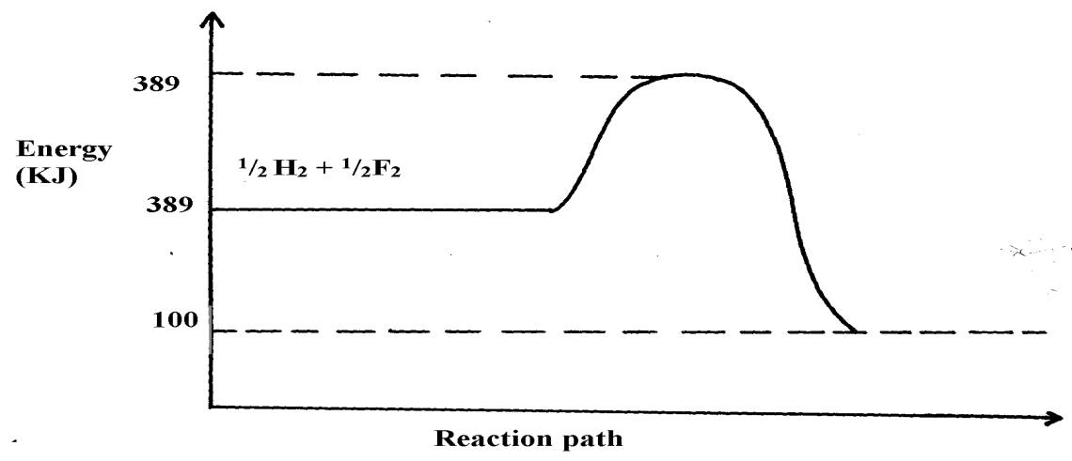
½ H_{2(g)} + ½ F_{2(g)} HF_{(g)}

HF

- Work out the activation energy for the reaction(1mk)

- Calculate the heat of formation of HF(1mk)

(c) Is the reaction endothermic or exothermic?(1mk)

4. Using the heats of combustion of the following substances, calculate the heat of formation
of ethanol(2mks)
C_{(s)} + O_{2 (g)} CO_{2 (g)}; ΔH = -393KJmol⁻¹
H_{2 (g)} + ½ O_{2 (g)} H₂O_{(l)};ΔH = -286KJmol⁻¹
CH₃CH₂OH_{(l)} + O_{2 (g)} 2CO_{2 (g)} + 3H₂O _{(l)} ;ΔH = 1386KJmol⁻¹

5. Nitrogen and hydrogen react reversibly according to the equation:-
N_{2(g)} + 3H_{2(g)} 2NH_{3(g); Δ}H = -92kjmol⁻¹

The energy level diagram for the above reaction is shown below:-
N_{2(g)} + 3H_{2(g)}
2NH_{3(g)}
Reaction path
Energy
(KJ)

(a) How would the yield of ammonia be affected by:
(i) A decrease in temperature(1mk)

(ii) An increase in pressure (1mk)

(b) How does a catalyst affect reversible reaction already in equilibrium?(1mk)

(c) On the above diagram, sketch the energy level diagram that would be obtained when
iron catalyst is added to the reaction(1mk)
6. Bond energies for some bonds are tabulated below:-
BOND | BOND ENERGY KJ/mol
H – H | 436
C = C | 610
C- H | 410
C – C | 345

a)Use the bond energies to estimate the enthalpy for the reaction
C₂H_{4(g)} + H_{2(g)} C₂H_{6(g) (3mks)}

b)Name the type of reactin above(1mk)

7. The able shows the results obtained when 20.2g of potassium nitrate was added in
50cm³ of water.
Time in (min) | 0.0 | 0.3 | 1.0 | 1.3 | 2.0 | 2.3 | 3.0 | 3.3 | 4.0
Temperature (ºC ) | 25.0 | 25.0 | 25.0 | 25.0 | 17.0 | 17.0 | 20.0 | 20.0 | 20.0
(i) Draw the graph of temperature against time(3mks) (ii) Using the graph, determine the temperature change(1mk)

(iii) Calculate the heat change(2mks)

(iv) Find the molar heat of solution of potassium nitrate(2mks)
. (Density of water = 1g/cm³,
specific heat capacity is 4.2kJ kg⁻¹K⁻¹)

8. Sodium hydrogen carbonate was strongly heated.
a) Write an equation for the reaction(1mk)

b) The grid below shows part of the periodic table. Use it to answer the questions that follow. The
letters are not the actual symbols.
A
B
L

F

G

C
H

K
D
J

E

- Write the equation for the reaction that occurs between elements L and D(1mk)

ii) The oxide of G reacts with both hydrochloric acid and sodium hydroxide. What is the nature of
the oxide of G?(1mk)

iii) Explain why elements H has a higher boiling points than element D(2mks)

.
iv) State one use of element E (1mk)

v) Compare and explain the atomic radius of B and C (2mks)

vi) 11.5g of L was completely burnt in oxygen .Calculate the volume of gas that was used.
(L = 23, molar gas volume at room temperature is 24dm³)(3mks)

9. (I) Study the graph below and answer the questions which follow:
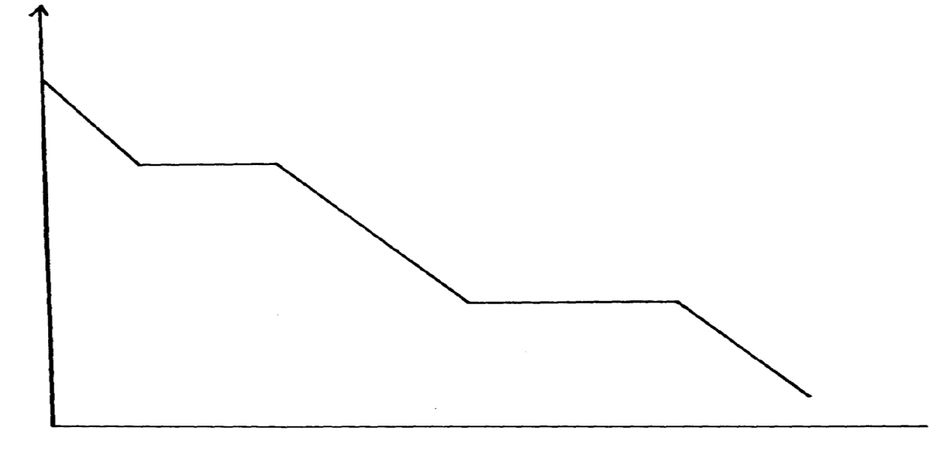
A

B

C

D

TEMPERATURE
TIME
A

- Distinguish between molar latent heat of fusion and molar latent heat of vaporization(2mks)

(b) (i) State the changes occurring between points(2mks)
BC ………………………………………… CD ………………………
10. A typical electrolysis cell uses a current of 40,000 amperes. Calculate the mass
(in Kg of aluminium produced in one hour). (Al = 27) (Faraday = 96500Coloumbs )(3mks)

11. Consider the following equilibrium reaction.
H₂(g) + Cl₂(g) 2HCl(g) ΔH= -74.4KJ
a) State and explain the effect of formation of hydrogen chloride if pressure was increased
in the equation above (2mks)

12. Turning of fossil fuels has adverse environmental effects:-
a) Name two pollutants from the burning of petroleum products(2mks)

b) Give one precaution taken to minimise the pollution by fossil fuels(1mk)

13. (a) Define the term fuel(1mk)

(b) State four reasons why wood fuel is chosen for domestic cooking(4mks)

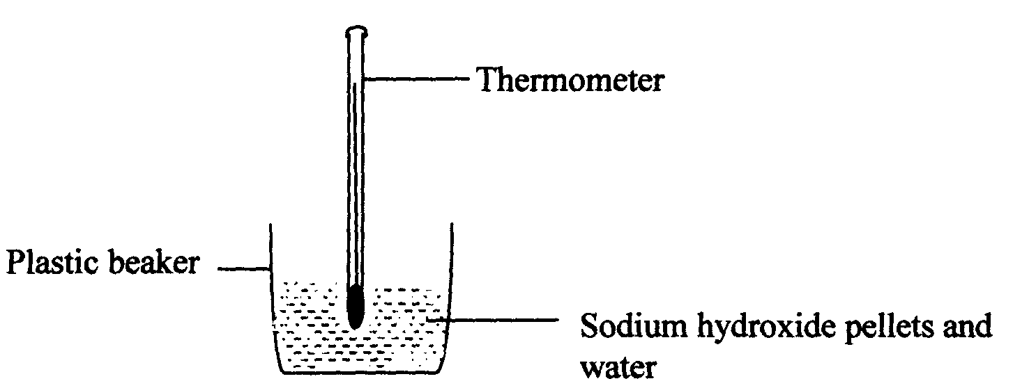
14. The setup bellow was used to investigate the changes that take place when sodium hydroxide
pellets dissolve in water.

- Why is a plastic beaker used instead of a metallic beaker?(1mk)

b) State and explain the observations made in the above reaction (2mks)

15. Study the diagram below and answer the questions that follow:

NH₄⁺(g) + Cl⁻(g)
∆H₂

NH₄⁺(_{aq}) + Cl⁻(_{aq})
∆H₃
∆H₁
NH₄Cl(_{s})
Energy
Reaction Co-ordinate
Reaction Co-ordinate

a) What do ∆H₁ and ∆H₂ represent?(2mks)
∆H₁ …………………………………………………………………….
∆H₂ ……………………………………………………………………..
b) Write an expression to show the relationship between ∆H₁, ∆H₂ and ∆H₃.(3mks)

