NYATIKE SUB-COUNTY JOINT EVALUATION EXAMS
CHEMISTRY 2
JULY/AUGUST 2014
MARKING SCHEME
1. (a) C and I √1
(b)(i) E √1
(ii) D √1
(c) E√1- its outermost energy electrons are strongly held by thr nucleolus because nucleus charge increases across the period
(d) G and D, K and I, D and E, J and E, J and G(Any correct pair leads to formation of ionic structure)
(e) H and C I and C √1( Pair that leads to formation acidic gas)
(f) B-2.5 B³+J² B²J³
J-2.8.2

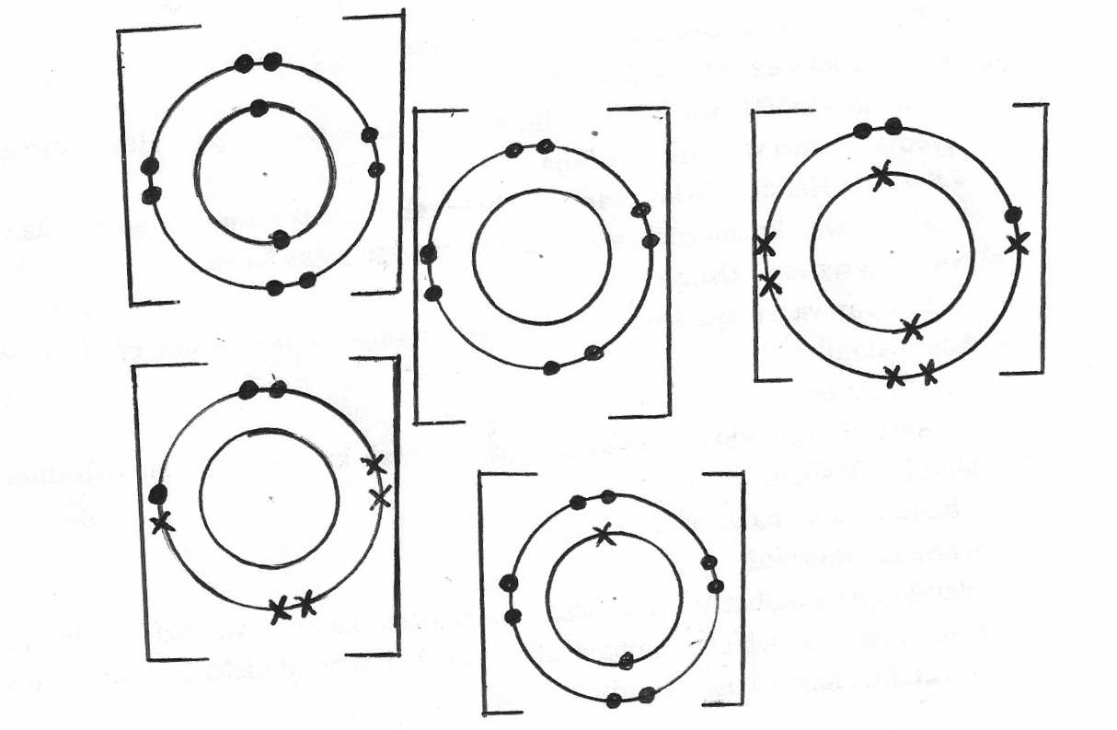
-3
J12p+
J12p+
B7p+
J12p+
B7p+
2+
3-

(g) K-2.8.2
D-2.8.8.1
The number of e-s used √1 in metallic bonding in K are more than the one used in D metallic bonding√1
2. (i)

(ii) 945±5cm³ (evidence of extrapolation emphasized)
(iii) Rate =
Evidence of extrapolation emphasized
Evidence of tangent at the 25th second for the curve emphasized
Units MUST be indicated
(iv) CaCO_{3(s)} +2HCl_{(aq)} CaCl2_{(aq)} + CO_{2(g)} + H₂O_{(l)}
Volume at 100th sec 1120cm3
1 mole of carbonate = 1 mole of CO_{2(g)}
100g = 22400cm³
? 1120cm²
= 100x1120 = 5g
22400

(II) Yellow colourisation intensify//solution become more yellow√1
The equilibrium shifts to the left/backward reaction is favoured√1

3. (a)(i) Mass of gas= 90.121-90.050
=0.071g√ 1
0.071 = 22.2
RAM X 22400√ ½

RAMX= 0.071x22400
22.2

(ii) C₃H₈+5 O₂ 3CO_{2(g)} + 4H₂O_{(g)}
(iii) For a fixed of a gas the volume is directly proportional to the absolute temperature provided pressure remains constant√1
(iv) V₁ = 4dm³ T1=227º C(500k) P1=152mmHg
V₂=2dm³ T2=-23ºC (250k)P₂ ? (conversion to Kelvin scale √1)
P1V1= P2V2 =4 x 1Ω= 2 x P2
T1 T2 500 250

=P2=4x152x250
500x2√ ½
P2=152mmHg√ ½
© (i) Solution Q –Aluminum sulphate Al₂(SO₄)₃
Solid R-Barium chloride (BaCl_{2(s)}/BaSO₄
4. I(a) Carbon is a stronger reducing agent than hydrogen (1mk)
(b) CO₂√1 or Carbon (iv) Oxide gas
(c)(i) 2Fe₂O₃ + 3C_{(s)} 4Fe_{(s)} + 3CO_{2(s)} √1
2 moles of Fe2O3 4 moles of Fe√1
Moles of oxide moles of metal
1.5 0.009398 x4 moles of metal
159.6 2
=0.009398nole 0.018797 moles of metal
1 mole Fe=55.8g√ ½
∴0.018797=55.8x0.18797=1.049√1g
(II) (i) Resins (Per…) contains Na⁺ which are exchanged for Ca²⁺ and Mg²⁺ in the hard water
OR Ca(HCO₃)₂ _{(aq)} CaO+ Na₂X_{(s)} CaX_{(s)} +2NaHCO_{3(aq)}
CaSO_{4(aq)} + Na₂X_{(s)} CaX_{(s)} + Na₂SO_{4(aq)}
(ii) By washing the resin with brine solution of sodium chloride
(iii) Provides Calcium for the body fro growth of teeth and bones// improves taste of water //Good for brewing of beer// Prevents lead poisoning (form insoluble lead sulphate and carbonate in Lead pipes prevents Lead from getting into water. √1
(iv) (a) Effervescence occurs/blue solution is formed
5. (i) Haematite // FeO3√1/magnetite/siderite
(ii) Coke (a) Produce Carbon (II) Oxide upon burning the main reducing agent
(b) Carbon (II) Oxide is the reducing agent√1
(iii) Zone P. (upper zone)
(1) 2C_{(s)} + O_{2(g)} 2CO_{(g)}
(2) Fe₂O_{3(s)} + 3CO_{(s)} 2Fe_{(s)} + 3CO_{2(s)}
(iv) 900ºC-1200ºC√1
(v) Calcium silicate and Calcium Aluminium Oxide(both √1)
(vi) Grey- white luster, has magnetic property up to 776oC
Density of 7.86gcm-3, mpt of 1530o, Bptof 3000oC, malleable, high tensile strength, conductor of heat and electricity (any correct two one mark each
(II)(a) XCO₃+2HCl XCl_{2(aq)} + CO_{2(g)} + H₂O
(b)(i) NaOH_{(aq)} + HCl_{(aq)} NaCl_{(aq)} + H₂O_{(l)}

Moles of acid= 25 x 0.1=0.0025moles
1000
Moles of acid: moles of base =1:1
∴moles of acids =0.0025moles√ ½
If 20cm3 of HCl= 0.0025mole
∴250cm3= 0.0025x250
20
= 0.03125moles in 250cm³
(ii) Moles in 50cm³= 50 x 1 = 0.05moles
1000
The moles that reacted with XCO₃
= 0.05-0.03125√1
=0.01875 moles
(iii) Moles of XCO₃ that reacted =
Mole ratio of carbonate: acid =1:2
∴Moles of XCO₃= 0.01875= 0.009375 √1mol
2
0.009375 = 1.5
RMM√ ½
RMM= 1.5 √ ½ = 160√ ½
0.009375
6. (i(a) Level of water rises in the test tube, to occupy the space left by the part of air used for rusting of iron
(2) Iron wool from grey turns to redish-brown, its oxidized to Iron (III) oxide // rusted √1
(ii) 4 Fe_{(s)} +3O_{2(s)} + 3H₂O 2Fe₂O₃H₂O_{(s)}
(II)
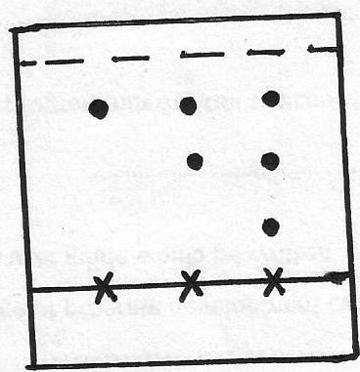
Each spot √ ½ mk total 1 ½
Solvent form 1mk
2
Solvent front
•
•
•
(III) (b)(i) Hydrogen or Ethyne/√1 /acetylene
(iii) Sulphur exist as S8…of molecules which is bulky hence stronger Van Der Waals√ ½ forces of attraction while Oxygen exist as a discrete √ ½ diatomic molecule (O2) hence weakens van der waals forces within the simple molecular structure.
(iv) Add water √ ½ to the mixture Sodium Sulphate dissolves filter to obtain lead (I) sulphate as a residue and filtrate to saturation allow to cool for crystals √ ½ to form then dry it between two filter papers
7. (i) Q ½ its boiling point is less than 25oC/boils at -47.7ºC
(ii)
S | T
S put in acidified Potassium Manganate (VII) the solution remains purple√1 | Decolorizes acidifies KMnO4 solution

H
H
H
H
H
H
O
H
H
׀ ׀ ׀
(iii) R - H - C - C - C - OH propanol
׀ ׀ ׀

׀ ׀׀
- H - C - C - O - H ethanoic acid
׀

K- Propane and ethanoate√1
Group of crystals-Esthers√1
(iv) B- Cathode √1
A-Anode√1
(v) Distilled water is not ionized// doesn’t have free and mobile ions, therefore no electric current was conducted√ ½
(c) (i) The bulb lights // gas bubbles seen in the test tubes
The resulting solution will have free and mobile ions, which conducts electricity
(ii) Anode 4 OH- 2H₂O_{(l)} + O_{2(g)} + 4e-
Cathode 4H⁺+4e⁻ 2H_{2(g)}
(iii) 4OH⁻_{(aq)}+ 4H⁺ 2H₂O_{(l)} + O_{2(g)} +2H₂O_{(g)}

