**Name:………………………………………………. Index no ……..…...................................** Candidate’s sign ……………………....

**233/1** Date**: …………………………**

**CHEMISTRY**

**PAPER 1**

**JULY/AUGUST 2014**

**TIME: 2 HOURS**

***Kenya Certificate of Secondary Education (K.C.S.E.)***

**233/1**

**Chemistry**

**Paper 1**

**2 hours**

**INSTRUCTIONS TO CANDIDATES:**

* *Write your* ***name*** *and* ***index number*** *in the spaces provided above.*
* *Sign and write the date of examination in the spaces provided above.*
* *Answer* ***All*** *the questions in the spaces provided below each question.*
* *Mathematical tables and electronic calculators may be used*
* *All working* ***MUST*** *be clearly shown where necessary.*

**For Examiner’s Use Only**

|  |  |  |
| --- | --- | --- |
| **Question** | **Maximum score** | **Candidate’s score** |
| 1-30 | 80 |  |

*This paper consists of 8 printed pages. Candidates should check to ascertain that all pages are printed as indicated and that no questions are missing*

1. (a) Aluminium is used in making cooking vessels and overhead cables. State the property of aluminium that makes it suitable for the two uses separately.

Cooking vessels………………………………………………… ( ½ mk)

Overhead cables ………………………………………………. ( ½ mk)

(b) Explain why it is not advisable to clean surfaces of cooking vessels made of aluminium using wood –ash solution (2mks)

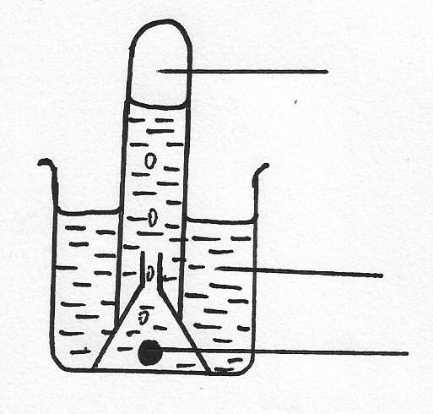2. The set-up below was used to prepare and collect gas L, produced by the reaction between water and calcium metal

**Gas K**

**Water**

**Piece of calcium**

(a) Name gas K (1mk)

…………………………………………………………………………………………………………

(b) At the end of the experiments, the solution in the beaker was found to have a PH of about 11, explain (2mks)

(c) Write a balanced chemical equation for the reaction that occurs (1mk)

…………………………………………………………………………………………………………

…………………………………………………………………………………………………………

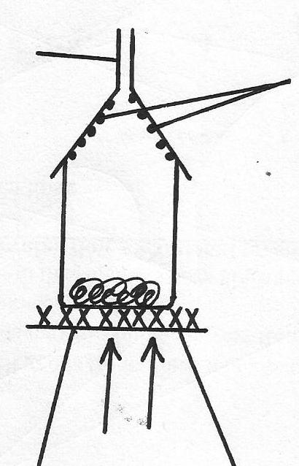3. The following set-up shows the heating of a mixture of equal amounts of sodium chloride and ammonium chloride

**Substance K**

**Glass funnel**

**Heat**

**Solid mixture of sodium chloride and ammonium chloride**

(a) What is substance K? (1mk)

…………………………………………………………………………………………………………

(b) What is the process by which substance K is formed? (1mk)

…………………………………………………………………………………………………………

4. Differentiate between the terms atomic number and mass number (2mks)

…………………………………………………………………………………………………………

…………………………………………………………………………………………………………

…………………………………………………………………………………………………………

5. Study the equilibrium between gases

E(g) F(g)

(i)Sketch a graph of the variation of the concentration of substance F with time, on the grid below

**Concentration**

**Time**

(ii) Explain the shape of the curve (2mks)

…………………………………………………………………………………………………………

…………………………………………………………………………………………………………

…………………………………………………………………………………………………………

6. Explain why very little carbon (IV) Oxide gas is evolved when dilute Sulphuric (VI) acid is added to Lead (II) carbonate (2mks)

…………………………………………………………………………………………………………

…………………………………………………………………………………………………………

7. A crystal of Copper (II) Sulphate was placed in a beaker of water. The beaker was left standing for two days without shaking. State and explain the observations that were made (2mks)

…………………………………………………………………………………………………………

…………………………………………………………………………………………………………

…………………………………………………………………………………………………………

8. Study the information in the table below and answer the questions that follows

|  |  |  |
| --- | --- | --- |
| Ions | Electron arrangement | Ionic radius |
| A+  B+  C2+ | 2.8  2.8.8  2.8 | 0.95  0.1333  0.065 |

Explain why the ionic radius of

(a) B+ is greater than A+ (1mk)

…………………………………………………………………………………………………………

…………………………………………………………………………………………………………

(b) C2+ is smaller than of A+ (2mks)

…………………………………………………………………………………………………………

…………………………………………………………………………………………………………

9. (a) State Graham’s law of diffusion (1mk)

…………………………………………………………………………………………………………

…………………………………………………………………………………………………………

(b) Gas D takes 110 seconds to diffuse through a porous partition. Gas D has a relative molecular mass of 34. How long will it take for the same amount of ammonia gas to diffuse under identical conditions? (H=1, N=14) (2mks)

10. When reacting sulphur (VI) Oxide and Hydrogen Sulphides some traces of water vapour is required for the reaction to occur.

(a) State the role of water vapour (1mk)

…………………………………………………………………………………………………………

…………………………………………………………………………………………………………

(b) Write an equation for the reaction that occurs (1mk)

…………………………………………………………………………………………………………

…………………………………………………………………………………………………………

(c) Identify the reducing agent in the reaction in (b) above (1mk)

…………………………………………………………………………………………………………

11. State and explain observation made when Conc. Sulphuric (VI) acid was added to sugar

crystals (2mks)

…………………………………………………………………………………………………………

…………………………………………………………………………………………………………

12. Name the class to which the following cleansing agents belongs

(i) R-COO-Na+ A ( ½ mk)

O

O-SO-3 Na+

(ii) R B ( ½ mk)

(iii) Which cleansing agent is suitable for use in hard water? ( ½ mk)

…………………………………………………………………………………………………………

(iv) Which cleansing agent above s not environmentally friendly? ( ½ mk)

…………………………………………………………………………………………………………

13. (i) Nitrogen (I) Oxide supports combustion of burning charcoal. Write an equation to show

this reaction (1mk)

…………………………………………………………………………………………………………

(ii) Ammonium nitrate can be heated to give off Nitrogen (I) oxide. However a mixture of

NH4Cl and NaNO3 is preferred. Explain (1mk)

…………………………………………………………………………………………………………

…………………………………………………………………………………………………………

(iii) State the physical test of Nitrogen (I) Oxide (1mk)

…………………………………………………………………………………………………………

…………………………………………………………………………………………………………

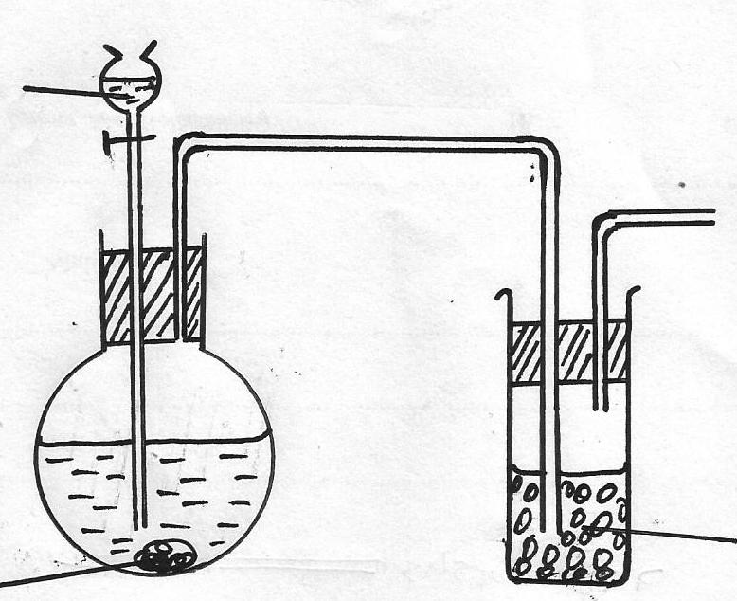14. The set-up below was used to prepare dry sample of hydrogen Sulphide gas

**Solid J**

**Solid H**

**Dil. Hydrochloric acid**

(a)(i) Complete the diagram to show how the gas was collected (2mks)

(ii) Identify the following

I: Solid H (1mk)

…………………………………………………………………………………………………………

II.Solid J (1mk)

…………………………………………………………………………………………………………

(b) Write an equation for the reaction that occurred in the flask between solid H and dilute hydrochloric acid (1mk)

…………………………………………………………………………………………………………

15. (a) Distinguish between nuclear fusion and fission (2mks)

…………………………………………………………………………………………………………

…………………………………………………………………………………………………………

(b) Complete the nuclear equation below

230

Th Pa + ____________

91

230

90

(c) Give one application of radioactivity in agriculture (1mk)

…………………………………………………………………………………………………………

…………………………………………………………………………………………………………

16. The formula given below represents a portion of a polymer

H

H

H

H

H

H

׀ ׀ ׀ ׀

C - C - C - C

׀ ׀ ׀ ׀





(a) Give the name of the Polymer (1mk)

…………………………………………………………………………………………………………

(b) Draw the structure of the monomer used to manufacture the Polymer (1mk)

17. Hydrogen chloride gas can be used to carry out fountain experiment. State the property of hydrogen chloride that make it suitable for this experiment (1mk)

…………………………………………………………………………………………………………

…………………………………………………………………………………………………………

18. 0.92g of ethanol were found to burn in excess air producing a temperature rise of 32.5oC in 200cm3 of water(C=12.0,H=1.0, O=16.0) Density of water is 1g/cm3, specific heat capacity of water is 42KjKg-1K-1

(a) Write the equation for the combustion of ethanol (1mk)

…………………………………………………………………………………………………………

…………………………………………………………………………………………………………

(b) Determine the molar heat of combustion of ethanol (2mks)

19. Iron is extracted from its ore by blast furnace form its ore by blast furnace process.

(a) Name one ore from which iron is extracted (1mk)

…………………………………………………………………………………………………………

(b) One of the impurities in iron is removed in the form of Calcium silicate. Write equations for the reaction in which calcium silicate is produced (2mks)

…………………………………………………………………………………………………………

…………………………………………………………………………………………………………

20. Calculate the amount of Zinc in grams that would remain if 1.96g of the metal were reacted with 100cm3 of 0.2M hydrochloric acid. (Zn=65.0, H=1.0, Cl=35.5) (3mks)

21. (a) Starting with solid Magnesium Oxide, describe how a solid sample of Magnesium hydroxide an be prepared (2mks)

…………………………………………………………………………………………………………

…………………………………………………………………………………………………………

(b) Give one use of Magnesium hydroxide (1mk)

…………………………………………………………………………………………………………

…………………………………………………………………………………………………………

22. An oxide of element F has the following F2O5. Determine the oxidation state of F in the compound (1mk)

…………………………………………………………………………………………………………

…………………………………………………………………………………………………………

23. A dynamie equilibrium is established when hydrogen and chlorine reacts as shown below

Cl2(g) + H2 2HCl(g)

(a) What is meant by the term dynamic equilibrium? (1mk)

…………………………………………………………………………………………………………

…………………………………………………………………………………………………………

(b) State and explain the effect of increasing pressure on the position of the equilibrium shown

in (a) above (2mks)

…………………………………………………………………………………………………………

…………………………………………………………………………………………………………

24. An element X has a relative atomic mass of 44. When a current of 0.5 A was passed through the molten chloride of X for 32 minutes and 10 seconds, 0.22g of X were deposited at the cathode

Determine the charge on an ion of X (1F=96,500c) (3mks)

25. (a) Differentiate between catalytic and thermal cracking of long chain organic compounds(2mks)

…………………………………………………………………………………………………………

…………………………………………………………………………………………………………

(b) State the disadvantage of C.F.C based compounds (1mk)

…………………………………………………………………………………………………………

26. The figure below shows a simple extraction process of Sulphur

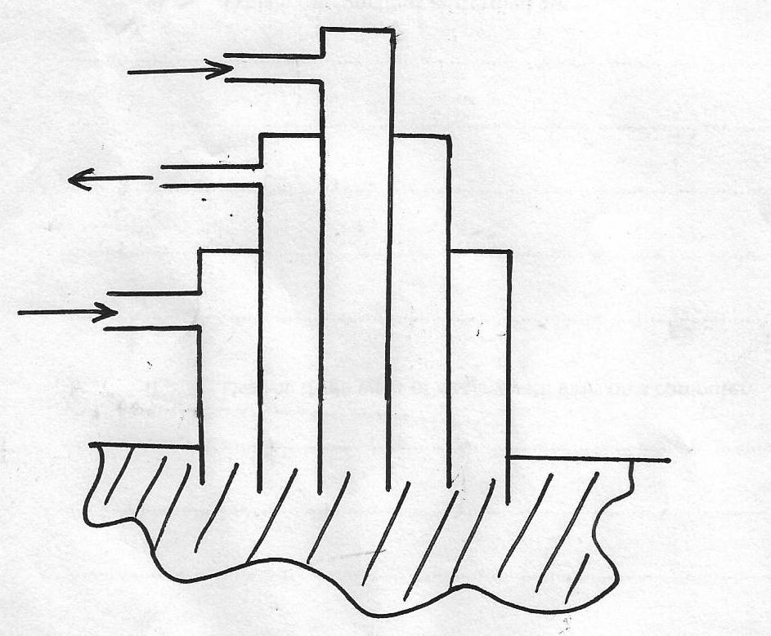

**Super heated hot water**

**N**

**M**

(a) Give the name of the process shown in the diagram above (1mk)

…………………………………………………………………………………………………………

(b) What is the use of the superheated hot water? (1mk)

…………………………………………………………………………………………………………

…………………………………………………………………………………………………………

(c) State two physical properties of Sulphur that make it possible to be extracted using water(2mks)

…………………………………………………………………………………………………………

…………………………………………………………………………………………………………

27. (a) Define molar latent heat of vaporization of a substance (1mk)

…………………………………………………………………………………………………………

…………………………………………………………………………………………………………

(b) The Molar latent heat of vaporization of water at 100oC is 41.1kJ/mol. Calculate the heat

change when 1.0g of water at 100oC is converted into vapour at 100oC (H=1, O=16) (2mks)

28. Metals **Q** and **T** had their half-cells connected to a Zinc half-cell and the following reduction potentials were obtained fro each metal

|  |  |
| --- | --- |
| Metal half-cell | Reduction potential (volts) |
| Q2+(aq) Q (s)  T+(aq)/T(s) | -1.37v  -0.83v |

(a) What name is given to the Zinc half-cell in this circumstances, and state its reduction

Potential (1mk)

…………………………………………………………………………………………………………

…………………………………………………………………………………………………………

(b) Metals Q and T were connected to form an electrochemical full cell

(i) Write the equations for the half-cell reactions that occur at the Q and T electrodes (1mk)

…………………………………………………………………………………………………………

I. At electrode Q:

…………………………………………………………………………………………………………

II. At electrode T:

…………………………………………………………………………………………………………

(ii) Calculate the e.m.f of the electrochemical full cell in b(i) above (1mk)