Name…………………………………… …………………………..………… Index No:………………………….

233/1 Candidate’s Signature …………..……………
CHEMISTRY Date: …………………………
PAPER 1
THEORY
JULY/AUGUST 2014
TIME: 2 HOURS

Kenya Certificate of Secondary Education (K.C.S.E.)
233/1
Chemistry
Paper 1
2 Hours

INSTRUCTIONS TO CANDIDATES

- Write your name and index number in the spaces provided above
- Sign and write the date of examination in the spaces provided.
- Answer all the questions in the spaces provided.
- Mathematical table and silent electronic calculators may be used.
- All working must be clearly shown where necessary.

FOR EXAMINERS USE ONLY
Question | Maximum score | Candidate’s score
1-29 | 80

This paper consists of 11printed pages. Candidates should check to ascertain that all pages are printed as indicated and that no questions are missing.
- Atoms of element X exists as and .
- What name is given to the types of atoms. (1mk)
………………………………………………………………………………………………….
………………………………………………………………………………………………….
- Draw a diagram to illustrate the atomic structure of x. (1mk)

- Write the formula of the oxide of x .(Atomic number of O = 8) (1mk)
………………………………………………………………………………………………….
………………………………………………………………………………………………….
- Describe how you would prepare a dry sample of lead (II) chloride with lead (II) carbonate. (3mks)
………………………………………………………………………………………………….
………………………………………………………………………………………………….
………………………………………………………………………………………………….
- What volume of 0.5M hydrochloric acid solution will neutralize 20cm³ solution of sodium carbonate containing 5.3 of anhydrous sodium carbonate per litre of solution .
(Na = 23.0 C = 12.0 O = 16.0 H = 1.0 Cl = 35.5) (3mks)

- Study the equilibrium between gases C and D below:
C_{(g)} D_{(g)}

- Sketch the graph of the variation of the concentration of gas D with time. (2mks)

- Explain the shape of the curve you have drawn in 4 (a) above. (1mk)
………………………………………………………………………………………………….
………………………………………………………………………………………………….
- Give two reasons why dry ice (solid carbon (IV) oxide) is preferred in the preservation of perishable foodstuffs. (2mks)
………………………………………………………………………………………………….
………………………………………………………………………………………………….
- When 20.3g of a hydrated salt ( Y.6H₂O) was heated to dryness,9.5 g of the anhydrous salt was obtained. Determine the relative formula mass of the hydrated salt. (H = 1.0 O = 16.0) (3mks)

- Study the set up below and answer the questions that follow.
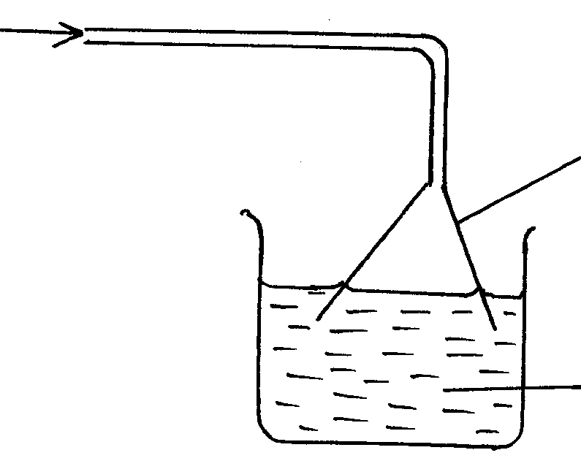
Hydrogen chloride gas

Inverted funnel

Lead (II) nitrate solution

- Why is the gas dissolved using an inverted funnel? (1mk)
………………………………………………………………………………………………….
………………………………………………………………………………………………….
- State and explain the observations that would be made in the beaker. (2mks)
………………………………………………………………………………………………….
………………………………………………………………………………………………….
- The information in the table below relates to the element in the same group of the periodic table Study it and answer the questions that follow.

Element | A | B | C
Atomic radius | 0.18 | 0.23 | 0.15

Which element has the highest ionization energy? Explain (2mks)
………………………………………………………………………………………………….
………………………………………………………………………………………………….

- The diagram below shows part of the structure of a polymer.

H H H H H H
| | | | | |
C C C C C C
| | | | | |
H H H H H H n

- Write the formula of the monomer. (1mk)
………………………………………………………………………………………………….
………………………………………………………………………………………………….
- If a sample of the polymer has a mass of 28125g, estimate the number of molecules of the monomer in it. (C=12.0 H = 1.0 Cl = 35.3) (2mks)

- A solid mixture consists of substances U and V, whose solubility at 25ºC and 60ºC are shown in the table below.

Substance | Solubility at (g/100g of water)
 | 25oC | 60oC
U | 70.00 | 0.02
V | 63.00 | 82.00

Describe how you would separate U and V. (3mks)
………………………………………………………………………………………………….
………………………………………………………………………………………………….
………………………………………………………………………………………………….
- Hydrogen sulphide gas is bubbled into two solutions of metallic nitrate as represented in the flow chart below:

Black solid W
Blue
solution

Hydrogen Sulphide

Green solution Q
Brown
solution

- Identify the cation present in:
(i) Blue solution (1mk)
………………………………………………………………………………………………….
(ii) Brown solution (1mk)
………………………………………………………………………………………………….
- Write an ionic equation for the formation of green solution Q. (1mk)
………………………………………………………………………………………………….
12 (a) Using dots (●) and cross (x) shows the bonding in hydroxonium ion (H₃O⁺)
(Atomic numbers H = 1 O = 8) (2mks)

- Chlorine has a very low melting and boiling points yet the atoms are joined by strong covalent bond. Explain. (1mk)

………………………………………………………………………………………………….
- The table below gives the melting points of oxides of elements in period 3. Study it and answer the questions that follow.

Formula of oxide | Na₂O | MgO | Al₂O₃ | SiO₂ | P₄O₁₀ | SO₃
Melting point (ºc) | 1190 | 3080 | 2050 | 1730 | 560 | -73

- Identify the compound in the above table that will dissolve in dilute hydrochloric acid and dilute sodium hydroxide. (1mk)
………………………………………………………………………………………………….
- Explain the difference in melting points of MgO and P₄O₁₀ (2mks)
………………………………………………………………………………………………….
………………………………………………………………………………………………….
14 (a) Complete the following equations by showing the value of x and y (1mk)
+ +
………………………………………………………………………………………………….
- Copper – 64 has half –life of 12.8days. What mass of copper – 64 will remain after 51.2 days starting with 20g of the isotope? (2mks)

- Study the diagram below and answer the questions that follow:
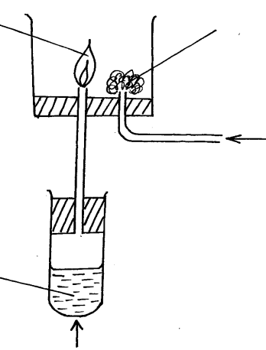
Flame
Gentle heat
Oxygen gas
Glass wool

Aqueous
ammonia

- Why is aqueous ammonia warmed gently ? (1mk)
………………………………………………………………………………………………….
- What is the colour of the flame? (1mk)
………………………………………………………………………………………………….
- Write an equation for the reaction that produces the flame. (1mk)
………………………………………………………………………………………………….
- Use the information be low to answer the questions that follow:
Q²⁺_{(aq)} / Q_{(s)} E^{θ} = - 0.76V
R²⁺_{(aq)} / R_{(s)} E^{θ} = + 0.34V

- Write the cell equation for the cell. (1mk)
………………………………………………………………………………………………….
- Calculate the E^{θ} value for the cell reaction. (2mks)
………………………………………………………………………………………………….
………………………………………………………………………………………………….
- Given the following information about aqueous solutions of y and x

Aqueous solution | pH | Electrical conductivity
x | 6 | 1.3
y | 2 | 2.8

Explain why y has a higher electrical conductivity than x. (2mks)
………………………………………………………………………………………………….
………………………………………………………………………………………………….
- Study the flow chart below and answer the questions that follow:
ZnS
Zn
ZnO
ZnSO₄ + water
Hot concentrated sulphuric (VI) acid
Step 3
Step 2
Step 1
Heat
O_{2 (g)}
Gas
Gas
Coke
Gas D

- State the condition necessary for the reaction in step 2 to occur (1mk)
………………………………………………………………………………………………….
………………………………………………………………………………………………….
- Name:
- (i) Gas D …………………………………………………………………. (1mk)
(ii) One use of zinc …………………………………………………….. (1mk)

- Calcium carbonate decomposes on heating producing a gaseous product and a residue. What volume of gaseous product at s.t.p is produced from 2.5 g of the carbonate . ( Ca = 40.0 C = 12.0 O = 16.0, molar gas volume at s.t.p = 22400cm³) (2mks)

- Study the scheme below and answer the questions that follow.
Solid R
No white precipitate
White precipitate insoluble in excess
White precipitate soluble in excess
Colourless solution Q
Solid S
water
Excess
NaOH_{(aq)}

Acidified
Ba(NO₃)_{2(aq)}

Dilute HCl_{(aq)}

Excess
NH_{3(aq)}

- Identify solution Q and solid R
- Solution Q …………………………………………………….... (1mk)
- Solid R …………………………………………………………… (1mk)
- Write an ionic equation for the reaction between solution Q and excess aqueous ammonia. (1mk)
………………………………………………………………………………………………….
- Name the process which takes place when:
- Iodine changes directly form solid to gas. (1mk)
………………………………………………………………………………………………….
- Fe²⁺ _{(aq)} changes to Fe³⁺_{(aq)} (1mk)
………………………………………………………………………………………………….
- White sugar changes to black solid when mixed with excess concentrated sulphuric (VI) acid. (1mk)
………………………………………………………………………………………………….
- The equations below shows the molar enthalpies of combustion of carbon, hydrogen and methane.

C _{(s)} + O_{2 (g)} CO_{2(g)} ΔHc = - 393.5 KJmole ⁻¹
H₂ + ½ O_{2 (g)} H₂O(_{l)} ΔHc = - 393.5 KJmole ⁻¹
CH_{4(g)} + O_{2(g)} CO_{2(g)} + H₂O_{(g)} ΔHc = - 393.5 KJmole ⁻¹
Use an energy cycle diagram to calculate the heat of formation of methane. (3mks)

- In an experiment, soap solution was added to three separate sample of water. The table below shows the volumes of soap solution required to from lather, with 100cm³ of each sample of water before and after boiling.

 | Sample I | Sample II | Sample III
Volume of soap before water is boiled (cm³) | 27.0 | 3.0 | 10.6
Volume of soap after water is boiled(cm³) | 27.0 | 3.0 | 3.0

- Which water is likely to be soft water? Explain (2mks)
………………………………………………………………………………………………….
………………………………………………………………………………………………….
- Explain the change in the volume of soap solution used in sample III (1mk)
………………………………………………………………………………………………….
- 60cm³ of sulphur (IV) oxide diffuses through a porous pot in 4seconds. How long would it take 100cm³ of oxygen gas to diffuse through the same pot under the same conditions? ( S = 32.0 O = 16.0) (3mks)

- Study the diagram below and answer the questions that follow:

Bleaching powder
Z
Chlorine

- Name substance Z (1mk)
………………………………………………………………………………………………….
- Write an equation for the reaction between substance Z and chlorine gas. (1mk)
………………………………………………………………………………………………….
- Ethene and ethyne are unsaturated hydrocarbons.
- Explain what is meant by unstauration in hydrocarbons (1mk)
………………………………………………………………………………………………….
- Explain how you would distinguish between ethyne and ethane. (2mks)
………………………………………………………………………………………………….
- Nitrogen (IV) oxide gas can be obtained by thermal decomposition of lead (II) nitrate crystals.
- Write an equation for the thermal decomposition of lead (II) nitrate crystals. (1mk )
………………………………………………………………………………………………….
- Explain how nitrogen (IV) oxide can be separated from the mixture of gases liberated. (2mks)
………………………………………………………………………………………………….
………………………………………………………………………………………………….
- (a) Name two allotropes of carbon. (1mk)
………………………………………………………………………………………………….
………………………………………………………………………………………………….

- Give two reasons why carbon (IV) oxide can be used to extinguish fires. (2mks)
………………………………………………………………………………………………….
………………………………………………………………………………………………….
- Name the apparatus below. (1mk)





