**NYATIKE SUB-COUNTY JOINT EVALUATION EXAMS**

**CHEMISTRY 233/3**

**JULY/AUGUST 2014**

**MARKING SCHEME**

1.Table 1

*CT-1*

*D-1*

*AC-1*

*P.A=1*

*F.A=1*

*=5mks*

|  |  |  |  |
| --- | --- | --- | --- |
|  | I | II | III |
| Final burette reading (cm3) | 37.8 | 37.9 | 38.0 |
| Initial burette reading (cm3) | 0.0 | 0.0 | 0.0 |
| Volume of solution B (cm3) | 37.8 | 37.9 | 38.5 |

Find the average volume of √ ½



√ ½

1. (b) (i) 8.8 √ ½ =0.22M√ ½

40

(ii) Moles of B used

 *correct answers*

Mole ratio 1:1 √ ½

Moles of A =correct answer above

Table II

*CT-1*

*D-1*

*AC-1*

*P.A=1*

*F.A=1*

*=5mks*

|  |  |  |  |
| --- | --- | --- | --- |
|  | I | II | III |
| Final burette reading (cm3) | 11.6 | 11.7 | 11.8 |
| Initial burette reading (cm3) | 0.0 | 0.0 | 0.0 |
| Volume of solution B (cm3) | 11.6 | 11.7 | 11.8 |

1. 

(b) (i) Moles of B used

Answer in (a) x 0.22 =correct answer

1000

Mole ratio 1:1√ ½

Moles of D= correct answer above

(ii) answer in b(i) x 250

25

Correct ans √ ½ or

Answer in b(i) x 10√ ½

Correct asn √ ½

(iii) Answer in b(ii) procedure I x 100√ ½

100

Correct answer √ ½ or

Answer in b(i) procedure I

10

Correct ans √ ½

(iv) Answer in b(iii) above –asnwer in b(ii) √ ½

Correct answer √ ½ I

(v) CO32- : H+

1 : 2√ ½

Answer in (iv) above I

2

(c) (i)Answer in (v) above x 106√ ½

Correct ans √ ½

(ii) Answer in c(i) above x 100√ ½

0.5

Correct answer √ 1.2

2.

|  |  |  |
| --- | --- | --- |
| Volume of water in boiling tube (cm3) | Temperature in oC at which crystals first appear | Solubility of solid Q in g/100g of water |
| 5  8  11  14  17 | 70  56  49  40  36 | 80.0  50.0  36.4  28.6  23.5 |

(b)(i) 61.5oC

(ii) 57-29=28g

28 x100

57

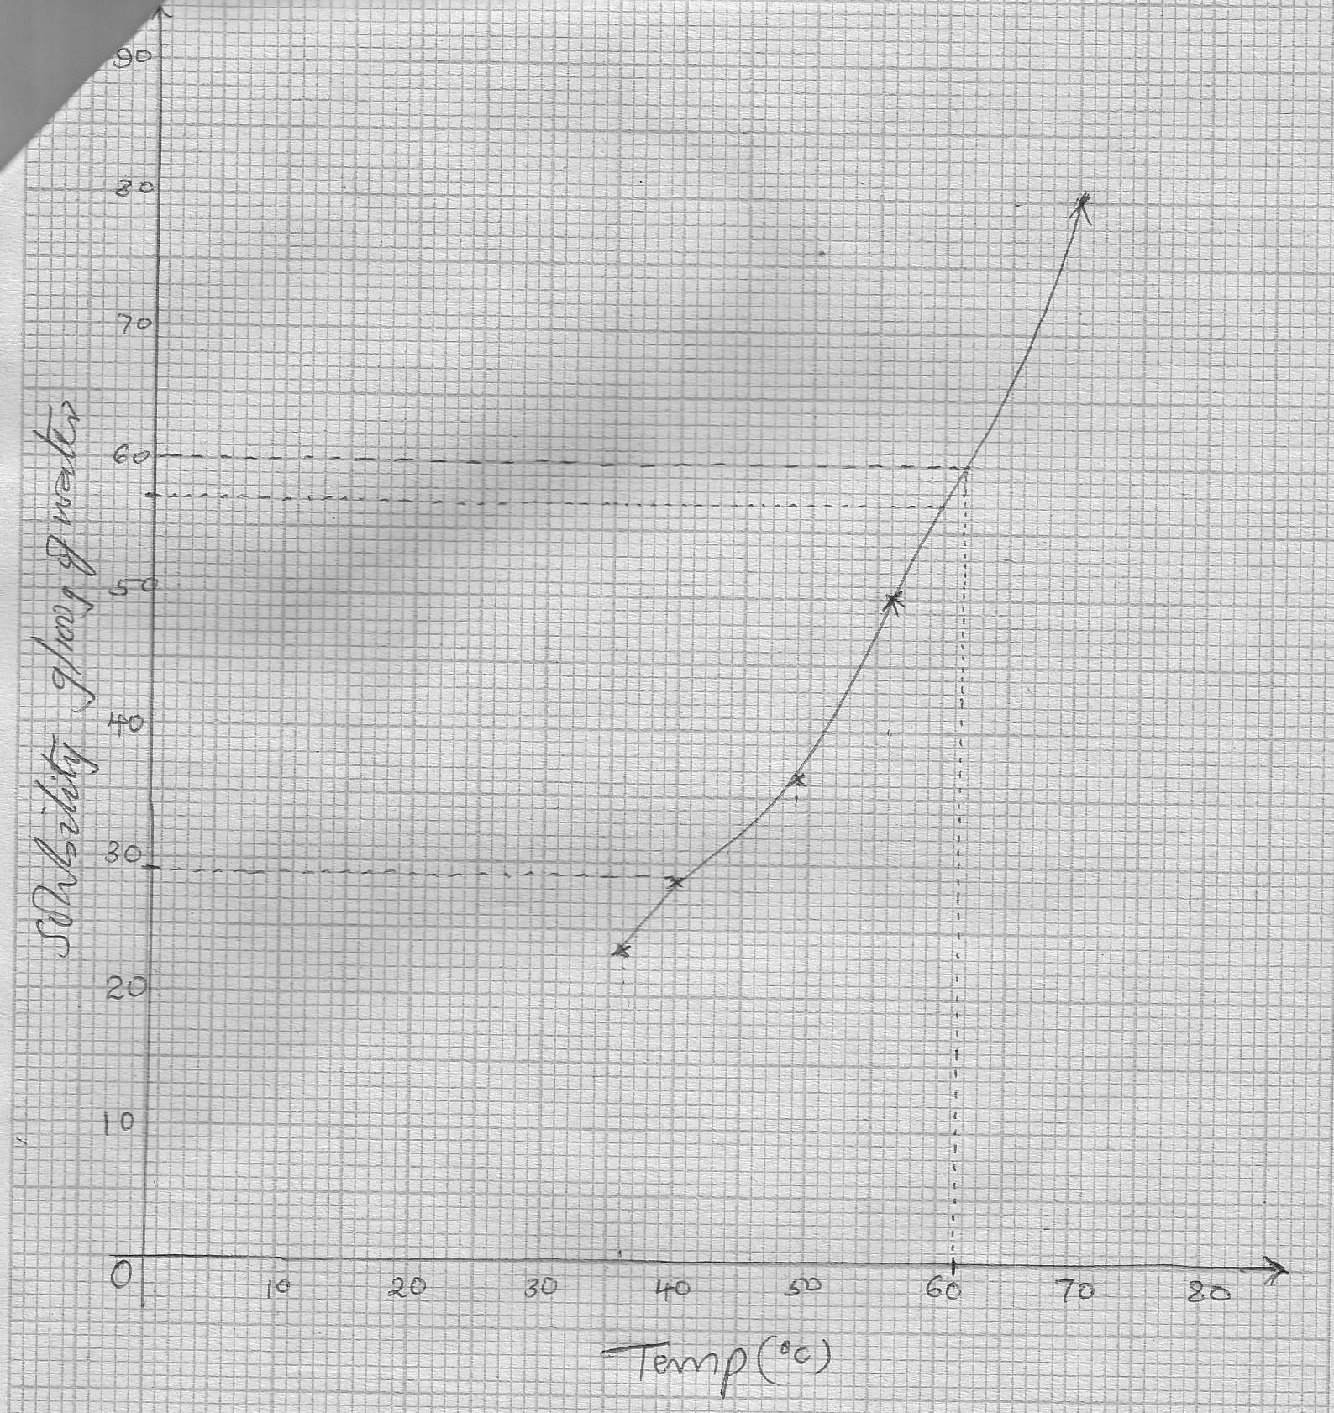

|  |  |
| --- | --- |
| Observations  White solid dissolves to form a colourless filtrate and white residue √ ½  (1mk) | Inferences  Sparingly soluble compound √  (1mk) |

3.

|  |  |
| --- | --- |
| Observations  Orange K2Cr2O7/H+ turns green  (1mk) | Inferences  C = C , -C = C - √ ½  (1mk) |

(ii)

(iii)

|  |  |
| --- | --- |
| Observations  Effervescence √ ½ of colourless gas √ ½  (1mk) | Inferences  O   * C – OH √1   (1mk) |

(b)(i)

|  |  |
| --- | --- |
| Observations  Effervescence √ ½  No white ppt√ ½  (1mk) | Inferences  CO32-√ ½  Pb2+,Ag+ absent √ ½  (1mk) |

(ii)

|  |  |
| --- | --- |
| Observations  White ppt soluble √1  (1mk) | Inferences  Zn2+ √1  (1mk) |