CHEM PP1 MARKING SCHEME 2019 TERM 2

1.(a) This is the energy required to remove the 1st outermost electron from an atom in gaseous state to form an ion √ 1
(b) C A B D √ 1
Increasing reactivity
Higher ionization energy implies high nuclear charge which hinders removal of electron.
2 i)Add excess methylbenzene to the mixture in a beaker (1 mk) and stir (½ mk). Filter (1 mk) to obtain sulpur as a residue (½ mk).
ii)Heterogeneous (1 mk). Its components can be recognized by the naked eye or through magnifying glass (1mk)

3. (a) Pt or copper
(b) No formed is oxidized by O₂ to NO₂ which is brown
(c) The reaction is exothermic

4.a)Energy change that occurs when one mole of gaseous ions become hydrated//form weak
bonds with water molecules (1mk)

b)∆H_{soln}= Lattice energy + Hydration energy (1mk)
=+2237+(-1891)+2(-384) (1 mk)
= -422 kJ mol⁻¹ (1 mk)

5. 2KOH_{(aq)} + H₂SO_{4(aq)} → K₂SO_{4(aq)} + 2H₂O_{(l)}
36cm³ 0.5M 25cm³
Moles of H₂SO₄ = 0.5 x 25 = 0.0125moles
1000
Moles of KOH = 2 x 0.0125 = 0.025
Molarity of KOH = 0.025 x 1000 = 0.6944
36
≈ 0.7
Concentration in g/dm³ = 38.9g

6.a)

H H H H H H H
C ═ C─ C─ C H H C ─ C ═ C ─ C H
H H H H H H
(1mk) (1mk)
b) Presence of ultraviolet radiation//sunlight (1mk)
c). Substitution

7. (a) Test tube 1 – there is effervescence / bubbles/dissolved.
Test tube 2 – No effervescence / no reaction/ dissolved
(b) Ethanoic acid ionizes in water to release H⁺ ions which react with CO₃²⁻ to form CO₂

8. | (a) Water which contains Ca^{2+/}Mg²⁺ions√ (1mk)  (b) – Addition of a few drops of hydrochloric acid √ (½mk)  - Gas bubbles/effervescence √ (½mk)  (c) – Brewing industries √ (1mk)  √ (1mk)  - Tie dye, textile industries  - processing of mineral water |  | 1  ½  ½  1 |  | Accept any 2 correct answers
9 |  | (a)  - Gas C is denser than air √ (1mk)  (b) – Nitrogen (IV) oxide  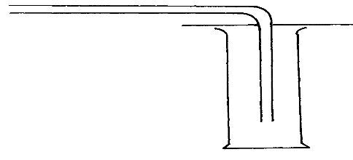  - Dinitrogen tetraoxide  Air  Gas C in  - Sulphur (IV) oxide  Gas C  - Sulphur (VI) oxide  √ (½mk)  √ (½mk)  - Carbon (IV) oxide  - Chlorine gas  - Hydrogen chloride |  | 2  1 |  | Accept any two correct answers
 |  |  |  | 3
10 |  | (i) O_{2(g)} + 2Mg_{(s)} 2MgO_{(s)} √ (1mk)  (ii) CO_{2(g)} C_{(s)} + O_{2(g)} √ (1mk) |  | 1  1

11.a,
-Q and U,they are isotopes
b, 7-3= 4 1

12. Condensation polymerization 1; Reject condensational

13 | (a) P₁V₁ = P₂V₂; P₁ = 750 V₁ = 250, T₁ = 27 + 273 = 300k  T₁ T₂  P₂ = 750, T₂ = 41 + 273 = 311k  V₂ = P₁V₁T₂ = 750 x 250 x 311 √ (1mk) = 311x 5  T₁ x P₂ 300 x 750 6  = 259.167cm³√ (1mk)  (b) The volume of a given mas of a gas at constant temeprature is inversely proportional to its pressure√ (1mk) | 1  1  1

14.a)H₂NCH₂COOH + H₂NCHCH₃COOH ﴾ HNCH₂CONHCHCH₃CO﴿ + 2H₂O
b)Condensation polymerization 1; Reject condensational

15 | - H₂S_{(g)} + 2FeCl_{3(aq)} 3FeCl_{2(aq)} + S_{(s)} + 2H⁺_{(aq)}  - -Pass excess gas, H₂S through ecess concentrated sulphuric acid √ (½mk) to absorb H₂S gas.  or 3H₂S_{(s)} + H₂SO_{4(l)} 4S_{(s)} + 4H₂O_{(l)}  - Hydrogen sulphide gas is poisonous √ (½mk)  (c) - Pass H₂S through Lead (II) nitrate solution √ (½mk)  - A black shinny solid precipitate is formed √ (½mk) | 1  ½  ½  1
- 16.iThe method of collection is wrong ( ½ mark)
- The gas is less dense than air (½mark) hence can’t be collected by downward delivery.
Ii, Concentrated sulphuric (VI) acid ( 1mark)
iii- It’s colourless ½mark
Odourless ½ mark
- Less dense than air.
Any two for (½ mark) each

17. H

3 (H – H) + 2 ( C – C ) H – C – C – H 6 ( C – H )

H H

6 ( C – H) - { 3( H – H ) + 2 (C – C }

= (6 x 414 √ ½ ) – { (3 x 435 √ ½ ) + (2 x 343 √ ½ ) }
= -957 kJ √ ½
Attempt to subtract √ ½
18. (a) Ammonia dissolves √ ½ in water to form ammonia solution which is basic √ ½
(b) Increase surface area to avoid sucking back of the gas. √1
19. | - Mix With Cold Water, Sodium Carbonate Dissolves√ (½mk)  - Filter off Lead (II) Chloride And Calcium sulphate as residue √ (½mk)  - Evaporate to obtain sodium chloride  - Mix the residue with hot water to dissolve Lead (II) chloride√ (½mk)  - Filter off Calcium sulphate as a residue dry over dessicator  - Cool the filtrate to precipitate Lead (II) chloride √ (½mk)  - Filter off residue as Lead (II chloride and dry √ (½mk) | ½  ½  ½  ½  ½  ½
_{20)a) manganese (iv )oxide}
b) to prevent collection of air previously in the apparatus.

22. (i) A – soapy detergent B – soapless detergent
(ii) - Non-biodegradable
- Nuisance as form formed on water bodies is not present.

They are unreactive. 1mk
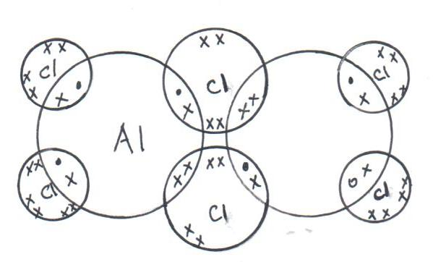
23a)

•

•

•

•

•

•

•

•

b)
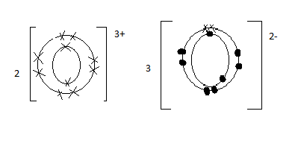

24.a) An apparent change an element has in an ion or a compound.
b)i) MnO₂ Mn= +4
ii) CrO-₄ Cr= +7
25. a)Chlorine water changes colour from yellow to colourless 1 mk
-Chlorine water decomposes to form hydrochloric acid and oxygen 1 mk
b) 2HOCl_{(aq)} 2HCl_{(aq)} + O_{2(g)} 1 mk
c)-Bleaching agent -Treatment of water 1 mk

