WEITHAGA ZONE JOINT EXAM 2019
CHEM PP2 MARKING SCHEME

1. (a) X - Sodium ethonoate 1
Q - Sodium ethoxide 1
R - Iodoethane 1

b) ${CH}_{3}{COONa}_{\left(s\right)}+ {NaOH}_{(aq)} {CH}_{4(g)} + {Na}_{2}{CO}_{3(s)}$

(c)
- I (2 marks)
Reagent - Propan-l-ol 1
Condition - Conc. H₂SO₄ 1

- IV (2 marks)
Reagent - Conc. H₂SO₄ 1
Condition - Temp 160 – 180⁰C 1
(d)
I - Esterification
II - Substitution
IV - Oxidation
V - Dehydration

2.(i) Noble gases √1
(ii) D₂SO₄ √1
(iii) (a) Y √1
(b) E √1
(iv) Ionic bond √1 – Because B reacts by losing an electron (s) which are gained by H. √1
(v) D//M √1 Any one, one mark
(vi) Because E reacts by gaining an extra electron which reduces √1 the electrostatic
pull by the positive nucleus making the ionic radius increase. wtte
(vii) At Period III Group IV
(viii) Because of the increase in the strength of the molecular bonds in the oxide of L as
compared to that of G. √1 w.t.t.e
(ix) C has a smaller atomic √1 radius than I because of the increase in the strength of the
nucleus on the valency electrons in C as the number of protons increase √1 w.t.t.e
(x) 1st ionization energies increases from J – L across the period due to addition of an
extra proton in the nucleus increasing the attraction of the valency electrons √
3.a)i
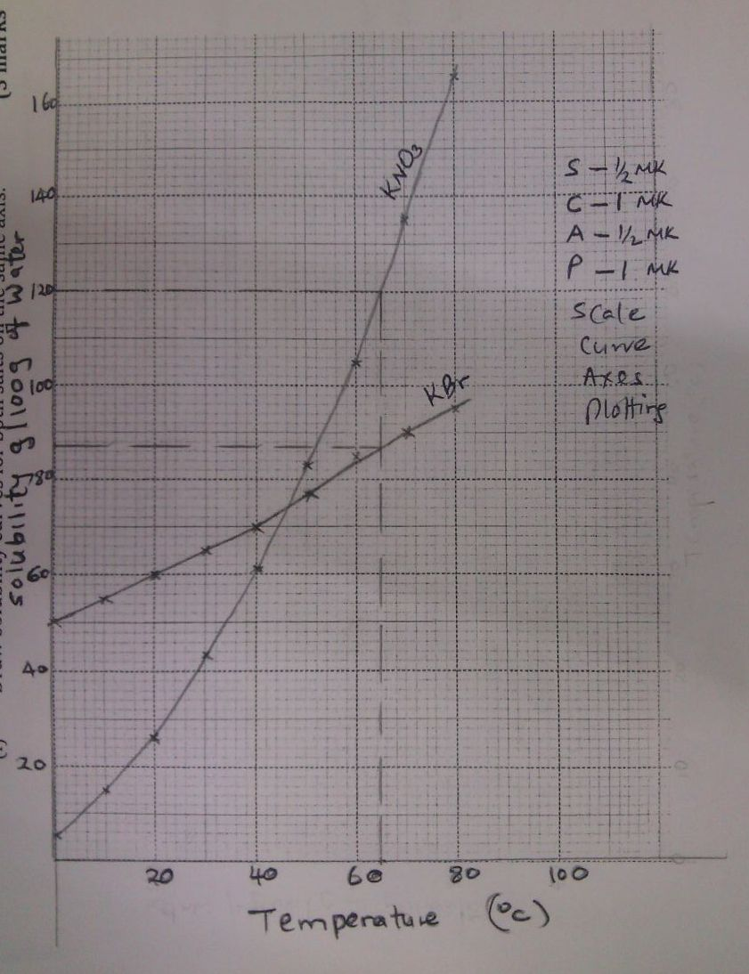

(ii) What was the solubility of each salt at 65⁰C? (1 mark)

${KNO}_{3}- 120g/100g$ of water $± 1$ ½

KBr $-$ 87g/100g of water $±$ 1 ½

(iii) 100g of a saturated solution of potassium nitrate at 70⁰C was cooled to 20⁰C. What mass of the crystals will be crystallized? (2 marks)

At 70⁰C solubility = 135g/100g of water
If 235g contain 135g of salt
100g contain 135g
$\frac{100 ×135}{235}=57.4468g$ ½

At 20⁰C solubility = 26g/100g of water
If 126g contain 26g of salt
100g contain ?
$\frac{100 ×26}{126}=20.6349g$ ½
Mass which will crystallized
57.4468 – 20.6349
= 36.8119g

b i)${CuCO}_{3(s)} heat {CuO}_{(s)} + {CO}_{2(g)}$

ii)Solution C - Copper (II) chloride (1 mark)
Solid D - Copper (II) hydroxide (1 mark)

(c)
2+

${{Cu (NH}_{3})}_{4}$

4
i)To displace air in flask H over the hot copper turnings.
(1 mark)
ii) The brown solid changes to black
(1 mark)
Iii )Nitrogen, carbon (IV) oxide, argon, (Xeron, neon) (Any one)
(1 mark)

Iv )410cm³

1
v) $\frac{\left(500 ×410\right)}{500}×100= \frac{90 ×100}{500}=18\%$1

B.
a) Black CuO turns to red-brown Cu.

(b) ${2H}_{2(g)} + O_{2(g )}{2H}_{2}O_{(l)}$

(c) To determine the reducing property of hydrogen. 1Hydrogen is above Cu 1 in the reactivityseries, thus it reduces the oxygen from CuO.
5A. a) A , The energy of the product is less than the energy of the reactant.
b) B, The enrgy of the product is greater than the energy of the reactant.

5B(a) The blue colour of solution fades /changes from blue to colourless Brown solid deposited√ ½
(b) i) No. of moles that reacted Zn = 65
0.65 √ ½ = 0.01moles √ ½
65

(ii) The no. of moles that was displaced from the solution (Cu =64)
0.64 √ ½ = 0.01moles√ ½
64

(iii) The mole ratio of Zn: Cu
0.01: 0.01
1:1

(c) Cu²⁺_{(aq)} + Zn_{(s)} Cu_{(s)} + Zn²⁺_{(aq)} or CuSO_{4(aq)} + Zn_{(s)} Cu_{(s)} + ZnSO_{4(aq)}

(d) (i) Enthalpy change that occurs when one mole of a substance is displaced from a solution of its ions √ 1
(ii) 1mole = 205.8Kj
0.01 moles = 205.8 x 0.01√ ½
= 2.059kJ √ ½
Mass of solution = 20cm³ x 1g/cm³
= 20g √ ½

H = mcΔθ
Δθ = mcΔθ
Δθ = H = 2.05kJ √ 1
20g x 4.2Jg⁻¹k⁻¹
Δθ = 24.5k √ ½

6.a) Reaction in which the electrons are lost and gained
b)i) Zinc /Zn
ii), Zn²⁺ + 2e Zn and Pb2+2e Pb
iii),Zn/Zn²⁺ //Pb²⁺ /Pb.

7. (a) Identify substances. (3 marks)
A - Hydrogen
B - Nitrogen
D - NO

(b) Step I - Iron finely divided / iron
Step II - Platinum – rhodium catalyst

(c) 4NH₍₃₎ + SO₂ 2NO_{(g)} + 6H₂O
(d)(i) Hot and concentrated sodium hydroxide. (1 mark)
6NaOH_{(aq)} + 3Cl_{2(g)}NaClO_{3(aq)} + 5NaCl_{(aq)} + H₂O_{(l)}
(ii) Dilute and cold sodium hydroxide. (1 mark)
2NaOH_{(aq)} + Cl₂ NaOCl + NaCl + H₂O
II.

- Liquid P - dinitrogen tetra oxide
- Gas Y - oxygen

$2Pb{\left({NO}_{3}\right)}_{2} {2PbO}_{(s)} +{ 4NO}_{2(s)} + O_{2(g)}$

- Nitrogen (V) oxide relights a glowing splint while nitrogen (II) oxide does not.
- N₂O has xtic sweet smell, while. NO₂ is odourless.

8. . (a) (i)CuFeS₂;
(ii) Copper (I) Sulphide;
(iii) 3Cu₂S + 4O₂ 2Cu_{(s)} + 2Cu₂O + 3SO_{2(g)}

(iv) SiO₂; FeO_{(l)} + SiO_{2(s)} FeSiO₃

(v) To reduce Copper (I) Oxide

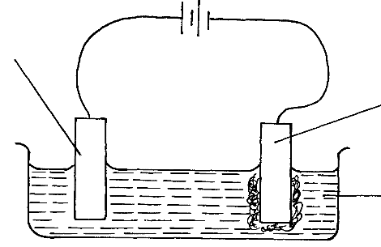
b)
Pure copper
Bristen copper
Copper (II) sulphate solution
+
-

