Name: …………………………………………………………………………….. Class: ………… Adm.No……………..
School: …………………………………………………………………………… Date: ………………………………………
233/2
CHEMISTRY
Paper 2
July 2019
Time: 2 hours

WEITHAGA J O I N T E X A M I N A T I O N - 2019
Kenya Certificate to Secondary Education
CHEMISTRY PAPER 2
TIME: 2 HOURS

INSTRUCTIONS TO CANDIDATES
- Write your name, admission number, date and school in the spaces provided.
- Answer all the questions in the spaces provided.
- All working must be clearly shown where necessary.
- Scientific calculators may be used.

1. Study the flow chart below and answer the questions that follow.
II
III
NaOH
Heat

Na₂CO₃
W
NaOH

I

NaOH
IV
Na
Q

V
Z
X

HI
R

VI

H H

C C

H H

Y

n

(a) Name substance. (3 marks) X -
Q -
R -
(b)Write down an equation for the reaction represented by step III(1 mk)

(c)What are the conditions and reagent required for steps?

- I (2 marks)
Reagent -
Condition - .

- IV (2 marks)
Reagent -
Condition -
(b) Name the process represented by: (4 marks)
I -
II -
IV -
V -

2..The grid given below represents part of the periodic table. Study it and answer the questions that follow. The letters are not the actual symbols of the elements.

 |  |  |  |  |  |  |  | A
B |  |  |  | G |  | H | E
 | J |  | I | L |  |  |  | C
D |  |  |  |  |  |  | M
Y
(i) What name is given to the family of elements to which A and C belong? ( 1 mark )

(ii) Write the chemical formula of the sulphate of element D. ( 1 mark )

(iii ) Which letter represents the most reactive ( 2 marks )

- Metal

- Non-metal

(iv) Name the bond formed when B and H react. Explain your answer. ( 2 marks )

(v) Select one element that belong to period 4. ( 1 mark )

(vi) Ionic radius of element E is bigger than the atomic radius. Explain.

( 2 marks )

(vii) The electron configuration of a divalent anion of element N is 2.8.8. Induce the
position of element N on the periodic table drawn above. ( 1 mark )

(viii) The oxide of G has a lower melting point than the oxide of L. Explain. ( 1 mark )

(ix) How do the atomic radii of I and C compare. Explain. ( 2 marks )

(x)Explain the trend in the 1st ionization energies of the elements J, I and L.(1mark )

3.(a)The solubilities of potassium nitrate and potassium bromide at different temperatures was determined. The following data was obtained.

Temperature ⁰C |  | 0 | 10 | 20 | 30 | 40 | 50 | 60 | 70 | 80
Solubility g/100g H₂O | KNO₃ | 5 | 15 | 26 | 43 | 61 | 83 | 105 | 135 | 165
 | KB_{r} | 50 | 55 | 60 | 65 | 70 | 77 | 85 | 90 | 95

(i) Draw solubility curves for both salts on the same axis.(3 marks)

(ii) What was the solubility of each salt at 65⁰C? (1 mark)

(iii) 100g of a saturated solution of potassium nitrate at 70⁰C was cooled to 20⁰C. What mass of the crystals will be crystallized? (2 marks)

(b) Study the flow chart below and answer the questions that follow.

Solution
C
Dil. HCl
Solid A
+
Gas B
Heat
Metal carbonate

A few drops of NH_{3(aq)}

Deep blue solution E
Excess of
NH_{3(aq)}
Solid D

(i) Write an equation for the formation of solid A and gas B. (1 mark)

(ii) Name;
Solution C - (1 mark)

Solid D - (1 mark)

(c) Write the formula of the complex ion in solution E. (1 mark)

4.A.In an experiment to determine the percentage of oxygen in air, the apparatus below were set up. Study the set up and the information provided to answer the
questions that follow.
K
Copper turnings
100

200

300

400

500
J

Water

I

Heat

Flask H (500cm³)

A 500cm³ measuring cylinder K was filled with water and assembled for gas collection. Copper turnings were heated red hot and water was slowly passed into 500cm³ flask H until it reached the 500cm³ mark. A colourless gas was collected in K.

(i) What was the purpose of passing water into flask H? (1 mark)

(ii) What observations were made in the tube I? (1 mark)

(iii) Name one of the gases that is likely to be found in J. (1 mark)

(iv) What was the volume of the gas collected in the measuring cylinder at the end of the experiment? (1 mark)

(v)Calculate the percentage of oxygen in air using the above results.(2 mks)

B. Study the diagram below and answer the questions that follow.

Ice cold water
Copper (II) oxide

$H_{2(g)}$

Colourless liquid Y
Heat

(a)Give one observation made in the combustion tube after some time(1mk)
(b) Write an equation for the formation of the colourless liquid Y.(1 mark)

(c) What was the aim of the above experiment as demonstrated in the combustion tube? Explain. (2 marks)

5.a)Consider this group of reaction energy profiles for some different reactions (A, B, C).
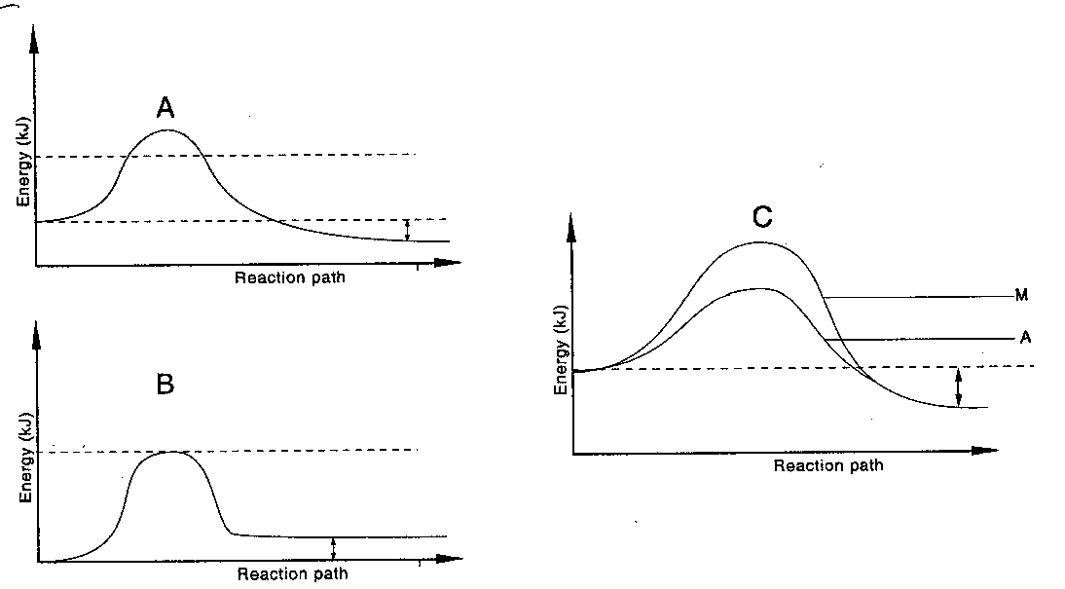

- Which reaction(s) is: (2 mks)
(i) exothermic
(ii) Endothermic

5. b). 0.65 of zinc was reacted with 20cm³ of 2 M copper(II) sulphate solution in a plastic beaker. The copper(II) sulphate solution was in excess. The initial temperature and the highest temperature of the solution were recorded. 0.64 of copper metal was formed.
- Other than change in temperature, state the observations made during the reaction
(1 mark)

- Calculate the:
I Number of moles of Zinc that reacted (Zn=65) (1 mark)

II The number of moles of copper that was displaced from the solution (Cu=64) (1 mark)

III The mole ratio of Zn: Cu (1 mark)

- Use the mole ratio obtained in III above to write the equation for the reaction (1 mark)

  - Define the term molar heat of displacement (1 mark)

  - The molar heat of displacement of copper by Zinc is -205.8 KJ mol⁻¹.
Determine the temperature change in the above experiment(assume density of copper(II) sulphate is 1g/cm³ and specific heat capacity 4.2Jg⁻¹k⁻¹) (3 mks)

6.a)Define redox reactions (1mk)

b)Use the standard electrode potentials given below to answer the questions that follow.
Half reaction | E^{Ɵ} (V)
Zn²⁺ + 2e – Zn  Pb²⁺ + 2e⁻ Pb  Ag²⁺ 2e⁻ Ag  Cu²⁺ 2e ⁻ Cu | -0.76  -0.13  +0.80  +0.34

7. I. Study the scheme below and answer the questions that follow.

Water
Colourless
gas D
Brown gas
Nitric (V) acid
Ammonia gas
Substance B
Substance A

Step I
Oxygen
Catalyst F

Step II
Oxygen

(a) Identify substances. (3 marks)
A -
B -
D -
(b) State the catalyst necessary for; (2 marks)
Step I -
Step II -

(c) Write an equation for the reaction taking place in step II.(1 mk)

(d)Write two balanced chemical equations for the reaction between chlorine
gas and;
(i) Hot and concentrated sodium hydroxide. (1 mark)

(ii) Dilute and cold sodium hydroxide. (1 mark)

II. The diagram below shows an experiment in which the Lead (II) nitrate crystals are heated.
Powdered Pb(NO₃)₂

Gas Y

Ice
Liquid P

- Name; (2 marks)

- Liquid P -

- Gas Y -

- Write a balanced chemical equation for the decomposition of Lead (II) nitrate. (1 mark

- Explain how you can distinguish between nitrogen (II) oxide and nitrogen (I) oxide.
(2 marks)

8 The flow chart below outlines some of the process involved during extraction of copper.

Hot air
Gas A
Limestone + Substance B
Gas A

Liquid T
2nd
Roasting
Furnace
1st
Roasting
Chamber
Copper
Pyrite
Smelting furnace

FeO+
Liquid T
Cu_{(l)} +Cu₂O_{(l)}
Slag C

Substance F
Chamber
D
Gas E

Cu_{(s)}

a) (i) Write the formula of copper pyrite. (1mk)

(ii) Name liquid T (1mk)

(iii) Write equations for the reactions taking place in the 2nd roasting furnace. (2mks)

(iv) Identify substance B and write equation for the reaction that take place in the smelting furnace. (2mks)

(v) State the purpose of substance F (1mk)

b) Copper obtained from chamber D is impure draw a well labelled diagram showing how the copper obtained can be purified. (2mks)

