NAME …………………………….. Candidate’s Sign. ……..…
ADM NO. ……….. Date ………………………..
CHEMISTRY
TIME: 2 HOURS

MWAKICAN FORM 3 JOINT EVALUATION – 2019 TERM II

CHEMISTRY
PAPER – 233/1
TIME: 2 HRS

INSTRUCTIONS TO CANDIDATES
- Write your name and admission number in the spaces provided above.
- Sign and write the date of examination in the spaces provided.
- ANSWER ALL QUESTIONS IN THE SPACES PROVIDED.
- All working must be clearly shown where necessary.
- Mathematical tables or silent electronic calculators may be used.

FOR EXAMINER’S USE ONLY

QUESTIONS | MAXIMUM SCORE | CANDIDATE’S SCORE
1 - 28 | 80

- Define the following terms (3mks)
  - Isotopes

(b)Mass number

(c) Isomers

- (a) Give a reason why ammonia gas is highly soluble in water. (1mk)

(b) The structure of ammonium ion is shown below
H

N

H

H
H

Name the type of bond represented in the diagram by N H……………………… (1mk)

3. Both diamond and graphite have giant atomic structures. Explain why diamond is hard while graphite is soft. (2mks)

4. (a) Using dot (.) and crosses(x) to represent electrons, show bonding in the compounds formed when
the following elements reacts. (C-=6, Na=11, F=9)
(a) Sodium and fluorine (1mk)

(b) Carbon and fluorine (1mk)

5. The table below gives information about the major components of crude oil. Study it and answer the questions that follow.

Components | Boiling point ºC
Gases | Below 40
Petrol | 40-175
Kerosene | 175-250
Diesel oil | 250-350
Lubricating oil | 350-400
Bitumen | Above 400
- Which of the compounds of crude oil has molecules with the highest number of carbon atoms?
Explain (1mk)

(ii) Name the process you would use to separate a mixture of diesel and petrol (1mk)

(iii) What condition could cause a poisonous gas to be formed when Kerosene is burnt (1mk)

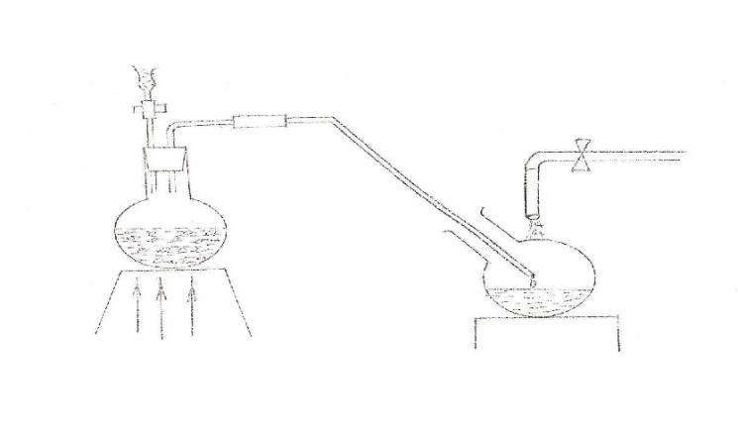
6. The set up below was used to prepare nitric (V) acid
Liquid T

Sodium cold water
Nitric acid
Nitrate

(a) Give the name of liquid T(1mk)
T……………………………………………………………………………………… ..(1mk)

(b) Write the equation for the reaction which took place in the reaction flask (1mk)

(c ) Explain why nitric acid is stored in a dark bottle
(1mk)
7. The table below gives information on four elements represented by K L M & N. Study it and
answer the questions that follow. The letters do not represent the actual symbols of the elements.
Elements | Electron arrangement | Atomic radius | Ionic radius
K | 2, 8 2 | 0.136 | 0.065
L | 2, 8, 7 | 0.099 | 0.181
M | 2, 8, 8, 1 | 0.203 | 0.133
N | 2, 8, 8, 2 | 0.174 | 0.099
(a) Which two elements have similar chemical properties? Explain (2mks)

- A certain carbonate XCO_{3 ,} reacts with dilute hydrochloric acid according to the equation
XCO_{3(s)} +2HCl _{(aq)} XCl_{2 (aq)} + CO_{2 (g)} + H₂O _{(l)}
If 4g of the carbonate reacts completely with 40cm³ of 2M hydrochloric acid, calculate the relative atomic mass of X. (C=12.0 ,O=16.0, Cl=35.5). (3 Marks)

- Give two uses of ethene gas (2Marks)

- a) What is meant by allotropy? (1 Mark)

b) The diagram below shows the structure of one of the allotropes of carbon.

- Identify the allotrope ( 1 Mark)

- State one property of the above allotrope and explain how it is related to its structure. (2Mark)
- 60cm³ of oxygen gas diffused through a porous hole in 50seconds. How long will it take 80cm³ of sulphur(iv)oxide to diffuse through the same hole under the same conditions (S=32.0 , O=16). (3 Marks)

11. The ionisation energies for three elements X,Y, and Z are shown in the table below:
Element | X | Y | Z
Ionisation energy  (KJ/mole) | 419 | 318 | 394
- What is meant by ionisation energy? (1 Mark)

- Which element is the strongest reducing agent? Give a reason. (2 Marks)

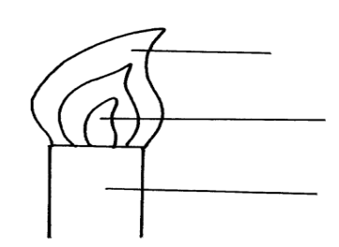
12. In the figure below:
F

H
G

(a) Name the parts labeled F, G, and H. (1 ½mks)
F……………………………………………………………………………………………....
G……………………………………………………………………………………………....
H……………………………………………………………………………………………....
- Describe an experiment that would confirm that region labeled G is unsuitable for heating (1½mks)

13. The diagram below is a set up used to investigate the effect of heat on hydrated copper(II) sulphate. Study the diagram and answer the questions that follow.
Copper (II) sulpahte crystals
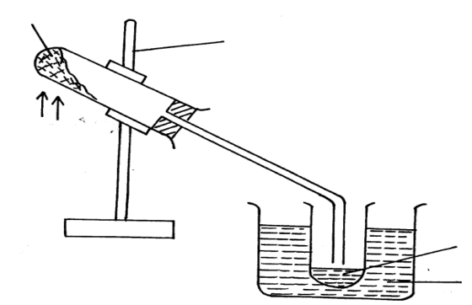
Clamp

Heat
Ice cold water
Liquid G
(a) Why is boiling tube slanted as shown? (1mk)

(b) What is observed in the boiling tube. (1mk)

(c) Identify liquid G. (1mk)

14. The electronic arrangement of two stable ions Q²⁺ and P²⁻ are 2.8.8 and 2.8.8 respectively.
(a) Write the electron arrangement of atoms Q and P. (1mks)
Q………………………………………………………………………………………....…
P………………………………………………………………………………………....…
(b) What is the most likely structure of an oxide element P? (1mk)

15. The set up below was used by a student. Filter paper soaked in purple litmus solution was placed in the middle of the combustion tube.
Cotton wool soaked in ammonia solution

Cotton wool
soaked in
Conc. HCl

Filter paper soaked in purple litmus solution

(i) What is the main aim of the experiment. (1mk)

(ii) State the first observation likely to have been made in the tube. Explain the observation. (2mks)

16. The empirical formula of a compound is CH₂ and it has a molecular mass of 42.
a) What is the molecular formula of this compound? (1mk)

b) Write the general formula of the homologous series to which the compound belongs. (1mk)

c) Draw the structural formula of the third member of this series and give its IUPAC name. (1mk)

17. 3.22g of hydrated sodium sulphate, Na₂SO₄ X H₂O were heated to a constant mass of 1.42 g. determine the value of X in the formula ( Na=23.0, S = 32.0, O = 16, H = 1) (3mks)

18. Complete the following reactions. (2mks)

(i) C₂H₂ 1 mole of HCl_{(s)}

1 mole Cl_{2 (g)}

(ii) CH₃CH₃ U.V light

19. A white solid K was heated. It produced a brown gas A and another gas B which relights a glowing splint. The residue left was yellow even after cooling.
a) Identify gases A and B (1mks)

b) Write a balanced chemical equation for the decomposition of solid K. (1mk)

X
18
X
16
20. An atom X contains 90% of isotope and 10% of isotope. Calculate the relative
8
8
atomic mass of X. (2mks)

21. Explain why aluminium articles are not easily corroded. (1mk)

22. Dry chlorine gas was passed through two pieces of coloured cotton cloth as shown.

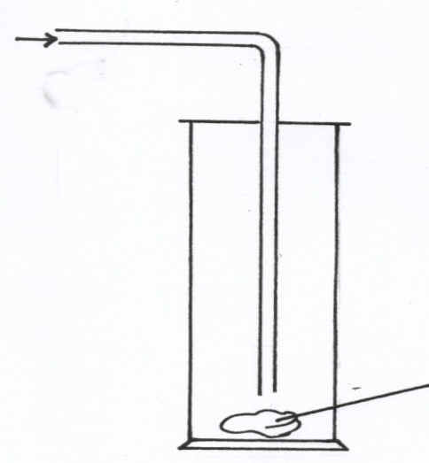
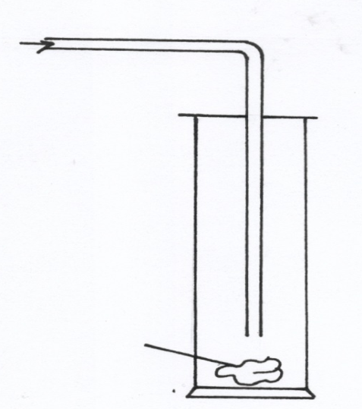
Dry chlorine
Dry chlorine

Wet cloth
Dry cloth

2

a) State what is observed in each experiment. (2mks)
Experiment 1

Experiment 2

b) Explain your observation using an equation for experiment 2 (1mk)

23. When burning magnesium ribbon is put into a gas jar of carbon (IV) oxide gas, it continues to burn
leaving behind white solid powder and black solid specks as residue write chemical equation for the
reaction that produces.
i) The white solid powder. (1mk)

ii) Black solid specks. (1mk)

24. Describe how you would obtain pure solid samples of each of the following components of a solid
mixture containing ; Lead (II) chloride, Sodium carbonate and calcium sulphate. (3mks)

25.a) State Boyle’s gas Law. (1mk)

b) A fixed mass of a gas has a volume of 250cm³ at 27ºC and 750mmHg pressure. Calculate the
gas volume that the gas would occupy at 41ºC and 750mmHg pressure. (0º = 273k) (2mks)

26. The diagram below shows a sample of ammonium chloride being heated in a dry boiling tube
containing a plug of cotton and dump red litmus paper
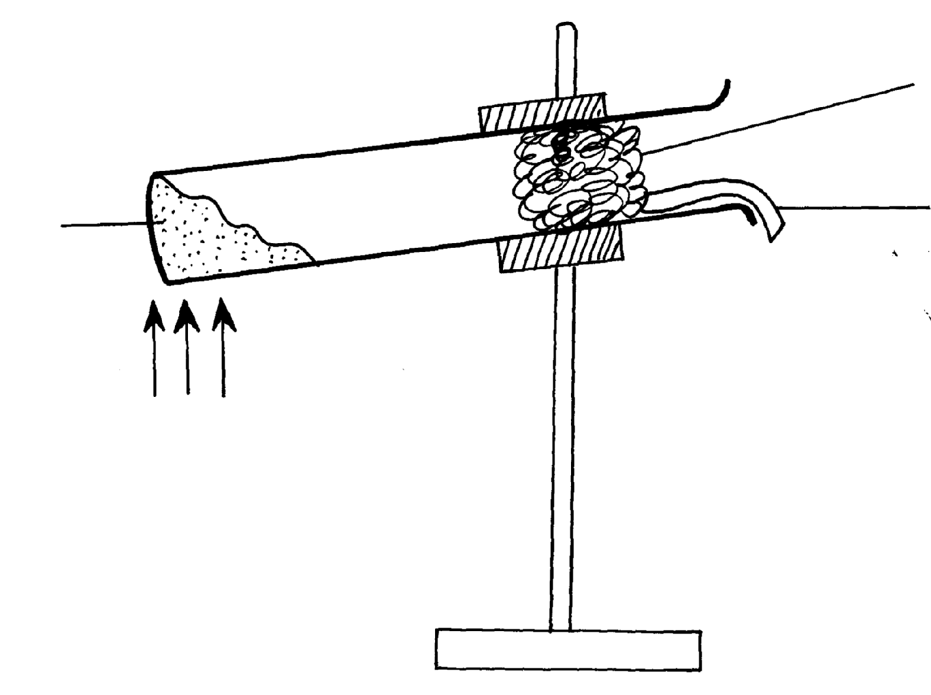
Heat
Ammonium chloride
Red Litmus paper
Dry cotton wool

State and explain what would be observed on the red litmus paper. (2mks)

27. a) The following diagram represents a set-up used to investigate conditions necessary fro rusting of iron.
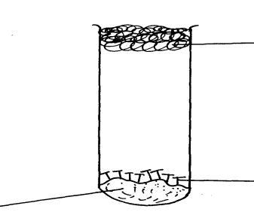
Cotton wool

Iron nails
Solid P

After several days it was found that the nails did not rust. Identify solid P. (1mk)

28. a) Write a chemical equation for the combustion of laboratory gas , when the Bunsen burner produces
a non-luminous flame. (1mk)

b) Describe two observable characteristics of aluminous flame. (1mk)

29 . Name the following compounds (1 mark)
(i) CH₃CH=CHCH₃

(ii) CH₃-CH₂-CH-CH₂CH₂CH₃ (1 mark)
CH₂CH₃
30 . The diagram below represents aset up that can be used to react Lithium with water to produce gas X which is then reacted with copper II oxide.
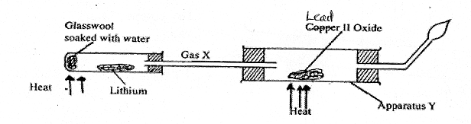
(i) Write an equation for the reaction between gas X and CuO (1mark)

(ii) Give the observation made in the apparatus (1 mark)

(iii) Why is it necessary to burn excess gas at the end of the jet (1 mark)

31. Solution R,S and T have P^{H} values shown in the table below:
Solution | pH value
R | 1.0
S | 6.5
T | 8.0
- What do you deduce about the nature of solution R? (1 mark)

- Which solution would react most vigorously with sodium hydrogen carbonate. (1 mark)

c) Which solution is likely to be ammonia solution? (1 mark)

