NAME…………………………………………CLASS………ADM……………

233/2
CHEMISTRY PAPER 2

TIME 2HRS

TERM 2 2019

MWAKICAN FORM 3 TERM 2 2019

INSTRUCTIONS TO CANDIDATES
- Write your name and admission number in the spaces provided above.
- Sign and write the date of examination in the spaces provided.
- ANSWER ALL QUESTIONS IN THE SPACES PROVIDED.
- All working must be clearly shown where necessary.
- Mathematical tables or silent electronic calculators may be used.

QUESTIONS | MAX SCORE | STUDENT SCORE
1 | 14
2 | 14
3 | 14
4 | 12
5 | 13
6 | 13
TOTAL | 80

Q1(a) The grid below represents part of the periodic table. Letters are not actual symbols of the elements. Use it to answer the questions that follow.

A |  |  |  |  |  |  |  | B
 |  |  | C |  | H
J | E |  | D |  |  |  | G
 | F

(i) Name the family to which E and F belong. (1mk)

(ii) Name the least reactive element and give a reason. (1mk)

(iii) What type of structure is formed when E and G react. (1mk)

(iv) Draw the structure of the molecular compound formed between D and G clearly showing the types of bonds that exist. (2mks)

(v) Write the formula of the compound formed between E and H. (1mk)

(vi) Name the product formed when sodium is burnt in insufficient oxygen and write the equation for reaction between the product and water. (2mks)

(vii) Indicate using a tick on the grid the position of element M which forms an ion with formula M²⁻ and electronic arrangement 2.8.8.8 (1mk)

aa(b) Study the table below and use it to answer the questions that follow. (Letters are not actual symbols)

Element | Atomic number
L | 13
M | 16
N | 19
P | 9
Q | 17

(i) Compare giving reasons the reactivity of P and Q. (2mks)

(ii) How does the radius of L and M compare (1mk)

(iii) Select the most reactive metal from the group. (1mk)

(iv) Write an equation for reaction between N and water. (1mk)

Q2 Use the flow chart below to answer the questions that follow. 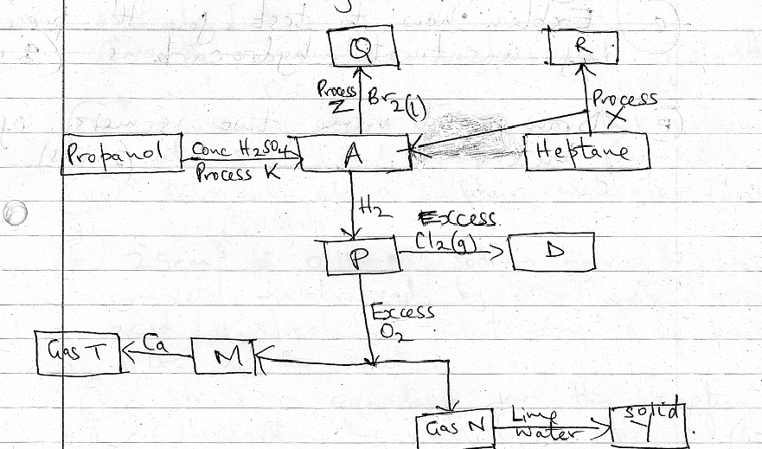

(a) Name the substances
(i) P
(ii) R
(iii) T
(iv) Y
(4mks)

(b) Write equations using actual formula of substances for formation of
(i) Q

(ii) M and N

(III) Gas T
(3mks)

(c) Name the processes
(i) X
(ii) K
(iii) Z
(3mks)

(d) Draw the structures of
(i) A

(ii) D

(2mks)

(e) Draw and name two isomers of butene. (2mks)

Q3(a) 2.56g of sulphur formed vapour at 546ºC and 760mmHg. The vapour occupied a volume of 672cm³.
Calculate
(i) the volume of vapour at 760mmHg and O^{O}C. (2mks)

(ii) Mass of 22.4 litres of the vapour at STP conditions. (2mks)

(iii) Formula of a sulphur molecule. (S =32) (2mks)

(b) 25cm³ of 0.154M sodium hydroxide, was completely neutralized by 30cm³ of mineral dibasic acid (H₂X) solution containing 6.3g per litre of the solution.
(i) Write an equation for the reaction. (1mk)

…………………………………………………………………………………………………………………………………………………………………………………………………………………………………………………………………………………………………………………………………………………………………………………………………………
(ii) Calculate the molarity of the acid. (3mks)
…………………………………………………………………………………………………………………………………………………………………………………………………………………………………………………………………………………………………………………………………………………………………………………………………………………………………………………………………………………………………………………………………………………………………………………………………………………………………………………………………………………………………………………………………………………………………………………………………………………………………………………………….
(iii) Determine the RFM of the acid. (2mks)
……………………………………………………………………………………………………………………………………………………………………………………………………………………………………………………………………………………………………………………………………………………………………………………………………………………………

(iv) Identify x (2mks)
(C=12,O=16,S=32,Cl=35.5,H=1,N=14)

…………………………………………………………………………………………………………………………………………………………………………………………………………………………………………………………………………………………………………………………………………………………………………………………………………

Q4 Hydrogen gas is passed through solid Y in a U-tube before being burnt in air.
(i) Explain how to test for presence of hydrogen gas. (1mk)
…………………………………………………………………………………………………………………………………………………………………………………………………………………………………………………………………………………………………………………………………………………………………………………………………………
(ii) What is the purpose of substance Y and suggest its identity. (2mks)
…………………………………………………………………………………………………………………………………………………………………………………………………………………………………………………………………………………………………………………………………………………………………………………………………………
(b) The products of burning hydrogen were passed through a test tube dipped in ice-cold water. Unburnt gas was then passed over heated CuO.

(i) Write an equation for burning of hydrogen in air. (1mk)
…………………………………………………………………………………………………………………………………………………………………………………………………………………………………………………………………………………………………………………………………………………………………………………………………………
(ii) Name a substance that can be used to test for the substance collected in the test-tube dipped in ice-cold water. (1mk)

…………………………………………………………………………………………………………………………………………………………………………………………………………………………………………………………………………………………………………………………………………………………………………………………………………
(iii) What is the observation made on the copper(II) oxide after a short while. (1mk)

…………………………………………………………………………………………………………………………………………………………………………………………………
(iv) Write an equation for the reaction that takes place on the copper(II) oxide solid. (1mk)
…………………………………………………………………………………………………………………………………………………………………………………………………………
(v) Other than for manufacture of ammonia and hydrochloric acid, , state another use of hydrogen. (1mks)
………………………………………………………………………………………………………………………………………………………………………………………………………………………………………………………………………………………………………………………………………………………………………………………………………
(c) The diagram below is a set-up used to show how water reacts with zinc metal.
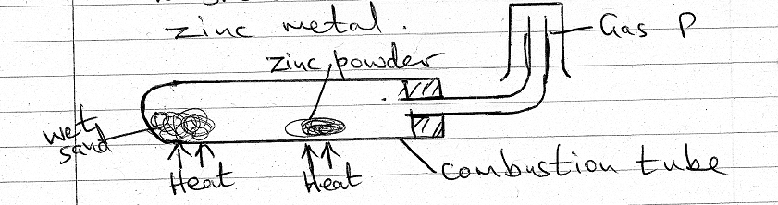

(i) Why is wet sand used and not water. (1mk)

(ii) Write an equation for the reaction in the combustion tube. (1mk)

(iii) What observation is made in the combustion tube as heating went on. (1mk)

(iv) Explain why potassium cannot be used in place of zinc. (1mk)

Q5(a) Carbon(II) Oxide gas can be prepared by dehydrating methanoic acid using concentrated sulphuric(VI) acid.

(i) Give two physical properties of carbon(II) oxide gas. (2mks)

(ii) Explain how carbon(II) oxide gas causes poisoning if inhaled. (1mk)

(iii) Describe a simple chemical test that can be used to distinguish between carbon(II) oxide and carbon(IV) oxide. (2mks)

(b) Soot is a form of impure carbon

(i) Name another form of carbon that is amorphous. (1mk)

(ii) State the difference in conductivity between the two crystalline allotropes of carbon. (2mks)

(iii) Give one use for each of the two crystalline allotropes. (2mks)

(c)(i) Write an equation for decomposition of ammonium carbonate on heating. (1mk)

(ii) Explain the observations made when each of the carbonates below is reacted with dilute
sulphure(VI) acid:
Lead carbonate
…………………………………………………………………………………………………………………………………………………………………………………………………………………………………………………………………………………………………………………………………………………………………………………………………………
Copper(II) carbonate
…………………………………………………………………………………………………………………………………………………………………………………………………………………………………………………………………………………………………………………………………………………………………………………………………………
(2mks)

Q6 The flow chart below shows some reactions undergone by some salts. Use it to answer the questions that follows.

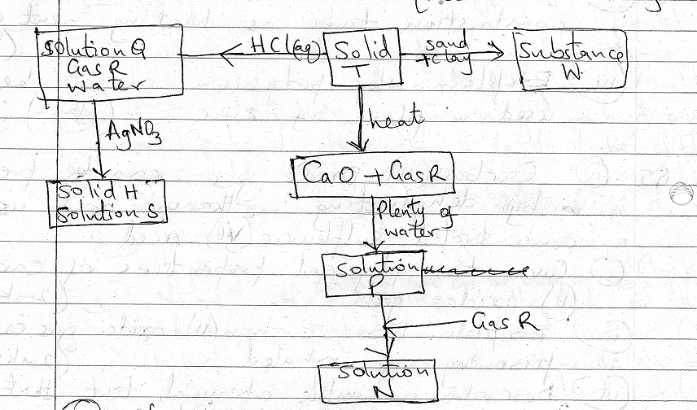

(a) Name
(i) Gas R
(ii) Solution N
(iii) Solid H
(3mks
(b) Write equations for the following reactions.
(i) Addition of AgNO₃ to solution Q

(ii) Heating solid T

(iii) Formation of solution P
(3mks)

(c) Give one use for the substances below
(i) Gas R

(ii) Substance W

(iii) Silver bromide

(3mks)

(d)(i) Name the method used to prepare salts H and S (1mk)

(ii) Name another salt that can be prepared using the method in d(i) above. (1mk)

(e) Ammonium ferrous sulphate hexahydrate an example of a double salt. Write its formula. (1mk)

(f) Give one example of a salt contained in fertilizers. (1mk)

