**NAME ………………………………………………………… DATE…………………………**

**ADM.NO ……………STREAM……………. CANDIDATE’S SIGNATURE ………………**

**233/1**

**CHEMISTRY FORM 3**

**(THEORY)**

**TIME: 2 Hours**

**CASPA AMUKURA PARISH EXAMINATION 2021**

***Instructions to Candidates***

1. Write your name and admission number in the spaces provided above
2. Sign and write the date of examination in the spaces provided.
3. Answer all the questions in the spaces provided
4. KNEC Mathematical tables and silent electronic calculator may be used.
5. All the working must be shown clearly where necessary
6. Candidates should answer questions in English.

**For Examiner’s Use Only**

|  |  |  |
| --- | --- | --- |
| **Questions** | **Maximum Score** | **Candidate’s Score** |
| 1-26 | 80 |  |

1. An element K has atomic number 20 while element M has atomic number 8.
2. Write the electronic configuration for K and M

K ……………………………………………………………………………………….……(1/2)

M …………………………………………………………………………………………….....(1/2)

1. Write the symbol of the most stable ion of K and M

K ………………………………………………………………………………………………(1/2).

M ………………………………………………………………………………………………..(1/2)

2. Molten Lead(II) bromide is electrolyzed using carbon electrodes. Write the half cell equation of the reactions that occur at the anode and the cathode.

a) Anode

…………………………………………………………………………………….…… (**1mrk)**

b) Cathode

……………………………………………………………...……….………………… (**1mrk)**

4. ThreemetaloxidesXO,YO,andZOareheatedwithpowderedmetalY.HotpowderedYwillremove oxygenfromXObutnotfromZO.Arrangethemetalsinorderofreactivity,startingwiththemostreactive.**1mark**

......................................................................................................................................................................................................................................................................................................................................

......................................................................................................................................................................................................................................................................................................................................

5.The table below shows the relative atomic masses and the percentage abundance of the isotopes T1 and T2of element T.

|  |  |  |
| --- | --- | --- |
|  | RAM | % abundance |
| T1 | 62.93 | 69.09 |
| T2 | 64.93 | 30.91 |

Calculate the relative atomic mass of element T [3mks]

……………………………………………………………………………………………………………………..……………………………………………………………………………………………………………………..……………………………………………………………………………………………………………………..……………………………………………………………………………………………………………………..……………………………………………………………………………………………………………………..……………………………………………………………………………………………………………………..……………………………………………………………………………………………………………………………………………………..

6. The diagram below is a set-up for the laboratory preparation of oxygen gas.

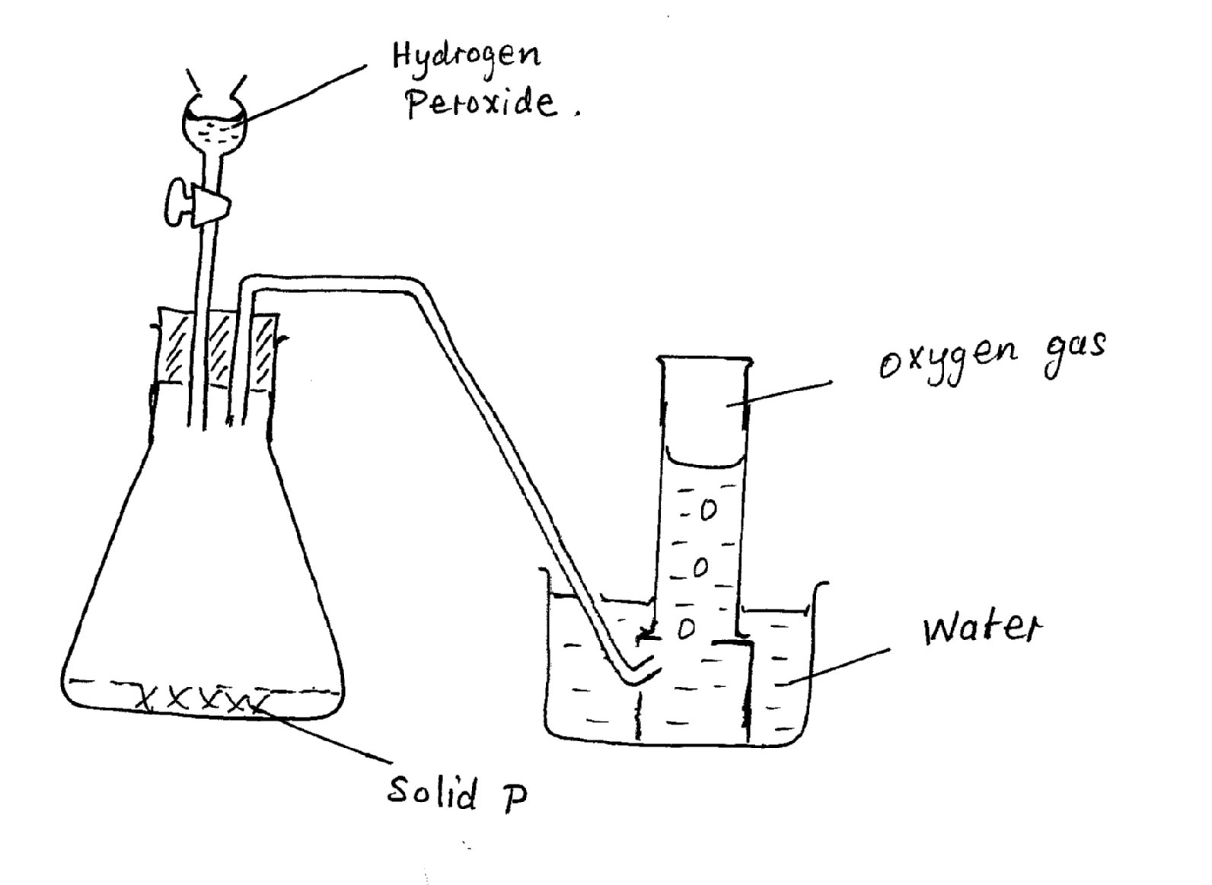

* 1. Name solid P.………………………………………………………………………………………..……[1 mk]
  2. Write a chemical equation for the reaction that takes place in the conical flask

………………………………………………………………………………………..…[1 mk]

* 1. Give two commercial uses of oxygen [1 mk]
     1. ………………………………………………………………………………………..…………………………………………………………………………………………..….

7. The figure shows a set-up by a form three student to prepare a certain gas

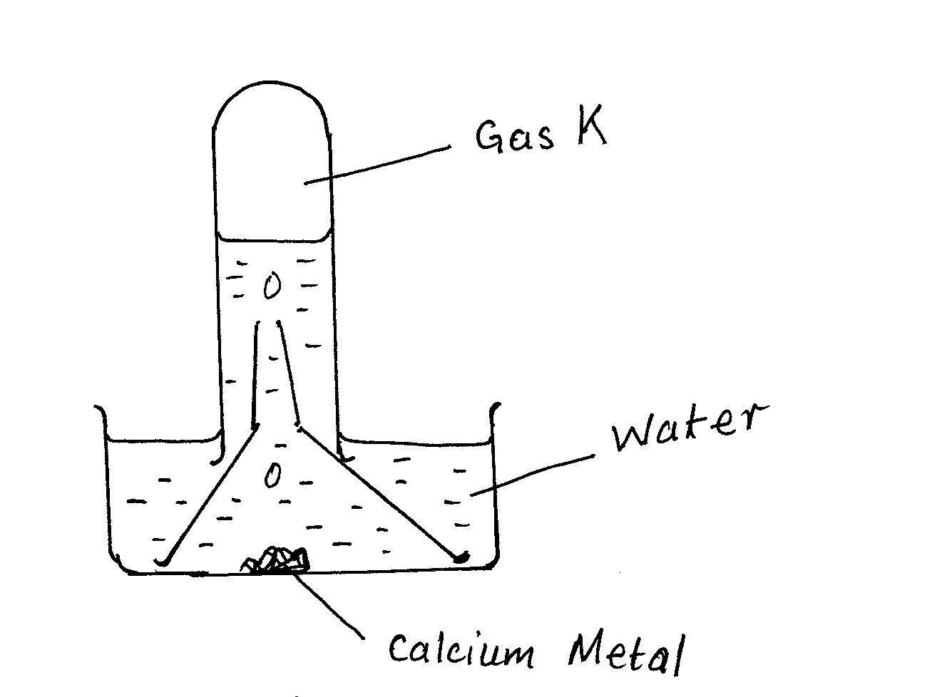

a) Write a chemical equation for the formation of gas K [1 mk]

………………………………………………………………………………………..………

b) Give one use of gas K in the industries [1 mk]

………………………………………………………………………………………..……………………………………………………………………………………………………………

c) Give one use of the resulting solution after the metal has reacted (1 mk)

…………………………………………………………………………………………………………………………………………………………………………………………………………

8. The diagram shows the structures of two allotropes of carbon. Study them and answer the questions that follow.

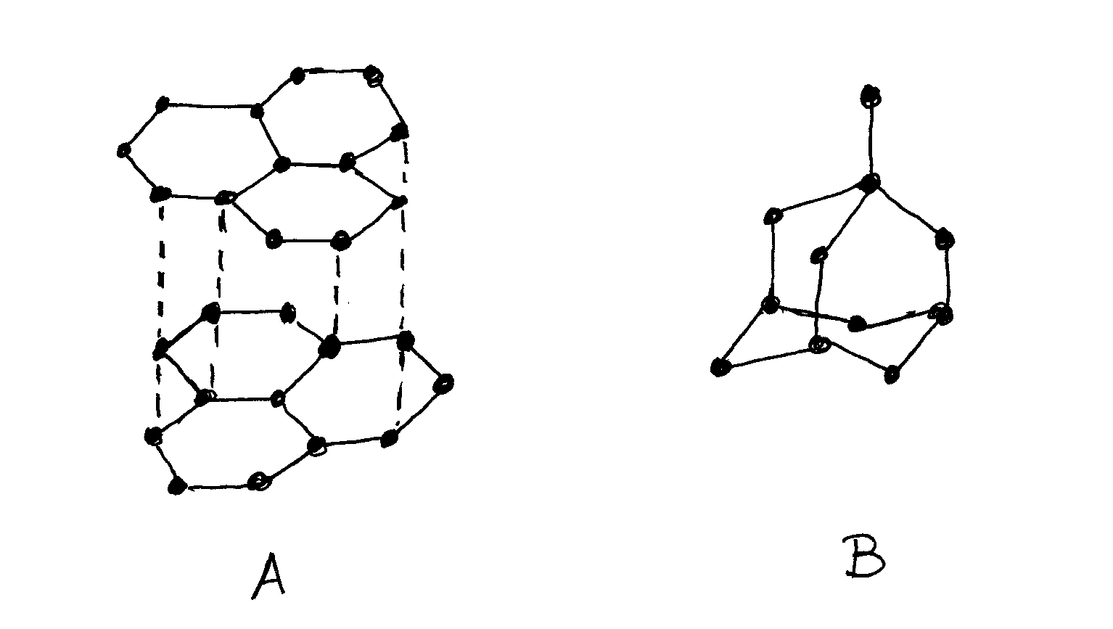

* 1. Name allotrope A and B [2 mks]

A…………………………………………………………………………………..

B……………………………………………………………………………………

* 1. Give two uses of allotrope B [2 mks]
     1. ……………………………………………………………………………
     2. ……………………………………………………………………………
  2. Which allotrope conducts electricity? Explain. [2 mks]

……………………………………………………………………………………………………………………..………………………………………………………………………………………………....

……………………………………………………………………………………………………………………..…………………………………………………………………………………………………………..……………………………………………………………………………………..…………………

9.Statetwodifferencesbetweenpermanentandtemporarychanges(2marks).

|  |  |
| --- | --- |
| Permanent. | Temporary. |
|  |  |
|  |  |

10.The table below gives some properties of substances I, J and K. .Study it and answer the questions

tha t follow.

|  |  |  |  |  |
| --- | --- | --- | --- | --- |
| Substance. | Melting point  (0c) | Solubility in  Water. | Electrical Conductivity in: | |
|  |  |  | Solid state. Molten state. | |
| I | 1063 | Insoluble | Conducts. | Conducts. |
| J | 113 | Insoluble | Doesn’t’t | Doesn’t |
| K | 402 | Sparingly soluble. | Doesn’t’t | Conducts and it is decomposed. |

(a)Suggest the type of structure in:

I …………………………………………………(1mark).

K ……………………………………………(1mark).

(b)Explain why molten K is decomposed by current but I is not decomposed. (1mark).

………………………………………………………………………………………………………………………………………………………………………………………………………………………………………………………………………………………………………………………………

11.Solution R, S and T have pH values shown in the table below.

|  |  |
| --- | --- |
| Solution | pH |
| R | 1.0 |
| S | 6.5 |
| T | 8.0 |

(a)What do you deduce about the nature of solution R? (1mark).

………………………………………………………………………………………………………………………………………………………………………………………………………………………………………….

(b)Identify two solutions that t will react to form a neutral solution.(1mark).

……………………………………………………………………………………………………………………………………………………………………………………………………………………………

12. Study the diagram below and answer the questions that follow.

|  |  |  |  |  |  |  |  |  |
| --- | --- | --- | --- | --- | --- | --- | --- | --- |
|  |  | | | | | | | E |
| A | B |  | C |  |  |  | D |  |
|  | G | I |  |  |  | H |  |
| F |  |  |  |  |  |  |  |  |

a) (i)Write down the electronic configuration of element E. (1mk)

…………………………………………………………………………………………

(ii) Ion formed by element H.

………………………………………………………………………..(1mk) (iii)Formula of compound formed when G combines with D.

……………………………………………………………..(1mk)

b) Identify the type of bond formed in a(iii)above? Give a reason.(2mks)

………………………………………………………………………………………………………………………………………………………………………………………....

c) Explain the differences in the m elting points of A and B. (2mks)

……………………………………………………………………………………………………………………………………………………………………………………………………………………………………………………………………………………..

d) Compare the reactivity of element D andH. (2mks)

………………………………………………………………………………………………………………………………………………………………………………………………………………………………………………………………………………………………………

13.The set up below was used to separate two miscibleliquids QandT (Bolingpoints;Q=98°C,T=78°C)

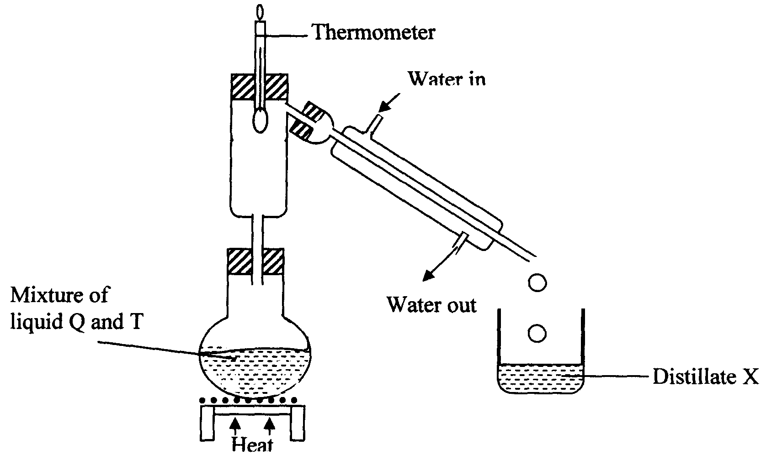

(a)Identify the mistakes in the setup above(2mks)

……………………………………………………………………………………………………………………………………………………………………………....

(b)Identify Distillate X (1mk)

………………………………………………………………………………………………………………………………………………………………………………………………………………

14.The diagram below show the heating curve of a substance .Study it and answer the questions that follow:

444 D Z

115

A

Temperature

Y

B

X C

Time

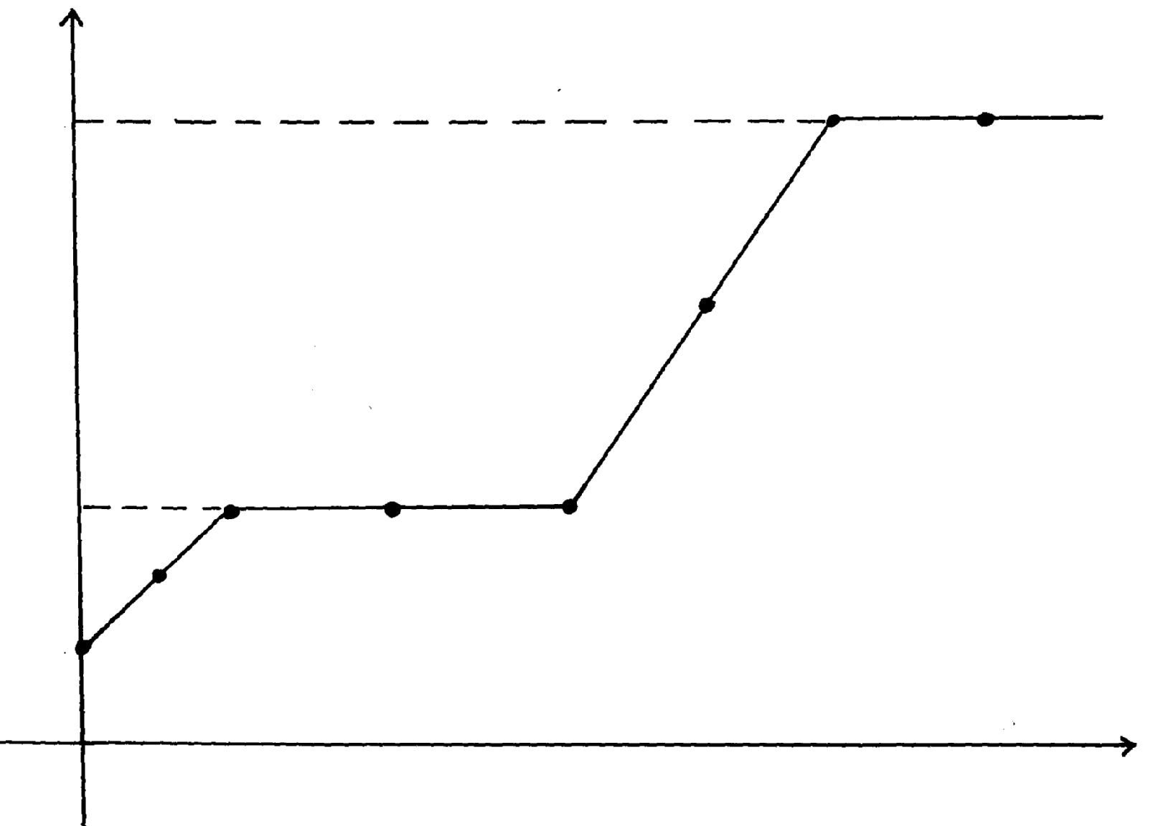

(a)What is the melting and boiling point of the substance?(1mk)

……………………………………………………………………………………………………………………………………………………………………………………........

(b)Explain what happens to the melting point when sodium chloride is added to this substance. (2mks)

……………………………………………………………………………………………………………………………………………………………………………….

15. Two pieces of cotton wool were separately soaked in concentrated Ammonia and Hydrochloric acid solution respectively. Then, were simultaneously placed at the end of an open-ended tube.



1. Name the white deposit. (1 mark).

……………………………………………………………………………………………………………

1. Workout the relative rates at which Ammonia (NH3) and Hydrogen chloride (HCl) gas diffuse. (N=14, H=1 ,Cl=35.5 ) (2mark).

……………………………………………………………………………………………………………………………………………………………………………………………………………………………………………………………………………………………………………………………………………………………………………………………………………………………………………………………………………………………………………………………………………………………………………………………………………………………..…

1. Name the gas law that explains the difference in the rate of diffusion. (1 mark)

…………………………………………………………………………………………………………………

16. a )What is allotropy? (1mk)

………………………………………………………………………………………………………………………………………………………………………………………………………………………………….... b)A burning magnesium continues to burn inside agas jar full of carbon(IV)oxide.Explain.

(2mks)

……………………………………………………………………………………………………………………………………………………………………………………………………………………………………………………………………………………………………………………….

17. Calculate the number of moles present in:

a)12g of sulphur (S=32) (2mks)

……………………………………………………………………………………………………………………………………………………………………………………………………………………………………………………………………………………………………………………………………………………………………………………………………………………………….

b) 9.8g of sulphuric acid (S=32,O=16,H=1) (2mks)

……………………………………………………………………………………………………………………………………………………………………………………………………………………………………………………………………………………………………………………………………………………………………………………………………………………………………………………………………………………………………………………………………….

18. When dry hydrogen gas passed over heated Lead (II)oxide in combustion tube, agrey solid was formed.

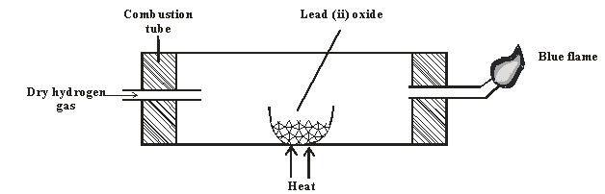

a) Identify the grey solid. (1mk)

………………………………………………………………………………………………………………………………………………………………………………………………………………

b) Write the equation of the reaction taking place in the combustion tube. (1mk)

………………………………………………………………………………………………………

…......................................................................................................................................................

c) Write the equation involving the blue flame. (2mks)

………………………………………………………………………………………………………

……………………………………………………………………………………………………

19. a) State Charles’ law (1mk)

………………………………………………………………………………………………………………………………………………………………………………………………………………………………………………………………………………………………………………………………………………………

b) The volume of a sample of nitrogen gas at temperature of 298kand 600mmHgpressure was0.048m3, calculate the temperature at which the volume of the gas wouldbe0.032m3 if pressure remains the same. (2mks)

……………………………………………………………………………………………………………………………………………………………………………………………………………………………………………………………………………………………………………………………………………………………………………………………………………………………………………………

20. Some sodium chloride was found to be contaminated with copper(II)oxide. Describe how asample of sodium chloride can be separated from the mixture. (**2marks** ……………………………………………………………………………………………………………………………………………………………………………………………………………………………………………………………………………………………………………………………………

21. Laboratory results showed the composition of acompound to be 58.81% barium,13.72%,sulphur and 27.47% Oxygen. Calculate the empirical formula of the compound. Ba=137, S= 32,O= 16. (2mks)

**………………………………………………………………………………………………………………………………………………………………………………………………………………………………………………………………………………………………………………………………………………………………………………………………………………………………………………………………………**

22. The flow chart below shows industrial manufacture of sodium carbonate by Solvay process. Study it and answer the questions that follow.

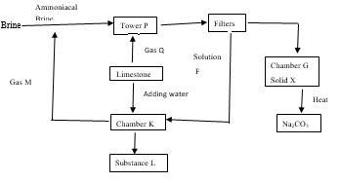

i) Name

I. Gas Q…………………………………………………………… (½mark) II. Gas M…………………………………………………………… (½mark) III. Solution F……………..………………………………………… (½mark)

IV. Substance L……………………………………………………………… (½mark)

ii) Write a chemical equation for the reaction that occurred; (1mark)

1. Chamber K

…………………………………………………………………………………………

………………………..…………………………………………………………………

II. Heating solid X (1mark)

…………………………………………………………………………………………

iii) Give two use of sodium carbonate. (2mks)

……………………………………………………………………………………………………………………………………………………………………………………………………………………………....

1. 20cm3of Hydrochloric acid requires 25cm3 of 0.2M Sodium hydroxide.
2. Calculate the moles of Sodium hydroxide solution in the reaction. (2mks)

……………………………………………………………………………………………………………………………………………………………………………………………………………………………………………………………………………………………………………………………………………………………………………………………………………………………………………………………...

1. Calculate the Molarity of Hydrochloric acid. (2mks)

…………………………………………………………………………………………………………………………………………………………………………………………………………………………………………………………………………………………………………………………………………………………………………………………………………………………………………………………………………………………………………………………………………………………………………………………………………………………………………………………………………………………………………………………………………………………………………………………………………………………………………………………………………………………………………………………………………………………………………………………………………………………………………..…

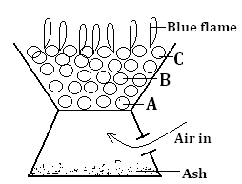24. The diagram below represents a burning jiko.

1. Write down the equation for the reactions taking place at; (2marks)

B

…………………………………………………………………………………………………………………………………………………………………………………………………………………………

C

……………………………………………………………………………………………………………………………………………………………………………………………………………………….

1. Why is it dangerous to use a jiko in a closed room? (1mark)

………………………………………………………………………………………………………………………………………………………………………………………………………………………....

25. Draw and name the apparatus that can be used to separate a mixture of water and kerosene. (2mks)

26. Describe how you can prepare a dry sample of lead (II) sulphate using the following reagents. (2mks)

* Dilute nitric(v)acid
* Solid lead(II)oxide
* Solid sodium sulphate

…………………………………………………………………………………………………………………………………………………………………………………………………………………………………………………………………………………………………………………………………………………………………………………………………………………………………………….……………………