NAME………………………………………………………………………………...CLASS…………….ADM…………

233/2
FORM 3 CHEMISTRY PAPER 2 THEORY

TIME 2HRS

TERM 1 2016

MWAKICAN JOINT EXAM TEAM (MJET) TERM 1 2016
Instructions to candidates.
- Write your name and index number in spaces provided in the question paper.
- Answer all the questions in the spaces provided in question paper.
- Mathematical tables and silent calculators may be used.
- All working must be clearly shown where necessary.
QUESTIONS | STUDENT SCORE
1
2
3
4
5
6
7

1. Study the table below and answer the questions that follow. The letters do not represent the actual symbols of the elements.
Element | A | B | C | D | E | F | G | H
Atomic no. | 11 | 12 | 13 | 14 | 15 | 16 | 17 | 16
Boiling point (°C) | 890 | 1110 | 2470 | 2360 | 280 | 445 | -34.7 | -186
Formulae of oxide |  | BO |  |  | E₂O₃ | FO₂ |  | xxxx
Boiling point of oxide (°C) | 1193 | 3075 | 2045 | 1728 | 563 | -72 | -91 | xxxx
(a) (i) Write the electronic arrangement for ion of element C and F. (1 mark)

- To which period and group do element B belong. (1 mark)
Period __________________________________________________________
Group __________________________________________________________

(b) Explain the difference in boiling points of element B and F. (2 marks)

- Write the formula of the compound formed between elements B and G. (1 mark)

d) The chloride of A has a higher boiling point than that of C. Explain.(2 marks)

(e) Complete the table to show the formulae of the oxides. (2 marks)

(f) Select an oxide that reacts with hydrochloric acid and potassium hydroxide.
Explain (1 mark)

(g) Determine the oxidation state of F in its oxide. (1 mark)

h) using dots (.) and cross (x) draw the structure of (2 marks)

NH₄ ⁺

2. A Study the arrangement below and answer the questions that follows.
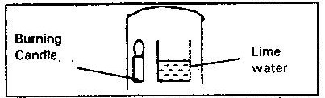

- What observation is made in the lime water after a short time. (1mk)

- Write an equation for the reaction taking place in the beaker containing lime water (1 mark)

(B) A piece of Phosphorus was burnt in excess air and the product obtained was shaken with small amount of hot water to make a solution.
i) Write an equation for the burning phosphorus in excess air (1mk)

ii) The solution obtained in above was found to have a PH of 2. Explain (lmk)

C) Explain why cooking pots made of aluminium do not corrode easily when exposed toair. ( 2 marks)

D. The diagram below represents a set-up used to prepare oxygen gas.
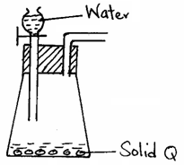

(a) Name substance Q. (1 mark)

(b) Complete the set-up to show how dry oxygen gas is collected. (2 mark

(c) Write the equation for the reaction that occurs. (1 mark)

3. (a) state Graham’s law of diffusion.(1mk)

- 20cm³ of un known gas Q takes 12.6 seconds to pass through small orifice. 10cm³ of oxygn gas takes 11.2 seconds to diffuse through the same orifice under the same conditions of temperature and pressure. Calculate the molecular mass of unknown gas Q (0=16) (2mks)

- A balloon used in a meterological station contains 250dm³ of helium at 25º c and 100kpa pressure. Calculate the temperature when will burst, when its volume reaches 400dm³ and 80kpa pressure. (3mks)

(b) (i) what is meant by empirical formula of a compound.(1mk)

(ii) a hydrated salt has the following composition.
By mass.
Copper 25.4% sulphur 12.8 %, oxygen 25.8%, water 36% . its relative formula mass is 249.5. determine the emperial formula of the hydrated salt.(3mks)

(iii)9.98g of hydrated salt were dissolved in distilled water and the total volume made to 200cm³ of solution. Calculate the concentration of the salt solution in moles per litre.(2mks)

(c)If 200cm³ of carbon (ii) oxide were burnt in 150cm ³ of oxygen. What is the volume of the remaining gases? (all volumes measured at the same temperature and pressure). What will be the volume of each of the remaining gases.

4. (a) A patient was given tablets with prescription 2 x 3 for 3 days on the envelope. Clearly outline how the patient should take the tablets. (1 mark)

- Two samples of equal volumes of water were put in 250cm³ beaker and heated for 10 minutes. Sample 1 registered a higher temperature than sample 2. State the conditions under which flame 1 is produced in the Bunsen burner. (1 mark)

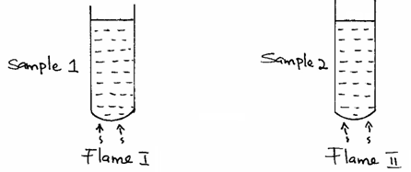

c) The apparatus below was used to separate a mixture of liquid A and B.
State two properties of the liquids that make it possible to separate them are using such apparatus. (2 marks)

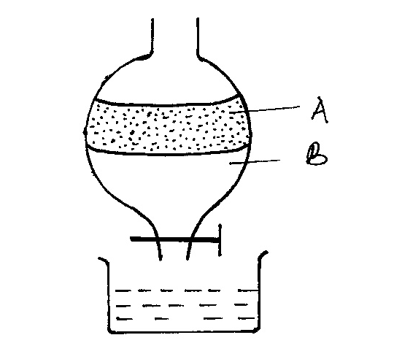

d) A laboratory technician accidentally mixed liquids suspected to be benzene (B.P. 78 ⁰C) and water (B.P 100⁰ C). He has a problem of separating the mixture and seeks your help. Describe to him. (2marks)
- ) The method he should use
- ) The precautions he should take when carrying out the separation.

e) A bee keeper found that when stung by a bee, application of a little solution of sodium hydrogen Carbonate help to relieve the irritation from the affected area. Explain. (2mks)
D The following data gives the PH value of solution P, Q and R.
Solution | PH value
P | 13.6
Q | 6.9
R | 1.3
i) Which solution would produce Carbon (IV) Oxide when reacted with Copper (II) Carbonate? (1mk)
ii) What would be the colour of solution “P” after adding a few drops of phenolphthalein indicator? (1mk)

5. A student set up the apparatus shown below to prepare and collect dry carbon (iv oxide gas

- State a correction for two mistakes in the set up above.(2mks)

- The flow chart below is for the manufacture of sodium carbonate by the Solvay process. Use it to answer the questions that follow.

5i) Name gas M and Q (2mks)
M

Q

(ii) Name solution F (2mks)

Solid x

(iii) Name the product L formed and give one of its use. (2mks)

(iv) Write equations of the reactions in tower P

Tower p (2mks)

Chamber k

6 Describe how solid samples of salts can be obtained from a mixture of lead (II) chloride, (a) sodium chloride and ammonium chloride. (3 marks

(i)Write the equation for thermo decomposition of:
- Sodium nitrate. (1 mark)

- Copper (II) nitrate. (1 mark)

- Calcium carbonate (1 mark)

(iii) Define the term electrolysis? (1mk)

(ii) The set up below was used to electrolyse a bromide of metal D, DBR_{2.}

Write equations for the reactions at the
- Cathode (1mk)

- Anode (1mk)

(iii) Give a reason why this experiment is carried out in a fume cupboard. (1mk)

(iv) State one application of electrolysis. (1mk)

7a) the set up below was used to prepare hydrogen gas. Complete the diagram to show how a dry sample of the gas can be collected.

- Write an equation for the reaction producing hydrogen gas.(1mk

(b) dry hydrogen gas was passed over heated copper (ii) oxide in a combustion tube as shown below.

- State and explain the observation made in the combustion tube.(2mks)

- Write an equation for the reaction that took place in the combustion tube.(1mk)

© (i) identify liquid x (1/2mk)

- Give one chemical test that can be used to prove the identity of liquid x. (1mk)

di) when magnesium oxide is used is placed of copper (ii) oxide, no liquid is formed in the u-tube dipped in ice-cold water . Explain. (1mk)

(ii) write an equation for the reaction at flame point. (1mk)

