Name ______________________________________Index No. ________________________

Candidate’s Signature _____________ Date __________________________
233/2
CHEMISTRY
PAPER 2
THEORY
SEPTEMBER 2021
2 HOURS

KASSU JET 2021
CHEMISTRY PAPER 2
Kenya Certificate of Secondary Education (K.C.S.E)

INSTRUCTIONS TO CANDIDATES
- Write your name and index number in the spaces provided above.
- Sign and write the date of examination in the spaces provided above.
- Answer all the questions in the spaces provided.
- Mathematical tables and silent electronic calculators may be used.
- All working must be clearly shown where necessary.
FOR EXAMINER’S USE ONLY

QUESTION | MAXIMUM SCORE | CANDIDATE’S SCORE
1 | 12
2 | 11
3 | 11
4 | 16
5 | 14
6 | 16
Total score | 80

This paper consists of 13 printed pages

- The diagram below shows the set-up of the apparatus used by a student to determine the enthalpy change of combustion of ethanol. The heat produced by burning fuel warms a known mass of water.

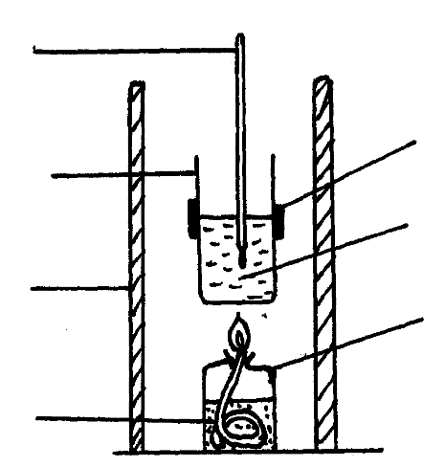
Thermometer

Metal calorimeter
Clamp
Spirit burner

Water
Draught shield

Liquid fuel

Results
Volume of water in the beaker = 500 cm³
Initial temperature of water= 12⁰C
Final temperature of water = 31.5⁰C
Mass of ethanol burnt = 1.50g
Density of water = 1 g/cm³
Specific heat capacity = 4.2 Jg⁻¹K⁻¹

- Define molar heat of combustion. (1 mark)
……………………………………………………………………………………………….......…
……………………………………………………………………………………………………...
……………………………………………………………………………………………………...
- (i) Calculate the heat required to raise the temperature of the water from 12⁰C to 31.5⁰C. (2 marks)

(ii) Find the molar enthalpy of combustion of ethanol. (2 marks)
$$(C=12, H=1, O=16)$$

- An accurate value for ΔH_{C} of ethanol is -1368 kJmol⁻¹. State two sources of errors for the low figure obtained. (2 marks)

……………………………………………………………………………………………….......…
……………………………………………………………………………………………………...
……………………………………………………………………………………………………...

- Draw an energy level diagram for the combustion of ethanol. (2 marks)

- Calculate the heating value of ethanol from the above experiment.
$(C = 12, H = 1, O = 16)$ (2 marks)

- State one factor that one may consider when choosing kerosene as a fuel in Eldoret town. (1 mark)
……………………………………………………………………………………………….......…
……………………………………………………………………………………………………...

- Ammonia can be prepared in the lab by reaction of Calcium hydroxide and an ammonium salt.
- Write an equation for the reaction that will take place. (1 mark)
……………………………………………………………………………………………….......…
……………………………………………………………………………………………………...
- Calculate the volume of ammonia produced at room temperature and pressure given that 20g of calcium hydroxide reacted fully. $(Ca = 40, H = 1, O = 16, N = 14, MGV = 24{dm}^{3}$) (3 marks)

- (i) Write an equation to show how ammonia is used to make phosphate fertilizer. (1 mark) ……………………………………………………………………………………………….......…
……………………………………………………………………………………………………...
……………………………………………………………………………………………………... (ii) Determine the percentage by mass of Nitrogen in the above fertilizer. $(N = 14, H = 1, P = 31, O = 16)$ (1 mark)

(iii) State the importance of using ammonium phosphate over urea as a fertilizer
(1 mark)
……………………………………………………………………………………………….......…
……………………………………………………………………………………………………...
……………………………………………………………………………………………………...
- Describe how the presence of nitrate ions can be determined in a solution using concentrated Sulphuric (VI) acid as one of the reagents. (3 marks)
……………………………………………………………………………………………….......…
……………………………………………………………………………………………………...
……………………………………………………………………………………………………...
- State one danger of continued use of Nitrogenous fertilizers. (1 mark)
……………………………………………………………………………………………….......…
……………………………………………………………………………………………………...
……………………………………………………………………………………………………...
- (a) Define solubility. (1 mark)
……………………………………………………………………………………………….......…
……………………………………………………………………………………………………...
……………………………………………………………………………………………………...

(b) The table below shows solubility of two salts X and Y at varying temperatures.
Temperature (⁰C) | 10 | 20 | 30 | 40 | 50 | 60 | 70 | 80 | 90
Solubility of Y (g/100g water) | 70.0 | 66.0 | 63.0 | 60.0 | 59.0 | 56.5 | 54.5 | 53 | 51
Solubility of X (g/100g water) | 12.0 | 18.0 | 24.0 | 31.0 | 38.0 | 48.0 | 51.0 | 74.0 | 88.0

- Draw the graph of solubility against temperature. (3 marks)

    - At what temperature is the solubility of both X and Y the same? (1 mark)
……………………………………………………………………………………………….......…
    - Which of the substances X and Y is likely to be a gas? Explain. (2 marks) ……………………………………………………………………………………………….......…
……………………………………………………………………………………………………...

    - What is the mass of Y that would dissolve in 50g of water at 48⁰C? (1 mark)

    - Determine the solubility of salt X at 55⁰C? (2 marks)
……………………………………………………………………………………………….......…
……………………………………………………………………………………………………...

    - State one application of solubility. (1 mark)
……………………………………………………………………………………………….......…

- (a) (i) What is meant by isomerism? (1 mark) ……………………………………………………………………………………………….......…
……………………………………………………………………………………………………...
……………………………………………………………………………………………………...

(ii) A hydrocarbon sample is found to contain 83.3% carbon and 16.7%
hydrogen. If the relative molecular mass of the compound is 72.0, determine its molecular formula. $(C=12, H=1)$ (3 marks)

(iii) Draw the structural formula and name the compound whose molecular formula is in (a) (ii) above. (2 marks)

- Study the chemical equation below and answer the questions that follow.

CH₃CH₂COOH + CH₃OH CH₃CH₂COOCH₃ + H₂O
R W

- Name the type of reaction represented by the above equation. (1 mark)

……………………………………………………………………………………………….........

- State two conditions in the reaction above. (2 marks)
……………………………………………………………………………………………….......…
……………………………………………………………………………………………………...
- Write an equation for the reaction between the compound labelled R and potassium hydroxide solution. (1 mark)

……………………………………………………………………………………………….......…
……………………………………………………………………………………………………...

- Name the type of reaction in b (iii) above. (1 mark)
……………………………………………………………………………………………….......…
- Give three differences between the reactions named in b (i) and b (iv) above.
(3 marks)
……………………………………………………………………………………………….......…
……………………………………………………………………………………………………...
……………………………………………………………………………………………………...
- 4 grams of methanol $\left({CH}_{3}OH\right)$requires 93.5 kJ of heat to vaporise completely. Calculate the heat required to vaporise one mole of methanol completely.
$(C = 12.0, H = 1.0, O = 16.0)$ (2 marks)

- a) Rubidium, atomic number 37 belongs to the same group as sodium.
- Explain why the element cannot occur free in nature. (1 mark)
……………………………………………………………………………………………….......…
……………………………………………………………………………………………………...
……………………………………………………………………………………………………...

- Suggest how the element would be stored in the laboratory (1 mark)
……………………………………………………………………………………………….......…
……………………………………………………………………………………………………...
……………………………………………………………………………………………………...
- Predict one physical property of Rubidium which is the same as that of transition metals such as iron. (1 mark)
……………………………………………………………………………………………….......…

- State two observations you expect when Rubidium is added to water. (2 marks)
……………………………………………………………………………………………….......…
……………………………………………………………………………………………………...
- What safety measure should be taken when adding Rubidium to water? (1 mark)
……………………………………………………………………………………………….......…
……………………………………………………………………………………………………...
- 43g of Rubidium was added to 1000cm³ of water, Calculate the volume of 0.5M sulphuric (VI) acid needed to neutralize 25cm³ of the solution
$(Rb=86, O=16, H=1,S=32)$ (3 marks)
$2Rb_{(s)}+2H_{2}O_{(l)}$ $2RbOH_{(aq)}+H_{2(g)}$

(b) Describe an experiment you can use to show that chlorine is more reactive than iodine. (2 marks)
……………………………………………………………………………………………….......…
……………………………………………………………………………………………………...
……………………………………………………………………………………………………...
(c) Aluminum Oxide is amphoteric and insoluble in water
- What do you understand by the term amphoteric oxide? (1 mark)

……………………………………………………………………………………………….......…
……………………………………………………………………………………………………...
- Describe how to show that Aluminium oxide is amphoteric. (2 marks)
……………………………………………………………………………………………….......…
……………………………………………………………………………………………………...
……………………………………………………………………………………………………...
- (a) Complete the table below to show the observation made and property when concentrated sulphuric (VI)acid is added to the following substances. (4 marks)
Substance | Observation | Property of Acid
sugar
Potassium nitrate crystals

(b) Below is a flow chart diagram for the contact process for the manufacture of sulphuric (VI) acid.
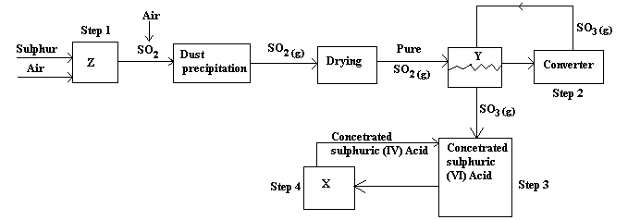
- Other than Sulphur state another substance that can be used (1 mark)
……………………………………………………………………………………………….......…
- Both platinum and vanadium (v) oxide can be used as catalyst, explain why vanadium (V) oxide is preferred over platinum in the process (1 mark)
……………………………………………………………………………………………….......…
……………………………………………………………………………………………………...
……………………………………………………………………………………………………...
- Give the name of chambers labeled (1 mark)
X ………………………………………….………………………………………………………
Y ………………………………………………………..…………………………………………
- State two uses of sulphuric(VI) Acid . (2 marks)
……………………………………………………………………………………………….......…
……………………………………………………………………………………………………...
……………………………………………………………………………………………………...

- State two precautionary measures taken to prevent pollution by the contact process (2 marks)
……………………………………………………………………………………………….......…
……………………………………………………………………………………………………...
……………………………………………………………………………………………………...
- Write the balanced equations for the reactions in; (2 marks)
Step 2: ………………………………………………………………………………………………………………………………………………………………………………………………………………
Step 4: ………………………………………………………………………………………………………………………………………………………………………………………………………………
- Calculate the volume of sulphur (VI) oxide gas in litres that would be required to produce 178kg of Oleum in step 3.
$(Molar gas volume at s.t.p.= 22.4L, H=1, O=16, S=32)$ (3 marks)

