EXPERT USER PROFICIENCY COURSE (EUP)
JUNE 2016 EXAMINATIONS SERIES
EUP 003: MS EXCEL: SPREADSHET.
            - Instructions
- Write your INDEX NUMBER in the space provided on the question paper
- Answer all questions in Section A.
- Answer all the theory questions in the spaces provided on the question paper
- Time allowed is: 30 minutes.

INDEX NUMBER: ___________________________________________________________________
SECTION A: THEORY - COMPULSORY (25MARKS)
QUESTION ONE (25 MKS)
- What is the purpose of Naming Ranges in formulas in Ms Excel? (4 marks)
……………………………………………………………………………………………………………………………………………………………………………………………………………………………….
- Explain the procedure for renaming a Sheet in Ms Excel (2 marks)
……………………………………………………………………………………………………………………………………………………………………………………………………………...……………………………………………………………………………………………..…………………………………………………………………………………………………………...………………………………………………………………………………...……………………………………………………………….
c. What is a spreadsheet? Give three examples of electronic spreadsheet software. (3 marks)
……………………………………………………………………………………………………………………………………………………………………………………………………………………………………………………………………………………………………………………………………………………………………………………………………………………………………………………………………………………………………………………………………………………………………………….

- Define the term Function as used in Ms Excel (2 marks)

Explain the uses of the following functions. (8 Marks)
- Date and Time
- Statistical
- Logical
- Math and Trig

……………………………………………………………………………………………………………………………………………………………………………………………………………………………………………………………………………………………………………………………………………………………………………………………………………………………………………………………………………………………………………………………………………………………………………………………………………………………………………………………………………………………………………………………………………………………………………………………………………………………………………………………………………………………………………………………….
……………………………………………………………………………………………………………………………………………………………………………………………………………………………………………………………………………………………………………………………………………………………………………………………………………………………………………………………….
(e) State the purpose of each of the following keyboard menu commands used in Microsoft Excel.
(6 Marks)
(i) ALT+V
(ii) CTRL+A
(iii) CTL+P
(iv)ALT+F4
(v) CTRL+HOME
(vi) F7
……………………………………………………………………………………………………………………………………………………………………………………………………………………………………………………………………………………………………………………………………………….
………………………………………………………………………………………………………………………………………………………………………………………………………………………………………………………………………………………………………………………………………………
EXPERT USER PROFICIENCY COURSE (EUP)
JUNE 2016 EXAMINATIONS SERIES
EUP 003: MS EXCEL: SPREADSHEET.
Instructions
- Answer any three questions in this section
- Marks will be awarded for both content and clarity of expression
- Create a folder on the Desktop and name it using your index number. Save all your practical work in this folder.
- Time allowed: 2 hours and 30 minutes.
SECTION B: (75 MARKS)
QUESTION 1
- A Company uses Excel to store salary information. Create the following sheet and do
any calculations indicated below (5 marks)

NAME GROSS SALARY TAX NET SALARY

Abel 32500
Alexander 25000
Blanks 30000
Catherine 25000
Steve 75000
Janc 90000
Edwards 45000
Diamond 45000
Davis 90000

- Given that the Tax=25% of the Gross Salary, calculate the value for
Tax and Net salary for all the employees. (4marks)
- Sort the above records in ascending order by making use of the Name column. (3marks)
- Filter those records having names starting with ‘A’. (3marks)
- Draw a Bar graph to represent your data. Insert a legend and all Titles (4marks)
- Format the values in Comma Style. (3marks)
- Save the file as Expract1. (3marks)

QUESTION 2
The spreadsheet below shows the details about some items for an individual.
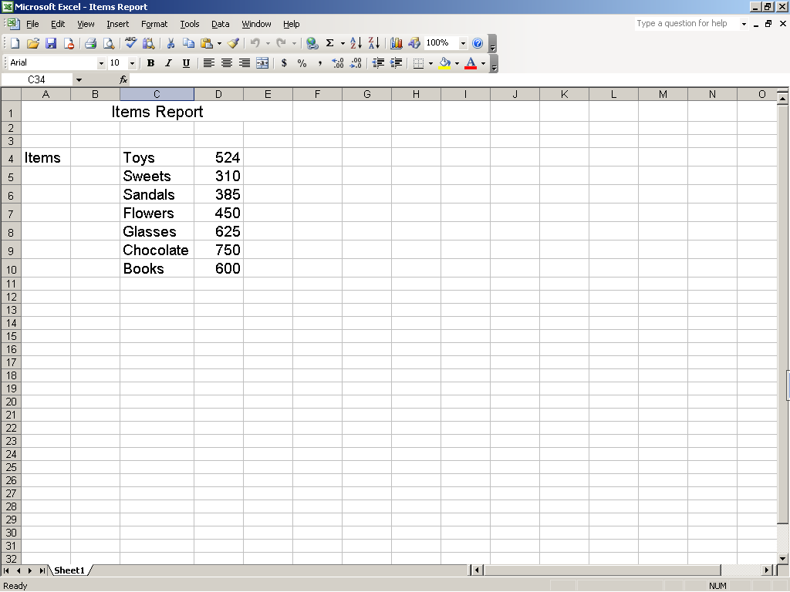

- Create a new Excel spreadsheet and enter the data exactly as it appears above.(8 Marks)
- Type Date in cell C3 and make it bold. (2 Marks)
- Use the function to insert date in cell D3. (2 Marks)
- Type Total in cell A11, Maximum in cell A12, Minimum in cell A13 and Average in cell A14. (4 Marks)
- Use the relevant functions to calculate Total in cell D11, Maximum in cell D12, Minimum in cell D13 and Average in cell D14. (8 Marks)
- Save the worksheet as Report on Items. (1 Mark)
QUESTION THREE (25 MARKS)

Prepare the following worksheet, which represents the stock records of Miami
ENTERPRISES LTD for the month of May. Save it as Miami. (5 marks)
ITCODE | PROD | QUANT | BPRICE | SPRICE | TBPRICE | TSPRICE | DISCALL | VAT | NTPRICE | PROFIT

- Enter at least ten relevant records of your choice in the following fields: Item code, Product,
Quantity, Buying price (Bprice) and Selling price (Sprice), Compute the following as per
the formula or condition given. (12 marks)
  - Tsprice = Sprice x Quantity
  - Tbprice = Bprice x Quantity
  - Discall = 2.3% of Tsprice
  - VAT = 8% of the buying price(Bprice)
  - Nprice =Tsprice-(VAT+Discall)
  - Profit = Nprice – Tbprice
- Compute the total profit or loss made during the month. (3 marks)
- Format the worksheet to have all the currency values in two decimal places and
Kshs sign. Using patterns, borders, fonts, and alignment commands on format-cells make
the worksheet to look as presentable as possible. (5 marks)

QUESTION FOUR (25 MARKS)
The table below shows part of a spreadsheet that is used by a company that employs salespersons. In addition to the basic salary each receives a commission of 20% on goods sold. All four are taxed at a rate of 15 %. Save work as QUESTION FOUR
      - Prepare a worksheet to hold the data (10 marks)
      - Calculate the employee’s commission. Write the formula that returns Edgar’s
Commission (2 marks)
- Calculate the employee’s Gross pay. Write the formula that returns Sheila’s Gross (4 marks)
- Calculate net income for each employee. Write the formula that computes Wallace Net Income
(5 marks)
- Generate a pie chart that shows the share of each employee’s Net Income only. (4 mark

