ASUMBI GIRLS HIGH SCHOOL
POST -MOCK 1
AUGUST/SEPTEMBER
2022

COMPUTER PP1 MS

Instructions to Candidates
- Write your Name, Admission number and Class in the spaces provided above.
- This paper consists of two sections; A and B.
- Answer ALL the questions in section A
- Answer question 16 and any other THREE questions from section B
- ALL answers should be written in the spaces provided on the question paper.
- This paper consists of 7 printed pages.
- Candidates should check the question paper to ascertain that all the pages are printed as indicated and that no questions are missing.
- Candidates should answer the questions in English

SECTION A (40 MKS)
Answer all questions in this section.
- State the software technological differences between the second generation and the third generation computers [2]
2nd generation used assembly languages while 3rd generation used high-level languages

- State two ways of ensuring proper ventilation in a computer room [2]
- Wide windows
- Use of vents/ventilators
- Air-conditioners/dehumidifiers/fans
- Providing spacious environment
- Avoid over crowding

3. Convert the decimal number 20.375 to it binary number system equivalent [3]
20₁₀ = 10100₂
.375 x 2 = 0.75
.75 x 2 = 1.5
.5 x 2 = 1.0
Hence 20.375₁₀ = 10100.011₂
- Pat has installed internet in his home computer in order to use it for browsing. State three ways in which he would prevent viruses from infecting the computer. [3]
- Using antivirus software
- Surfing smart e.g. avoid certain sites/ovoid downloading certain attachments
- Use of firewalls to prevent certain attachments/hackers
- Use of complex password to restrict data access
- Scanning downloads
- Enabling the security settings in the browser
- State three ways of transforming a picture embedded in a Desktop Publishing programme in order to fit in a designated space on a computer. [3]
- Rotation
- Flipping
- Cropping
- Stretching
- Resizing
- Distinguish between a line printer and a page printer as used in computers. [2]
Line printer prints one line of text at a time while page printer prints a whole page at a time

Line printer is impact while page printer is non-impact

Line printer is slow while page printer is fast
Line printer is noisy while page printer is quiet

- Describe virtual reality as used in computers. [2]
Computer generated simulation of a three-dimensional image/environment that can interarcted with in a seemling real or physical way by a person wear specialized head gear.
- State the function of each of the following features of an email software
- Inbox [1]
Storage location where new email messages aare stored.
- Draft [1]
A storage location where messages composed but not yet sent are stored
- a) Explain the term toggle key as used in computer keyboard [2]
Keys that alternate the input mode. When press ON they intended to perform a task, when pressed OFF, they perform a different task.
b) List two examples of toggle keys on a keyboard [2]
Caps lock, Insert, Num lock and Scroll locl
10. State the type of error that would occur in data processing for each of the following cases:
a) Entering the number 315 instead of 351 [1]
Transposition error
b) Entering the text “Kwys” instead of “Keys” [1]
Transcription error
11. State four factors to consider when selecting an input device for use in a computer room. [4]
- Compatibility with existing system
- Cost of the device
-Extra features in the device
- Purpose of the device
- Nature of data to be captured
- Portability
12. State three functions of Un-Interruptible Power Supply (UPS) [3]
- Stabilizes power
- Stores power
- Alerts user through an alarme system when poer is down
13. Distinguish between a page break and a column break as used in a word processor. [3]
Page breaks marks the end of a page while column page marks the end of a column
NB. Accept illustrations
14. State three factors to consider when selecting an operating system to install in a computer. [3]
-Hardware configuration a computer e.. RAM.HDD, and othersystemrequirements
- Type of computer in terms of size and make
- User-friendliness
- Number of users it can support
- Cost
- Applications intended for use in the computer
15. Differentiate between analogue signal and digital signal as used in computers. [2]
Analog data uses values that change continuously while digital uses values that are descrett
NB. Accept illustrations

SECTION B (60 marks)
Answer ALL questions from this section in the spaces provided.
16. a) Explain the term dry running as used in program development. [2]
Process where a programmer manually (pen & Pencil) work through a code to trace the values of variables and to identify errors
b) Describe three properties of an algorithm. [3]
_Must have a start and a stop
-Steps must be precise
- Statements must not have more than one meaning/no ambiguity
- There should be clear indentation of statements
- Input,Output and Procesing statements should be clearly defined using keywords

c) Write an algorithm using both pseudocode and flow chart to print the sum and average of numbers from 1 to n where n is provided by user and n>=1. [10]
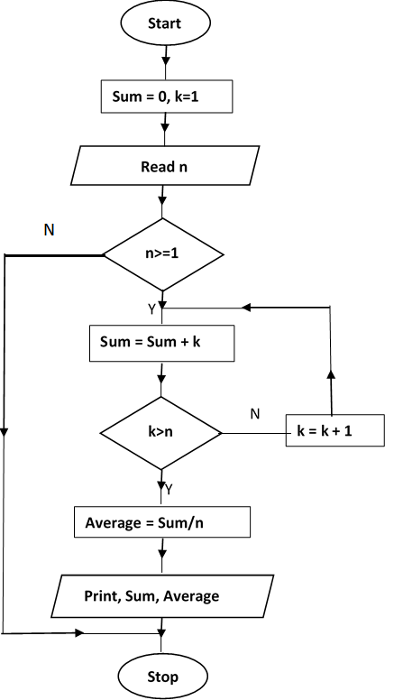
Start
Sum=0, k=1
Read n
If n>=1 then
Repeat
Sum=Sum + k
k=k+1
Until k=n
Average=Sum/n
Print Sum, Average
Stop

17. a) State four outcomes that may result from using incorrect requirement specifications during system development. [4]
- System may end up being costly
- System may be delivered late
- System may not meet user specification
- Higher cost of maintenance
- System may be unreliable and prone to errors
- System may not meet legal requirements
b) A school opted to use direct change over approach when installing a new system. Explain three challenges that the school may face as a result of this approach. [6]
- In case of a problem thre will be no fall back
- There will be less time for users to familirise themselves with new system
- Possibility of sabotage by users because of less time to monitor and manage stress resistance
c) State three reasons that may lead an organization to install an intranet. [3]
- to isolate resource from the internet
- to provide communation and collaboration amongst organization staff
- to publish and share valuable information easily with users
- to safely run critical applications
d) The figure below shows a coaxial cable. State the function of the part labelled A. [2]
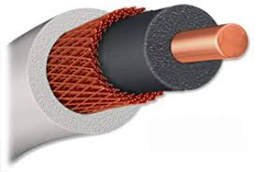
A

Used to provide insulation
To block electromagnetic fields from interference
To protect signal distortion

18. Use the figure below to answer the questions that follow:.
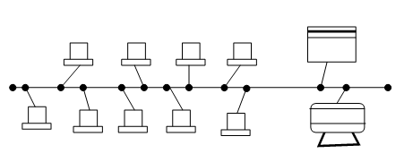

a) Give the name of the above network topology [1]
Bus
b) State three disadvantages of the above topology [3]
- Slow
- T-Joints weaken the signal (BNC connectors)
- A bus that is not terminated causes Ringing
c) A publisher intends to use a desktop publishing programme to create a publication which is to have many graphics. State three ways in which the graphics may be acquired for this purpose. [3]
- Using digital camera
- Scanning thegraphics from other sources
- Downloading from the Internet
- Drawing/Drawing tools
- Clipart
d) Interpret each of the following spreadsheet formula:
- =count if(D2:D9,”>”B4) [2]
Count those values in the range D2;D9 with values greater than the value in cell B4
- =sumif(B3:B11,”4M”,D3:D11) [2]
Sum the values in the cell range D3;D11 for records whose corresponding values in cell range B3:B11 equals to “4M”
d) i) The following are the fields of products table in a database created to store records of products manufactured in factory:
- Product number Autonumber/Text
- Product name Text/String
- Price Currency/Number
- Product description Memo/Text/String
I. State the appropriate data type for each field [4]

19. Explain three features of a graphical user interface as used in computers. [6]
- Windows
- Icons
- Menus
- Pointers
b) State the function of each of the following computer keyboard keys:
i) Caps Lock [1]
Is a toggle key when ON the characters typed are in uppercase and when OFF the characters typed are in lower case
ii) Shift [1]
Used together with alphanumeric key to type the alternate character
- Home [1]
Used to take the cursor to the beginning of a line
Used in conjunction with other keys to modify the function of the key

c) Using two’s complement notation, determine the value of the operation 25₁₀ – 29₁₀. [6]
25₁₀ = 0001 1001₂
29₁₀ = 0001 1101₂

2s complement of 29₁₀ = 1110 0010
+ 1
1110 0011

Adding the two binary numbers
0001 1001
+ 1110 0011
11111100
20. a) Distinguish between a computer drive and computer driver. [2]
A computer drive is a hardware component that facilitates storage and retrieval of data on incorporated to the operating system the controls the functionality of their specific peripheral devices. A removable storage device while a computer driver is sets of instructions installed
Difference @ 2 Marks

b) State two peripheral devices connected to the computer via PS2 [1 ]
- Keyboard
-Mouse
c) Jane encountered desktop computer with the following features
- 3.0 USB ports
- 4.0 GB primary storage
-19” TFT VDU
- 500 SATA HDD
-Linux 7.1
-AVG antivirus
- Give 3 reasons for wide use of USB gadgets in the society today. [3]
- Allows multiple peripheral devices on a single port
Quality data transmission
Faster data transmission
- What is the meaning of the following specifications :
- 4.0 GB primary storage [1 ]
-19” TFT VDU [1]
- 500 SATA HDD [1]
-Linux 7.1 [1]

iii) Give three factors to consider when selecting an OS to install in your computer. [3]
- Processor speed
- Purpose of the computer
- Memory size
- Compatibility and
- Upgradeablility
- User needs
- User friendliness
- Make of the computer

iv). Describe two symptoms of a computer infected by virus. (2]
-Hang ups
-Shutting down frequently
-Error messages
-Quizical messages
- file increase and decrease

