NAME ____________________________________________ ADM NO ______________
DATE ________________________________ Class ___________________________
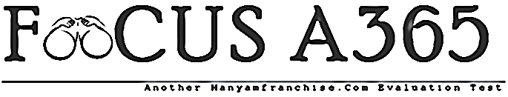

FORM 1 TERM 2 CRE EXAMINATIONS 2018

1. Give four reasons why Christian religious education (C.R.E) is learnt in schools (4mks)

2. a)Identify four poetic books in the old testament (4mks)

b)Explain four reasons that make Christians not to be able to read the bible (4mks)

3. Outline four responsibilities given to human beings during creation in the Old Testament (4mks)

4. State four consequences of sin according to the book of Genesis (4mks)

5.a)Outline six promises made to Abraham by God (6mks)

b)State four ways in which Christians demonstrate their faith to God today (4mks)

6.a)Explain three differences between the Jewish circumcision and traditional African circumcision
(6mks)

b)Identify four forms of modern covenants in our society today ( 4mks)

7.a) Describe the call of Moses [exodus 3:1-22] (8mks)

b)Identify four attributes of God that a Christian can learn from the ten plagues (4mks)

8a) Explain four ways in which God demonstrated his love to Israelites during the exodus. (8mks)

b) In which ways do Christians go against the Decalogue today. (5mks)

9a) Give six reasons why Israelities demanded for a king. (6mks)

b) Identify five ways in which church leaders fail in their duties today. (5mks)

10. a) Explain four achievements of king David as king of Israel. (8mks)

b) Outline the importance of the temple in Israel. (6mks)

11a) State five reasons why Elijah faced danger in Israel. (5mks)

