**MWAKICAN JOINT TEAM EXAM (MJET)**

**FORM 4 AGRICULTURE PAPER 2**

**END OF TERM 1 2016**

**SECTION A: 30MKS**

**SECTION B: 20MKS**

**SECTION C: 3 ESSAY QUESTIONS STUDENTS TO ANSWER 2 EACH**

**CARRYING 40MKS.**

**SECTION A ( 30MKS)**

**ANSWER ALL QUESTIONS IN THIS SECTION**

1. State two importance of litter in a poultry house. (1mk)

2. Give three ways by which infections livestock disease can be spread on a farm. (1 ½ mks)

3. Distinguish between Wessex saddlebacks & Berkshire breeds of pigs. (1mk)

4.a) Give two uses of a planter. (1mk)

b) State two ways of connecting a planter onto a tractor. (1mk)

5. Name two bacterial diseases which are not vector-transmitted. (1mk)

6. State two types of mowers. (1mk)

7. State how each of the following practices controls livestock diseases

a) Quarantine (1mk)

b) prophylaxis (1mk)

8. List four farm structures used in the control of livestock parasites. (2mks)

9. State two effects of mange mites on goats. (1mk)

10. Name four cattle breeds that originated from England. (2mks)

11. State two functions of the crop in the digestive system of poultry. (1mk)

12. Give two reasons why a dairy should be white washed but not oil painted. (1mk)

13. Below is a table showing animals of different ages and sexes. Give the name that describes the animals in the respective columns. (2 ½ mks)

|  |  |  |  |
| --- | --- | --- | --- |
| Description | Cattle | Pigs | Poultry |
| Young from hatching/birth to weaning |  |  |  |
| Young female before1st birth/k |  |  |  |
| Mature male for breeding |  |  |  |

14. Give the functional difference of the following pair of tools. (2mks)

a) Bastard file and Rasp file

b) Copying saw and hacksaw. (1mk)

15. Why are the following conditions maintained during artificial incubation of eggs in poultry production.

a) Proper ventilation. (1mk)

b) Relative humidity at 60%. (1mk)

16. Give two reasons for rearing indigenous cattle in marginal areas of Kenya. (1mk)

17. State four limitations of using hydroelectric power on the farm. (2mks)

**SECTION B: (20MKS)**

**ANSWER ALL QUESTIONS**

18.a) State the class of each of the following feedstuffs. (1mk)

i) Molasses-

ii) Maclick super-

b) The diagrams below represent livestock parasites

Z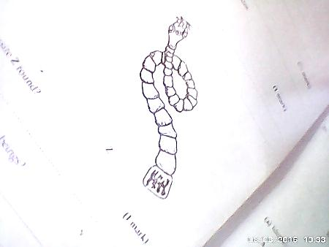

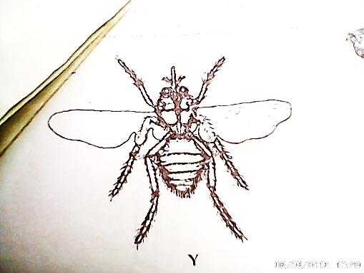

Y

i) Identify the parasites. (1mk)

Y-

Z-

ii) In which organs in livestock is parasite Z found? (1mk)

iii) How is parasite Z passed from livestock to human beings? (1mk)

18.c) Give two control measures of each parasite. (2mks)

i) Y

ii) Z

1`9.a) State two functions of a hypodermic syringe and a needle. (1mk)

b) Distinguish between closed and open methods of castration. (1mk)

c) Give two importance of progeny testing method of selection over mass selection method. (2mk)

20.a) Study the diagram below and answer the questions that follow

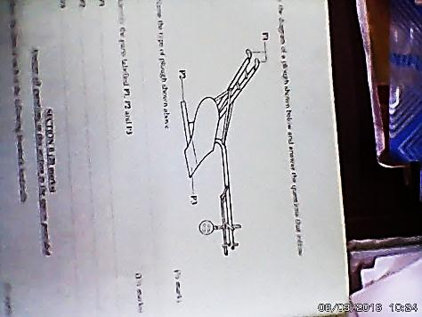 P1

i) Name the type of plough shown above. (1mk)

ii) Identify the parts labeled P1,P2,and P3. (1 ½ mks)

p1-

p2-

p3-

iii) State two ways through which a farmer would increase the depth of cultivation when using the implement. (1mk)

b) Study the farm tools illustrated in the diagrams below

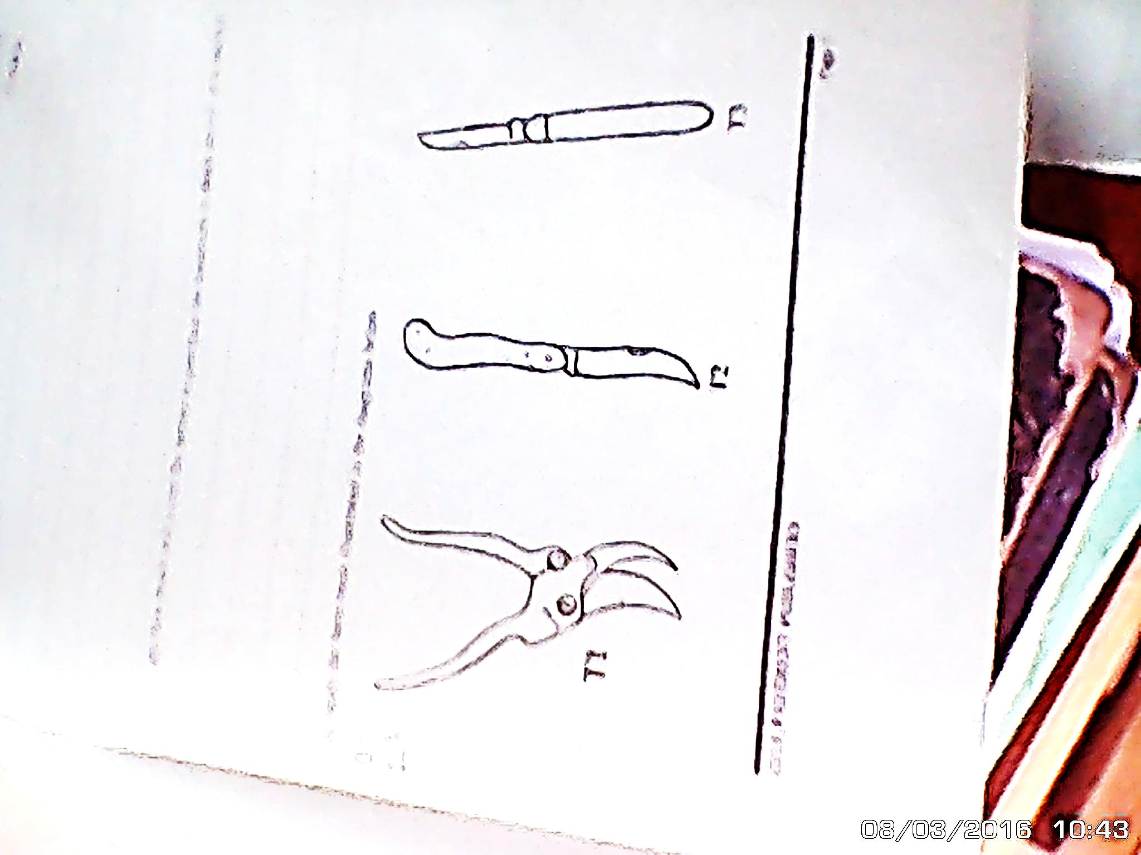

i) Identify each of the farm tools illustrated in the diagrams above. (1 ½ mks)

T1-

T2-

T3-

ii) State one use of the tool labeled T1. (1/2mk)

c) State two uses of green houses on the farm. (1mk)

d) Name two chemicals used in wood preservation. (1mk)

21.a) State four factors that cause swarming of bees. (2mks)

b) Define a fingerling. (1/2mk)

**SECTION C: 40MKS**

**ANSWER ONLY TWO QUESTIONS**

22.a) Outline the procedure followed when hand spraying cattle to ensure effective use of acaricides to control ticks. (8mks)

b) Outline the daily maintenance practices that should be carried out on a farm tractor. (7mks)

c) State the reasons for maintaining farm tools equipment and machinery in good working conditions. (5mks)

23.a) Discuss cannibalism in poultry rearing under the following sub-headings

i) Definition of cannibalism. (1mk)

ii) Types of cannibalism. (2mks)

iii) Causes of cannibalism. (8mks)

iv) Control of cannibalism. (9mks)

24.a) Explain ten factors considered when selecting livestock for breeding. (10mks)

b) Describe the working of a four stroke cycle petrol engine. (10mks)