NAME …………………………….. INDEX NO. ……..…
DATE ……………………………. CLASS ……………..
MWAKICAN FORM 4 JOINT EXAMINATION – 2016 TERM 1
KENYA CERTIFICATE OF SECONDARY EDUCATION
233/1
CHEMISTRY

(THEORY)
END OF TERM 1 2016
2 ¼ HRS
INSTRUCTIONS TO CANDIDATES
(a) Answer your name and index number in the spaces provided above.
(b) Answer all the questions in the spaces provided in the question paper.
(c) Mathematical tables and silent electronic calculators may be used.
(d) All working must be clearly shown where necessary.

1. (A) Distinguish between allotropy and isomerism (2mks)

(b)Draw and name an isomer of butane (1mks)

2. (A) State grahams law of diffusion (1mks)

(b) 60cm³ of oxygen gas diffused through a porous portion in 50 seconds. How long would it take of sulphur (IV) oxide gas to diffuse through the same portion under same conditions?(S=32.0, O=16.0) (3mks)

3. (A) Both iodine and astatine belong to the same group in the periodic table.name the group
(1mks)

(b) Astatine is below iodine in the group how does their boiling points compare Explains?(2mks)

4. A mixture contains iron (ii) chloride, zinc (ii) oxide and potassium chloride. Describe how each of the substances can be obtained from the mixture (3mks)

5. (A) what is a fuel (1mks)

(b) Other than heat content what other two factors should be considered when choosing a fuel (1mks)

6. The following is a flow chart representing the manufacture of fertilizer
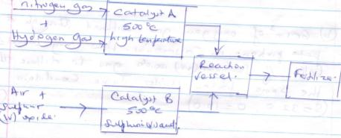

(a) Identify (2mks)
(i) Catalyst A

(ii) Catalyst B

(b) Give one source of hydrogen gas (1mks)

(c) Write down the formula of fertilizers formed (1mks)

Water from kerugoya is suspected to contain sulphate ions. Describe how the presence of sulphate ions in the water can be shown (2mks)

(b) State one advantage of drinking hard water rather than soft water (1mks)

8. The diagram below represents neutralization process carried out by a student
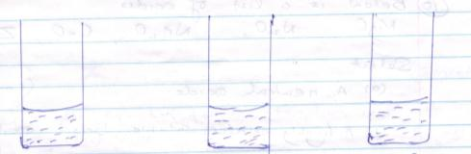
50cm³of 2M NaoH 50cm³of 2M 100cm³of solution
At 21ºc Hcl at 21⁰c of 2M Naoh and 2M HCL at 27⁰C

Calculate the molar heat of neutralization for the reaction that takes place (take specific heat capacity =4.2kg⁻¹k⁻¹ and density of solution =1g/cm³) (3mks)

9. The table below shows relative atomic masses and percentage abundance of the isotopes L1, L2 of element L
 | Relative atomic masses | %of abundance
L1  L2 | 62.93  64.93 | 69.09  30.91
Calculate the relative atomic mass of L (3mks)

10. Below is a list of oxides
MgO, N₂O, Na₂O, CaO, .
Select
(a)Neutral oxide (1mks)

(b)Highly water soluble basic oxide (1mks)

(C) An amphoteric oxide (1mks)

11. (A) state Charles law (1mks)

(b) A certain gas occupied 4.2dm³ at 27ºC and 2 atmosphere pressure. At what pressure will it be halved if the temperature then was 127⁰C (3mks)

12.study the chart below for manufacture of nitric(v)acid and answer the questions that follows
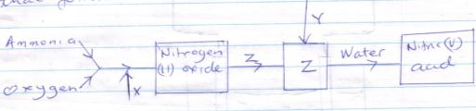
(A) Name:
X_________________
Y__________________
Z__________________ (3mks)
(b)Give the equation for the reaction in which nitrogen (ii) oxide is formed (1mks)

(c) State one use of nitric (v) acid (1mks)

13.Starting with calcium oxide describe how a solid sample of calcium carbonate can be prepared (3mks)

14.The diagram below shows set up which was used by a student to investigate the effect of electricity on molten lead(ii) iodide
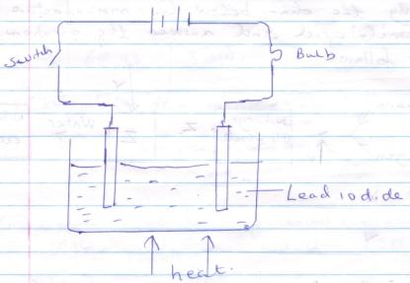
(a) Identify cathode and anode (1mks)

(b) Why does solid lead (ii) iodide not allow the passage of electricity (1mks)

(c) Write equations to show reaction taking place
(i) At cathode

(ii) At anode (2mks)

15. The diagram below shows a set up used by a student to prepare and collect chlorine gas
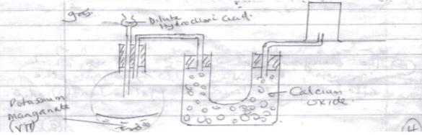
(a) Identify with reasons two mistakes in the set up (3mks)

(b) Give another set of reagents that can be used to prepare chlorine gas (1mks)

16. Given below are pH. values of different solutions P, Q, and S. study it and answer the questions that follows
Solution Ph.
P 1
Q 7
S 14
(A) Which two solution would react together to give a pH. of 7.0 (1mks)

(b) Which solution is likely to be sodium chloride solution (1mks)
(c) What is the color of phenolphthalein when added to solution S (1mks)

17. The table below gives properties of four substances
Substances | Melting points | Boiling point | Electrical conductivity
A  B  C  D | 1083  -182  1723  993 | 2567  -164  2230  1695 | solid | liquid
 |  |  | Good  Poor  Poor  poor | Good  Poor  Good  poor

State with reasons which of the above is
(i) An ionic compound (1mks)

(ii)Metallic structure (1mks)

(iii) A giant atomic structure (1mks)

18.Metal X displaced Z from its salt solution and metal Y displaced metal W from its salt solution . It was also observed that W and Y reacted with steam but X and Z did not. The reactivity of the metals starting with the most reactive is (2mks)

19. Two detergents And B represented as
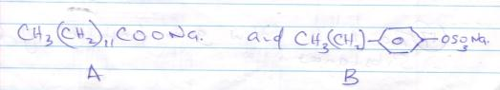
(a) Which of the detergent is suitable for washing using water containing magnesium sulphate (2mks)
(b)Give one disadvantages of continuous use of the detergent you have choose in (a) above (1mks)

20. A compound was found to contain 48.7% carbon 8.1% hydrogen while the rest was oxygen by mass. If the relative molecular mass of the compound is 148 determine its molecular formula(C=12, H=1, O=16) (3mks)

21. (a) What is a saturated solution (1mks)

(b) 28gms of a saturated solution of the salt at 25⁰c yielded 7gms of solid when evaporated to dryness. Find the solubility of the salt at 25⁰C . (3mks)

22. (a) The lattice energy for sodium chloride is 781kj/moa while the hydration energy is 774kjmol-1 calculate the enthalpy of solution of sodium chloride (2mks)

b) Draw an energy level diagram when 1 mole of sodium chloride dissolves in water. (2mks)

23. A form two student during an experiment left a container containing concentrated sulphiric (vi) acid exposed in air for two days. After two days he observed the level of acid had risen
(i) Why did the level of acid in the container rise (2mks?)

(ii) How is this useful in the laboratory (1mks)
24.A clean knife is left in the open overnight and found to be coated with a reddish brown substances
(I) Write down the chemical formula of reddish-brown substances (1mks)

(ii)Give one condition necessary for the brown substance to be formed (1mks)

(iii) Suggest two methods that can be used to prevent formation of the reddish brown substances on the knife (2mks)

