MWAKICAN JOINT EXAMINATION TEAM-MJET
PHYSICS PAPER 1
MARKING SCHEME
FORM 4 2016
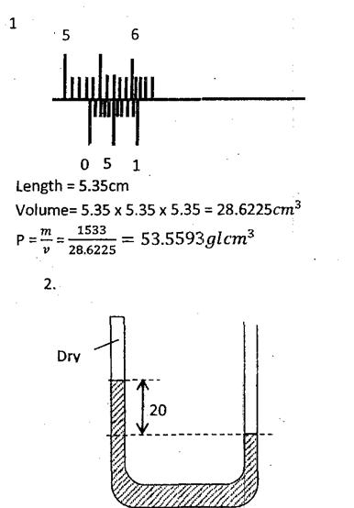
10

2 cm
Total pressure = atm + ρgh
= 760mmHg+20mmHg
= 780mmHg

3. This breaks the surface tensionof water running over the canvas tent hence increasing adhesive force so
that the tent leaks.

4. Cohesive forces are stronger in solids than in liquids

5. In case of fire outbreak, the temperature increases, brass expands more than iron.
The bimetallic strip bends towards the iron side and makes the contact.
This completes the circuit causing the electric bell to ring.

6. The metallic chair is a good conductor of heat and gains heat faster than the wooden bench, which is a poor conductor of heat

7. For a system in equilibrium, the sum of clockwise moments is equal to the sum of anticlockwise moments

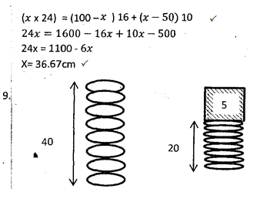

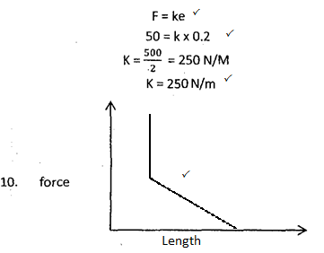

11. The length of the spring reduces as the masses are added until it cannot reduce anymore

12. For a fluid that is non-viscous incompressible and the flow is streamline, then an increase in velocity causes a corresponding decrease in pressure it exerts.
13. a.
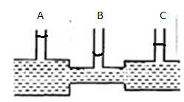
b. Water level in manometer B is lower than the levels in manometer A and C. Water level in manometer A is the highest hence high pressure compared to B and C.

14. i. B will have a higher temperature than the water in A. Dull surfaces are good obsorbers of heat
ii.
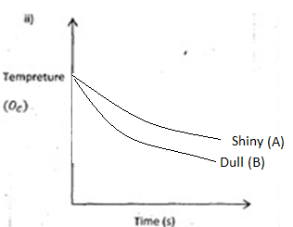
15. a. For a fixed mass of gas volume is directly propotional to absolute temperature provided pressure is kept constant.
b. i) - Length of the air column trapped / volume of air (L)
- Temperature of the water bath
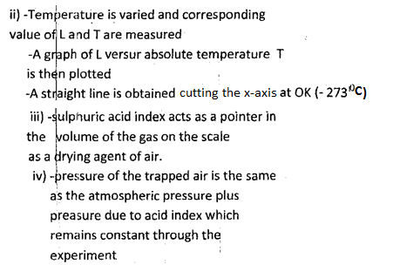
recorded

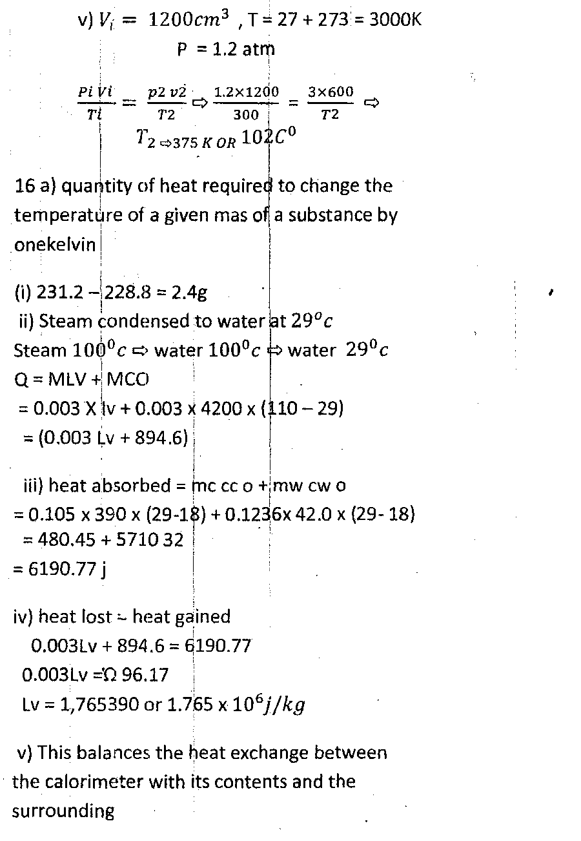
102⁰c

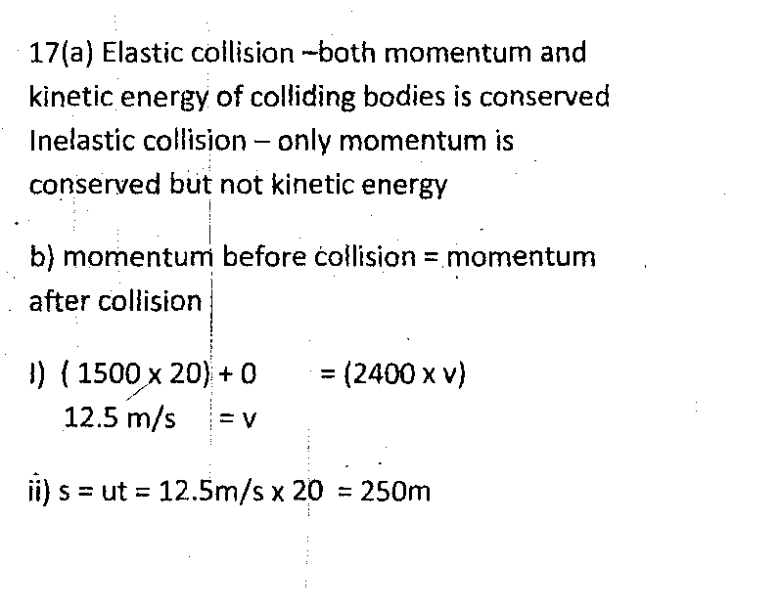
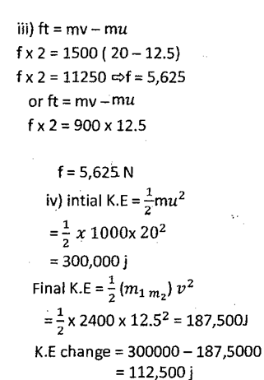
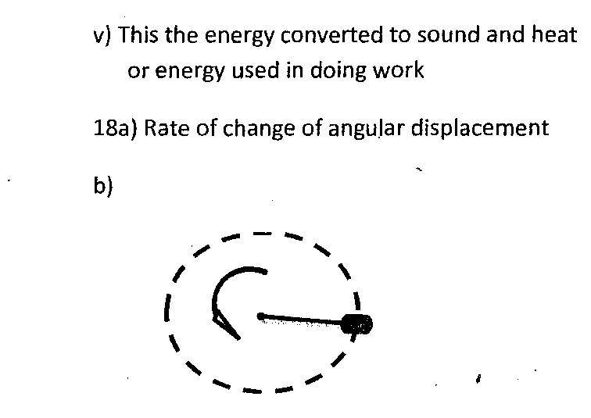
F
ii) f=2Hz
ω= 2$πf$
= 2 x 3.142x2
= 12.56
V= r ω
= 0.35 x 12.56
= 4.3982m/s

