**FORM 4 PHYSICS PAPER 3**

**MARKING SCHEME**

1

|  |  |  |  |  |  |
| --- | --- | --- | --- | --- | --- |
| Angle i | L(cm) | L2(cm) | (cm-2) | Sin2i |  |
| 20 | 6.9 | 47.61 | 0.0210 | 0.1170 |  |
| 30 | 7.1 | 50.41 | 0.0198 | 0.2500 |  |
| 40 | 7.3 | 53.29 | 0.0188 | 0.4132 |  |
| 50 | 7.9 | 62.41 | 0.0160 | 0.5868 |  |
| 60 | 8.2 | 67.25 | 0.0149 | 0.7500 |  |
| 70 | 8.6 | 73.96 | 0.0135 | 0.8830 | (6mks) |

h) Slope = 

(0.70, 0.0152) (1.02, 0.012)

Slope = 

i) C = 0.0224

B = 2.20

j) Q = 

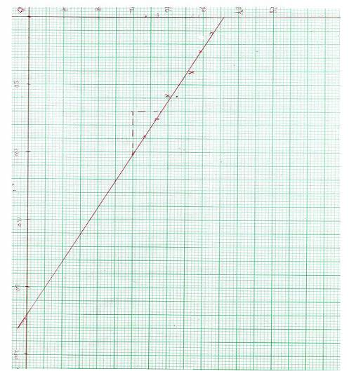



Sin²i × 10²

= 2.24 =1.020

2.

|  |  |  |  |  |  |  |  |
| --- | --- | --- | --- | --- | --- | --- | --- |
| Length L(cm) | I(A) | Pd V(v) | I(mA) | pdV(v) (mV) | Log I | Log V |  |
| 20 | 0.14 | 0.25 | 140 | 250 | 2.146 | 2.398 |  |

2.

|  |  |  |  |  |  |  |  |
| --- | --- | --- | --- | --- | --- | --- | --- |
| Length L(cm) | I(A) | Pd V(v) | I(mA) | pdV(v) (mV) | Log I | Log V |  |
| 20 | 0.14 | 0.25 | 140 | 250 | 2.146 | 2.398 |  |
| 30 | 0.16 | 0.35 | 160 | 350 | 2.204 | 2.544 |  |
| 40 | 0.18 | 0.50 | 180 | 500 | 2.255 | 2.699 |  |
| 50 | 0.19 | 0.65 | 190 | 650 | 2.279 | 2.813 |  |
| 60 | 0.20 | 0.85 | 200 | 850 | 2.301 | 2.929 |  |
| 80 | 0.24 | 1.30 | 240 | 1300 | 2.380 | 3.114 | (9mks) |

Appropriate straight line graph from the given values (strictly from the table values)

e) Slope = (3.0,2.32) (0.16,1.50)

 (3mks)

f) Log k =C =1.46 k=10 1.43 = 28.84 (2mks)

n=slope=0.2284 (1mk)