NAME INDEX NO…………………....................
CANDIDATES SIGN……………………
DATE……………………………………
232/2
PHYSICS
PAPER 2
(THEORY)
MARCH/APRIL ,2016
TIME:2 HOURS
MWAKICAN JOINT EXAMINATION – 2016
Kenya Certificate of Secondary Education
Form 4 Physics
Paper Time:2 Hours.
Instructions to candidates.
- Write your name and index number in the spaces provide above.
- This paper consists of two sections A and B.
- Answer all questions in section A and Bin the spaces provided.
- All working must be clearly shown in the spaces provided.
- Non-programmable silent calculators and KNEC mathematics tables may be used.
FOR EXAMINERS USE ONLY.
SECTION | question | Maximum score | Candidates score
A | 1-12 | 25
B | 13-17 | 10
 |  | 10
 |  | 12
 |  | 15
Total |  | 80

SECTION A(25MKS)
ANSWER ALL QUESTIONS IN THIS SECTION IN THE SPACES PROVIDED.
- Figure 1 shows a point object O in front of a plane mirror M.
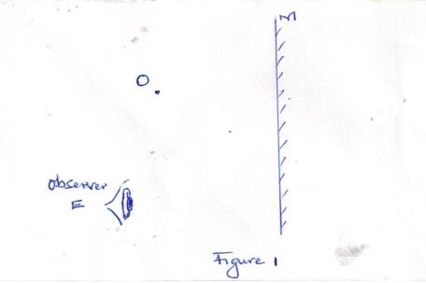

On the same diagram locate the position of the image as observed by the observer E. 3mks
- A positively charged sphere is suspended by an insulating thread .A negatively charged conductor is suspended near it. The conductor is first attracted ,after touching the sphere it is repelled .Explain this observation. (2mks)

- A current of 0.5 A flows through an electric circuit. Determine the quantity of change that passes a point in the circuit in 6 minutes.(2mks)

Figure 2 shows a wire wound on a magnetic material, and then connected to direct current source. Use to answer question 4 and 5.
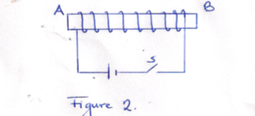

- Determine the polarity of A and B when the switch is closed.(1mk)

- State two ways of increasing the strength of the magnet formed through the method in number 4.(2mks)

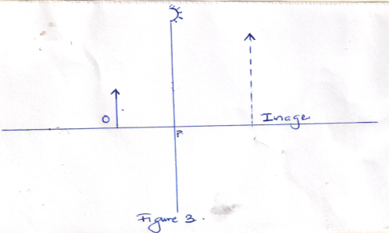
- An object is placed in front of a concave mirror as shown in figure 3.

The image of the object is formed as shown above. Locate the principal focus of the mirror and determine its focal length.(3mks)

- Figure 4 shows a displacement time graph of a wave travelling at 200 cm/s.
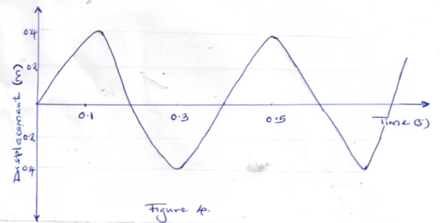

Determine the wavelength of the wave.(3mks)

- A solder standing between two cliffs fires a gun. He heard the first echo after 2.0 seconds and the next 5.0 seconds later. Determine the distance between the two cliffs.(Speed of sound in air is 320 m/s.(3mks)

- An electric heater rated 1.5 kw, 240 v is used to heat water for 6 minutes. Determine the energy consumed by the heater in this time.(2mks)

- State two conditions necessary for two progressive waves moving in opposite direction to produce a stationary wave.(2mks)

- Arrange the following radiations in order of decreasing wavelength.
Gamma rays, visible light, Radio waves, ultraviolet radiation.(1mk)

- State one detector of Gamma rays.(1mk)

(SECTION B:55 MARKS)
Answer all questions in this section in the spaces provided.
- (a) Sate what is meant by the term “ electromagnet”(1mk)

(b) Figure 5 shows a simple electric motor.
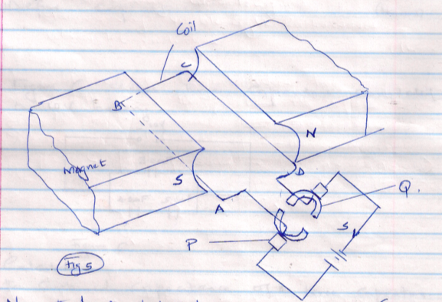

- Name the parts labeled
P-
Q-
- The switch s is closed ,indicate the direction of current in the coil and how the motor works.(4mks)

- State three ways in which the speed of the motor can be increased.(3mks)

- (a) Define capacitance.(1mk)

(b) Figure 6 shows three capacitors connected to 10V battery .
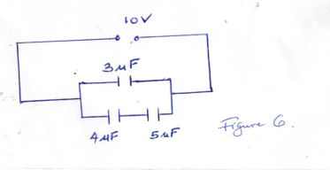

Calculate
- The combined capacitance of the three capacitors.(3mks)

- The change on the 5.0 $μ$F capacitor.(3mks)

- (a) State what is meant by “ refractive index”.(1mk)

(b) In an experiment to determine the refractive index of a liquid, a student measured the real and apparent depths of a coin in a beaker.
The results were as shown.

Real depth(cm) | 5 | 10 | 15 | 20 | 25
Apparent depth (cm) | 3.3 | 6.7 | 10 | 13.3 | 16.7

- Plot the graph of real depth against apparent depth.(5mks)

- From the graph ,determine the refractive index of the liquid.(3mks)

(c)Figure 7 shows a ray of light incident on glass air interface.
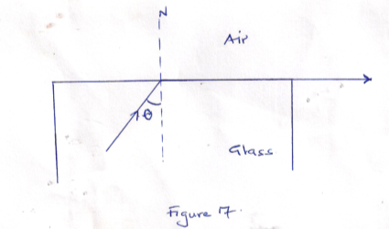

Given that the refractive index of glass is 1.6, determine angle O.(3mks)

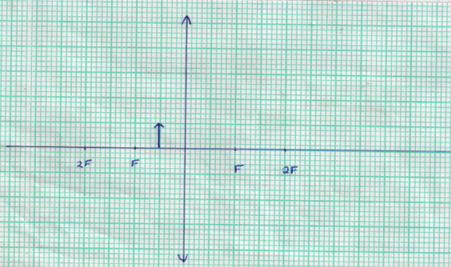
- (a) Figure 8 shows an object in front of a convex lens of focal length 10cm.

- On the same figure draw a ray diagram showing the location of image .(4mks)
Use the ray diagram drawn in (i) above to determine the
- Image distance (2mks)

- The magnification(2mks)

(b) A vertical object is placed 20cm in front of a convex lens of focal length 5cm.
i. Determine
I the image distance (3mks)

II the magnification (2mks)

ii.State two characteristics of the image (2mks)

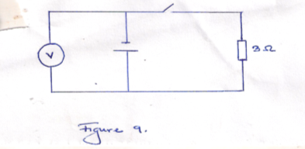
- (a) Figure 9 shows a cell in series with a 3 resistor and a switch .A high resistance voltmeter is connected across the cell.

The voltmeter reads 1.5v with switch open and 1.2 v with the switch closed.(1mk)

- State the e.m.f of the cell.(1mk)

- Determine the current through the 3 resistance of the cell.(2mks)

(b) Another resistor R is connected in series with the 3 resistor so that a current of 0.15 A flows when the switch is closed. Determine the resistance R.(3mks)

