DARAJANI BOYS’ HIGH SCHOOL,
P.O BOX 20-90129, NGWATA.

School Motto: “Knowledge is Liberty, Ignorance is Fatal”.

END OF YEAR EXAMINATION, 2015
FORM 2,
AGRICULTURE
TIME: 2½ HRS

NAME:________________________________________ADM.NO___________CLASS______
SECTION A (40 MKS)
Answer all the questions in this section in the spaces provided

1. Give one reason why Agricultures is regarded as a science. (1 mk) ………………………………………………………………………………………………
2. Give two reasons why ranching is important in the arid and semi arid areas of Kenya ………………………………………………………………………………………………………………………………………………………………………………………………………………………………………………………………………………………………………………………
3. Give two importances of living organisms in soil formation. (2mks)
………………………………………………………………………………………………………………………………………………………………………………………………………………………………………………………………………………………………………………………………………………………………………………………………………………………………………………………………………………………………………
4. State four characteristics of nitrogenous fertilizes (2 mks)
……………………………………………………………………………………………………………………………………………………………………………………………………………………………………………………………………………………………………………………………………………………………………………………………………………………………………………………………………………………………………………………………………………………………………………………………………………………………………………………………………………………………………………………………………………………………………………………………………………………………………………
5. (a) Give three advantages of ridging in crop production. (3mks)
…………………………………………………………………………………………………………………………………………………………………………………………………………………………………………………………………………………………………………………………………………………………………………………………………………………………………………………………………………………………………………………………………………………………………………………………………………………………………………………………………………
(b) Give one reason in each case for carrying out the following operations in crop production? (2mks)
I) Levelling …………………………………………………………………………………………………………………………………………………………………………………………………………………………………………………………………………………………………………………………………..

- Rolling
………………………………………………………………………………………………………………………………………………………………………………………………………………………………………………………………………………………………………………………………….
(c) State four farming practices that are carried out in minimum tillage. (4mk)
……………………………………………………………………………………………………………………………………………………………………………………………………………………………………………………………………………………………………………………………………………………………………………………………………………………………………………………………………………………………………………………………………………………………………………………………………………………………………………………………………………………………………………………………………………………………………………………………………………………………………………
6. (a) Define the term pollution. (1mk)
…………………………………………………………………………………………………………………………………………………………………………………………………………………………………………………………………………………………………………………………………….
(b) Give four agricultural practices, which will lead to water pollution. (4 mks)
……………………………………………………………………………………………………………………………………………………………………………………………………………………………………………………………………………………………………………………………………………………………………………………………………………………………………………………………………………………………………………………………………………………………………………………………………………………………………………………………………………………………………………………………………………………………………………………………………………………………………………
(c) List three methods used to prevent water pollution. (3mks)
………………………………………………………………………………………………………………………………………………………………………………………………………………………………………………………………………………………………………………………………………………………………………………………………………………………………………………………………………………………………………………………………………………………………………………………………………………………………………………………………………………………………………………………………………………………………………………………………………………………………………………………………………………………………………………………………
7. a) Name the intermediate host for the following parasites. (2mks)
i)Tape-worm
………………………………………………………………………….…………………………………………………………………………
- Liver fluke
……………………………………………………………………………………………………………………………. ………………………
(b) State four control measures of tapeworms ( 4 mks)
……………………………………………………………………………………………………………………………………………………………………………………………………………………………………………………………………………………………………………………………………………………………………………………………………………………………………………………………………………………………………………………………………………………………………………………………………………………………………………………………………………………………………………………………………………………………………………………………………………………………………………………………………………………………………………………………………………………………………………………………………………….
8. State four importance of raising crops in nursery before transplanting. (4 marks)
……………………………………………………………………………………………………………………………………………………………………………………………………………………………………………………………………………………………………………………………………………………………………………………………………………………………………………………………………………………………………………………………………………………………………………………………………………………………………………………………………………………………………………………………………………………………………………………………………………………………………………
- Give four methods of seed treatment. ( 4 marks)
……………………………………………………………………………………………………………………………………………………………………………………………………………………………………………………………………………………………………………………………………
10. Give one use of each of the following hammers. (2mks)
- Ball pein hammer
………………………………………………………………………………………………………………………………………………
- Sledge hammer
…………………………………………………………………………………..……………………………………………………………
11. List two control measures of keds in sheep. (2mks)
………………………………………………………………………………………………………………………………………………………………………………………………………… ……………………………………….…………………………………………………………
12. State two stool management practices in banana production (2mks)

SECTION B (20MKS)
13. Below are diagrams of workshop tools.
(i)
(iii)

(ii)

(iv)

- State the functions of tools. (4mks)
- …………………………………………………………………………………………………
- ………………………………………………………………………………………………
- ………………………………………………………………………………………………
(iv) ………………………………………………………………………………………………
b) What is the name given to the metallic brush which is used to clean out wood chippings from tool (1) above.
…………………………………………………………….…………………………………………………………………………………………
14. The diagram below represents a method of crop propagation.
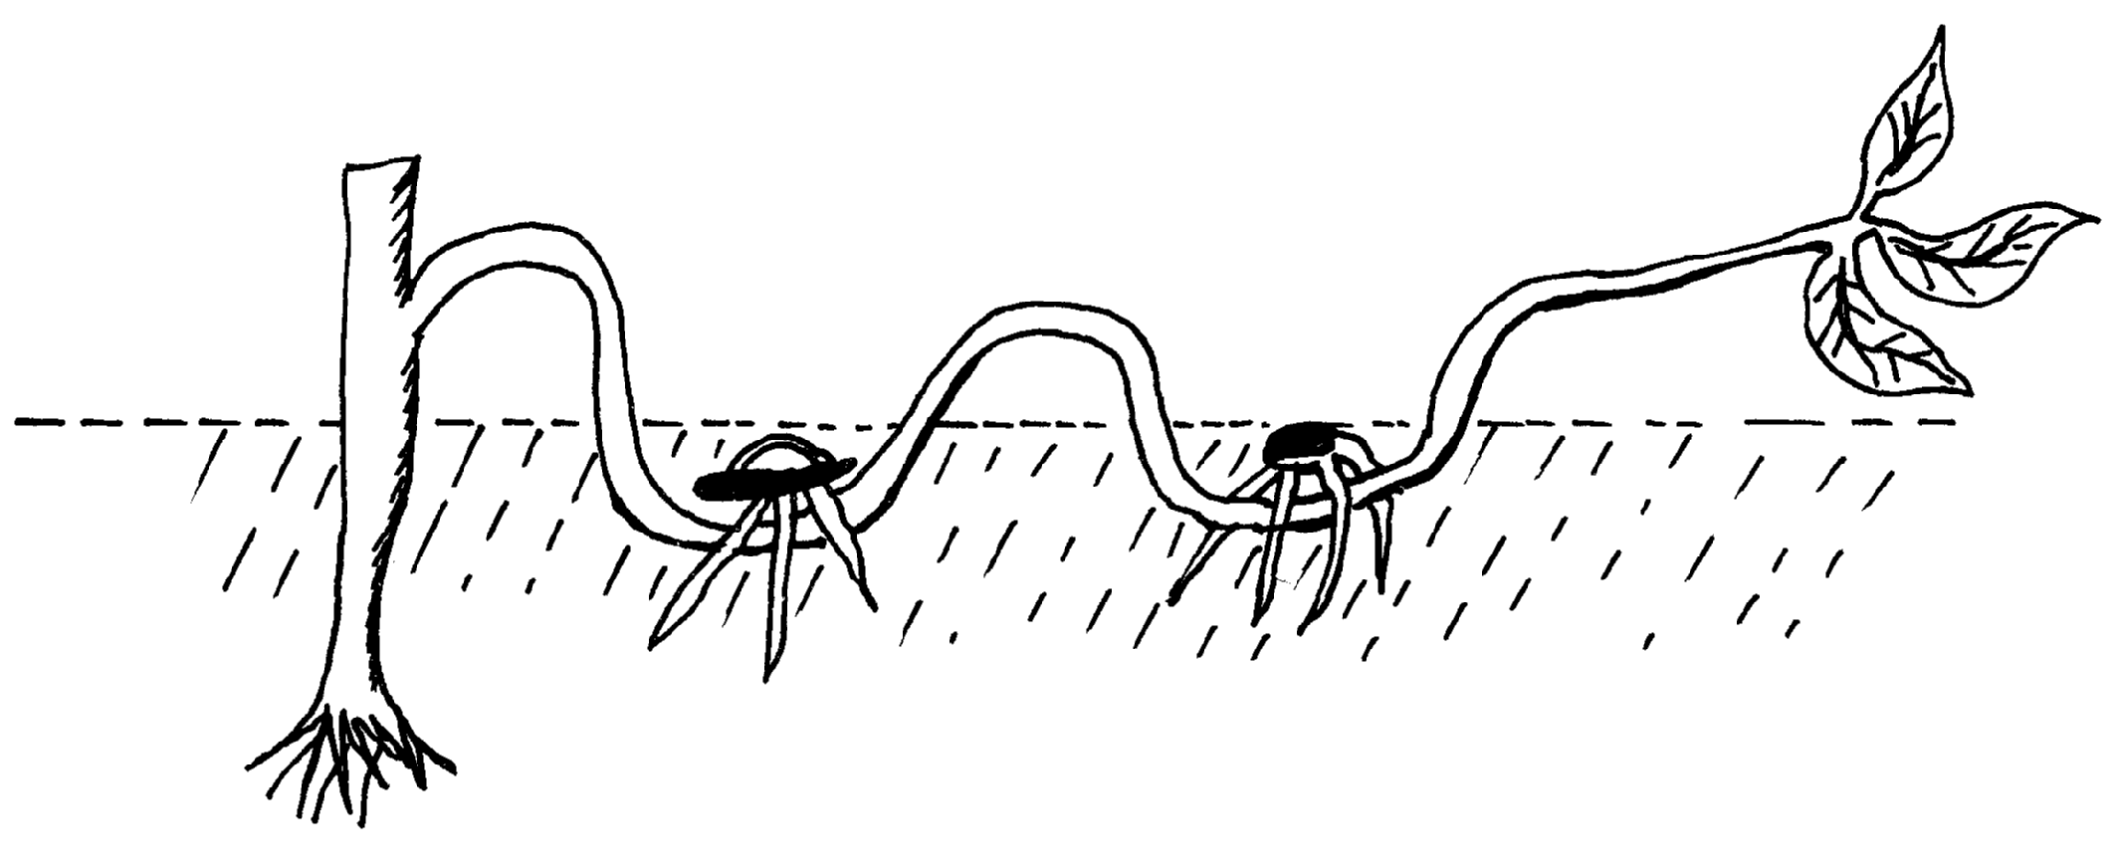
Mother plant
Soil cover
Peg
Roots developed here
Ground level

(a) Identify the method of propagation ( 1 mk)
……………………………………………………………………………………………………………………………………………………
(b) What is the benefit of the above method of crop propagation? (1mk)
…………………………………………………………………………………………………………………………………………………………………………………………………………………………………………………………………………………..…………………….
(c) List any two processes by which part of a system is induced to produce roots while attached to the mother plant. (2mks)
………………………………………………………………………………………………………………………………………………………………………………………………………………………………………………………………………………………………………………………………………………………………………………………………………………………………………………………………………………………………………
d) State five factors which affect the rooting of cuttings. (5 mks)
………………………………………………………………………………………………………………………………………………………………………………………………………………………………………………………………………………………………………………………………………………………………………………………………………………………………………………………………………………………………………………………………………………………………………………………………………………………………………………………………………………………………………………………………………………………………………………………………………………………………………………………………………………………………………………………………………………………………………………………………………………

15. 21. The diagram below illustrates a method of pruning.

- Identify the method of pruning shown above (1mk)
…………………………………………………………………………………………..…………………………………………………………..........
(b) Give any four advantages of pruning in crops. (4mks)
……………………………………………………………………………………………………………………………………………………………………………………………………………………………………………………………………………………………………………………………………………………………………………………………………………………………………………………………………………………………………………………………………………………………………………………………………………………………………………………………………………………………………………………………………………………………………………………………………………………………………………
c) Name the two types of pruning in coffee (2mks)
………………………………………………………………………………………..………………………………………………………………………………………………………………………………………………………………………………………………………………
SECTION C (40 mks)
Answer any two questions in this section in the spaces provided.
16. a) Describe any six methods used in draining land during land reclamation. (6 mks)
b) What is the importance of draining marshy areas as a land reclamation method? (6 mks)
c) Describe some of the agricultural practices that pollute water. (3 mks)
d) How can the problems of water pollution be prevented. (5 mks)
17. (a) State the advantages of farm yard manure over straight fertilizer. (6mks)
(b) State and explain the factors that determine the spacing of crops when planting (10mks)
(c) Discuss the advantages of mulching. (4mks)
18. a) Name three diseases transmitted by ticks (3 mks)
b) State four effects of ticks investation in livestock (4mks)
c) Describe the life cycle of a three host tick (9 mks)
d) State four characteristics of an effective accaricide (4mks)

**********************************END_ALL THE BEST*****************************

