**Name…………………………………………………Adm NO:………………..class.……**

**MOI HIGH SCHOOL KABARAK**

**MATHEMATICS FORM 2**

**COMMON 1 EXAM**

**TERM II**

**2 ½ HOURS**

# INSTRUCTIONS TO CANDIDATES

*1. Write your name, admission Numberand class in the spaces provided at the top of this page*

*2. The paper consists of two sections. Section I and Section II.*

*3. Answer ALL the questions.*

*4. Non programmable silent electronic calculator and KNEC Mathematical tables may be used except where stated otherwise.*

### Section I FOR EXAMINER’S USE ONLY

|  |  |  |  |  |  |  |  |  |  |  |  |  |  |  |  |  |  |  |  |  |  |
| --- | --- | --- | --- | --- | --- | --- | --- | --- | --- | --- | --- | --- | --- | --- | --- | --- | --- | --- | --- | --- | --- |
| **Question** | **1** | **2** | **3** | **4** | **5** | **6** | **7** | **8** | **9** | **10** | **11** | **12** | **13** | **14** | **15** | **16** | **17** | **18** | **19** | **20** | **TOTAL** |
| **Marks** |  |  |  |  |  |  |  |  |  |  |  |  |  |  |  |  |  |  |  |  |  |

## Section II

|  |  |  |  |  |  |  |
| --- | --- | --- | --- | --- | --- | --- |
| **Question** | **21** | **22** | **23** | **24** | **25** | **TOTAL** |
| **Marks** |  |  |  |  |  |  |

**Grand Total**

*This paper consists of 12 printed pages.*Candidates should check the question paper to ensure that all pages are printed as indicated*and no questions are missing*

**Section I (50 marks)**

1. Simplify  (3 marks)
2. Use logarithm tables to evaluate:  (4 marks)
3. The cost of one kilogram of meat is Sh m and the cost of one packet of biscuits is Sh b. Madai bought 3kg of meat and 2 packets of biscuits and spent a total of sh500. Katei bought 4kg of meat and 3 packets of biscuits and spent a total of Sh700. Find the cost of 1kg of meat and a packet of biscuits (3mks)
4. Three metal rods of lengths 324cm, 234cm and 270cm were cut into pieces of equal length to make window grills. Calculate the total number of pieces that can be obtained from the three metal rods. (3 marks)
5. A tourist arrived in Kenya with U$ 12,000. He exchanged all the money into Kenya shillings and spent half of the money in the country and exchanged the remaining to South African rand. Use the table below to calculate the amount of money he got in rands. (3 marks)

Buying selling

1 U$ dollar 109.35 110.20

1 SA rand 9.55 10.05

1. Solve for x in the following equation:  (3 marks)
2. Three tractors A, B and C take 4 hours, 3 hours and 2 hours respectively to complete a piece of work when working separately. Tractor A and B started working together but after working for 1 hour 30 minutes tractor A broke down and tractor B and C had to complete the piece of work. How long did B and C working together take to complete the work? (3 marks)
3. Find the value of P and Q for which the number 1P3Q90 is divisible by 11. (3 marks)
4. Use square roots, reciprocals and cubes tables to evaluate (4 marks)

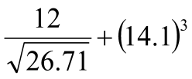

1. A two digit number is such that, the sum of the digits is 13. When the digits are reversed, the new number exceeds the original by 9. Find the number. (3 marks)
2. Solve for the value of x in  (3 marks)
3. Two consecutive odd numbers are such that the difference of thrice the larger number and twice the smaller number is 21. Find the numbers. (2mks)
4. In the figure below, find the angles marked by a and b. (2mks)

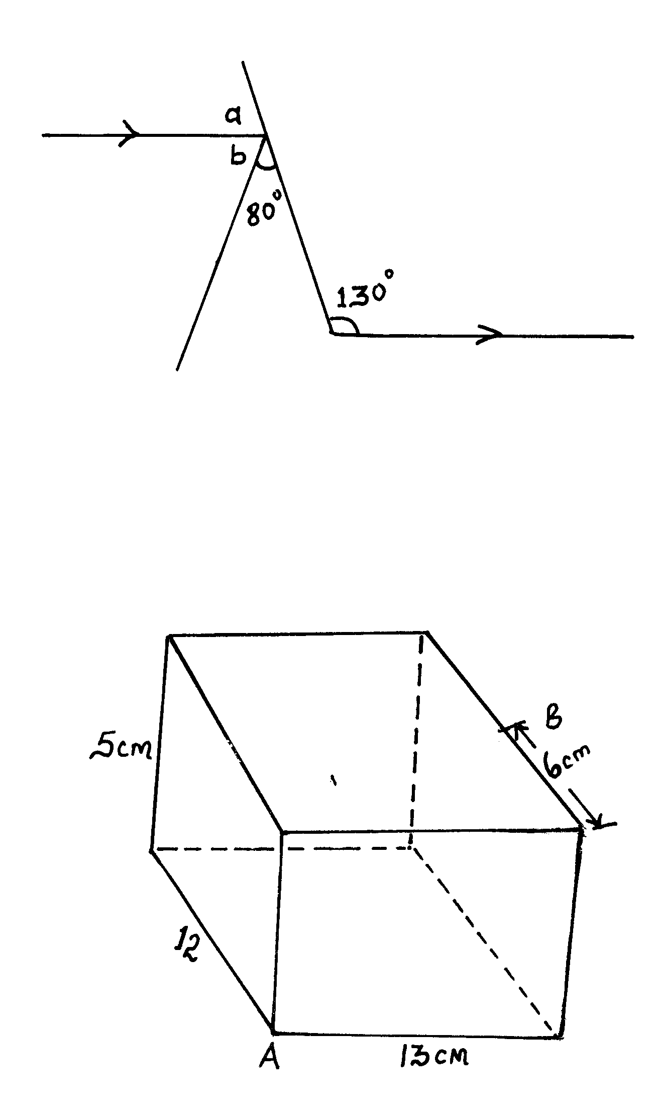

1. line L1 passes through A(4, -2) and B(-8,4). Find the equation of line L2 which is a perpendicular to AB and passes through A. (3 marks)
2. The interior angle of a polygon is thrice its exterior angle. Name such a polygon. (3 marks)
3. The map of a forest is drawn to a scale of 1:2,000 in the map below, find its area in hectares. (3mks)

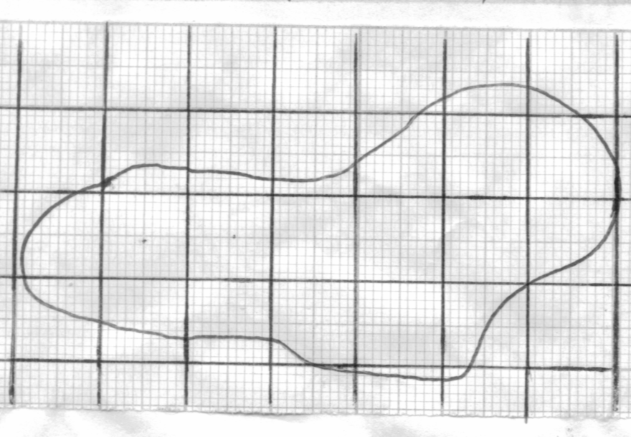

1. The GCD of 6480, 7200 and a third number is 144. The LCM of the three numbers is  . Find the smallest third number. (3mks)
2. Express  as a fraction in its simplest form (3mks)
3. The population of the three (West, East and North) Laikipia Districts is estimated to be 1,760,793. The ratio of the population in Laikipia East to that in Laikipia North is 5:2. The ratio of the population of Laikipia North to that of Laikipia west is 3:8. The population is estimated to be growing evenly at a rate of 50% per annum. Calculate the estimated population of Laikipia west district after one year. (3mks)
4. A point P divides in the ratio 3 : 4. By dividing AB into seven equal parts locate point P . (3mks)

A B

**Section II (50 marks)**

1. (a) A salesman earns a basic salary of Kshs.10,000. In addition he gets a commission of 10% on goods sold over kshs.50,000 and below ksh.250,000 and 20% on goods sold over kshs. 250,000. In a certain month he sold goods worth kshs. 500,000. Calculate his earnings for that month. (4 marks)

(b) A customer bought a cloth whose marked price is sh.600 after been given a discount of 20%. If the shopkeeper made a profit of 30% from the sale, calculate the amount the shopkeeper bought the cloth. (2 marks)

(c) A manufacturer sold an item whose marked price is shs.400, after allowing a discount of 40%. He made a loss of 10%, calculate the cost of making the item. (2 marks)

1. A storage tank in form of a cuboid, whose internal dimensions are 2.1m by 2.6m and 3m high. The storage tank is  full of orange juice.
2. Calculate the volume of the juice in litres (3mks)
3. The juice is to be packed in small cylindrical packets of radius 7 cm and height 20cm. Each packet full packet of juice costs Sh. 65.00. Calculate amount that will be obtained from the sale full packet juices. (5mks)
4. (a) Draw on the grid the triangle A(2,1) B(3,4), C(4,2). (1mk)

(b) A’,B’,C’ is the image of triangle ABC after the reflection in the line x = 0. Obtain the coordinates of the image. (2mks)

(c) A’’ B’’ C’’ is the image of A’,B’,C’ after a reflection in the line y = 0. Obtain the coordinates of the image. (2mks)

(d) A’’’ B’’’ C’’’ is the image of A’’ B’’ C’’ after a -600 turn about the origin. Obtain the coordinates of the image. (3mks)

1. Four points A, B, C and D lie on the same plane. Point A is 42km due south west of point C. point B is 50km on a bearing of 1200 from point C. Point D is on a bearing of 1200 from A and 2200 from B.

(a) Using the scale 1cm represents 10km, construct a diagram showing the positions of A, B,

C and D. (4mks)

(b) determine:

(i) The distance between AB

BD (2mks)

(ii) The bearing of C from from D. (1mk)

(iii) The compass bearing of A from D (1mk)

1. The measurements (in metres) of a field were given in a field note book as follows:

Base line XY = 250m

Y

To R 60 180

150 50 To P

To Q 60 120

To T 30 40 20 To M

X

1. Draw by construction the piece of the field (3mks)
2. Find the area of the field in hectares. (3mks)