NAME: ………………………………………………………………………

ADM NO.:…………………………………………………………………

DATE: ………………………………………………………………………

COUNTY MULTILATERAL EXAMINAITON

GEOGRAPHY

FORM ONE

TERM TWO 2016

TIME: 2 ½ HOURS

SECTION A
ANSWER ALL THE QUESTIONS

l. a) What is practical geography? (2 mks)

b) Give 3 importances of studying geography in your school (3 mks)

2. a) When local time is 4pm at longitude 60°E, what is the longitude of a place whose local time is 7 pm? (3 mks)

b) Give 2 effects of the oval shape of the orbit of the earth. (2 mks)

3. a) Distinguish between asteroids and meteors. (2 mks)

b) State 3 characteristics of the sun (3mks)

4. a) Describe how humidity is measured (4mks)

b) Give two factors that influence relative humidity (2mks)

5. a) What is a Stevenson’s screen? (2mks)

b) Give 3 features of the Stevenson’s screen. (3mks)

SECTION B
6. The table below shows temperature readings at a weather station for one week.
TEMP/DAY | MON | TUE | WED | THUR | FRI | SAT | SUN
MAX (0C) | 28 | 22 | 28 | 26 | 29 | 29 | 26
MIN (0C) | 18 | 18 | 20 | 16 | 22 | 21 | 19

- Calculate
i) The diurnal range of temperature for Thursday. (2mks)

ii) The mean temperature for Monday (2mks)

- i) Name three sources of water vapour in the atmosphere. (3mks)

ii) Give 2 factors that are considered when classifying clouds. (2mks)

iii) Name 3 types of clouds. (3mks)

c. i) Distinguish between mist and fog. (2mks)

ii) Apart from mist and fog, name two other types of precipitation. (2mks)

iii) Explain 2 factors that determine the amount of solar radiation reaching the earth’s surface. (4mks)

7.a) What is weather forecasting? (2mks)

ii) Give 2 benefits of weather forecasting. (2mks)

iii) Name 2 devices which are used to communicate information on weather.
(2mks)

b)
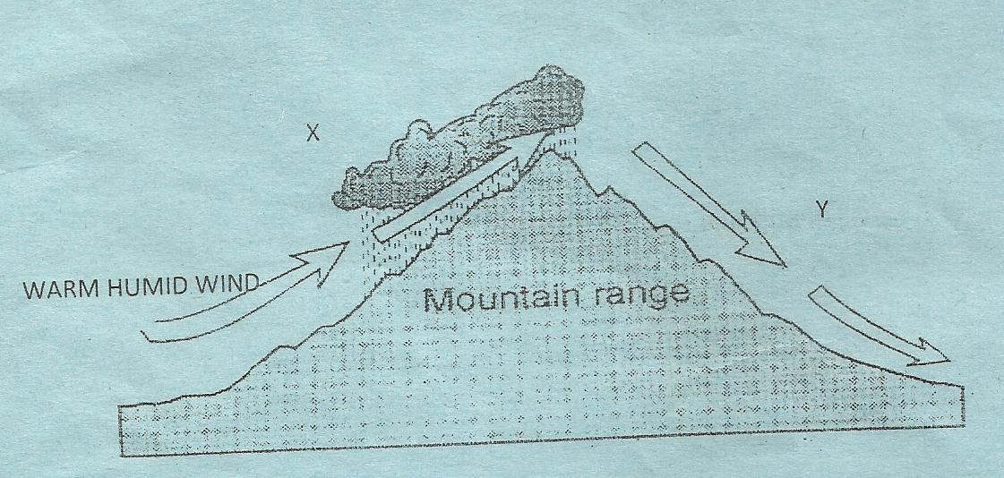

The diagram above shows relief rainfall.
- Name the areas marked X and Y. (2mks)

- Apart from the above rainfall, name two other types of rainfall.(2mks)

- Give 3 characteristics of the region marked Y. (3mks)

8. a) What is field work? (3mks)

b) You intend to carryout a field study on the weather experienced in the locality of your school.
i) State 3 objectives you would formulate for your study. (3mks)

ii) Formulate 2 hypothesis for your study (2mks)

iii) Name 3 secondary sources of information you would use to prepare for your field study. (3mks)

c. i) What is observation? (2mks)

ii) Apart from observation meintioned other 3 methods they are likely to use to collect data. (3mks)

iii) Give 3 ways they would use to record the collected data. (3mks)

- List 3 problems that you are likely to experience during the field study.
(3mks)

d) State 3 advantages of studying geography through field work. (3mks)

9. a) Define the following
i) Statistics (2mks)

ii) Statistical data (2mks)

b) List 2 sources of geographical data. (2mks)

c) Give 3 measures of central tendency. (3mks)

10. a) i) Define a map. (2mks)

ii) State 2 major types of maps. (3mks)

b) State any 2 uses of maps in geography. (2mks)

