GATITU MIXED SECONDARY SCHOOL
FORM ONE GEOGRAPHY MIDTERM EXAM TERM 2 2015

1. Draw a well labeled diagram of the internal structure of the earth (6mks)

2(a) Name any two planets without satellites (2mks)

(b) Explain the effect of the following forces for the shape of the earth.

(i) Gravitational force (1mk)

(ii) Centrifugal force (1mk)

(iii) Centripetal force (1mk)

(b) List any three areas that need practical aspect (3mks)

(b) State any three evidences supporting the continental drift theory. (3mks)

3. (a) Define positive lapse rate (2mks)

(b) The table below shows the climate of a station in Kenya. Study it and answer
the questions that follow.
Month | J | F | M | A | M | J | J | A | S | O | N | D
Temp ⁰C | 24 | 25 | 27 | 29 | 24 | 26 | 25 | 26 | 28 | 26 | 26 | 24
Rainfall (mm) | 124 | 109 | 119 | 284 | 235 | 118 | 104 | 140 | 215 | 76 | 107 | 122

(ii) Calculate mean annual rainfall of the station (4mks)

(c) In a weather station, explain reasons why

- The rain gauge is sunk into the ground

(ii) The top of the gauge being 30cm above the ground

(iii) The Stevenson screen is raised 121cm above the ground

(iv) The Stevenson screen has louvered sides (4mks)

(i) State any three instruments you are likely to find in the weather station. (3mks)

4. (a) Name four heavenly bodies found in the solar system (4mks)

(b) State three weaknesses of the passing star theory. (3mks)

(a) Differentiate between Lunar and Solar Eclipse. (4mks)

(b) Give two effects of solstices on the length of day and night. (2mks)

- State three characteristics of the troposphere. (3mrks)

- Name three isothermal zones of the atmosphere (3mks)

- Give two factors that cause variation in the radiations reaching the earth’s surface (2mks)

5. (a) State two effects of the rotation of the earth (2mks)

(b) Study the diagram below and answer the questions that follow
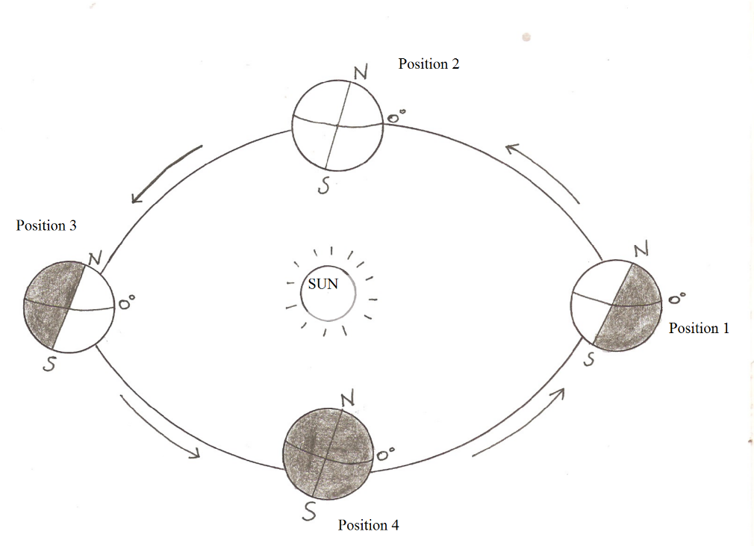

(c) Which movement of the earth is represented by the diagram (1mk)

(d) Give two effects of the movement represented by the diagram (2mks)

(b) The diagram below represents a type of a wind, use it to answer the questions that follows.
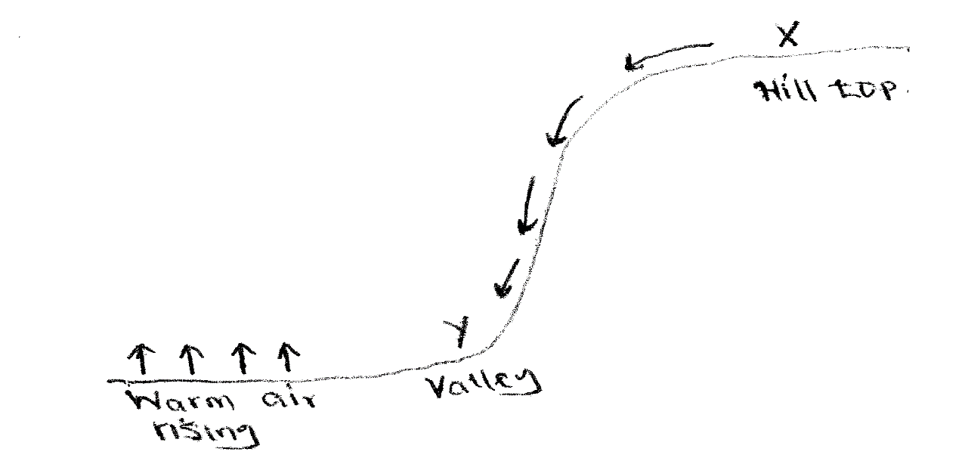
Name:
(i) The type of wind (lmk)

(ii) Zone x and y (2mks)

