GATITU MIXED SECONDARY SCHOOL
END OF TERM EXAMS
GEOGRAPHY FORM I
Time:1Hr 45Mins
Attempt all questions
1.Explain the relationship that exists between geography and the following disciplines (4mks)
i. Physics
ii History
- i. List two branches of Geography (2mks)
ii. Explain four importance of studying geography (4mks)
- State three proofs that the earth is spherical (3mks)
- Explain why the Earth is not a perfect sphere (2mks)
- State two theories that explain the origin of the solar system (2mks)
- Differentiate between SIMA and SIAL (2mks)
- The diagram below shows the structure of the earth. Use it to answer the questions that follows.

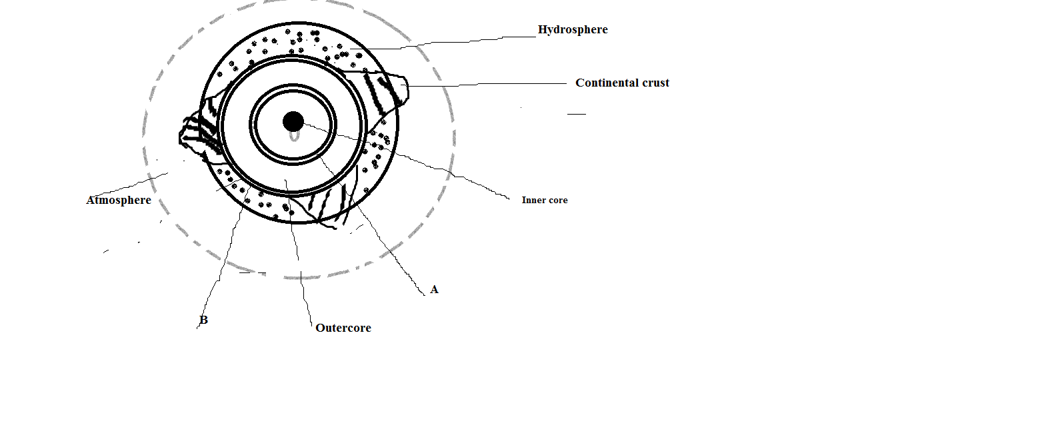i. Name the discontinuities labeled A and B.(2mks)
ii. State three reasons why the interior of the earth is said to be hot (3mks)
- I. Distinguish between rotation and revolution of the earth (2mks)
ii. State three effects of earth’s rotation (3mks)
iii. When it is 2.00PM in Greenwich, what is the local time of Tokyo (Longitude 160⁰E) (2mks)
- I. Differentiate between weather and climate (4mks)
ii. Identify four elements of weather (4mks)
iii. Name three conditions considered in choosing a suitable site for a weather station.(3mks)
iv. What are the importances behind weather forecasting (3mks)
v. With the aid of a well labeled diagram, explain the formation of a land breeze. (8mks)
vii. Identify four factors that influence weather (2mks)
viii. Outline four layers of the atmosphere (4mks)
ix. Explain the meaning of the following lapse rates (3mks)
a)Normal lapse rate
b) Zero lapse rate
c) Negative lapse rate
- i. Name the characteristics of primary and secondary data and explain (2mks)
ii. Elucidate the points considered when preparing a questionnaire (3mks)
iii. Explain the disadvantages of experimentation as a method of data collection. (3mks)

THE END
HARD WORK PAYS!!
MR KARANJA

