GEOGRAPHY
3RD TERM 2013
2 ½ HRS

GATITU MIXED DAY SECONDARY SCHOOL
GEOGRAPHY
FORM ONE 3RD TERM EXAMINATION 2013

Instructions
- Answer all the questions
- All answers must be written in the answer booklet provided
1)a) Describe the word geography (2mks)
b) Name two branches of Geography (2mks)
2. a) Name the nearest planet to the sun (1mk)
b) What is the distance between the earth and the sun? (1mk)
c) Apart from the planets, name two other celestial bodies (2mks)
d) Name two layers that form the crust (2mks)
3. a) Name two instruments found in a Stevenson screen. (2mks)
b) State two importance of water vapour in the atmosphere (2mks)
c) Name two types of fog (2mks)
d) Other than rain, name two types of precipitation (2mks)
4. a)i) State three uses of topographical maps. (3mks)
ii) Name three marginal information which can be obtained from a map (3mks)
b)i) Convert 1/300000 into statement scale (2mks)
ii) Convert 1cm on the map represent 1km on the ground into representative fraction (2mks)
C) if one full square represents 1km2 ,calculate the area enclosed by the circle in the graph in km2 . show your calculation.
Scale 1:50000
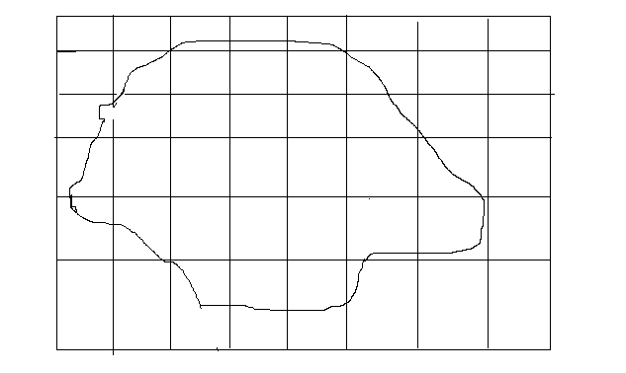

5. Geography students from your school decided to go for a field work on study of rocks.
a)i) State four reasons why they conducted a reconnaissance (4mks)
ii) Formulate two objective of their study (2mks)
iii) Formulate two hypotheses for their study (2mks)
b)i) Give two advantages why they used observation as a method of data collection (2mks)
ii)State two disadvantages for using observation as a method of data collection (2mks)
c)i) Give two advantages of using content analysis as a method of data collection (2mks)
ii) Give two disadvantages of using content analysis as a method of data collection (2mks)
d) State two problems they could have encountered during their field study. (2mks)
6.i) What is minerals? (2mks)
ii) Name any three elements of the earth crust (3mks)
b) i) What is a rock (2mks)
ii) Name two types of igneous rocks (2mks)
c) i) Describe how sedimentary rocks are formed mechanically. (2mks)
ii) Give three examples of mechanically formed sedimentary rocks. (3mks)
d) i) Describe how metamorphic rocks are formed (2mks)
ii) When the following rocks undergo metamorphism which rocks do they change to. (2mks)
Sandstone
Granite
Limestone
Coal
7. a)i) State three factors influencing occurrence of minerals (3mks)
ii) Give five factors influencing exploitation of minerals (5mks)
iii) Name four types of underground mining method (4mks)
b) Explain the four significance of minerals in Kenya (8mks)
c )i) State four effects of mining on the environment (4mks)
ii) State four problems facing diamond mining in South Africa (4mks)
iii) Give four ways on how Gold has contributed to the economy of South Africa (4mks

