MIDTERM EXAMS TERM 1 2017
FORM 2 GEOGRAPHY
ANSWER ALL QUESTIONS ON SPACE PROVIDED
1.a) Define geography. (2mks)

b) state importances of studying geography. (2mks)

2.a)Define solar system. (2mks)

b) state characteristics of planet mercury. (3mks)

3. a) State the weakness of passing star theory. (3mks)

b)what is an eclipse. (2mks)
c)Through aid of a diagram draw solar eclipse and name the following. (5mks)
i) sun
ii) moon
iii) penumbra
iv) umbra

4.a)Draw a diagram of the internal structure of the earth and label the following.
(4mks)
- Crust
- Core
- Mono discontinuity

b) name the minerals found in the continental crust. (2mks)

5.a)Define weather (2mks)

b) State factors or conditions necessary for siting a weather station. (3mks)

6. a) Name types of precipitation. (5mks)

b) Name types of rainfall. (3mks)

7.a) Name types of fieldwork . (2mks)

b) State different ways in which students prepare themselves to field study.
(5mks)
8.a)Differentiate between rock and mineral and mineral two (2mks)

b)Give 3 classes of rocks according to their mode of formation. (3mks)

c)State examples of mechanically formed sedimentary rocks. (4mks)

9. a)What is mining (2mks)

b)State 3 ways in which minerals are mined. (3mks)

c) State ways in which minerals occurs. (3mks)

d) Explain important of mining gold in S. Africa. (6mks)

e) list 3 countries which mine oil. (3mks)

10. a)State feature which comes as a result of folding. (3mks)

b)Explain positive significances of folding to human activities. (6mks)

11. a)Define faulting. (2mks)

b) State theories which course faulting. (3mks)

c) State types of faults. (3mks)

d) Explain how the Riftvalley is formed through tensional forces through the aid of a diagram. (5mks)

e) Study the diagram below and answer the following questions.
i) Name the parts marked A,B,C,D, and E. (5mks)

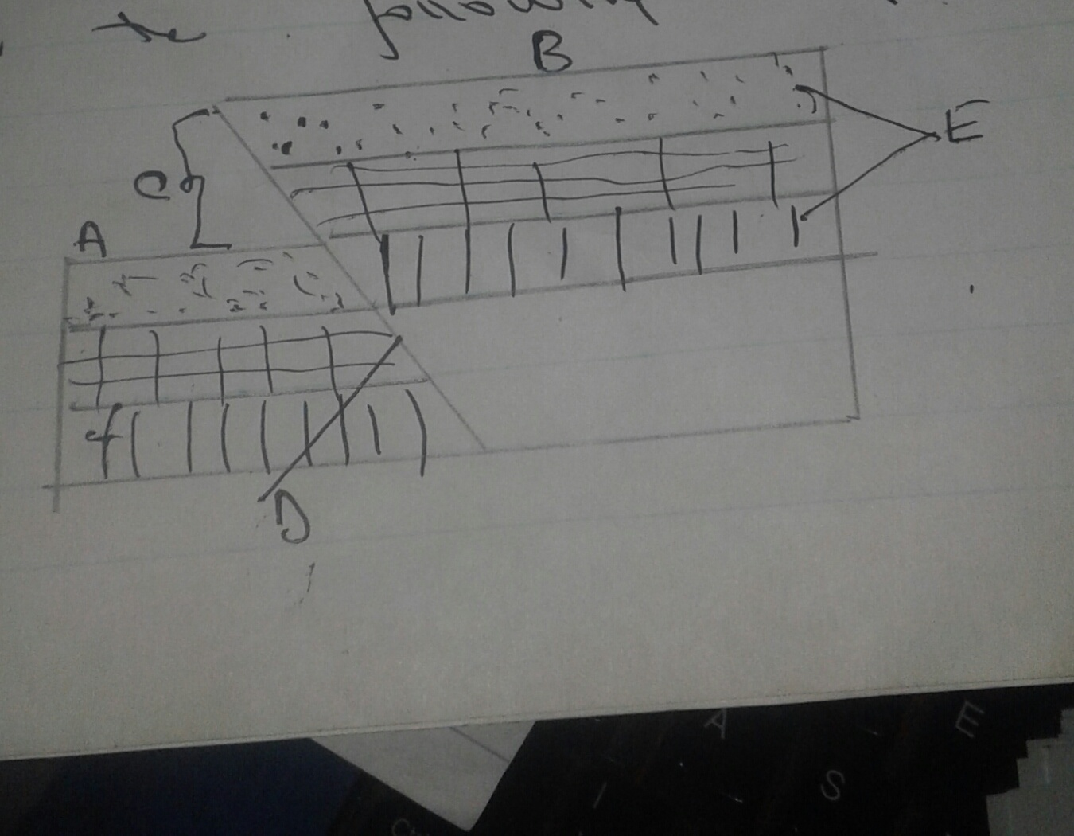

ii) Name the process that leads to the formation of the landscape shown in the diagram. (1mk)

iii) Name the folies responsible for the formation of the above feature.

