PERFECT STEPS PUBLISHERS
END TERM EXAMS 2015
0721 745374/ 0721 707626 NAIROBI
GEOGRAPHY FORM 2
Answer all questions in this section
1. (a) Name two constituents of the troposphere 2 mks)
(b) Name the gas that is found in the stratosphere and state its significance. (1mk)
(c ) What is the relative humidity of a given mass of air if at 30⁰C it has 45g/m³ of vapour and yet it can still hold a maximum of 55 g/m³ at the same temperature? (2mks)
2. (a) What is faulting (1mk)
(b)i) Name two landforms that result from faulting (2mks)
(ii)State the boundaries that result from the movements of the tectonic plates. (2mks)
3.I)(a) Differentiate between aridity and desertification (2mks)
(b) State four natural causes of aridity in Africa (4mks)
(II) Name two types of vegetation (2mks)
(iii) state four major classification of the world climate (4mks)
(iv) state four elements of weather. (4mks)
4.(a) i) What is vulcanicity (2mks)
(ii) With the help of a diagram describe how a lava plateau is formed. (6mks)
(III)Distinguish between a crater and a caldera (3mks)
b)Explain 4 negative influences of vulcanicity and associated features to human activities in Kenya 8mks (c ) Suppose you have been asked by your Geography department to carry out a
Field study of volcanic activities around your school,
(I)Design a working programme (schedule) you would use during the day of the study 3mk
ii)State 4 follow-up activities you may have been involved in after the field study.4mks
5.The diagram below represents plant succession in an alphine region. Use it to answer questions that follow.
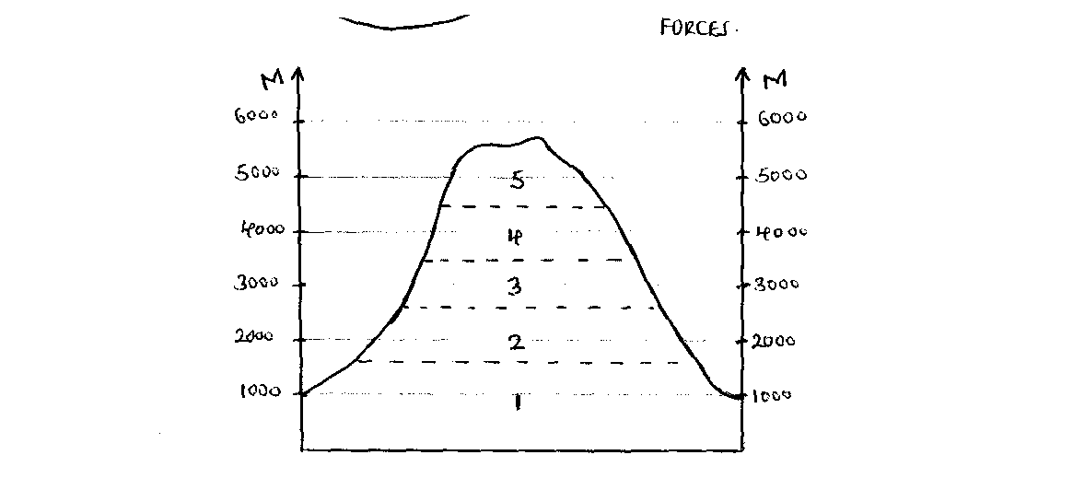
(a) i) Explain reasons why the region marked 5 has poor vegetation (6mks)
(ii) Differentiate between epiphytes and saprophytes (2mks)
(b) Account for the characteristics of tree vegetation found in region marked 2 (8mk
(c ) Supposed you were to carry out a field study on the influence of rainfall on vegetation
(i) State two hypothesis for your study (2mks)
(ii)What methods will you use to present your data. (3mks)
iii)During the field study students noted that the area received frontal rainfall.
Describe its formation. (4mks)
6.a) (i) Define dereliction. (2 mks)
(ii) State 3 characteristics of a derelict landscape. (3 mks)
(iii) State any two non – metallic minerals found in E. Africa. (2 mks)
b) (i) Highlight four economic factors which have favoured the exploitation of diamond in South Africa.4
(ii) Give 3 uses of Diamond. (3 mks)
c) Describe how deep – shaft mining is carried out. (5 mks)
d) Explain three problems that Kenya experiences as a result of overdependence on petroleum. (6 mks)

PRINTED AND COMPILED BY
PERFECT STEPS PUBLISHERS
0721 745374/ 0721 707626 NAIROBI

GEOGRAPHY FORM 2
MARKING SCHEME
1. (a) Name two constituents of the troposphere (2mks)
- Elements of weather/weather making constituents
- Oxygen/life supporting layer
- Most of the atmospheric water vapour
- Clouds
- Dust
- Pollutants
( Any 2 x 1 = 2mks)

- Name the gas that is found in the stratosphere and state its
significance (1mk)
-ozone gas – Absorbs the ultraviolet radiation from the sun. (1mk)
(c ) What is the relative humidity of a given mass of air if at 30⁰C it
has 45g/m³ of vapour and yet it can still hold a maximum of
55g/m³ at the same temperature? (2mks)
- Absolute Humidity x 100% (1mk)
Max water vapour that air can hold at the same temperature
- x 100 = 81.81% (1mk)
2. (a) What is faulting? (1mk)
- Faulting is the breaking /fracturing/crumbling of the crystal
rocks due to tectonic forces. (1mk)
(b)i) Name two landforms that results from faulting (2mks)
- Fault scarps
- Fault steps
- Fault Blocks
- Rift valleys
( Any 2 x 1 = 2mks)
- State the boundaries that result from the movements of the
tectonic plates. (2mks)
- Extensional boundaries / constructive boundaries
- Compressional boundaries / destructive boundaries
- Transform boundaries / conservative boundaries
( any 2 x 1 = 2mks)
3. i)(a) Differentiate between aridity and desertification (2mks)
- Aridity is the state of insufficient moisture leading to s
canty /lack of vegetation and deficiency of soil
fertility while desertification is slow but steady encroachment
of desert-like conditions on formerly productive land.
(b) State four natural causes of aridity in Africa (4mks)
- Low and reliable rainfall of below 250mm
- High temperatures and high evaporation rates during the year
- Location of a place on leeward sides of mountains / Relief barriers
- Wind systems
- Continentality /distance from the sea.
- Cold ocean currents. ( Any 4 x 1 = 4mks)
- Types of vegetation 2mks
-Natural
-manmade/cultivated
(iii) Types of world climate 4mks
-Hot
-Warm
-Cool
-Cold
(iv) Elements of weather 4mks
Precipitation
Humidity
Air pressure
Temperature
Wind
4. (a) i) What is vulcanicity (2mks)
- This is process by which Solid, liquid and gaseous materials
are forced out either on the surface of the earth or into the
sub-crustal layers of the earth.
(ii) With the help of a diagram describe how a lava plateau is formed. (6mks)

Surface of the plateau
Layer of lava
Original surface rock

Diag = 3mks
Text 3mks = 6mk
Vents✓ /fissures
A lava plateau is formed when basic /basaltic lava spreads out from several fissures .
Because lava has low viscousity it may spread covering great distances /wide area before cooling and solidifyingSuccessive eruptions makes lava to form different layers on top of each other resulting to formation of a lava plateau. (5 max. 3mks).

(iii) Distinguish between a crater and a caldera (2mks)
A crater is a funnel-shaped volcanic depression at the mouth of a
volcanic vent while a caldera is a very large basin shaped
depression surrounded by steep sides /cliffs on top of a volcano. (2mks)
- Explain four negative influences of vulcanicity and associated
features to human activities in Kenya (8mks)
- Recent weathered volcanic materials like ashes and granites form infertile soils. These soils fail to support farming as they are poorly developed e.g on slopes of Mt. Longonot.
- Some volcanic features create barriers that make building of transport and communication lines difficult and expensive.
- The rugged nature of some volcanic landscapes discourages economic activities like agriculture and settlement.
- Mofettes and Solfatara which are associated with volcanicity emits poisonous gases that are harmful to human beings and livestock as they cause pollution.
- Volcanic maintains like Mt. Kenya create rains shadow effects on their leeward sides which cause aridity in such areas. ( Any 4 x 2 = 8mks)
(c ) Suppose you have been asked by your Geography department to carry out a
field study of volcanic activities around your school.
(i) Design a working programme (schedule) you would use during the day
of the study. (3mks)
Assemble equipments
Depart for the area of study
Arrive at the area of study
Embark on data collection
Report back to school(Any 3 x 1 = 3mks)
- State four follow-up activities you may have been involved in after the field study (4mks)
- Report writing
- Class discussionsAsking /answering questions Displaying collected specimens
- Analysing photographs /tape recorded work.( Any 4 x 1 = 4mks)
- Reading more about the topic
- The diagram below represents plant succession in an apine region. Use it to answer questions that follows:
(6mks)
(a)i) Explain reasons why the region marked 5 has poor vegetation
  - Lack of adequate moisture which is important for vegetation growth.

  - There is snow cover which inhibits vegetation growth
  - The region has bare rocks which do not support vegetation
  - There are strong winds/snow storms /blizzards which do not favour vegetation growth.
  - The soils are permanently frozen/permafrost which limits the amount of warmth required for vegetation growth.
  - ( Any 3 x 2 = 6 mks) Differentiate between epiphytes and saprophytes
-Epiphytes are climbing plants that grow on other trees while saprophytes are plants that grow in dense forests and are devoid of chlorophyll. (2mks)
- Account for the characteristics of tree vegetation found in region
marked 2 (2mks)
  - Trees are evergreen because it is hot and wet throughout the year /production of leaves and falling take place simultaneously.
  - Trees occur in layers due to competition for sunshine/different rates of growth.
  - Trees occur in mixed stand due to abundance of rainfall
  - Trees have long straight trunks due to faster growth as they compete for sunshine.
  - Trees have broad leaves to allow faster loss of moisture due to high humidity.
  - Trees have buttress roots so that they can be able to anchor/support themselves as they are huge.
( Any 4 x 2 = 8 mks)
(c ) Suppose you were to carry out a field study on the influence of rainfall on vegetation.
(i) State two hypothesis for your study (2mks)
- Vegetation type found in an area is determined by the amount of rainfall.
- There is no relationship between the rainfall and the vegetation
type in the area.
* Accept any other relevant hypothesis. (2mks)
(ii) What methods will you use to present your data (3mks)
- Drawing graphs
- Drawing charts
- Drawing sketch maps
- Drawing diagrams
- Displaying the samples
- Playing the tapes/watching videos
- Giving a lecture
- Displaying photographs.
(Any 3 x 1 = 3mks)
- During the field study students noted that the area received frontal
rainfall. Describe its formation. (4mks)
  - Cold and warm air masses meet at a frontal zone
  - Warm air which is lighter is forced to rise over cold air.
  - The warm air is cooled as it ascends
  - The moisture in it condenses to farm clouds
      - When clouds are heavy they fall as cyclonic rainfall.
      - (Must be mentioned to score a max. of )
      - (Any 4 x 1 = 4mks)

6. a.i) Dereliction: (1mk)
- Is the damaging of the land by some process such as mining rendering it incapable of being used in that state.

ii) Characteristics of derelict landscape
  - Has open pits
  - Presence of piles of waste materials.
  - Has deep pools of water.
  - Poor soils shown by low agricultural production .
  - Limited biodiversity.
  - Highly prome to landslides
  - Littered with sharp /dangerous objects. (any 3 x 1 = 3mks)
iii)Non – metallic minerals found in E. Africa.
- Diatomite - Sandstone
- Phosphates - Stones eg Gabbro
- Flourspar - Cammon salt
- Kaolin - Kollastonite
- Limestone ( any 2 x 1 = 2mks)
b.i) Factors favouring diamond exploitation in S. Africa.
- Advanced technological know how to run the machine during extraction of diamonds.
- Well established roads rails and Air transport network to facilitate marketing of diamond and transportation of workers.
- Large labour supply which enables exploitation operations.
- Large and ready market which consumes the product at high prices.
- The scientific knowledge, advanced facilities prospecting exploitation, processing and making.
-Large capital outlay from local and foreign companies for investment in the diamond industry.
- The abundance of the diamond deposits which justifies the heavy capital investment.
- High value of the diamond leading to high local and external demand bringing a long huge profit. (any 4 x 1 = 4mks)

- The uses of Diamonds :
  - For cutting instruments
  - As abrasive for drilling purposes.
  - For polishing purposes from dust diamond. (any 3 x 1 = 3mks)
- Describe how deep shaft mining is carried out :
  - Vertical shafts are dug/ sunk
  - Horizontal tunnels are dug to reach the mineral ore
  - Props are erected to support the roof
  - Mineral ore is blasted or drilled out
  - Mineral ore is transported on light rail tracks or conveyors to the bottom of vertical shaft.
  - Cranes or conveyors are used to transport the ore to the surface.
  - Cages are used to transport miners and their equipment. (Any 5x1= 5 mks)
d) Problems Kenya experiences as a result of over- dependence on petroleum. (6mks)
  - Sharp increase in oil prices which affects the balance of payments.
  - High amount of money spent on importation of oil, ignoring other sectors of the economy.
  - High prices of oil are determined by the oil producing and exploiting countries, forcing importing countries to increase taxes.
  - Shortages of petroleum products such as gas inconveniences the users.
  - Use of the products has led to increased air pollution from the gases emitted on combustion of petroleum products. ( Any 3x2= 6 mks)

