COUNTY MULTILATERAL EXAMINATION 2015
FORM THREE GEOGRAPH: END OF TERM TWO
ANSWER ALL THE QUESTIONS IN THIS PAPER

1(a) Name two types of costal deltas. (2 mks)

b) State two conditions that lead to deposition of silt at the mouth a river. (2 mks)

2(a) Name two types of soil according to texture. (2 mks)

b) State two ways in which humans improve the quality of soil. (2 mks)

3(a) what is a lake. (1 mk)

b) State three ways through which lakes are formed. (3 mks)

4. Study the map below and answer the following questions.
a) Name the ocean current marked x, y. (3 mks)

b) State two effects of a warm ocean current on the adjacent land. (2 mks)

5(a) Outline two factors that influence the development of a karst of economy. (2 mks)
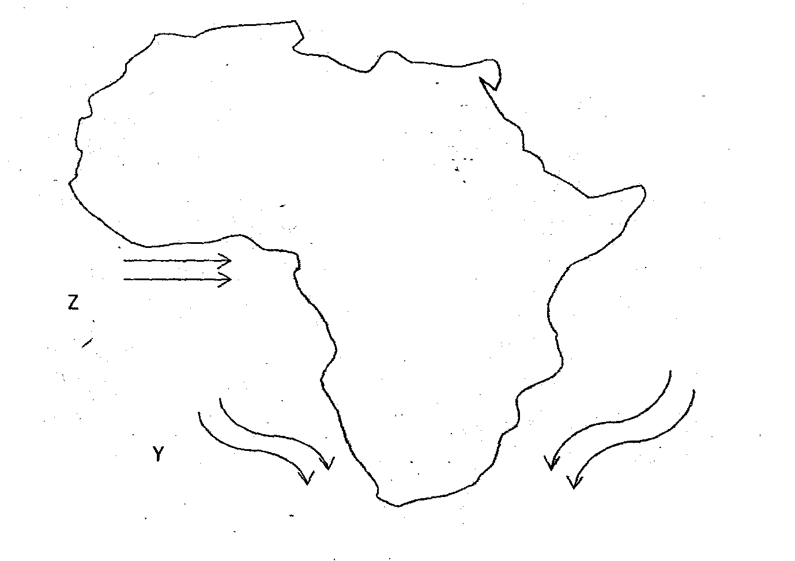

b) State three reasons why there are few settlements on a karst landscape. (3 mks)
c) Metnione three processes of chemical weathering. (3mks)

6(a) Study the map of Migwani provided (1:50,000) and answer the following questions.
(i) What is the height of the peak represented by the primary trigonometric station in the grid square 9264 (2mks)

(ii) Using the marginal information name the district when the map was taken from. (1 mk)

iii) Name the three man made features found in grid square 9274. ( m3ks)

b((i) Measure the length of all weather road (bound surface) from grid reference 923788 to the northern edge of the map. Give your answer in kilometres. (2 mks)

ii) Citing evidence, give two human activities in the area covered by the map.
(4 mks)

c)(i) Name two vegetation types found in the area covered by the map. (2 mks)

(ii) Draw a rectangle frame 12 cm by 10cm to represent the area covered by the map on the rectangle mark and name. (6 mks)
- Kitui hills
- River Ikoo
- Dam
- Outcrop rock
- Conical hill
d) Students of Ikoo Secondary school grid square 05-70 carried a field study of River Ikoo.
i) Name three features of river deposition that they identified. (3 mks)

ii) What problems would they encounter in the field study. (2 mks)

7(a)(i) Give two processes through which wind erode the earth’s surface. (2 mks)

ii) Explain three ways through which wind transports its load. (6 mks)

b) Describe how the following features are formed.
i) Oasis ( 5mks)
ii) Zeugen ( 5mks)

c) Students carried out a field study of an area undergoing desertification in northern Kenya.
i) State two ways of preparing for the field study. (2 mks)

ii) Give two types of information that they would collect through observation.
(2 mks)

iii) What measures would they recommend the local community for controlling desertification. (3 mks)

8(a) Name three components of soil. (3 mks)

b) Explain how the following factors influence the formation of soil.
(i) Climate (4 mks)
ii) Topography (4 mks)
c(i) State two economic uses of soil. (2 mks)

ii) Explain four ways in which human activities contribute to soil erosion. (8 mks)

d) Describe how the following types of erosion occur
i) Sheet erosion. (2 mks)

ii) Gully erosion (2 mks)

