GATITU MIXED SECONDARY SCHOOL
END OF TERM III EXAMS
GEOGRAPHY FORM III
NAME: ______________________________________________ADM:_______DATE:_________

INSTRUCTIONS

Answer all the questions in the spaces provided

  - a) Name two theories that explain the origins of the earth. (2 marks)

b) Name four layers of the earth’s atmosphere. (4 marks)

  - a) What is a rock? (2 marks)

b) Differentiate between plutonic rocks and volcanic rocks. (2 marks)

c) State two characteristics of sedimentary rocks. (2 marks)

d) Give two examples of non-metallic minerals. (2 marks)

  - a) Apart from the planets, give any other components of the solar system. (2marks)

b) State FOUR evidences that support continental drift theory. (4 marks)

  - a) Give two examples of slow mass wasting. (2 marks)

b) State three factors that influence mass wasting. (3marks)

  - a) Name any three types of deltas. (3 marks)

b) State any three conditions necessary for the formation of a delta. (3 marks)

  - a) State three causes of earth quakes. (3marks)

b) Explain how the following processes of weathering takes place.
(i) Block disintegration (2 marks)

(ii) Frost action. (2 marks)

(iii) Exfoliation. (2 marks)

c) State three ways in which soil creep occurs. (3 marks)

d) Describe three effects of soil creep (6marks)

8a) The diagram below represents the structure of the earth. Use it to answer the questions that follow.

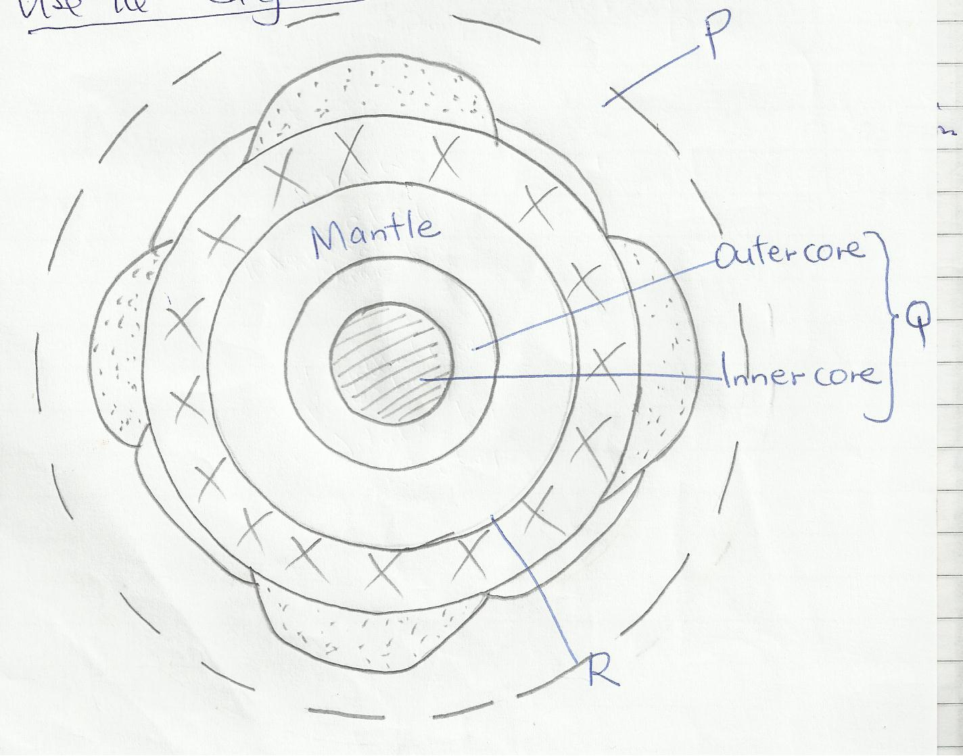

Name
- The parts marked P and Q. (2 marks)

- The discontinuity marked R. (1 mark)

b) State three characteristics of the mantle. (3 marks)

c) (i) Explain three weaknesses of the passing star theory. (3 marks)

- Differentiate between the hydrosphere and atmosphere. (2 marks)

**THE END**
MR KARANJA

