312/2
GEOGRAPHY
PAPER 2
July/August 2016
2hours

TOP KCSE EVALUATION EXAMINATIONS – 2016
The Kenya Certificate of Secondary Education
GEOGRAPHY
Paper 2
2hours

Instructions to candidates
- This paper contains two sections: A and B.
- Answer all the questions in section A.
- Answer question 6 and any other two questions from section B.
- All answers must be written in the answer booklet provided.
- This paper consists of 6 printed pages.
- Candidates should check the question paper to ascertain that all the pages are printed as indicated and that no questions are missing.

SECTION A

Answer all the questions in the section.

1. (a) What is the relationship between Geography and Physics. (2 marks)
- Name the three main layers at the atmosphere from the earth’s surface upwards.
(3 marks)
2. The diagram below show the formation of some type of rainfall.
Use it to answer question (a) and (b).
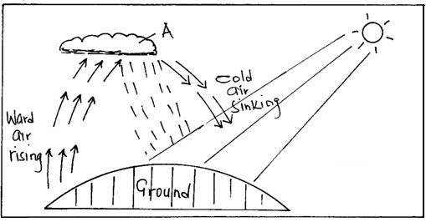

(a) (i) Name the type of rainfall shown by this diagram. (1 mark)
(ii) Name the type of cloud marked (A). (1 mark)
- List three weather conditions associated with the above name (a) type of rainfall. (3 marks)

- The tables below represent temperature and rainfall for two stations A and B. Study them and answer the questions that follow.
Station A
Months | Jan | Feb | Mar | Apr | May | Jun | Jul | Aug | Sep | Oct | Nov | Dec
Temperature (⁰C) | 27 | 27 | 27 | 26 | 25 | 25 | 25 | 26 | 27 | 27 | 26 | 26
Rainfall (mm) | 65 | 85 | 150 | 250 | 225 | 125 | 75 | 75 | 75 | 112 | 125 | 125

Station B
Months | Jan | Feb | Mar | Apr | May | Jun | Jul | Aug | Sep | Oct | Nov | Dec
Temperature (⁰C) | 27 | 28 | 27 | 27 | 26 | 24 | 23 | 23 | 24 | 24 | 26 | 27
Rainfall (mm) | 68 | 81 | 142 | 286 | 187 | 28 | 28 | 28 | 36 | 55 | 68 | 78

- (i) Calculate the annual range of temperature for the stations A and B. (2 marks)
(ii) Calculate the annual rainfall for station B. (1 mark)
- Describe the characteristics of rainfall for station A. (2 marks)
4. a) Define an air mass. (2 marks)
b) State three conditions that are associated with a depression. (3 marks)
5. a) Name two types of glaciers. (2 marks)
b) Describe how ice moves by plastic flowage. (3 marks)

SECTION B
Answer question 6 (compulsory)& any other TWO questions from this section.

6. Use map of Busia 101/1 provided to answer question 6
(a)
(i) Give the latitudinal and longitudinal position of South East end of the map. (2 marks)
(ii) Which two methods have been used to represent relief? (2 marks)
(b)
(i) Determine the length in metres of the All-weather loose surface road (C526) from the road junction at Odiado to the road junction at Bumula. (2 marks)
(ii) What is the bearing of the road junction at Matayo from the air photo principal point at Kisoko? (2 marks)
(iii) Mention any three social services offerefd at Funyula. (3 marks)
- Describe the drainage of the area covered by the map. (8 marks)
- Supporting your points, explain three factors that facilitate trading activities in the area covered by the map. (6 marks)

7. The diagram below represents a well developed soil profile. Use it to a answer questions that follow.
Vegetation
Humus
Horizon A
Horizon B
Horizon C
Horizon D
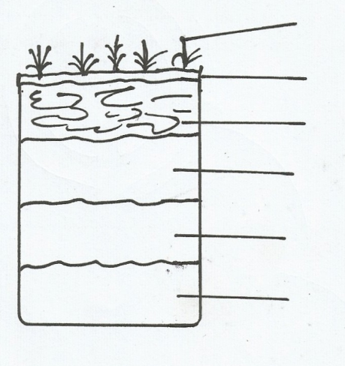

- (i) Describe the characteristics of Horizon B ( 3marks)
(ii)A part from humus, name three other components of soil. (3marks)
(iii) State three ways in which humus contributes to the quality of soil. (3marks)
(b) (i)Differentiate between soil structure and soil texture. (2marks)
(ii) Explain how the following factors influence soil formation:
- Topography (6marks)
- Time (2marks)

(c) Explain how the following farming practices may lead to loss of soil fertility.
    - Overgrazing (2marks)
Frequent ploughing (2marks) Continuous irrigation (2marks)
8 a) i) State three types of faults. (3 marks)
ii) Explain two processes that may cause faulting. (4 marks)
b) i) Apart from the Rift valley, name two other features resulting from faulting. (2 marks)
ii) With the aid of diagrams, explain how a Rift valley is formed by tensional forces. (8 marks)
c) Explain four positive effects of faulting. (8 marks)
9. a) i) Define the term karst scenery. (2 marks)
ii) Outline three conditions necessary for the formation of karst scenery. ( 6 marks)
b) Using a well- labeled diagram, describe how the following features of limestone areas are formed.
i) Stalactite (5 marks)
ii) Dolines (5 marks)
c) Explain three ways in which limestone landscape influence human activities. (3 marks)
d) Form four students of your school undertook a field study on a karst landscape.
i) State two objectives of their study. (2 marks)
ii) Give two reasons why they concluded that some areas of karst landscape were unsuitable for settlement. (2 marks)

10. a) i) Name two types of river erosion. (2 marks)
ii) State three factors influencing the rate of river erosion. (3 marks)
b) Name and describe three ways by which a river transports its load. (6 marks)
c) i) Apart from deltas, give two river depositional features. (2 marks)
ii) Giving an example from Kenya, describe the formation of acute delta. (3 marks)
d) Describe the formation of the following river patterns :
i) Dendritic pattern (3 marks)
ii) Centripetal pattern (3 marks)
e) State three positive significance of rivers. (3 marks)

