FORM FOUR TRIAL 2, 2019
Kenya Certificate of Secondary Education
312/2 GEOGRAPHY
PAPER TWO
TIME: 2¾HRS
INSTRUCTIONS
- This paper consist of two section A and B
- Answer ALL the questions in section A
- Answer question 6 and any other two questions from section

SECTION A (25MKS)
Answer ALL the questions from this section
- i) Mention two irrigation schemes established in Kisumu County with the aim of land rehabilitation (2mks)
ii) What is a polder? (1mk)
iii) Name three crops grown in the polder (3mks)
- i) Distinguish Horticulture and market gardening (2mks)
ii) State three problem facing horticultural farming in Kenya (3mks)
- i) Define the term mining? (2mks)
ii) State any three negative effects of mining to the environment (3mks)
- i) Give two indigenous soft wood trees grown in Kenya (2mks)
ii) State three problems facing forestry in Canada (3mks)
- a) Name three types of fish (2mks)
b) State three problems facing fishing in JAPAN (2mks)

SECTION B
Answer question 6 and any other two questions
- a) Study the information provided. Later answer the questions that follows
Crop production in Kenya between 1998 and 2002 in million bags.
Use a scale of 1cm represents 5 million bags
CROP/YEAR | 1998 | CT | 1999 | CT | 2000 | CT | 2001 | CT | 2002 | CT
Maize | 27.30 |  | 25.00 |  | 25.00 |  | 30.00 |  | 26.00
Beans | 3.00 |  | 4.00 |  | 3.70 |  | 4.10 |  | 4.00
Sorghum | 0.90 |  | 1.20 |  | 0.90 |  | 1.20 |  | 0.80
Millet | 0.37 |  | 0.66 |  | 0.40 |  | 0.50 |  | 0.60

- CT refers to the cumulative totals
- Using a suitable scale, draw a cumulative bar graph based on data provided above.
(10mks)
- Calculate the maize percentage decline in production between years 2001 and 2002.
(2mks)
- What general conclusion can be made based on crop production between years 2000 and 2001 (2mks)
b) i) Apart from tsetse fly control mention five other methods used to reclaim land in Kenya (5mks)
ii) Explain any three control measures applied to eliminate tsetse flies in Kenya. (6mks)
- a) i) Define wildlife (2mks)
ii)Distinguish between agame sanctuary and a game ranch (4mks)
iii) Study the following map of East Africa and answer the questions below.
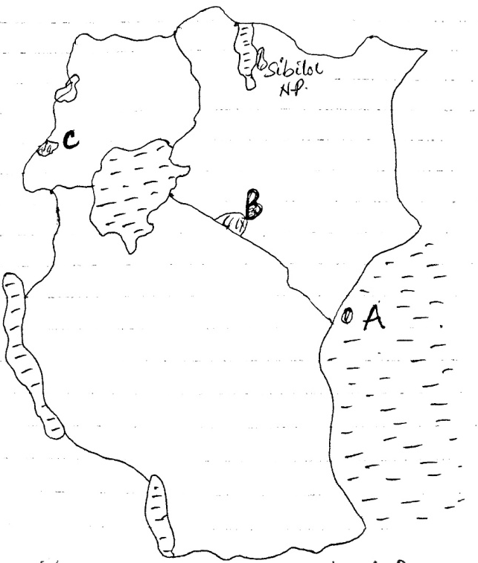

Name National parks marked A, B & c (3mks)
b) i) Explain four factors showing the future of tourism Industry in Kenya (8mks)
ii) Explain how the following factors influence wildlife
- Vegetation (4mks)
- Altitude (4mks)
- a) i) What is fishing (2mks)
ii) Name the two major fishing ground in the Pacific Ocean (2mks)
iii) Name four fresh water fisheries in Kenya (4mks)

b) i) Explain four reasons why Fresh water fishing is more popular than marine fishing in East Africa. (8mks)
ii) Describe trawling as a method of fishing (7mks)
iii) Distinguish phytoplankton and 200 planktons (2mks)

- a) i) Name two main types of coffee grown in Kenya (2mks)
ii) Identify two counties in Kenya where coffee is grown in large scale (2mks)
b) i) State four factors favoring growing of coffee in Kenya (4mks)
ii) Describe the stages of coffee processing once it’s delivered to the factory (9mks)
c) i) Explain two benefits of coffee farming in Kenya (4mks)
ii)State four problems facing coffee farmers in Brazil (4mks)
- a) i) Give three by-products of crude oil (3mks)
ii) List four ways through which occurrence of minerals is influenced. (4mks)
b) Explain four contribution of mining Industry to economy (8mks)
c) Name the minerals found in the following areas in East Africa (4mks)
- Kariandusi
- Kerio Valley
- Kwale County
- Lake Magadi
d)i) State four factors influencing mineral exploitation (4mks)
ii) Give two uses of Gold (2mks)
Answer part of question 6 on the graph sheet below

