MWAKICAN
MARKING SCHEME FORM 3
GEOGRAPHY 312/1

PAPER ONE

SECTION A

- (a) Theories explaining causes of earth movement
- Continental drift theory
- Plate tectonic theory

(b) Boundaries separating tectonic plates
- Extension boundary - separate two plates that move away from each other
- Compression boundary - separate plates moving towards each other
- Shear / Transform boundary - found where two plates move in opposite direction/slide past each other
3 x 1 = 3mks
Award for a complete comparison

2. (a) Types of igneous rocks
Intrusive/plutonic rocks
Extrusive/volcanic rocks

2 x 1 = 2mks

(b) Classes of Igneous rocks based on their chemical composition
Acidic
Basic
Intermediate
Ultra basic
3 x 1 = 3mks

1

3. (a) Layer of atmosphere from earth surface upwards
Troposphere
Stratosphere
Mesosphere
3 x 1 = 3mks
NB: order should be followed

(b) Boundaries separating layers of the atmosphere
Stratospause
Mesupause
Tropopause
2 x 1 = 2mks

4. (a) (Components of Solar system apart from Sun
Planets
Moon
Comets
Meteorites/meteors
3 x 1 = 3mks

(b) Why sun is a unique star
- Generates its own energy
- All planets revolve around it in an orbit
- Its at centre of solar system
- It does not move its static unlike other stars
2 x 1 = 3mks

2
5. (a) Diagram of simple fold
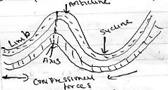

Diagram - 1mk
Anticline - ½ mk
Syncline – ½ mk
Limb – ½ mk
Axis - ½ mk
Total (3mks)

(b) Fold Mts in Africa
- Atlas
- Akwapim hills
- Cape ranges

SECTION B

6. (a) (i) The administrative divisions of Kitale - - West Pokot
- Tran - Nzoia
- Elgeyo Marakwet

2 x 1 = 2mks

(ii) 6 Grid reference of Kupsain pouce post 341253 (2mks)

(iii) Methods of presenting relief
Contours
Trigonometric stations
Spot height Any 2 x 1= 2mks

(b) (i) Area of Kitale Municipality
Full squares 6 = 6
Half squares 15/2 = 7.5/13.5 + 0.5
= 13.5 59Km
13Km² - 14Km² (2mks)

3
(ii) Functions of Kitale township
Health centre (hospital)
Trading centre (shops)

Recreation / Entertainment centre (Sports club)
Administrative - pouce station
Transport - Loose surface road

Any 2 x 1= 2mks

(iii) Types of vegetation
Scattered trees
Scrub
Forest
Woodland
Papyrus swamp
Any 2 x 1= 2mks

(c) A rectangle measuring 10cm by 12cm between Easting 24 to 29 and Northing 12 to 18.

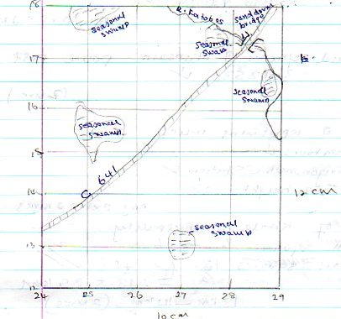

Award : Rectangle - ½ mrk

4
Title - ½ mk
Seasonal Swamp - 1mk
Sandrum Bridge - 1mk
R. Katobos - 1mk
Road C641 - 1mk
Total (5mks)

(d) Farmers at delgany farm carried out a study at colleagues farm at Longleat estate.
(i) Reasons why they need a Map of Kitale:-
- Get exact location of the area
- Identify suitable mode of transport to us
- Prepare work schedule
- Decide on suitable collection technique
- Get to know the extent of the area to be covered

Any 2 x 1= 2mks

(ii) Methods they would use to collect data (2mks)
- Observation
- Interview
- Measurement
- Questionnaire
Any 2 x 1= 2mks

(iii) Data information they would collect
- Types of crops grown/animals rent
- Management principles
- Marketing of the products
- Problems experienced/solutions
- Mode of transport for their produce

Any 2 x 1= 2mks

7. (a)(i) Differentiate between Ocean and Sea.
An Oceans is an extensive mass of Saline water between continents, while a Sea is a mass of Isaline water along continental margins (2mks)

- Name two types of waves along the African Coast
Swash waves
Back wash waves (2mks)

5

(b) Describe three processes through which waves erode the coast.
- solution takes place where coastal rocks are soluble they dissolve in seas water and are carried away.

- Attrition - there is collision between materials carried by waves reducing them in size.

- hydraulic action – process in which waves use water force to hit the coastal rocks making them to shatter/waves compress air in cracks along the coastal rocks causing them to break.

(c) Using diagrams describe how a stack is formed.
- its formed when a headland is attacked by wave action through abrasion and hydraulic action from both sides leading to development of notches on both sides of the headland.

- Continued erosion leads to formation of caves on both sides.

- Continued erosion on enlarged caves eventually maxes the causes to join to form and arch.

- The roof of the arch finally collapses. Water separates a section of the headland from the coast.

- The separated headland leaves a isolated rock pillar known as stack.
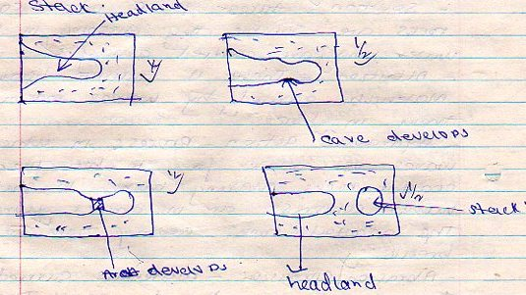

6
Award 2 marks for diagrams
Award 3 marks for explanation
Total (5mks)

(d) (i) Name types of Coasts
Coral coasts
Submerged coasts
Emerged coasts
3 x 1 = 3 mks

(ii) Conditions necessary for growth of coral polyps
- Sea water should be warm
- Sea water should be shallow to allow light to penetrate
- The water should be saline
- The water should be clear/free from silt or mud.
- There should be plenty of planktons
- The water should be well oxygenated
(3mks)
(e) Students of Budonga carried field study along the coast. Some of wave depositional features they were able to identify
Spit
A tombolo
Off – shore bar
Beaches
Cusphate foreland
Marshes and mudflats
Bay bars
4 x 1 = 4 mks

8. (a) (i) Desert in Africa
Kalahari
Namib
Sahara
chalbi 2 x 1 = 2mks

(ii) Types of deserts according to the nature of their surfaces
- Sandy/erg/koum deserts
- Stony/rep/seviv deserts
- Rocky/ Hamada deserts
- badland
3 x 1 = 3mks

7

(b) (i) Two factors which influences wind transportation
- Strength and speed of the wind
- Obstacles in the path of the wind
- Nature and size of the load the wind is carrying
- State of the obstacles
(2mks)

(ii) Describe three ways in which wind transport its load
- Surface creep - process in which large materials and heavy are pushed along the ground surface
- Siltation – the materials are rolled on the ground bounce off into the air and fall again
- Suspension - very fine particles are suspended in the air or held up in turbulence of the wind

2 x 3= 6

(c) Using illustrations describe the formation of mushroom block

- Wind abrasion attack a homogeneous rock
- There’s more abrasion near the base of the rock where abrasive tools are heavier.
- The action produces a rock block with a narrow base and broad top which is polished known as a mushroom block

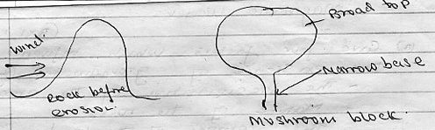

Award 4 marks explanation
2 marks diagram
(6mks)

(d) Students of Kirima school carried out a field study of a desert region.

8
- State two ways in which students prepared
- They formed groups
- They sought permission from relevant authorities
- They carried a pre-visit
- They assembled necessary tools for study
- The formulated objectives hypothesis (2mks)

- Name four desert water features they may have seen
- Inserbergs - Dry river valleys
- Wadis - pediment
- Messas/butes
- Playas/Salinas
(4mks)

9. (i) Sources of underground water
- Rain water
- melt water
- Lake/Sea water
- Magmatic water
(3 x 1 = 3mks)

(ii) Give four factors which influence the existence of ground water
- The precipitation of the area
- Nature of the rocks
- The slope of the land
- Vegetation cover
- Level of saturation of the rocks
4x 1 = 4mks

(iii) State four conditions ideal for the formation of artesians wells
- The aquifer must be sandwiched between impermeable rocks
- The aquifer must be of same permeable rock/materials
- The aquifer must be exposed in an area of sufficient precipitation
- One or both ends of the aquifer must be exposed to allow water percolate.
(4 x 1 = 4mks)

(b)(i) Name three surface features found in Karst Scenery

- Grikes
- Clints
- Swallow holes
- Dolines
- Dry valley

9
- Uvala
- Polje
- Gorges
Any 3 x 1 = 3mks

(ii) Describe how a stalactite is formed:-
- Water seeps through the roof of a cave in limestone area
- The water dissolves calcium carbonate to form calcium bicarbonate.
- The solution drips slowly from the roof of leave
- As each drop hangs on the roof of the cave some water evaporates with Co² given off.
- The chemical change is reversed and the calcium carbonate accumulates on the roof.
- The processes is repeated over a long period of time and forms a column of limestone growing from the roof called stalactite (5mks)

(c) Significance of resultant features in limestone areas.
- They form beautiful features which attract tourists
- The limestone landscape discourage settlement as some area are rugged/rocky with thin soils.
- Limestone blocks are used for building and construction/raw materials for cement manufacturing industry

3 x 2 = 6 mks
10. (a) Draw a Map of Africa and on it mark and name
- Benguela current
- Canary current
- Regions of tropical continental climate
- Mozambique current

10
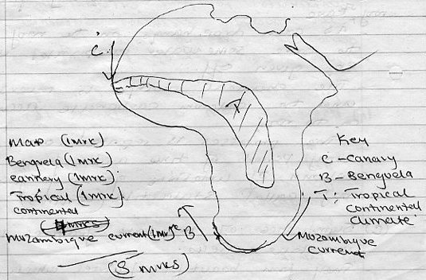

(b) State six characteristics of tropical continental climate
- Rainfall is mainly convectional
- Rainfall comes in summer
- Summers are hot with temperatures rising upto 32⁰C
- Annual temperature range is about 12⁰C
- Moderate rainfall 730mm - 1308mm annually
- Winters are cool and mild with temperatures about 22⁰C
- Trade winds blows mountainous areas receive relief rainfall

(6mks)
(b) (ii) Factors influencing climate

- Latitude
Areas near the equator are hotter than the areas far away from the equator. This is due to a higher concentration of the Sun’s ray per unit area at the equator/ the amount of Solar radiation decreases pole wards since it passes through a longer distance of atmosphere leading to low temperature at the poles.

11
The sun rays strikes the earths surface at right angle / 90⁰ at the equator leading to intense heating / the angle of the Sun rays is lower / acute at the poles leading to less intense heating (2mks)

- Aspect
- In Northern hemisphere outside the tropics the north facing slopes are colder than the South facing slopes because they don’t receive direct solar radiation.
- The reverse is true in Southern hemisphere.

- Windward slopes of high mountains / hills are generally wetter than toward slopes because the moisture laden winds rise and drop their moisture on this first (2mks)

- Ocean currents
- Where winds are onshore, warm ocean currents have a warming effect on the adjacent coast/lead to higher rainfall than inland areas.
- Cold ocean current have a cooling effect/drying effect on the adjacent lands (2mks)

(c) You intend to carry out field study in a weather station around the school
(i) State four preparations you would make before field study.
- Formulation of hypothesis/objectives
- Conduct revisit
- Writing questions
- Discussing in class in groups
- Seek permission from relevant authorities
- Prepare necessary study tools
- x 1 = 4mks

(ii) Name two instruments you would observe in the Stevenson Screen

- thermometer
- hydrometer / wet / dry bulb thermometer

- Give two follow up activities you would undertake after the field study
- Carrying out class discussion
- Writing/ compiling notes
- Data analysis and interpretation
- Making conclusions based on the findings

Any 2 x 1 = 2mks

