NAME: ADM NO:

DATE: SIGN:
312/2
GEOGRAPHY
PAPER 2
FORM IV
END OF TERM II EXAM (2019)
TIME: 2 ¾ HRS

Instructions
- This paper has section A and B. Answer all the questions in section A.
- In section B, answer questions 6 and any other two questions.
- Answer should be written in the answer booklet provided.
- Provided your answers in English
- Follow the instructions as provided.

SECTION A
Answer all questions in this section
1)a) Name two rivers to the West of the Rift valley that causes flooding (2mks)
…………………………………………………………………………………………………………………………………………………………
…………………………………………………………………………………………………………………………………………………………
………………………………………………………………………………………………………………………………………………………..
b) Give three ways how floods can be controlled (3mks)
…………………………………………………………………………………………………………………………………………………………
…………………………………………………………………………………………………………………………………………………………
………………………………………………………………………………………………………………………………………………………..
2)a) What is urbanization? (2mks)
…………………………………………………………………………………………………………………………………………………………
…………………………………………………………………………………………………………………………………………………………
………………………………………………………………………………………………………………………………………………………..
b) Name one functional zone of an ideal urban centre (1mk)
…………………………………………………………………………………………………………………………………………………………
…………………………………………………………………………………………………………………………………………………………
c) State two factors which have led to the development of Mombasa as a major sea port (2mks)
…………………………………………………………………………………………………………………………………………………………
…………………………………………………………………………………………………………………………………………………………
………………………………………………………………………………………………………………………………………………………..
3)a) Distinguish between Horticulture and market gardening (2mks)
…………………………………………………………………………………………………………………………………………………………
…………………………………………………………………………………………………………………………………………………………
………………………………………………………………………………………………………………………………………………………..
b) Identify three reasons why horticulture is developed in Netherlands (3mks)
…………………………………………………………………………………………………………………………………………………………
…………………………………………………………………………………………………………………………………………………………
………………………………………………………………………………………………………………………………………………………..
4) Study the map below showing the St. Lawrence sea way and the great lakes and answer question a (i), ii, (iii)

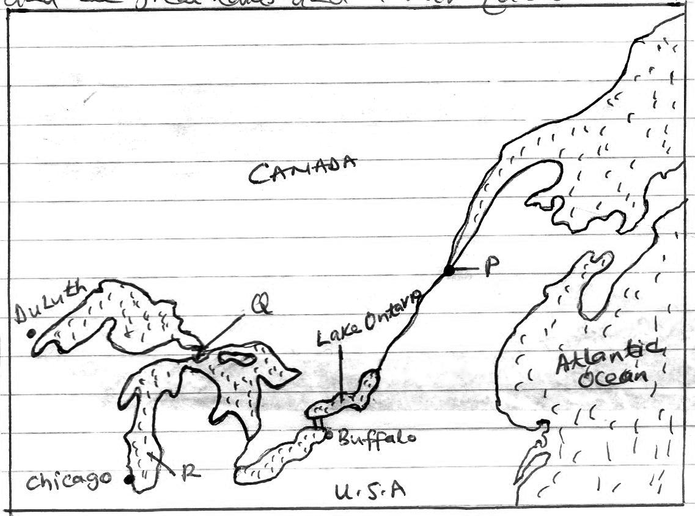

a)i) Name the town marked P (1mk)
…………………………………………………………………………………………………………………………………………………………
…………………………………………………………………………………………………………………………………………………………
ii) Identify the canal located at point Q (1mk) …………………………………………………………………………………………………………………………………………………………
…………………………………………………………………………………………………………………………………………………………
iii) Name the lake marked R (1mk)
…………………………………………………………………………………………………………………………………………………………
…………………………………………………………………………………………………………………………………………………………
b) In what ways is Kenya going to benefit from direct air flight with United States of America (3mks)
…………………………………………………………………………………………………………………………………………………………
…………………………………………………………………………………………………………………………………………………………
………………………………………………………………………………………………………………………………………………………..
5)a) What is the major difference between a National park and a game reserve (2mks)
…………………………………………………………………………………………………………………………………………………………
…………………………………………………………………………………………………………………………………………………………
………………………………………………………………………………………………………………………………………………………..
b) Apart from game reserves and National park, give three ways in which wildlife is conserved in Kenya (3mks)
…………………………………………………………………………………………………………………………………………………………
…………………………………………………………………………………………………………………………………………………………
………………………………………………………………………………………………………………………………………………………..

SECTION B
Answer questions 6, and any other two questions.
Study the photograph below and answer questions a, b and c
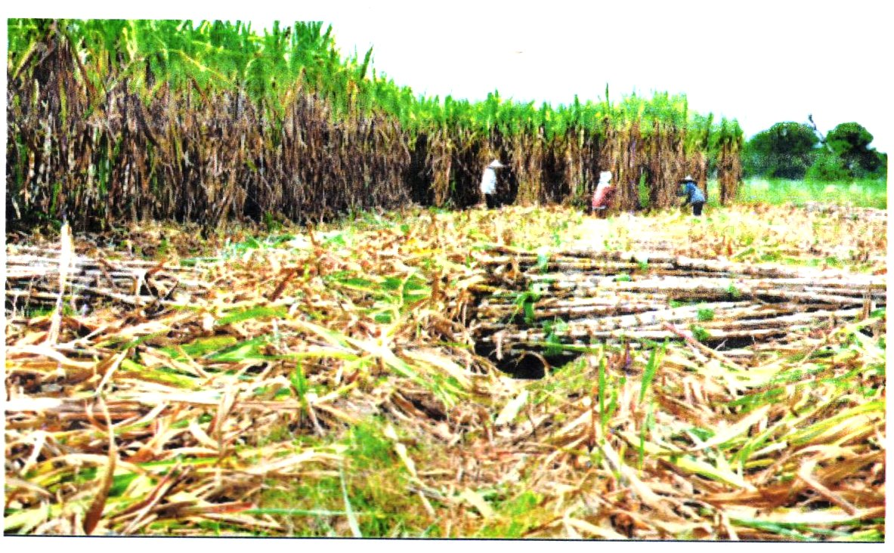

a)i) Identify the type of photograph shown above (1mk)
…………………………………………………………………………………………………………………………………………………………
…………………………………………………………………………………………………………………………………………………………
ii) List two counties West of the Rift Valley where this crop is grown in Kenya (2mks)
…………………………………………………………………………………………………………………………………………………………
…………………………………………………………………………………………………………………………………………………………
………………………………………………………………………………………………………………………………………………………..

iii) Draw a rectangle measuring 15cm by 10cm (1mk)

On the rectangle sketch and label the main features (4mks)
b) Briefly describe the above photograph (3mks)
…………………………………………………………………………………………………………………………………………………………
…………………………………………………………………………………………………………………………………………………………
………………………………………………………………………………………………………………………………………………………..
c) Describe the cultivation of the above crop from land preparation to the stage shown on the photograph (5mks)
…………………………………………………………………………………………………………………………………………………………
…………………………………………………………………………………………………………………………………………………………
………………………………………………………………………………………………………………………………………………………..
…………………………………………………………………………………………………………………………………………………………
…………………………………………………………………………………………………………………………………………………………
………………………………………………………………………………………………………………………………………………………..
d)i) Name two dairy breeds reared in Denmark (2mks)
…………………………………………………………………………………………………………………………………………………………
…………………………………………………………………………………………………………………………………………………………
………………………………………………………………………………………………………………………………………………………..
ii) State four physical factors that support dairy farming in Denmark (4mks)
…………………………………………………………………………………………………………………………………………………………
…………………………………………………………………………………………………………………………………………………………
………………………………………………………………………………………………………………………………………………………..
…………………………………………………………………………………………………………………………………………………………
…………………………………………………………………………………………………………………………………………………………iii) What is the role of Kenya government in dairy farming (3mks)
…………………………………………………………………………………………………………………………………………………………
…………………………………………………………………………………………………………………………………………………………
………………………………………………………………………………………………………………………………………………………..
7)a)i) What is an industry (2mks)
…………………………………………………………………………………………………………………………………………………………
…………………………………………………………………………………………………………………………………………………………
………………………………………………………………………………………………………………………………………………………..
ii) List two non-agricultural manufacturing industries in Kenya (2mks)
…………………………………………………………………………………………………………………………………………………………
…………………………………………………………………………………………………………………………………………………………
………………………………………………………………………………………………………………………………………………………..
b) Give four roles of the Jua Kali Industry to the economic development of Kenya (4mks)
…………………………………………………………………………………………………………………………………………………………
…………………………………………………………………………………………………………………………………………………………
………………………………………………………………………………………………………………………………………………………..
…………………………………………………………………………………………………………………………………………………………
…………………………………………………………………………………………………………………………………………………………
c)i) List two major areas where cottage industry is highly developed in India (2mks)
…………………………………………………………………………………………………………………………………………………………
…………………………………………………………………………………………………………………………………………………………
………………………………………………………………………………………………………………………………………………………..
ii) Give five characteristics of the cottage Industry in India (5mks)
…………………………………………………………………………………………………………………………………………………………
…………………………………………………………………………………………………………………………………………………………
………………………………………………………………………………………………………………………………………………………..
…………………………………………………………………………………………………………………………………………………………
…………………………………………………………………………………………………………………………………………………………
………………………………………………………………………………………………………………………………………………………..
d) Study the map below showing Ruhr industrial region in Germany, and use it to answer question i, and ii below:
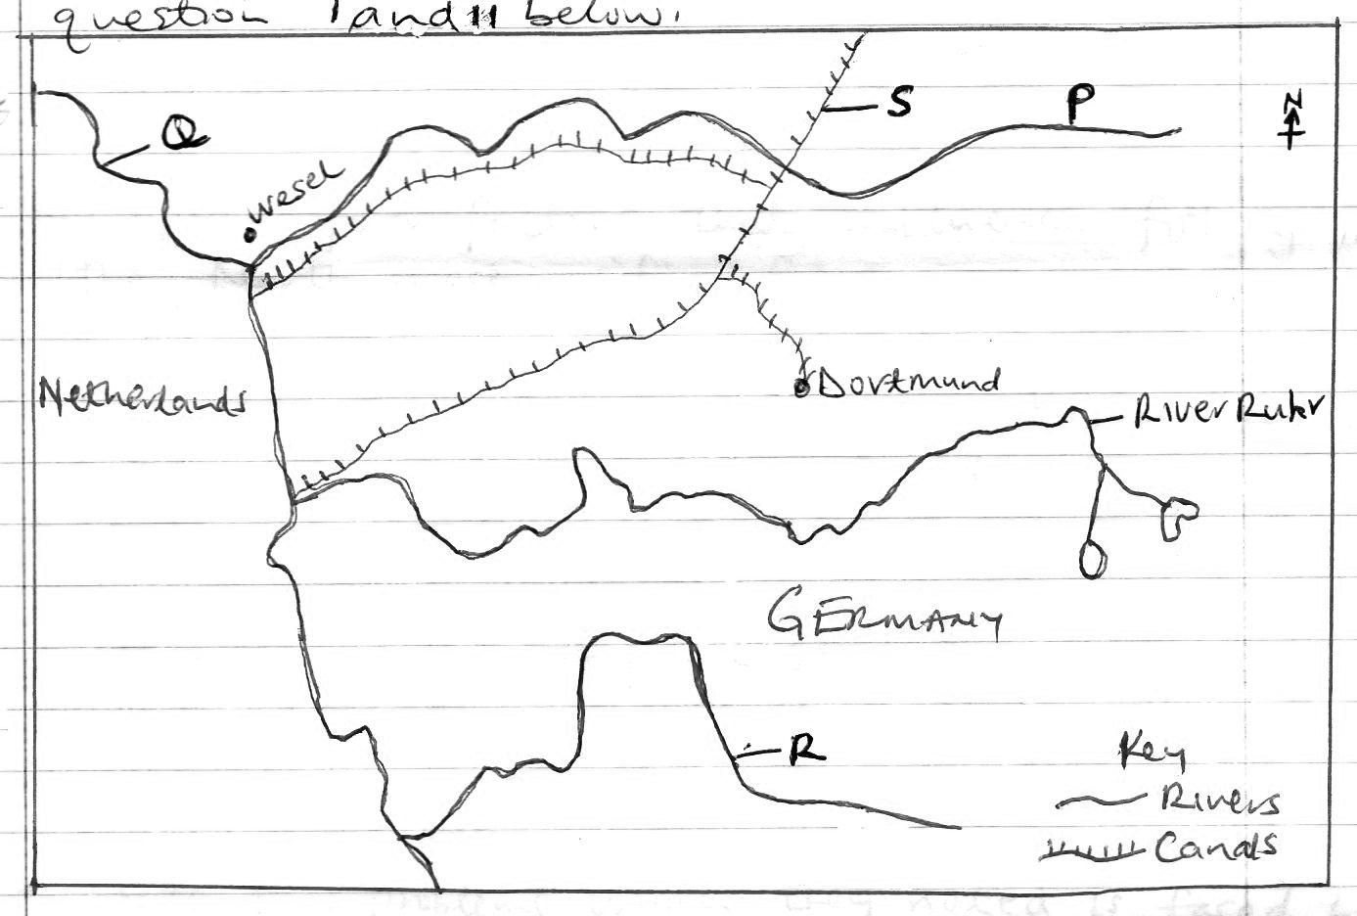

i) Identify the Rivers marked P, Q and R (3mks)
…………………………………………………………………………………………………………………………………………………………
…………………………………………………………………………………………………………………………………………………………
………………………………………………………………………………………………………………………………………………………..
ii) Name the canal labeled S. (1mk)
…………………………………………………………………………………………………………………………………………………………
…………………………………………………………………………………………………………………………………………………………
e) Explain how the following factors have influenced industrial growth in the Ruhr region of Germany
i) Capital (2mks)
…………………………………………………………………………………………………………………………………………………………
…………………………………………………………………………………………………………………………………………………………
………………………………………………………………………………………………………………………………………………………..
ii) Raw materials (2mks)
…………………………………………………………………………………………………………………………………………………………
…………………………………………………………………………………………………………………………………………………………
………………………………………………………………………………………………………………………………………………………..
iii) Market (2mks)
…………………………………………………………………………………………………………………………………………………………
…………………………………………………………………………………………………………………………………………………………
………………………………………………………………………………………………………………………………………………………..
8)a)i) Differentiate between pelagic and demersal fish (2mks)
…………………………………………………………………………………………………………………………………………………………
…………………………………………………………………………………………………………………………………………………………
………………………………………………………………………………………………………………………………………………………..
ii) List two examples of demersal fish (2mks)
…………………………………………………………………………………………………………………………………………………………
…………………………………………………………………………………………………………………………………………………………
………………………………………………………………………………………………………………………………………………………..
b) Outline four reasons why fresh water fishing is more popular in east Africa than marine fishing (4mks)
…………………………………………………………………………………………………………………………………………………………
…………………………………………………………………………………………………………………………………………………………
………………………………………………………………………………………………………………………………………………………..
…………………………………………………………………………………………………………………………………………………………
…………………………………………………………………………………………………………………………………………………………
c)i) Name the Ocean current that makes the coastal water of U.S.A ice free during winter (1mk)
…………………………………………………………………………………………………………………………………………………………
…………………………………………………………………………………………………………………………………………………………
ii) Explain four factors that influence fishing in the North West pacific fishing ground (8mks)
…………………………………………………………………………………………………………………………………………………………
…………………………………………………………………………………………………………………………………………………………
………………………………………………………………………………………………………………………………………………………..
…………………………………………………………………………………………………………………………………………………………
…………………………………………………………………………………………………………………………………………………………
………………………………………………………………………………………………………………………………………………………..
…………………………………………………………………………………………………………………………………………………………
…………………………………………………………………………………………………………………………………………………………
………………………………………………………………………………………………………………………………………………………..
…………………………………………………………………………………………………………………………………………………………
…………………………………………………………………………………………………………………………………………………………
………………………………………………………………………………………………………………………………………………………..
d) Form four students from a school in Kisumu carried out a field study on fishing in L. Victoria
i) State one objective that they could have used for the study (1mk)
…………………………………………………………………………………………………………………………………………………………
…………………………………………………………………………………………………………………………………………………………
ii) State the reasons why the students needed a route map during the study (2mks)
…………………………………………………………………………………………………………………………………………………………
…………………………………………………………………………………………………………………………………………………………
………………………………………………………………………………………………………………………………………………………..
iii) Give three advantages of studying fishing through field work (3mks)
…………………………………………………………………………………………………………………………………………………………
…………………………………………………………………………………………………………………………………………………………
………………………………………………………………………………………………………………………………………………………..
iv) State two problems which they noted is faced by fishermen in Lake Victoria (2mks)
…………………………………………………………………………………………………………………………………………………………
…………………………………………………………………………………………………………………………………………………………
………………………………………………………………………………………………………………………………………………………..
9)a)i) What is a fossil fuel? (2mks)
…………………………………………………………………………………………………………………………………………………………
…………………………………………………………………………………………………………………………………………………………
………………………………………………………………………………………………………………………………………………………..
ii) List two fossil fuels that have recently been discovered in Kenya (2mks)
…………………………………………………………………………………………………………………………………………………………
…………………………………………………………………………………………………………………………………………………………
………………………………………………………………………………………………………………………………………………………..
iii) State three formations in which mineral ore occurs (3mks)
…………………………………………………………………………………………………………………………………………………………
…………………………………………………………………………………………………………………………………………………………
………………………………………………………………………………………………………………………………………………………..
b) Explain how the following factors influence mining
i) Value of the mineral (2mks)
…………………………………………………………………………………………………………………………………………………………
…………………………………………………………………………………………………………………………………………………………
………………………………………………………………………………………………………………………………………………………..
ii) Transport (2mks) d
…………………………………………………………………………………………………………………………………………………………
…………………………………………………………………………………………………………………………………………………………
………………………………………………………………………………………………………………………………………………………..
c)i) Describe how solution mining method is carried out (5mks)
…………………………………………………………………………………………………………………………………………………………
…………………………………………………………………………………………………………………………………………………………
………………………………………………………………………………………………………………………………………………………..
…………………………………………………………………………………………………………………………………………………………
…………………………………………………………………………………………………………………………………………………………
………………………………………………………………………………………………………………………………………………………..
ii) Give three negative effects of mining to the environment (3mks)
…………………………………………………………………………………………………………………………………………………………
…………………………………………………………………………………………………………………………………………………………
………………………………………………………………………………………………………………………………………………………..
d)i) Name two areas where gold is mined in South Africa (2mks)
…………………………………………………………………………………………………………………………………………………………
…………………………………………………………………………………………………………………………………………………………
………………………………………………………………………………………………………………………………………………………..
ii) Describe how diamond is processed (4mks)
…………………………………………………………………………………………………………………………………………………………
…………………………………………………………………………………………………………………………………………………………
………………………………………………………………………………………………………………………………………………………..
…………………………………………………………………………………………………………………………………………………………
…………………………………………………………………………………………………………………………………………………………
10)a)i) Define the term energy (2mks)
…………………………………………………………………………………………………………………………………………………………
…………………………………………………………………………………………………………………………………………………………
………………………………………………………………………………………………………………………………………………………..
ii) Name two non-renewable sources of energy (2mks)
…………………………………………………………………………………………………………………………………………………………
…………………………………………………………………………………………………………………………………………………………
………………………………………………………………………………………………………………………………………………………..
b)i) Identify two potential sites in Kenya for wind energy production (2mks)
…………………………………………………………………………………………………………………………………………………………
…………………………………………………………………………………………………………………………………………………………
………………………………………………………………………………………………………………………………………………………..
ii) State three reasons why wind energy is still underdeveloped in Africa (3mks)
…………………………………………………………………………………………………………………………………………………………
…………………………………………………………………………………………………………………………………………………………
………………………………………………………………………………………………………………………………………………………..
c) Use the map of Africa shown below to answer question c (i)
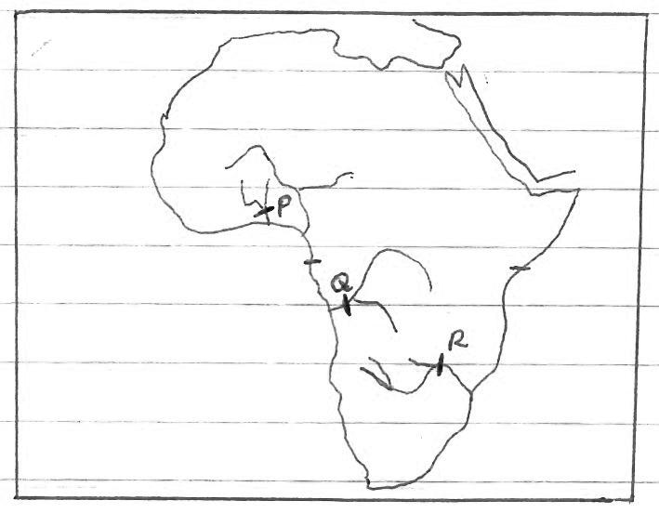

i) Name the power plant laballed P, Q and R (3mks)
…………………………………………………………………………………………………………………………………………………………
…………………………………………………………………………………………………………………………………………………………
………………………………………………………………………………………………………………………………………………………..
ii) Explain the problems facing generation of hydro-electric power production (6mks)
…………………………………………………………………………………………………………………………………………………………
…………………………………………………………………………………………………………………………………………………………
………………………………………………………………………………………………………………………………………………………..
…………………………………………………………………………………………………………………………………………………………
…………………………………………………………………………………………………………………………………………………………
………………………………………………………………………………………………………………………………………………………..
…………………………………………………………………………………………………………………………………………………………
…………………………………………………………………………………………………………………………………………………………
………………………………………………………………………………………………………………………………………………………..
iii) Apart from providing power, state three other benefits of the power dams in Africa (3mks)
…………………………………………………………………………………………………………………………………………………………
…………………………………………………………………………………………………………………………………………………………
………………………………………………………………………………………………………………………………………………………..
d) Explain how the following two factors causes energy crisis
i) Artificial shortage (2mks)
…………………………………………………………………………………………………………………………………………………………
…………………………………………………………………………………………………………………………………………………………
………………………………………………………………………………………………………………………………………………………..
ii) Oil prices (2mks)
…………………………………………………………………………………………………………………………………………………………
…………………………………………………………………………………………………………………………………………………………
………………………………………………………………………………………………………………………………………………………..

