MWAKICAN EXAM
GEOGRAPHY PAPER II FORM 3 MARKING SCHEME

SECTION A: 25 MARKS
Answer all the questions
1. (a) What is a photograph? (2 mks)
A photograph is an image of an object, person or scene recorded by a camera on a light sensitive film or paper. (2x1) = 2 mks

(b) Name three types of ground photographs. (3 mks)
- Ground close up
- Ground general view photographs
- Ground oblique (3 x 1) = 3 mks

2. (a) State three formations in which minerals occur. (3 mks)
- Veins and lodes
- Beds and seams
- Weathering products
- Alluvial or placer deposits (3x1) = 3 mks

(b) Name two areas where gold is mined in East Africa. (2 mks)
Kakamega - Kenya
Mabuki, Geita, Mpanda, Musoma, Chunya, Mbeya – Tanzania (2x1) = 2mks

3. (a) Distinguish between forest and forestry. (2 mks)
Forest is a continous and extensive land covered with a closed stand of tall trees usually of commercial value, while forestry is the science of developing or cultivating forests.
(2x1) = 2 mks

(b) State three factors favouring growth of Mt. Kenya forest. (3 mks)
- The area receives high rainfall throughout the year which encourages continous growth of trees.
- The area has deep fertile volcanic soil that allow the roots to penetrate deep hence able to hold trees.
- The area is a gazette reserve prohibiting cultivation and settlement hence allowing growth of trees.
- The steep slopes discourage settlement thus forests thrive. (3 x 1) = 3 mks

4. (a) Name two types of questionnaires. (2 mks)
- Personal interview questionnaires.
- Rigid questionnaire. (2x1) = 2mks

(b) State three factors to consider when preparing a questionnaire. (3 mks
- The questions should be simple and clear.
- The questions should not be too many as this discourages the respondents.
- Questions should be arranged in a logical order beginning with the simplest to the more difficult ones.
- Questions should be related to the topic under research.
- Questions should not annoy the respondents i.e they shouldn’t touch on the respondents personal life.
- The questions should be free from bias ie avoid leading questions. (3 x1) = 3mks

5. (a) Name three middle east countries that are oil producers. (3 mks)
- Saudi Arabia
- Iraq
- Iran
- Kuwait
- United Arab Emirates

(b) Give two by products obtained when crude oil is refined. (2 mks)
- Wax
- Bitumen/peat/asphalt
- Grease/lubricants
- Resin/petrol chemicals

SECTION B
Answer question 6 and any other two questions.
6. The table below shows Kenya’s principal mineral by value in Ksh. 000,000 between 1991 – 1994.
MINERAL | 1991 | 1992 | 1993 | 1994
SODA ASH | 60 | 70 | 80 | 100
FLOURSPAR | 25 | 50 | 40 | 60
DIATOMITE | 35 | 40 | 50 | 55
LIMESTONE | 70 | 80 | 95 | 110
(a) (i) Draw a cumulative bar graph to represent the information given above. (8 mks)
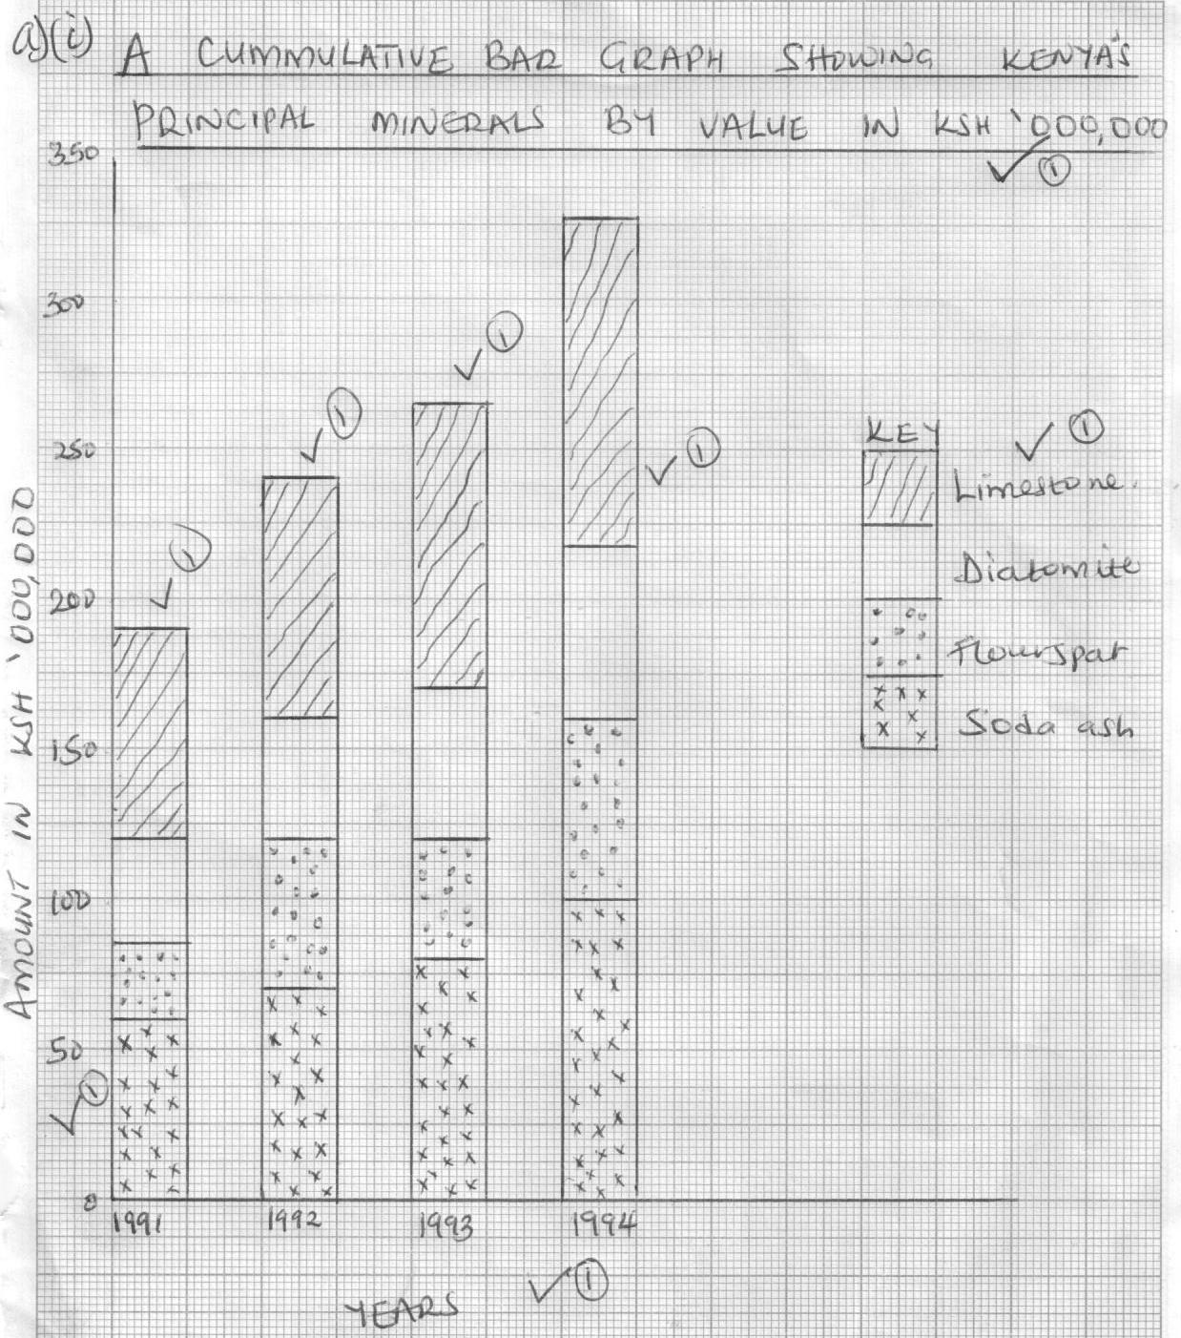

(ii) State three advantages of using cumulative bar graph in data presentation. (3 mks)
- Different variables can be represented on one bar.
- Totals of components for individual years are clearly brought out.
- There is easy comparison for the same component in different bars because of uniform shading.
- Easy to interpret because bars are shaded differently.
- It can be used to present a large variety of data. 3x1 = 3 mks
(b) Explain three ways in which Kenya has benefited from mining soda ash. (6 mks)
- Through exporting soda ash kenya earns foreign exchange which is used to import essential items such as machinery.
- It has led to the development of industries by providing raw materials e.g. glass, soap, paper and ceramic industries.
- It has led to the growth of Magadi town ie. Urbanization.
- It has led to the provision of social amenities such as schools, hospitals, social clubs etc which have improved the living conditions of the local Maasai community.
- Mining of Soda ash has provided job opportunities for many Kenyans hence raising their standard of living.
- Taxation of the soda ash earns the government revenue income used for development.
- Had led to the development of infrastructure eg. Railway line from Konza to Magadi town.
3x2 = 6 mks

(c) (i) Name three main places where diamonds are mined in south Africa. (3 mks)
- Kimberley
- Pretoria
- Jagerfontein
- Vacal orange valleys
- Bulfon tein 3x1 = 3 mks

(ii) Describe the processing of diamond in South Africa. (5 mks)
- The diamond bearing ore is crushed into small pieces, the pieces are washed to remove dirt.
- The remaining rock with diamond is passed over a rotating table covered with grease.
- The grease repels the water and wet pieces of mineral ore do not stick but slides off the table as a waste.
- Diamond stick onto the greased belt/table.
- The moving belt/rotating is topped to remove diamond. The diamond are then sorted out by hand.
NB: Sequence but be followed logically. (5x1 = 5 mks)

7. (a) (i) Name two indigenous softwood trees in Kenya. (2 mks)
- Cedar
- Podo
- African pencil 2x1 = 2 mks

(ii) State five factors that favour the development of softwoods in Kenya. (5 mks)
- Cool climate that enables coniferous trees to grow/flourish.
- Highlands receive high amounts of rainfall.
- Rugged highlands discourage settlement and agricultural activities leaving forestry as the alternative.
- High demand for the soft woods products encourage tree planting.
- Deep soils favour forest growth.
- Softwoods grow quite first due to warm temperatures.
5x1 = 5 mks
(b) (i) Explain four problems experienced in commercial exploitation of tropical rain forests in Africa. (8 mks)
- Wide variety of trees species hence exploitation of the required species difficult.
- Valuable tree species are widely scattered hence difficult and expensive to exploit.
- Thick/dense undergrowth hinder accessibility/exploitation.
- Dangerous wild animals/insecurity.
- Humid climate – malaria conditions.
- Heavy rainfall all year round – impassable roads.
- Low demand – markets are far away.
- Bulkiness of logs – transportation is difficult.
2x3 = 6 mks

(ii) Give four protective roles of forests in a country. (4 mks)
- Protect water resources/catchment areas.
- Protect and improve climate by preventing excessive evaporation from bare ground.
- Control/reduce soil erosion by breaking force of falling raindrops/bind soil particles together.
- Act as wind breakers.
- Provide humus to soil which absorb most of the moisture.
4X1 = 4 mks

(c) Explain three problems Canada experiences in exploiting her forests. (6 mks)
- Cold climate means trees take long period to mature hence delaying harvesting.
- Accidents/fire destroys large tracts of forests reducing area of forests.
- Rugged landscape hinder smooth exploitation of forests.
- Northern part experiences very cold conditions making the area inaccessible.
3x2 = 6 mks

8. (a) Name three methods of underground mining. (3 mks)
- Drift or adit method
- Shaft method
- Solution method
- Drilling method
3x1 = 3 mks

(b) Explain four factors influencing the exploitation of minerals. (8 mks)
- Value of minerals. Minerals of a higher value have a greater demand hence are mined even at a high cost.
- Size of mineral deposits. Small quantities of mineral deposits will discourage mining because they may not meet the cost of mining.
- Quality of the ore. Ore containing a large quantity of a quality mineral will be economically viable for exploitation.
- Method of mining used. If very expensive, it will discourage mining.
- The level of technology. If not locally available, importing it is expensive hence discourages mining.
- Availability of market. If available, it encourages mining.
- Availability of cheap mode of transport/accessibility. This encourages mining.
4x2 = 8 mks

(c) Give four significance of mining in Kenya. (4 mks)
- Led to development of industries.
- Led to development of transports and communication/infrastructure.
- Creates employment opportunities.
- Has led to development of settlements.
- Leads to development of social facilities.
- It is vital in earning foreign exchange.
4x1 = 4 mks

(d) State four problems facing the mining industry in Kenya. (4 mks)
- Pollution, noise, water and air.
- Inadequate capital.
- Control by multinational mining companies.
- Insufficient skilled personnel.
- Mineral occurring in small quantities.
- Inaccessibility in certain mines.
- Deaths from collapsed mines.
- Land use conflicts e.g. Titaniumin Kwale.
4x1 = 4 mks

(e) Explain three negative effects of mining on the environment. (6 mks)
- Encourages pollution.
- Leads to clearance of vegetation.
- Leaves very large, ugly deposits of sand.
- Creates pits which are breeding grounds for disease carrying pests.
- Some minerals pollute the environment.
- Land dereliction/makes land generally useless after mining is completed.
- Loss of bio diversity.
3x2 = 6 mks

9. Use the table below to answer the questions that follow.
(a) Differentiate between secondary and primary data. (2 mks)
Number of dairy animals in division X on the Kenyan highlands in 1992.
TYPE | NUMBER
Guernsey | 8400 | $$\frac{8400}{48000} ×12=2.1 \left(\frac{8400}{4000}=2.1\right)$$
Ayrshire | 7200 | $$\frac{7200}{48000} ×12=1.8 \left(\frac{7200}{4000}=1.8\right)$$
Jersey | 10800 | $$\frac{10800}{48000} ×12=2.7 \left(\frac{10800}{4000}=2.7\right)$$
Friesian | 16400 | $$\frac{16400}{48000} ×12=4.1 \left(\frac{16400}{4000}=4.1\right)$$
Sahiwal | 5200 | $$\frac{5200}{48000} ×12=1.3 \left(\frac{5200}{4000}=1.3\right)$$

(b) (i) Using a scale of 1cm to represent 4000 animals, represent the above data using a divided rectangle. (6 mks)

(c) State two advantages of using a divided rectangle to represent data. (2 mks)
- Each individual component is clearly seen.
- It allows for comparison of the quantities of the various components.
- It can be used to represent a wide range of data.
2x1 = 2 mks

(d) Name three other ways through which the data above can be statistically presented. (3 mks)
- Pie charts/proportional circles
- Bar graphs
- Simple line graph
3x1 = 3 mks

(e) Name five methods of collecting data. (5 mks)
- Administering questionnaires
- Interviews
- Observation
- Sampling
- Taking measurements
- Experimentation
- Extracting from secondary sources.
5x1 = 5 mks

(f) Name three major methods of analyzing data. (3 mks)
- Calculation of percentages
- Measures of central tendencies
- Measures of dispersion
3x1 = 3 mks
(g) Give two advantages and two disadvantages of using a simple wind rose in
data presentation. (4 mks)
- It is easy to read and interpret since one can easily tell the number of days the wind blew in a certain direction.
- It gives a good visual impression.
2x1 = 2 mks
Disadvantages
- It does not slow the speed of wind.
- It does not show a comparison of wind direction in various places or for various months.
- It is only used to present data on wind direction.
2x1 = 2 mks

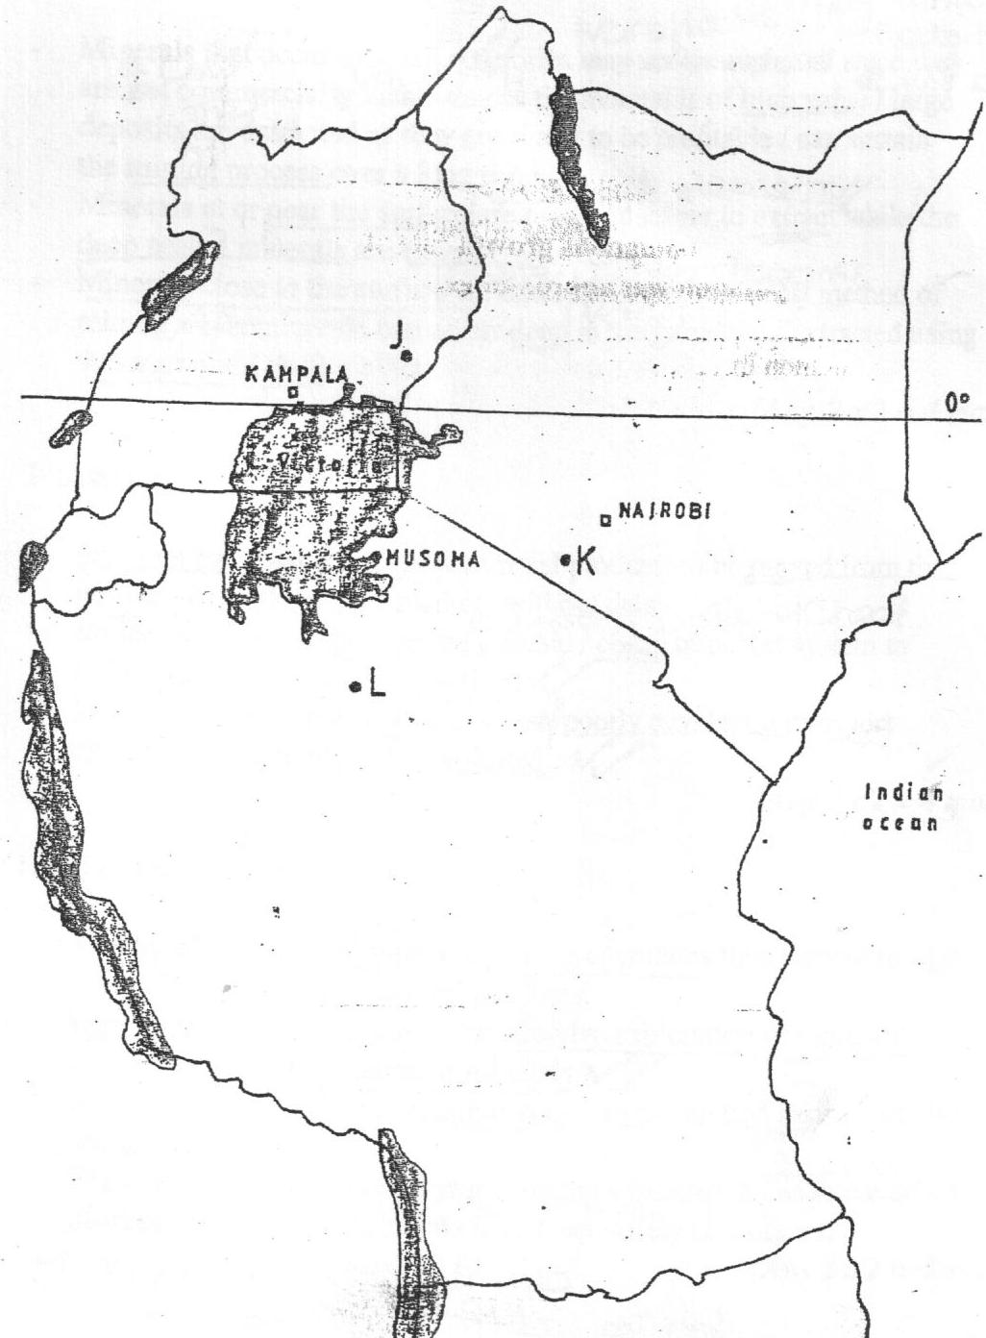
10. The map below shows the location of some minerals in East Africa.

(a) Name the minerals mined in the areas marked J, K and L. (3 mks)
J – Limestone
K – Soda ash/Trona
L – Diamond

(b) Students from Gatero secondary school went for a field work in the area marked K.

- List down the normal pattern that the fieldwork procedure takes. (5 mks)
Identify the topic of study

Statement of objectives

Formulation of the hypothesis

Prepare for the field work

Conduct the actual study
5x1 = 5 mks
The order must be followed

(ii) Give five activities the students will require to do before going for the fieldwork. (5 mks)
- Seek permission from authorities
- Conduct a reconnaissance
- Adjust objectives and hypothesis
- Choose methods of data collection
- Assemble necessary tools
- Prepare a working schedule
- Divide the students into groups.

(iii) State three objectives of the study. (3 mks)
- To find which mineral is mined at place K.
- To find out the method of mining used.
- To find out the challenges encountered during mining.
(any other relevant objectives)
3x1 = 3 mks

(iv) List three problems they are likely to encounter during the study. (3 mks)
- Harsh climate like too much heat.
- Danger of wild animals e.g snakes in the semi-arid environment.
- Lack of drinking water.
3x1 = 3 mks

(v) Prepare a working schedule to be used during the study. (4 mks)
- 5.00 – 5.30 am Arrival
- 5.30 – 8.30 am Travelling
- 8.30 – 9.30 am Breakfast
- 9.30 – 10.30 am Instructions and dividing into groups
- 10.30 – 12.00 am Field study in the lake
- 12.00 – 1.00 pm Interviewing the miners
- 1.00 pm – 2.00 pm Lunch
- 2.00 – 4.00 pm Field study in the factory
(Any other well organized schedule) 4x1 = 4 mks
(vi) List two follow-up activities that they will carry out after the study. (2 mks)
- Discussing and comparing notes in groups.
- Group secretaries make a presentation to class.
- Compiling the reports
- Present the data in tables, graphs etc.
2x1 = 2 mks

