NYERI SUB COUNTY JOINT EXAMINATION
END OF TERM 2 EXAM
FORM FOUR GEOGRAPHY PAPER 2
MARKING SCHEME

1(a) A cottage industry is a small scale industry which uses local raw materials and requires little capital to start and operate. (2 mks)

(b) Reasons why the government of Kenya encourages the establishment of Jua Kali industries.
- requires little capital investments.
- requires little skills.
- encourages innovation.
- diversify production/export goods.
- to cater for real needs/save on foreign exchange.
- to produce cheap consumer goods.
- to make use of locally available raw materials.
- to create employment opportunities.

2(a) Factors that favour growth of forest on Mt Kenya.
- Cool climates enables forests to flourish.
- High rainfall experienced in the area enhance growth of trees.
- The steep nature of the forested land makes it a conducive area for forest growth. (3 mks)
(b) – Mvule
- Meru oak
- Elgon teak
- Elgon olive (2 mks)

3 (a) Wildlife is defined as all untamed plants/flora and animals/fauna existing in their natural habitat. (2 mks)

(b) Reasons why it is necessary to conserve wildlife in Kenya.
-to attract tourist
- to protect endangered species of plants and animals
- to preserve wildlife for future generations.
- to maintain the genetic diversity.
- to ensure sustainable utilization of species.
- to maintain aesthetic value forrecreation.
- to provide raw materials for medicinal use. (3 mks)

4(a) Uses of soda ash.
- Manufacture of glass
- Manufacture of soap
- Manufacture of detergent
- Manufacture of caustic soda. (2 mks)

(b) Ways in which mining derelicts can be rehabilitated.
-planting trees
- creating a park to attract tourists.
- introducing aquaculture/fish farming.
- landscaping for settlement or farming.
- refilling the pits. (3 mks)

5 (a) Factors that lead to formation of nucleated settlement.
- Availability of social amenities.
- Presence of natural resource/industrial plant.
- Limitation of land for building.
- Assurance of security/defence.
- Government policy on settlement. (2 mks)

(b) Social functions of Kisumu town
- Eduction centre
- Religious centre
- Residential centre
- Cultural centre
- Recreation centre
- Medical centre.
6 (a)
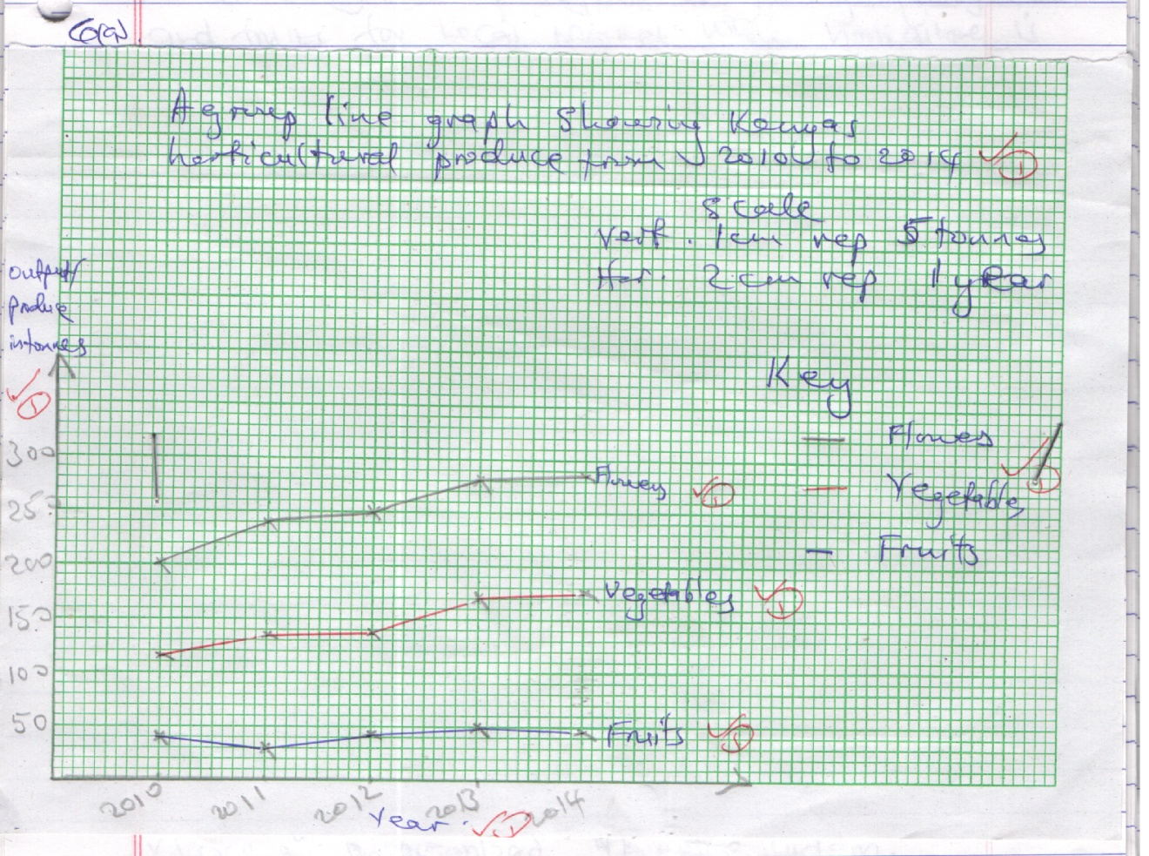
(b) Advantages of using group line graph.
- easy to construct.
- gives clear visual impression.
- easy to read.
- easy to interprete.
- easy to compare.

(c) Distinguish between market gardening and horticulture:-
- market gardening refers to growing of vegetables and fruits for local market while horticulture is growing of flowers, fruits and vegetables mainly for foreign market. (2 mks)

(d) Factors that favour horticulture in Netherlands:-
- Advanced technology in the use of glass/green houses hence faster growth and better quality products.
- Well established transport network/roads/railways/rivers which ensure fast deriveries.
- Skilled labour ensures high production.
- Market is easily accessible due to its central location.
- Organized market system which encourages the farmers.
- Fertile soils in the polder which favours crop growth. (8 mks)

(e) Factors that hinder development of horticulture in Kenya.
- Inadequate capital.
- Lack of an organized marketing system.
- Pests and diseases.
- Poor farming methods.
- Inadequate refrigeration facilities.
- Stiff competition for market. (5 mks)

7(a) Sources of renewable energy:-
-wind -tides/waves
- sun - steam
- water - biomass
- wood/trees (3 mks)

(b)(i) H.E.P stations along River Tana
-Masinga - Kindaruma
- Kaburu - Kiambere
- Gitaru (3 mks)

(ii) Benefits of the dams along the River Tana.
-The reservoirs provide water for domestic/industrial use/irrigation.
- the dams/reservoirs are tourist attraction.
- the reservoirs are fresh water fisheries.
- the reservoirs modify local climate.
- the dams act as bridges across the river.
- the dams control floods downstream. (4 mks)

(iii) Problems that affect the production of power form the stations along River Tana:-
- Fluctuations of water levels in the reservoirs.
- Inadequate capital for maintenance.
- Silting of the reservoirs. (2 mks)

(c) Measures the government of Kenya has taken to conserve energy.
-Encouraging peple to use renewable sources in order to reduce the overreliance of fossil fuels.
- Developing energy saving technologies in order to reduce the high consumption of energy.
- Educating public on the careful use of energy in order to save it.
- Proper planning of road networks in urban areas to reduce traffic jam hence saving on fuel consumption.
- Encouraging the use of public transport/walking in order to reduce the number of vehicles on the roads thus reducing energy consumption.
- Discouraging importation of high fuel consumption vehicles to reduce amount of fuel used.
- Encouraging afforestation and reafforestation for continous supply of wood fuel.

(d)(i) Sampling techniques:-
- Stratified
- Random
- Systematic

(ii) Advantages of using sampling techniques:-
- To save on time
- To reduce bias
- To allow for detailed study
- To reduce cost. (3 mks)

8(a)(i) Transport is the movement of goods and people from one place to another while communication is the transmission of ideas or information from one person to another. (2 mks)

(ii) Modern means of communication used in Kenya:-
- Telephone/cellular phone/mobile phone.
- Fax
- Telex
- E-mail
- Internet

(b)(i) Factors hindering the development of road transport in Kenya:-
- poor technology causes substandard work on roads causing them to wear out in a short time.
- inadequate capital for construction of new roads or maintenance of existing ones.
- presence of physical barriers like mountain, water bodies and escarpment that makes road construction difficult and expensive.
- absence of resources potential in some parts of North Eastern Kenya, are sparsely populated with few economic activities making construction of roads non viable.
- harsh weather during the rainy season, the dry weather roads are muddy and impassable, flooding caused by heavy rains destroy sections of roads and bridges.
(8 mks)
(ii) Proposed major highways in Africa:-
- The Trans Africa highway Lagos to Mombasa.
- The Great North Road/Cairo to Gaborone/Cape town.
- The Trans-saharan highway/Algiers to Lagos.
- Tripoli to windhoek (Cape town)
- Dakar to Lagos.
- Tripoli to Cape town. (2 mks)

(c) Ways in which the Great lakes and St. Lawrence sea way has contributed to the growth of industries in the region.
- It has increased internal and external trade.
- It has facilitated the transportation of bulky products.
- It has reduced the cost of transportation of bulky products.
- The reservoirs along the sea way provide HEP for industrial use.
- It has led to the development of lake, ports and towns.
- Provide market/labour/housing facilities.

(d) Why the government of Kenya is expanding pipeline transport:-
- to reduce damage on road tankers.
- to reduce the congestion on roads.
-to reduce road accidents by tankers.
- to reduce congestion at the terminus.
- pipeline transport is cheaper compared to road transport.
- pipeline transport is more reliable/convenient than road.
- to reduce loss of oil/water/contamination while being transported.
- to minimize environmental pollution. (any 4) (4 mks)

9(a)(i) Fisheries are water bodies where exploitation of acquatic organism is carried out.
(2 mks)
(ii) Countries in Southern Africa that are important for marine fish production:-
- South Africa
- Angola
- Namibia
(b)(i) Problems experienced in marketing fish in Kenya;-
- Some fishing areas are far from the markets, fish goes bad on route.
- Fishermen lack appropriate storage and preservation facilities.
- There are limited local markets due to cultural beliefs.
- The external markets are limited by tight restrictions/competition from other producers.
- The limited number of fish species limits the market.

(ii) Ways in which Kenya is promoting the fishing industry:-
- Fishermen are given loans to expand their fish farming.
- Fishermen are encouraged to form co-operatives.
- Research is carried out/re-stocking over fished areas.
- There is standardization of mesh size of nets used in fishing.
- There is restriction of fishing from some specific parts of the sea where fish breeds.
- Laws have been enacted against water pollution to protect fish.
- Clearing of water hyacinth from fresh water fisheries. (4 mks)

(c)(i) Trawling method (1 mk)

(ii) How the method is used in catching fish;-
- A bag shaped net is attached to trawler/ship,
- the net mouth is kept open by other boards,
- the upper parts of the net are kept a float by corks/floats,
- weights are used to keep the lower part of the net at the sea bed,
- the trawler drags the net along the sea bed, after sufficient fish has been caught, the net is hauled to the trawler to empty the fish. (4 mks)

(d) Factors that favour fishing industry in Japan:-
- the cool waters are ideal for fish breeding because of abundant supply of plankton on which fish feed on.
- the coast has many offshore islands which are sheltered inlets, ideal for the establishment of fishing port.
- the intended coastline provides secure breeding grounds for fish.
- the meeting of the warm kuro siwo and the cold oya siwo ocean currents result in upwelling of the sea water thus bringing minerals for the planktons from the sea bed to the surface.
- the Japanese have advanced technology that is used in fishing, processing and preservation of fish.
- Japan has a large population which provides ready local market for fish.
- Japanese have a long history of sea faring thus are highly experienced in fishing.
- the cool waters encourages thriving of numerous species of acquatic life.
- the shallow continental shelf allows light to the sea bed for growth of micro- organisms which are food for fish. (8 mks)

10(a)(i) Causes of water pollution:-
- Industrial effluent when discharged into rivers.
- Oil leaks from ship/trucks.
- Washing away chemical/fertilizers, into rivers.
- Washingbathing/watering animals in rivers/lakes.
- Disposing of raw sewages into rivers/lakes.
- Surface run-off into water depositing silt.
- Dumping of solid waste into water courses. (2 mks)

(ii) Effects of water pollution on the environment.
- It may cause death of acquatic life.
- It destros the aesthetic beauty of beach/water bodies.
- Causes foul smell.
- Leads to Eutrophication/water hyacinth/ water weeds. (2 mks)

(b) Methods used to control floods on rivers in Kenya:-
- dykes are constructed along river banks to increase their height in order to prevent water from over flowing.
- dredging of river channels to deepen them to make it possible for them to accommodate excess water.
- dams are built across the rivers to control the amount of water discharges downstream.
- planting of trees in the catchment areas to reduce surface run off and increase infiltration.
- Diverting tributaries to other rivers to reduce the volume.
(any 4) (8 mks)
(c)(i) Areas prone to lightening
- Kisii
-Kakamega
-Nyamira
- Kisumu (2 mks)

(ii) – lightening being an electrical discharge can cause loss of human and animal life
-lightening destroys property such as buildings, cars,trees when it strikes.
-lightening frequently start fires, which in turn destroys the property around as well as forest fires.
-lightening interferes with aviation activities as they may strike airplanes. (4 mks)

(d)(i) Reasons for a pre-visit.
- to get permission from the relevant authority.
- to be able to formulate the objectives.
- to familiarize with the area of study.
- to be able to prepare a working schedule.
- to assess the likely problems to be encountered.
-to determine the materials required. (3 mks)

(ii) Methods you would use to collect data.
-interviewing
- taking photographs
- observation
- measuring the extent of polluted area.
- administering questionnaires
- tape recording/video taking/shooting. (2 mks)

(iii) Follow-up activities:-
- Discussing the findings.
- Analyzing the data.
- Writing a report.
- Giving relevant advice to the stakeholder.
- Drawing sketches.
- Displaying photographs/sketches. (3 mks)

